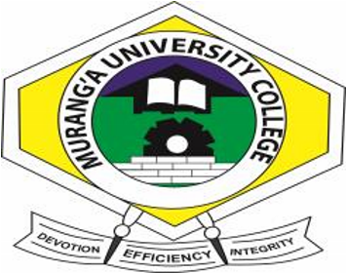

MURANG’A UNIVERSITY COLLEGE
(A constituent College of Jomo Kenyatta of Agriculture & Technology)
SCHOOL OF BUSINESS AND ECONOMICS

MAIN CAMPUS

UNIVERSITY EXAMINATIONS
2014/2015 ACADEMIC YEAR

EXAM: END OF SEMESTER 2 EXAM

DIPLOMA IN KNEC EXAMS

UNIT CODE : BS 1114

UNIT NAME : SUPPLY & TRANSPORT MANAGEMENT
REGULAR EXAMINATION

INSTRUCTIONS TO CANDIDATES TIME: 2HOURS
Question ONE (1) is compulsory and any other
Answer two (2) Questions

Q1a) Explain cost incurred in an organization through poor safety measures. | (5marks)
b)Explain factors to consider before choosing a mode of transport | (5marks)
c) Highlight five functions of transport department in an organization | (5marks)
d) Discuss Five codes of ethics for a purchasing executive | (5marks)
e) Describe Five minimum precautions in a storehouse | (5marks)
f) Highlight the meaning of following terms
- FOB
- FAS
- FOR
- Free docks
- Price in bond (5marks)
Q2) a) Describe ways in which a purchasing executive would ensure safety in his department
(10marks) b) Explain the main reasons for international purchasing (10marks)
Q3a) Describe the elements of transport (8marks)
- What are the consideration which would be made by an organization in locating a store
(6marks) c) Explain Five limitations in foreign trade (6marks)
Q4a) Highlight costs incurred in ensuring the right transport is available to an organization
(6marks) b) Discuss FIVE provisions by compensation Act (8marks)
- Discuss codes of ethic for a purchasing executive (6marks)

