MOUNT KENYA UNIVERSITY

Faculty of Applied and Health Sciences
Department of ENVIROMENT & Health Sciences
UNIVERSITY EXAMINATION FOR: Bachelor of EDUCATION ARTS (BEDA)/ Bachelor of EDUCATION SCIENCE (BEDSC)
BMA 3116: BIOSTATISTICS
END OF SEMESTER EXAMINATION
SERIES:AUG-DEC 2017
TIME: 2HOURSE: Pick Date Select Month Pick Year
Instructions to Candidates
You should have the following for this examination
-Answer Booklet, examination pass and student ID
This paper consists of five questions. Attempt question ONE (Compulsory) and any other TWO questions.
Do not write on the question paper.

Question One (Compulsory) (30 mks)

- The sample below represent the number of sick days claimed on 9 federal income tax returns: 15, 7, 8, 95, 19, 12, 8, 22, 14.

Find
- Mean (2 mk)
- Mode (1 mk)
- Median (2mk)
- Which value appears to be the best measure of the center of these data and why ? (2 mks)

- In a length of hospitalization study conducted by several cooperating hospitals, a random sample of 64 HIV patients was drawn from a list of all HIV patients ever admitted to the participating hospitals and the length of hospitalization per admission was determined for each. The mean length of hospitalization was found to be 8.25 days. If the population standard deviation is known to be 3 days ,find a 95% confidence interval for the population mean. (5 mks)

- A biologist studying the germination rate of a certain type of seed finds that 90% of the seeds germinate. She has a box of 45 seeds. What’s the probability that
- None of the seeds germinate (3 mks)
- 40 of the seeds germinate (3 mks)
- All the seeds germinate (3mks)

- A study of the effects of smoking on sleep patterns is conducted. The measure observed is the time, in minutes, that it takes to fall asleep. These data is represented in the box plot below . Use the box plots to answer the questions

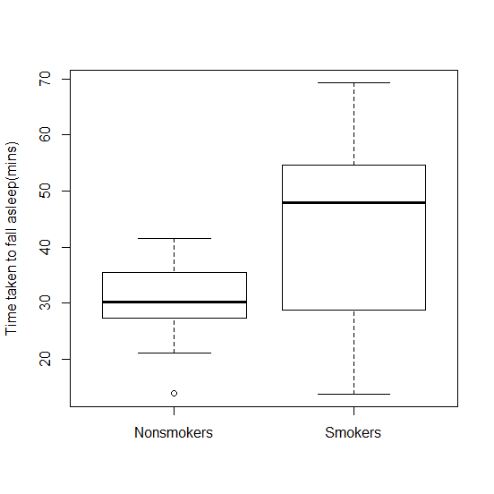
- Estimate the median time of falling asleep in the two groups. (2 mks)
- What does the bottom and the top of box represent ? (2 mks)
- What is the small circle below the non-smokers box plot ? (1 mks)
- What impact does smoking seem to have on sleeping pattern? (2mks)

- List two properties of discrete probability distribution (2 mks)

- If the uric acid values in normal adult males are approximately normally distributed with a mean and standard deviation of 5.7 and 1 mg respectively, find the probability that give a normal adult uric acid will be greater than 6? (3mks)

Question Two (20 mks)

(a)Many cardiac patients wear an implanted pacemaker to control their heartbeat. A plastic connector module mounts on the top of the pacemaker. Assuming a standard deviation of 0.0015 inch and an approximately normal distribution, find a 95% confidence interval for the mean of the depths of all connector modules made by a certain manufacturing company. A random sample of 75 modules has an average depth of 0.310 inch. (5 mks)

(b) The duration of time from first exposure to HIV infection to AIDS diagnosis is called the incubation period. The incubation periods of a random sample of 7 HIV infected individuals is given below (in years)
12.0, 10.5, 9.5, 6.3, 13.5, 12.5, 7.2
- Find the sample mean (2 mks)
- Find the sample standard deviation (4 mks)
- If the sample comes from a normal population, test the hypothesis that the average incubation period is greater than 9 yrs at 5% level of significance (6 mks)

(c) A 5-litre bucket of water is taken from a swamp. The water contains 75 mosquito larvae. A 200mL flask of water is taken form the bucket for further analysis. What is
the expected number of larvae in the flask? (3mks)

Question THREE (20 MARKS)
A company sets different prices for a particular stereo system in eight different regions of the country. The accompanying table shows the numbers of units sold and the corresponding prices (in hundreds of dollars).

PRICE | 5.5 | 6.0 | 6.5 | 6.0 | 5.0 | 6.5 | 4.5 | 5.0
SALES | 420 | 380 | 350 | 400 | 440 | 380 | 450 | 420

Required
a) Draw a scattered diagram of of price (x-axis) against sales (y-axis)
b) Find the correlation between the two
c) Deduce regression equation
d) What effect would you expect a $100 increase in price to have on sales?
(20 marks)

Question FOUR (20 MARKS)
- One of the demographic variables the researchers collected for all sharks during a marine expedition was the Body Mass Index (calculated by dividing weight in kg by the square of the shark’s height in cm). The following are the BMI values of 29 sharks

33.57 27.78 40.8125.21 30.49 27.38
38.34 29.01 47.7836.42 41.50 29.39
26.86 54.33 28.9924.54 41.75 44.68
24.49 33.23 47.0929.07 28.21 42.10
26.54 27.74 33.4831.44 30.08

Use these data to construct:
- A frequency distribution
- A relative frequency distribution
- A cumulative frequency distribution
- A cumulative relative frequency distribution
(8 marks)
- If the mean number of serious accidents per year in a large factory (where the number of employees remains constant) is five, find the probability that in the current year there will be:

- Exactly 7 accidents
- Ten or more accidents
- No accidents
- Fewer than five accidents
(12 marks)

Question FIVE (20 MARKS)
- Frequency of Family History of Mood Disorder by Age Group among Bipolar Subjects

Family History of Mood Disorders E= 18 L>18 Total
Negative (A) 28 35 63
Bipolar disorder (B) 19 38 57
Unipolar (C) 41 44 85
Unipolar and bipolar (D) 53 60 113
Total 141 177 318
Calculate the following probabilities
  - Conditional
  - Joint
  - Marginal
(15 marks)
- In a certain high school class, consisting of 60 girls and 40 boys, it is observed that 24 girls and 16 boys wear eyeglasses. If a student is picked at random from this class, the probability that the student wears eyeglasses, P (E), is 40/100, or .4. What is the probability that a student picked at random wears eyeglasses, given that the student is a boy? (5 marks)

