SUNSHINE SECONDARY SCHOOL
233/2
CHEMISTRY PAPER 2
(Theory)
PRE-MOCK 1 - MARCH 2017
TIME: 2 HRS

NAME: …………………………………………………………………INDEX:……………….

CLASS:………………………………….. DATE:……………SIGN:…………………

INSTRUCTIONS

- Write your name and index number in the spaces provided.
- Answer all questions in the spaces provided.
- Mathematical tables and calculators may be used.
- All working must be clearly shown.

EXAMINER’S USE

QUESTION | MAX. SCORE | CANDIDATES SCORE
1 | 14
2 | 15
3 | 16
4 | 11
5 | 05
6 | 11
7 | 08
Total | 80

- Study the table below and answer the questions that follow. The letters do not represent the actual symbols of the element.

Formula of ion | Electronic configuration
E²⁺ | 2
D⁻ | 2.8
Cl⁻ | 2.8.8
B³⁺ | 2.8
A²⁺ | 2.8

(a) Select elements found in:
(i) The same group (1mk)
………………………………………………………………………………………………
………………………………………………………………………………………………
(ii) Period three (1 mk)
……………………………………………………………………………………………
………………………………………………………………………………………………
(iii) What is the family name given to the group number to which element B belongs
(1mk)
………………………………………………………………………………………………
………………………………………………………………………………………………
(b) With reasons compare the atomic radius of elements B and A. (2 mks)
………………………………………………………………………………………………
………………………………………………………………………………………………
(c) State two industrial uses of element B. (2 mks)
………………………………………………………………………………………………
………………………………………………………………………………………………
(d) With reasons, compare the reactivity of E and A. (2 mks)
………………………………………………………………………………………………
………………………………………………………………………………………………

(e) Write the formula of the compound formed when D and A react. (1mk)
………………………………………………………………………………………………
………………………………………………………………………………………………
(b) What type of bond is formed when element E reacts with oxygen. Give a reason or your
answer. (2mks)
………………………………………………………………………………………………
………………………………………………………………………………………………
- (a) The diagram below represents the extraction of sulphur by the frasch process.
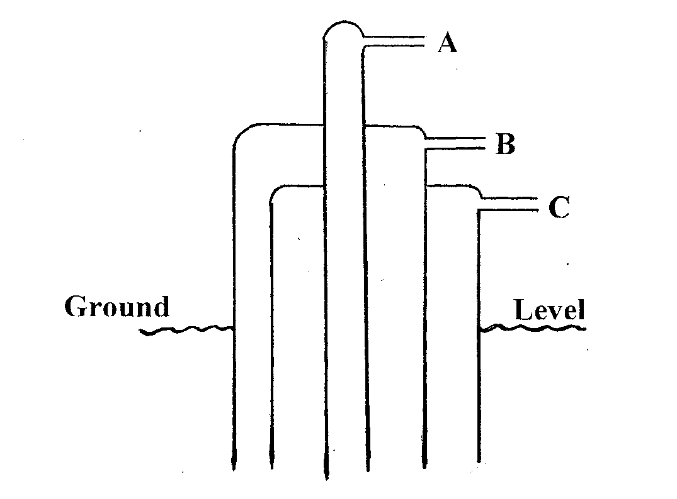
(i) Identify and state the use of the substances that pass through tubes A and C (4mks)
A………………………………………………………………………..
C………………………………………………………………………..
(ii) Rhombic and monoclinic are Allotropes of sulphur. They are inter convertible as
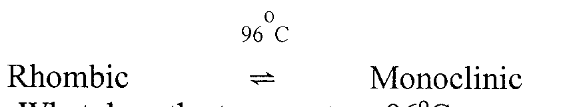
shown below.

What does the temperature 96°C represent. (1 mk)
………………………………………………………………………………………………
………………………………………………………………………………………………
- State the difference in crystalline appearance between rhombic and monoclinic crystals. (l mk)
………………………………………………………………………………………………
………………………………………………………………………………………………

(b) The following scheme represents the steps followed in the contact process, study it and answer the questions which follow.
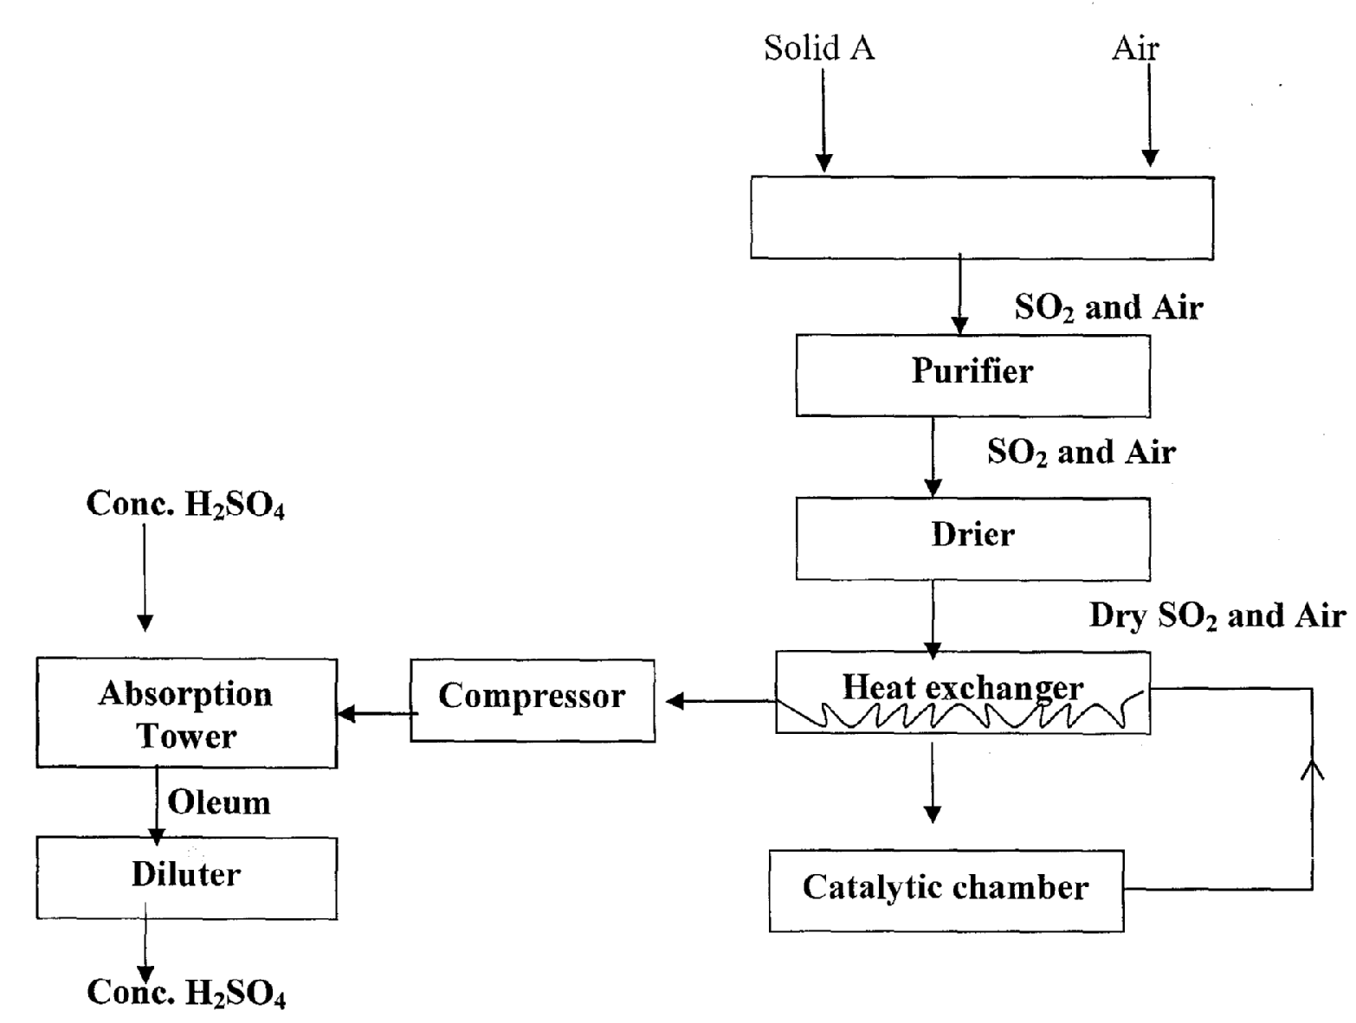

- Name two possible identities of solid A. (l mk)
………………………………………………………………………………………………
………………………………………………………………………………………………
………………………………………………………………………………………………
(ii) Name two impurities removed by the purifier. (1mk)
………………………………………………………………………………………………
………………………………………………………………………………………………
(iii) Why is it necessary to remove impurities? (1mk)
………………………………………………………………………………………………
………………………………………………………………………………………………
- Write the chemical equations for the reactions taking place. (2mks)
- Catalytic chamber

………………………………………………………………………………………
- Absorption tower

………………………………………………………………………………………
- Explain why SO₃ is absorbed in concentrated sulphuric (VI) acid instead of water. (1mk)
………………………………………………………………………………………………………………………………………………………………………………………………………………………………………………………………………………
- (a) (i) Apart from ethanol, name two liquid fuels. (1mk)
………………………………………………………………………………………………
………………………………………………………………………………………………
(ii) State two factors that should be considered when choosing a fuel for cooking. (2mks)
……………………………………………………………………………………………
……………………………………………………………………………………………
……………………………………………………………………………………………
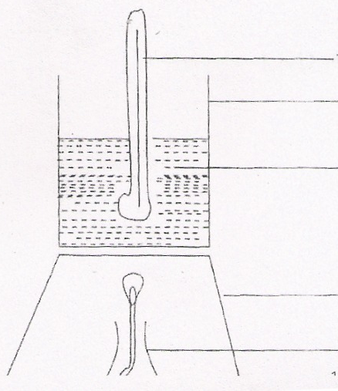
Lamp

Tripod stand

Water

Metallic container

Thermometer

During the experiment, the data given below was recorded.
Volume of water = 500cm³
Initial temperature of water = 25.0°C
Final temperature of water 46.5°C
Mass of ethanol + lamp before burning 125.5g
Mass of ethanol + lamp after burning = 124.0g

Calculate;
(i) Heat evolved during the experiment (Density of water = lg/cm³, specific heat capacity of
water = 4.2J/g/k. (3mks)

(ii) Molar heat of combustion of ethanol (C 12.0, 0 = 16.0, H = 1.0) (2mks)

(iii) Write the thermochemical equation for the complete combustion of ethanol. (1 mk)
……………………………………………………………………………………………
………………………………………………………………………………………………
(iv) The experiment value of molar heat of combustion of ethanol obtained in (b) (ii) above is lower than the theoretical value. Give two reasons for this variation. (2mks)
………………………………………………………………………………………………
………………………………………………………………………………………………
………………………………………………………………………………………………
(v) Why is the water in the container continuously stirred with thermometer? (1mk)
…………………………………………………………………………………………………
…………………………………………………………………………………………………..

b) The hydration energy of Al³⁺ and Cl⁻ are -4690 kJmol⁻¹ and -364kJmol⁻¹ respectively. The heat of solution of aluminium chloride is -332kJ mol-¹.

- Draw an energy cycle diagram to represent the above information. ( 1mk)

ii) Calculate the lattice energy of aluminum chloride (2mks)

- a) A current of 0.75 Amperes was passed through a solution of chromium for one hour and four minutes in the process of electroplating an iron spoon. The mass of chromium deposited on the spoon was 0.52g (1F = 96500C, Cr = 52)
- Calculate the quantity of electricity passed. (1mk)

- Deduce the charge of the Chromium ion. (3mks)

- How many moles in chromium were deposited? (1 mk)

- Draw a well labeled diagram to show how the spoon was electroplated (3mks)

b) Below is a simplified diagram of a Down’s cell used for the manufacture of Sodium metal. Study it and answer the questions that follow.

a) Name the substance the anode is made of (1mk)
……………………………………………………………………………………………… ………………………………………………………………………………………………

b) Explain your answer in (a) above (1mk)
………………………………………………………………………………………………………………………………………………………………………………………………………………………………………………………………………………..
c) What is the role of the diaphragm in Down’s cell (1mk)
………………………………………………………………………………………………
………………………………………………………………………………………………
d) In Down’s cell for the manufacture of Sodium metal, Calcium chloride salt is added to lower the melting point from 800⁰C to 600⁰C. Explain why it is necessary to lower the melting point (1mk)
………………………………………………………………………………………………
………………………………………………………………………………………………
……………………………………………………………………………………………..

- Complete the diagram to show how dry hydrogen chloride gas is collected. (2marks)
(b) Identify liquid Q ( 1mark)

……………………………………………………………………………………………
(c) Write a balanced equation for the reaction that produces hydrogen chloride gas in
the above experiment (1mark)

………………………………………………………………………………………………
(d) State the effect of dry hydrogen chloride gas on
(i) Dry blue litmus paper ( 1mark)
………………………………………………………………………………………………………………………………………………………………………………………………
……………………………………………………………………………………………
(ii) Wet blue litmus paper (1mark)
………………………………………………………………………………………………
………………………………………………………………………………………………………………………………………………………………………………………………
(e) Calculate the volume of hydrogen chloride gas produced if 120g of sodium chloride was used with excess of liquid Q at S.T.P .( Na= 23,Cl=35.5,H=1.0, S = 3) molar gas volume = 22.4 litres at s.t.p). (3marks)

(f) State and explain the observations made when hydrogen chloride gas is bubbled through silver nitrate solution. (2marks)
………………………………………………………………………………………………………………………………………………………………………………………………………………………………………………………………………………………………………………………………………………………………………………………………………………………………………………………………………………………………
- Below gives a summary of a small part of organic chemistry. Use it to answer the accompanying questions.

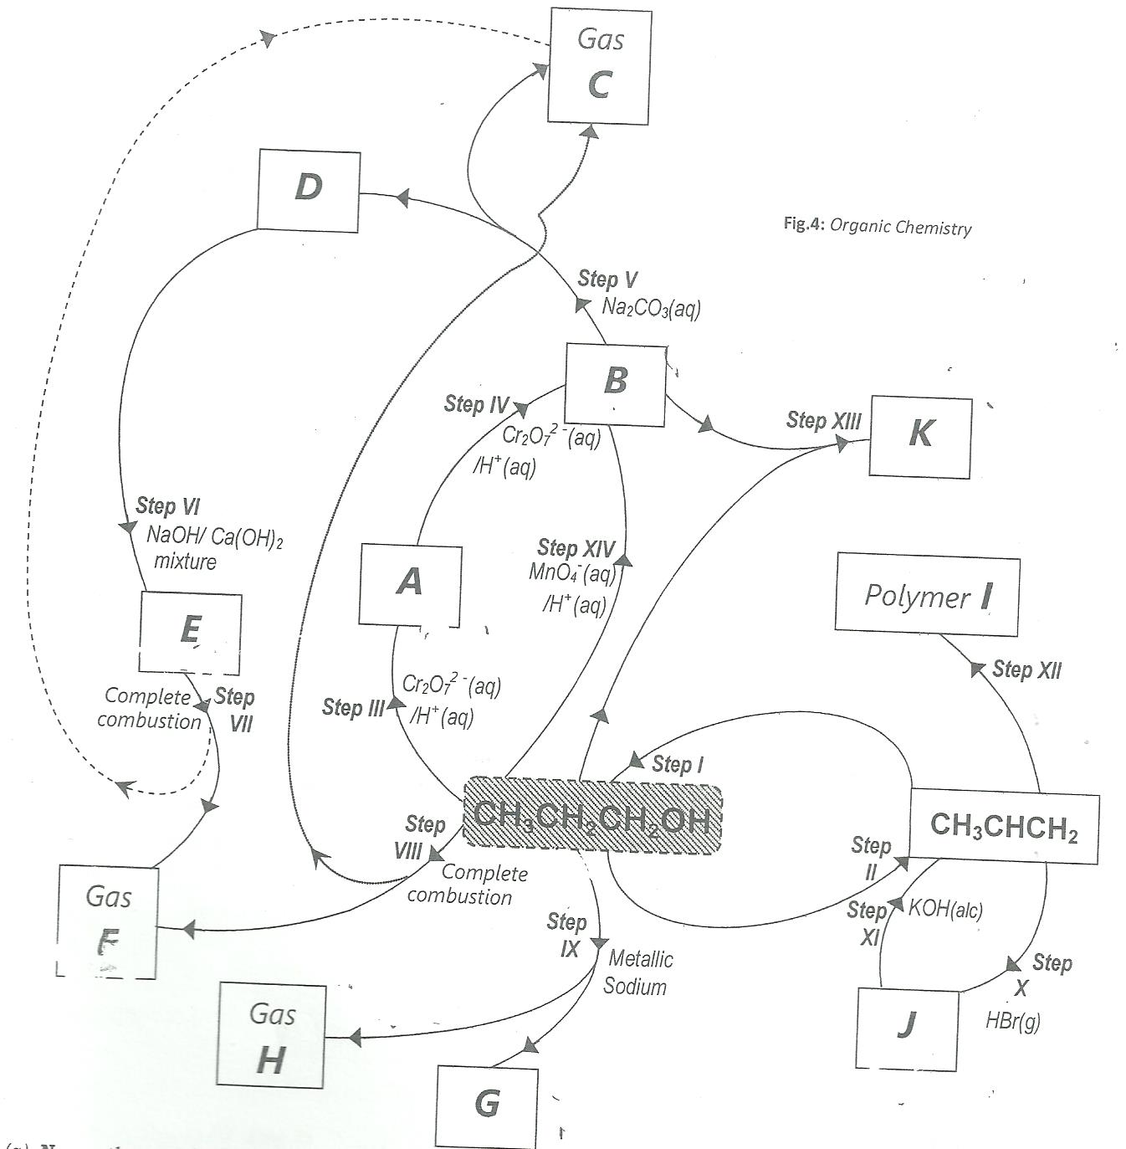

- Name the species labelled:
- A ------------------------------------------------v) E ---------------------------------------
- B ------------------------------------------------vi) Gas F ---------------------------------
- Gas C ----------------------------------------vii) G -------------------------------------
- D ---------------------------------------------viii) Gas H -------------------------------
- i) step I: ---------------------------------------------iv) step VI -------------------------------
- step II: ------------------------------------------- v) step X: -------------------------------
- step III: --------------------------------------------vi) step III: -------------------------------
- Draw the structure and give the name K (2mks)
----------------------------------------------------------------------------------------------------------------------------------------------------------------------------------------------------------------------------------------------------------------------------------------------------------------------------------------------------------------------------------------------------------------------------------------------------------------------------------------------------------------------------------------------------------
- Name polymer I and draw a part of its structure showing 3 repeating units. (2mks)
------------------------------------------------------------------------------------------------------------------------------------------------------------------------------------------------------------------------------------------------------------------------------------------------------------------------------------------------------------------------------------------------------------------------------------------------------------------------------------------------------------------------------------------------------------
- Write the equation showing step VI. (1mk)
----------------------------------------------------------------------------------------------------------------------------------------------------------------------------------------------------------------------
- Explain the observations that would be made during step XIV. (2mks)
------------------------------------------------------------------------------------------------------------------------------------------------------------------------------------------------------------------------------------------------------------------------------------------------------------------------------------
- Name the possible isomers of J. (2mks)
-----------------------------------------------------------------------------------------------------------------------------------------------------------------------------------------------------------------------------------------------------------------------------------------------------------------------------------
- Attempt an equation for step XI. (1mk)
------------------------------------------------------------------------------------------------------------------------------------------------------------------------------------------------------------------------

