SUNSHINE SECONDARY SCHOOL
FORM 4
GEOGRAPHY 312/1
PAPER 1
PRE – MOCK EXAMS
MARCH 2017
TIME 2 HOURS 45 MINUTES

NAME ------------------------------------------------------------ADM NO -------------CLASS ----------

INSTRUCTIONS TO CANDIDATES
- This paper comprises of two sections A and B.
- Section A and question 6 are compulsory.
- In section B, answer question 6 and any other two questions.
- All the answers in section A and B must be done on the provided foolscaps.

SECTION A
QSTN 6
QSTN 7
QSTN 8
QSTN 9
QSTN 10
TOTAL

SECTION A
- a) State two forces responsible for the shape of the earth. (2mks)
-----------------------------------------------------------------------------------------------------------------------------------------------------------------------------------------------------------------------------------------------------------------------------------------------------------------------------------
b) Describe three characteristics of the mantle. (3mks)
-----------------------------------------------------------------------------------------------------------------------------------------------------------------------------------------------------------------------------------------------------------------------------------------------------------------------------------------------------------------------------------------------------------------------------------------------
- a) The diagram below shows a local wind.
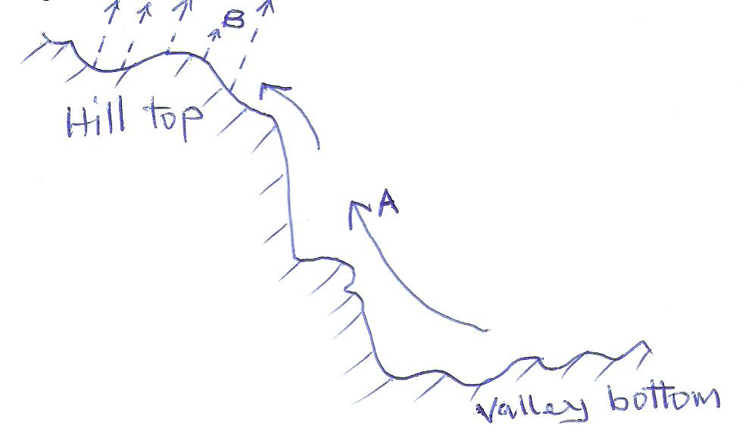
Name the parts marked A and B. (2mks)
A ----------------------------------------------------------------------------------------------------------
B ----------------------------------------------------------------------------------------------------------
b) Give three factors that influence the speed and direction of the wind. (3mks)
-------------------------------------------------------------------------------------------------------------------------------------------------------------------------------------------------------------------------------------------------------------------------------------------------------------------------------------------------------------------------------------------------------------------------------------------------------------------------------------------------------------------------------------------------------------------------------------------------------
- a) Outline two surface feature of limestone scenery/landscape. (2mks)
------------------------------------------------------------------------------------------------------------------------------------------------------------------------------------------------------------------------------------------------------------------------------------------------------------------------------------
b) State three factors that influence the development of a Karst Scenery. (3mks)
-----------------------------------------------------------------------------------------------------------------------------------------------------------------------------------------------------------------------------------------------------------------------------------------------------------------------------------------------------------------------------------------------------------------------------------------------------------------------------------------------------------------------------------------------------------
- a) Define weathering. (2mks)
------------------------------------------------------------------------------------------------------------------------------------------------------------------------------------------------------------------------------------------------------------------------------------------------------------------------------------
b) Describe frost action as a process of physical weathering. (3mks)
------------------------------------------------------------------------------------------------------------------------------------------------------------------------------------------------------------------------------------------------------------------------------------------------------------------------------------------------------------------------------------------------------------------------------------------------------------------------------------------------------------------------------------------------------------------------------------------------------------------------------------------------------------------------------------------------------------------------------------------------------------------------------------
- a) Give two physical factors that are responsible for aridity and desertification. (2mks)
------------------------------------------------------------------------------------------------------------------------------------------------------------------------------------------------------------------------------------------------------------------------------------------------------------------------------------------------------------------------------------------------------------------------------------------------
b) State three measures that can be taken to combat Aridity and desertification. (3mks)
----------------------------------------------------------------------------------------------------------------------------------------------------------------------------------------------------------------------------------------------------------------------------------------------------------------------------------------------------------------------------------------------------------------------------------------------

- Study the map of Kitale 1:50,000 (sheet 75/3) provided and answer the questions.
- i) Give the position of Rogurr hill in the North East by six figure grid reference. (1mk)
ii) What is the bearing and direction of Rogurr hill from the air photo – principal point at grid 4022. (1mk)

iii) give the position of crafts bridge by latitude and longtitude. (2mks)

iv) Measure the distance of the dry weather road (C642) from the junction at grid 3022 to where it ends in grid 3428. (2mks)

- i) Calculate the area of Kitale municipality (Give your answer in square kilometres) (2mks)
ii) Name two physical features found between grid 4818 and 4916. (2mks)
c) Identify three settlement patterns found on the map. (3mks)
d) Explain 3 factors which influenced the location of Kitale township. (3mks)
ii) Draw a sketch section along Northing 17 between Easting 42 and Easting 50. (2mks)

- a) Name the earth movements that occur within the earth’s crust. (2mks)

b) Explain how the following factors cause earth movements.
i) Gravitative pressure (3mks)
ii) Conventional currents in the mantle. (4mks)
iii) Name two features that result from vertical movements. (2mks)

c) i) Describe the plate tectonic theory. (3mks)
ii) Distinguish between an overfold and recumbent fold. (2mks)

d) i) Describe how fold mountains are formed. (6mks)
ii) State three negative effects of Fold Mountains. (3mks)

- .a) i) what is a river?
ii) Draw a well labelled diagram of a hydrological cycle. (3mks)

b) Describe the following processes of river erosion.
i) Attrition
ii) Abrasion

c.i) State three conditions that lead to deposition of silt at the mouth of a river. (4mks)
ii) State three characteristics of a river in the Old Stage. (3mks)

d i)List two features that river capture. (2mks)
ii) Explain three negative effects of river to the human environment. (6mks)

- a) i) Differentiate between the submerged coast and emerged coast. (2mks)
ii) Name three features associated with a submerged highland coast. (3mks)

b) State three characteristics of submerged lowland coasts. (3mks)

- The diagram below represents a coral coast. Use it to answer questions that follow.
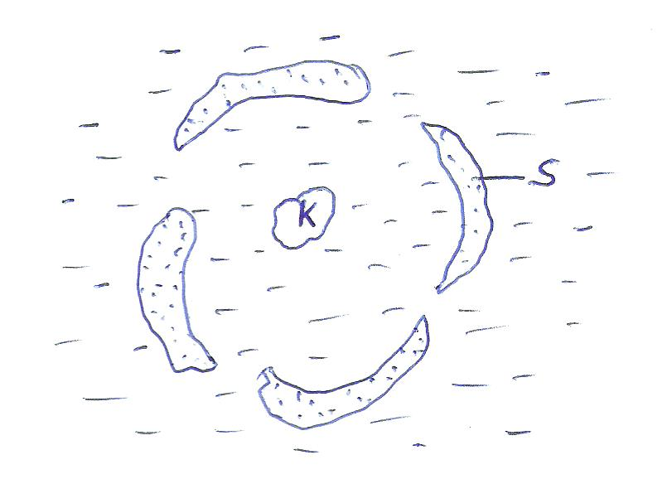

- Name the above feature. (1mk)
- Identify the features K and S. (2mks)
- Describe how the above feature is formed. (5mks)

- State three conditions which favour the development of coral rock. (3mks)

- Explain three positive significance of coastal features to human activities. (6mks

- a) i) Define the word glaciation. (2mks)
ii) State three factors that influence the movement of ice. (3mks)

b) Describe the formation of a pyramidial peak. (4mks)

c) i) Explain two conditions which lead to glacial deposition in lowlands. (4mks)
ii) Explain three positive significance of glaciated uplands to human activities. (6mks)

d) Students from Sunshine School carried out a study on the glaciated area on Mount Kenya.

i) Apart from the pyramidal peak name two other features they found on the glaciated highland area. (2mks)

ii) Identify two methods they used to record data. (2mks)
- State two problems they encountered during the study. (2mks)

