SUNSHINE SECONDARY SCHOOL
312/2
GEOGRAPHY
FORM 4
PRE-MOCK EXAM
MARCH 2017
TIME: 2 HOURS 45 MINS

NAME---------------------------------------------------------------------------------- ADM NO ------------
CLASS ----------------------------

Instructions
- The paper below comprises of two sections A and B
- Attempt all the questions in section A on the spaces provided.
- In section B, attempt question 6 and any other two.
- Use separate answer sheets for each question in section B
- Tick the questions you have attempted in section B on the score sheet below.

SECTION A
QTN 6
QTN 7
QTN 8
QTN 9
QTN 10
TOTAL

SECTION A
Attempt all the questions in section A.
- a) Name two exotic species of tree planted in Kenya. (2mks)
------------------------------------------------------------------------------------------------------------------------------------------------------------------------------------------------------------------------------------------------------------------------------------------------------------------------------------
b) State three reasons why it is necessary to carry out afforestation programmes in Kenya.
(3mks)
------------------------------------------------------------------------------------------------------------------------------------------------------------------------------------------------------------------------------------------------------------------------------------------------------------------------------------------------------------------------------------------------------------------------------------------------------------------------------------------------------------------------------------------------------------
- a) Give three physical conditions that favour cultivation of maize in Trans Nzoia District in Kenya. (3mks)

------------------------------------------------------------------------------------------------------------------------------------------------------------------------------------------------------------------------------------------------------------------------------------------------------------------------------------------------------------------------------------------------------------------------------------------------------------------------------------------------------------------------------------------------------------
b) State two problems facing maize farming in Kenya. (3mks)
------------------------------------------------------------------------------------------------------------------------------------------------------------------------------------------------------------------------------------------------------------------------------------------------------------------------------------------------------------------------------------------------------------------------------------------------
- a) State three benefits of that resulted from the reclamation of the Yala Swamp. (3mks)
-----------------------------------------------------------------------------------------------------------------------------------------------------------------------------------------------------------------------------------------------------------------------------------------------------------------------------------------------------------------------------------------------------------------------------------------------------------------------------------------------------------------------------------------------------------

b) Identify two methods used to control tsetse flies in Kenya. (2mks)
-----------------------------------------------------------------------------------------------------------------------------------------------------------------------------------------------------------------------------------------------------------------------------------------------------------------------------------------------------------------------------------------------------------------------------------------------
- a) Name two renewable sources of energy. (2mks)
------------------------------------------------------------------------------------------------------------------------------------------------------------------------------------------------------------------------------------------------------------------------------------------------------------------------------------
b) State three problems facing Hydro-electric power projects in Kenya. (3mks)

-----------------------------------------------------------------------------------------------------------------------------------------------------------------------------------------------------------------------------------------------------------------------------------------------------------------------------------------------------------------------------------------------------------------------------------------------------------------------------------------------------------------------------------------------------------
- a) Differentiate between transport and communication. (2mks)
------------------------------------------------------------------------------------------------------------------------------------------------------------------------------------------------------------------------------------------------------------------------------------------------------------------------------------
b) State three cases of the decline in the use of letter writing as a means of communication. (3mks)
------------------------------------------------------------------------------------------------------------------------------------------------------------------------------------------------------------------------------------------------------------------------------------------------------------------------------------------------------------------------------------------------------------------------------------------------------------------------------------------------------------------------------------------------------------

SECTION B
- The table below shows the number of tourists who visited Kenya from various parts of the world in 2005 and 2006. Use it to answer questions (a) and (b)

Place of origin | No of tourist per year
 | 2005 | 2006
Europe | 942,000 | 945,000
Africa | 120,000 | 154,000
Asia | 97,000 | 128,000
North America | 94,000 | 103,000
Australia & New Zealand | 19,000 | 24,000
All other countries | 29,000 | 41,000
Total | 1,301,000 | 1,415,000

Source: central bureau of statistics
- i) Which continent had the highest increase in the number of tourists visiting Kenya between 2005 and 2006? (2mks)

ii) Calculate the percentage increase of tourists from Australia and New Zealand between 2005 and 2006. (2mks)

iii) Draw a divided rectangle 15cm long to represent the number of tourists that visited Kenya in 2006. Show your calculations. (10mks)

- i) Give three reasons why domestic tourism is encouraged in Kenya. (3mks)

ii) Explain four reasons why Switzerland is a better tourist destination in Europe. (8mks)

- a) i) What is agriculture? (2mks)

ii) Identify four characteristics of plantation farming in Kenya. (4mks)

b) Give four physical factors that influence the growing of tea in Kenya. (4mks)

c) Explain four problems facing small scale tea farming in Kenya. (8mks)

d) You plan to carry out a field study in a tea farm

- Give your reasons why you need a route map for the study. (4mks)

- What information are you likely to gather about marketing of processed tea during the study? (3mks)

- a) i) What is Industrialization? (1mk)
- Identify three types of industries. (3mks)

- Explain how the following factors influence the location of industries in Kenya.
(3mks)

- Transport (2mks)

- Availability of capital (2mks)

- Give three reasons why some industries are located near source of water.
(3mks)
c. i) Outline two examples of cottage Industries in Kenya. (2mks)
ii) State four characteristics of cottage Industries in India. (4mks)
d. i) Explain four reasons why Kenya should be industrialized. (8mks)
9. a. i) Differentiate between fishing and fisheries. (2mks)
ii) Using the outline map of East Africa provided, name the fisheries marked X, Y Z. (3mks)
b. i) Explain three problems facing the fishing industry in Kenya. (6mks)
ii) Explain three reasons why fresh water fisheries are more popular than marine fisheries in East Africa. (6mks)
c. i) Explain four reasons why most of the world’s fishing ground are located in the Northern Hemisphere. (8mks)
10. a) i) Define population. (2mks)
ii) Identify two primary sources of population data apart from population census. (2mks)
iii) State three problems of a population census. (3mks)
b. Explain three factors that lead to slow population growth. (6mks)
c. Study the population pyramid given below and use it to answer questions (i) & (ii).
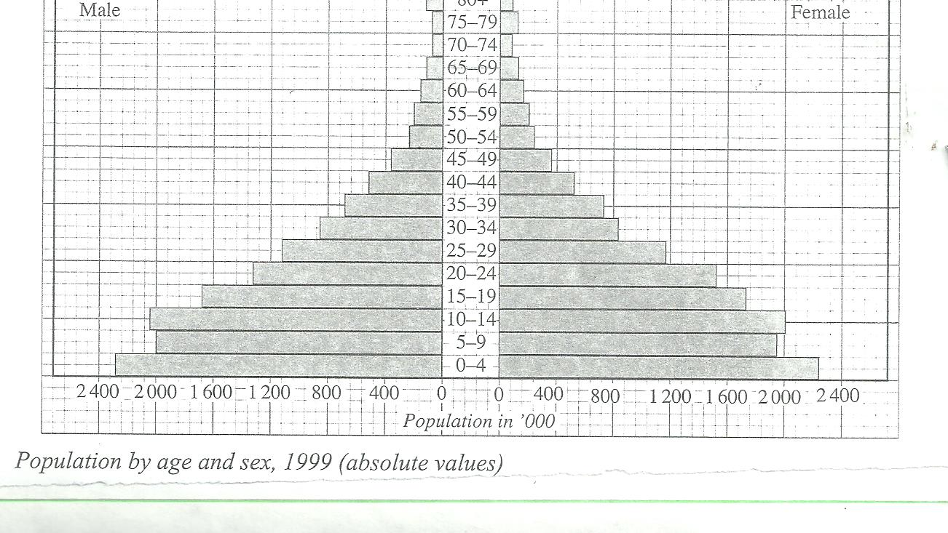
- Describe four characteristics of the population represented by the pyramid. (4mks)
- In 1989, Kenya’s population was 21.4 million while in 1999, it was 28.7 million. Calculate the population growth rate over the 10 years period.
d. Explain three differences between the population of Kenya and Sweden. (6mks)

