Name: ………………………………………… ………………Index №……………….…..Adm.№…………..
School………………………………………………………… Class………………………………………....…
232/1 Candidate’s signature: …………………..……
PHYSICS -231/2
Paper 1
(THEORY) Date: ………..…………………………………., March 2017
2 Hours

SUNSHINE SECONDARY SCHOOL
PRE-MOCK ONE
Kenya Certificate of Secondary Education

Instructions to candidates

- Write your Name, Index Number, School and Class in the spaces provided above.
- Sign and Write the date of examination in the spaces provided above.
- This paper consists of two Sections: A and B.
- Answer ALL the questions in Section A and B in the spaces provided.
- ALL working MUST be clearly shown.
- Non-programmable silent electronic calculators and KNEC Mathematical table may be used.
- This paper consists of 12 printed pages.
- Candidates should check the question papers to ascertain that all the pages are printed as indicated and that no questions are missing.

For Examiner’s Use Only
Section | Question | Maximum Score | Candidate’s Score
A | 1 -14 | 25
 | 15 | 11
 | 16 | 11
 | 17 | 12
 | 18 | 10
 | 19 | 11
 | TOTAL | 80

SECTION A: (25 marks)
Answer ALL questions in this Section in the spaces provided

- The figure 1 shows picture of a metre rule and a tree on a sunny day and their respective shadows. The shadow of the metre rule is 75cm long and that of the tree is 840cm long.
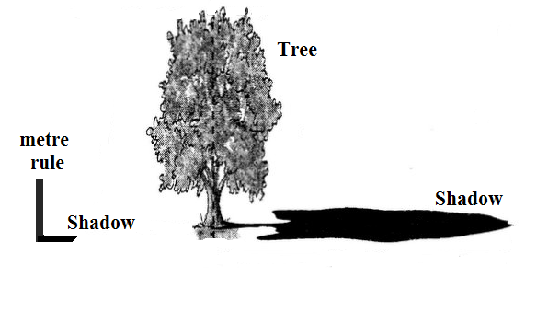
Figure 1
75cm
h
1m
840cm

Determine the height, h of the tree in metres. (2 marks)
………………………………………………………………………………………………………………………………………………………………………………………………………………......................................................................................................................................................…………………………
- Same quantities of hydrogen gas and helium gas at room temperature are released simultaneously at one end of a room. State with a reason which gas is likely to be detected earlier at the other end of the laboratory. (2 marks)

……………………………………………………………………………………………………………………………………………………………………………………………………………………………………………………………………..……………………………………………………………………...
- In an experiment to investigate the unusual expansion of water, a fixed mass of water at 0ºC was heated until its temperature reached 10ºC. On the axes provided, sketch a graph of mass against temperature of water from 0ºC to 10ºC. (1 marks)

Volume

Temperature ºC
O

- Figure 2 shows a circular disc of diameter 2m and weight 300N. The disc is pulled by a horizontal force, F acting through its centre of gravity, G. the force acting against a step 0.4m high.

Figure 2

Determine the initial horizontal force, F just sufficient to turn the disc so that it will rise over the step. (3 marks)

………………………………………………………………………………………….…………………………………………………………………………………………………………………………………………………………………………………………………………………………………………………
5. Figure 3 shows a paper tape with marks made by a ticker-tape. A is the initial mark. The frequency of the ticker timer is 50Hz. The average acceleration of the tape is 1.5ms⁻².
Figure 3
Determine the Length x. (3 marks)
……………………………………………………………………………………………………………………………………………………………………………………………………………………………………………………………………………………………………………………………………………..
………………………………………………………………………………………………………………
- A barometer has reading of 675mmHg at a certain place. The average density of air is 1.25kgm⁻³. Determine the altitude of the place. Take the atmosphere pressure at sea level to be 760mmHg. (3 marks)
……………………………………………………………………………………………………………………………………………………………………………………………………………………………..
……………………………………………………………………………………………………………
- Figure 4 show a fire hose straight-stream nozzle. The nozzle has a diameter of 4.76cm where it is connected to the hose and a diameter of 2.54cm at the open end.

Figure 4

Water enters the nozzle at a speed of 4m/s. Determine the speed with which it leaves the nozzle. (2 marks)
…………………………………………………………………………………………………………………………………………………………………………………………………………………………
- Figure 5 shows a funnel dipped into a liquid soap solution.
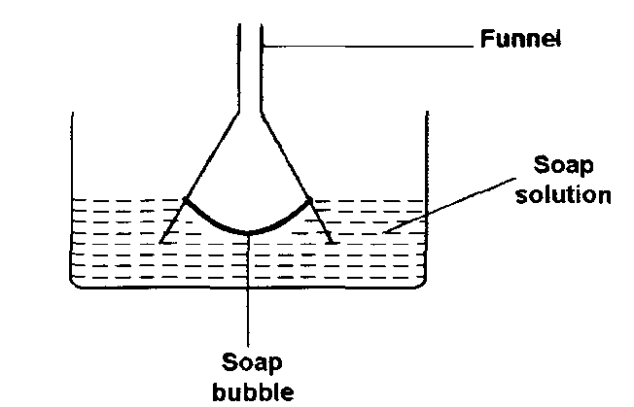

Figure 5

State and explain what happens as the funnel is lifted up from solution (2 marks)

……………………………………………………………………………………………………………………………………………………………………………………………………………………………
- You are provided with two identical pieces of wires. How can you make two springs of different spring constants? (1 mark)

…………………………………………………………………………………………………………
- Figure 6 (a) shows a container full of water held at some height above the ground. Water spurts out the holes at the bottom. Figure 6(b) shows the same container falling freely. Water is no longer spurting from the holes.
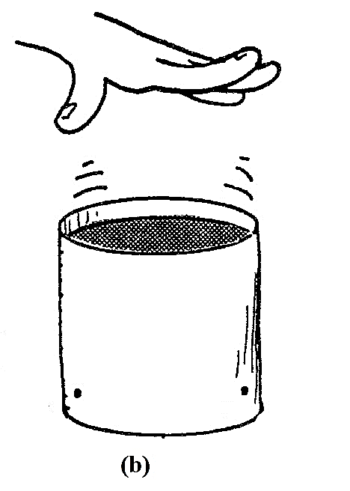
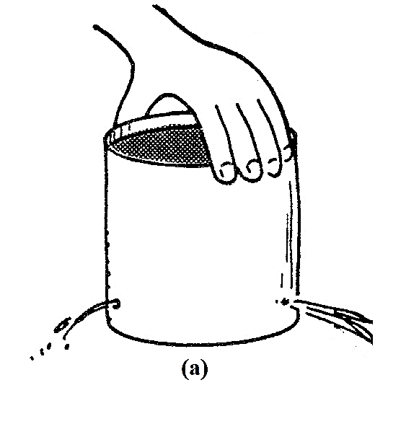

Figure 6

Explain these observations. (2 marks)
…………………………………………………………………………………………………..………….………………………………………………………………………………………………………………

- An air bubble rises from the bottom of a pond and bursts at the surface of the pond. The graph in figure 7 shows variation of the pressure with the reciprocal of the volume of the of the bubble. The atmospheric pressure at the place is 1.0 x 10⁵Pa.
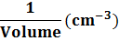
Pressure (x 10⁵Pa)
Figure 7

Determine the volume of the air bubble just before it bursts. (2 marks)
……………………………………………………………………………………………..…………………………………………………………………………………………………………
- An object is thrown vertically upwards from the top of a tower takes 3 seconds to attain maximum height. It drops to the ground at the bottom of the tower after 9 seconds. Sketch a displacement time graph for the motion. ( 2 marks

SECTION B: (55 marks)
Answer all the questions in this Section in the spaces provided

- a) State the law of conservation of linear momentum (1 marks)
………………………………………………………………………………………………………………………………………………………………………………………………………………………………
b) A body of mass 5kg moving with a velocity of 6m/s collides head on with another body of mass
4kg moving in the opposite direction at 9m/s. If after collision, the bodies coalesce.

6m/s 9m/s
4kg
5kg

(i) Calculate the common velocity V. (3 marks)
……………………………………………………………………………………………………………………………………………………………………………………………………………………………………………………………………………………………………………………………………………… (ii) The direction of motion for both masses. (1 marks)
………………………………………………………………………………………………………………
C (i) Figure 8 shows a mass of 6Kg on piston B balanced by force F acting on piston A
Figure 8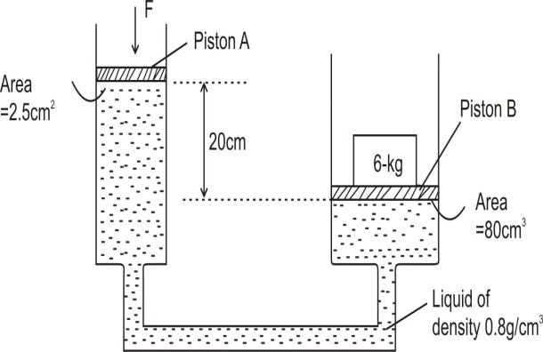
Determine the value of the force F. (3mrks)
………………………………………………………………………………………………………………………………………………………………………………………………………………………………
. (ii) Figure 9 below shows a trolley of mass 60 kg resting on an inclined plane. It is then pulled up the slope by a force of 200 N from X to Y at a constant speed.
Trolley
Figure 9
200N
X
Y
20m
76⁰

Determine the efficiency of the system. (3marks)
........................................................................................................................................................................................................................................................................................................................................................................................................................................................................................................................
- a) Distinguish between latent heat of fusion and latent heat of vaporization. (1 mark)
………………………………………………………………………………………………………………………………………………………………………………………………………………………………
b) Figure 10 shows a set-up to demonstrate regelation of ice.
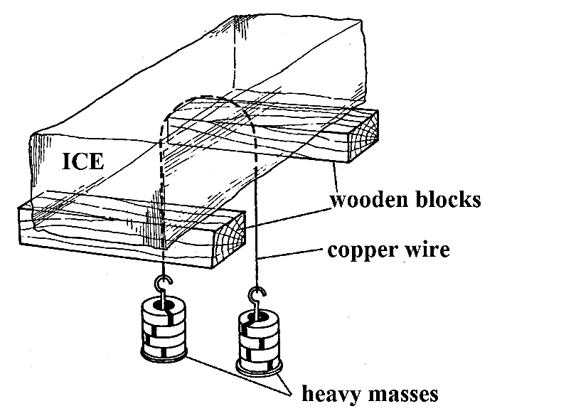
Figure 10
Explain how the copper wire passes through the ice without cutting the block of into two. (2 marks)
…………………………………………………………………………………………………………………………………………………………………………………….………………………………………………………………………………………………………………………………………………………
c) m grams of steam at 100ºC is bubbled into a copper calorimeter of mass 100g containing 325g of water and 140g of ice. The final temperature of the system is 35ºC. (Take specific capacity of water = 4200Jkg⁻¹K⁻¹; specific heat capacity of copper = 400Jkg⁻¹K⁻¹; specific latent heat of fusion of ice = 3.35 x 10⁵Jkg⁻¹ and specific latent heat vaporization of steam = 2.26 x 10⁶Jkg⁻¹)

Determine the:
(i) amount of heat given out by steam. (leave the answer in terms of m) (3 marks)
………………………………………………………………………………………………………………………………………………………..……………………………………………………………………………………………………………………………………………………………………………………
(ii) amount gained by ice, water and the calorimeter. (3 marks)
………………………………………………………………………………………………………………………………………………………………………………………………………………………………………………………………………………………………………………………………………………………………………………………………………………………………………………………………
(iii) value of m. (2 marks)
………………………………………………………………………………………………………………………………………………………………………………………………………………………………………………………………………………………………………………………………………………
17. a) Figure 11 shows an object of mass 200g, width 10cm and height 5cm floating in a liquid of density 800kgm⁻³. Take g = 10ms⁻².

Figure 11

Determine the:
- upthrust on the object (2 marks)
………………………………………………………………………………………………………………………………………………………………………………………………………………………………………………………………………………………………………………………………………………
- volume of the object. (3 marks)
………………………………………………………………………………………………………………………………………………………………………………………………………………………………………………………………………………………………………………………………………………
- cross-sectional area of the object. (2 marks)
………………………………………………………………………………………………………………………………………………………………………………………………………………………………………………………………………………………………………………………………………………
b) The object is now tied with a string and pulled downwards.
(i) What is the tension in the string? (2 mark)
……………………………………………………………………………………………………………

c) An air bubble is created at the bottom of a lake. It rises and finally bursts at the surface of the lake.

- State and explain how it volume changes as it rises from the bottom of the lake until it reaches the surface. (2 marks)

………………………………………………………………………………………………………………………………………………………………………………………………………………………………………………………………………………………………………………………………………………
- Why does the bubble burst when it reaches the surface of the lake? (1 mark)

………………………………………………………………………………………………………………………………………………………………………………………………………………………………

- a)An oil drop, of volume 7.0 x 10⁻⁵ cm³, introduced on a clean surface of water spread to form a circular patch of diameter 200mm.
- Determine the diameter of a molecule of the oil. Give your answer to 3 significant figures. (3 marks)
………………………………………………………………………………………………………………………………………………………………………………………………………………………………………………………………………………………………………………………………………………
- State one assumption you made in obtain your answer in (i) above. (1 mark)
………………………………………………………………………………………………………………
b) (i) When an inflated balloon is left out for a while on sunny day it volume increases.
Use the kinetic theory of gases to explain this observation. (3 marks)

………………………………………………………………………………………………………………………………………………………………………………………………………………………………………………………………………………………………………………………………………………………………………………………………………………………………………………………………
- A gas is put in a container of fixed volume at a pressure of 2.1 x 10⁵ Pa and temperature 27ºC. the gas is then cooled to a temperature of -23ºC.

Determine the new pressure. ( 3 marks)
……………………………………………………………………………………………………………………………….………………………………………………………………………………………...……………………………………………………………………………………………………………………………………………………………………………………………………………………………………
- a)Figure 12 shows two identical beetles, P and Q on a turntable moving with constant angular velocity. Beetle Q is at distance which is twice as far from the centre of rotation as beetle P. Beetle P moves with a linear velocity of 4m/s.

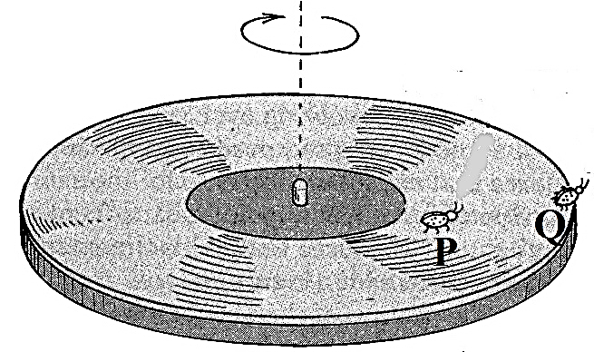
Figure 12

- Indicate on the diagram the direction of the force, F which keeps beetle Q from sliding. (1 mark)

- Name this force F. (1 mark)
………………………………………………………………………………………………………………
- Determine the linear velocity with which beetle Q moves. (3 marks)
……………………………………………………………………………………………………………………………….………………………………………………………………………………………...……
b) Figure 13. Shows a mass,m, which is rotated anticlockwise in a vertical circle. The speed of the mass is gradually increased until the string breaks. The string breaks when the mass is at its lowest position P at a speed of 30m/s. Point P is 5m above the ground.

p

5m
Figure 13.
- Show on the diagram the initial direction of the mass at the point the string breaks. (1mk
ii)The horizontal distance the mass travels before it hits the ground. (3mks
………………………………………………………………………………………………………………………………………………………………………………………………………………………………………………….………………………………………………………………………………………...……
iii) The vertical velocity with which it strikes the ground. ( 2mks
……………………………………………………………………………………………………………………………….………………………………………………………………………………………...……
THIS IS THE LAST PRINTED PAGE.

