NAME--------------------------------------------------------------------ADM NO -------------------
CLASS ---------------------------- SIGNATURE -----------------------------------
PHYSICS 232/2
THEORY)
MARCH 2017
TIME 2 HOURS
SUNSHINE SECONDARY SCHOOL
PRE-MOCK (I)
PHYSICS PAPER 2
INSTRUCTIONS TO CANDIDATES
Write your name, class and admission number in the spaces provided above.
This paper consists of two sections A ( 25 MARKS) and B ( 55 MARKS)
Working must be clearly shown
Non-programmable silent calculator may be used.
Take Acceleration due gravity, g = 10Nkg⁻¹
SPEED OF LIGHT IN VACCUM, C = 3.0 X 10⁸ m/s

FOR EXAMINER’S USE ONLY
SECTION | QUESTIONS | MARKS | CANDIDATES’CSORE
A | 1 -8 | 25
B | 9 | 08
 | 10 | 08
 | 11 | 06
 | 12 | 11
 | 13 | 06
 | 14 | 10
 | 15 | 06
 | TOTAL

SECTION A ( 25 MARKS)
- a) State the law of electrostatic charges. (1mk)
--------------------------------------------------------------------------------------------------------------------------------------------------------------------------------------------------------------------
b) State two uses of a charged gold leaf electroscope. (2mks)
------------------------------------------------------------------------------------------------------------------------------------------------------------------------------------------------------------------------------------------------------------------------------------------------------------------------------------
c) A conductor is slowly brought near the cap of a positively charged electroscope. The leaf collapses and then diverges. State the charge on the conductor. (1mk)
-----------------------------------------------------------------------------------------------------------------------------------------------------------------------------------------------------------------------
- A current of 1.5A flows in a circuit. Determine the quantity of charge that crosses a point in 5 minutes. (1mk)
-----------------------------------------------------------------------------------------------------------------------------------------------------------------------------------------------------------------------
- Explain how polarization reduces current in a simple cell. (1mk)
-----------------------------------------------------------------------------------------------------------------------------------------------------------------------------------------------------------------------
- a) Define focal plane as used in concave mirrors. (1mk)
------------------------------------------------------------------------------------------------------------
b) Complete the ray diagram below. (2mks)
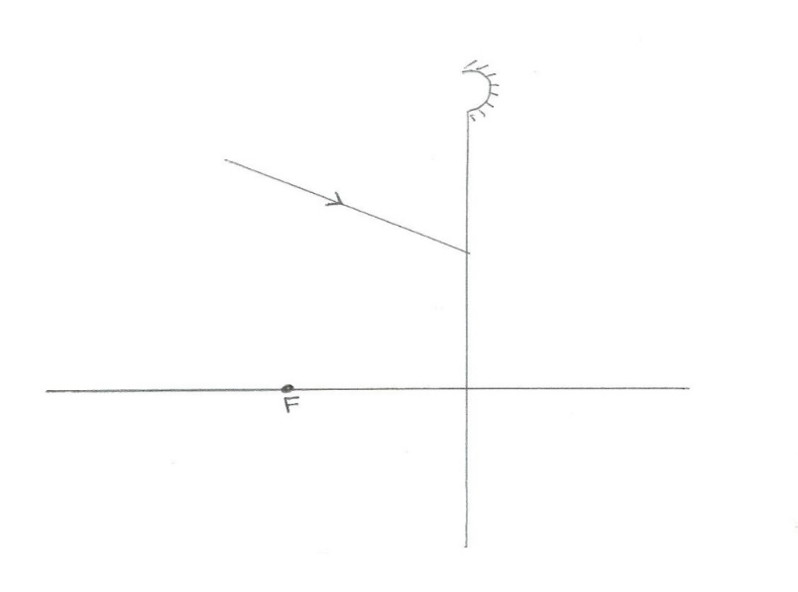
- Determine the number of images formed when an object is placed between two plane mirrors inclined at 60º. (2mks)
------------------------------------------------------------------------------------------------------------------------------------------------------------------------------------------------------------------------------------------------------------------------------------------------------------------------------------
- State one application of mirrors inclined at an angle. (1mk)
--------------------------------------------------------------------------------------------------------------------------------------------------------------------------------------------------------------------
- a) Differentiate between magnet and magnetism. (2mks)
------------------------------------------------------------------------------------------------------------------------------------------------------------------------------------------------------------------------------------------------------------------------------------------------------------------------------------
b) Draw the magnetic field pattern of the arrangement shown below. (1mk)

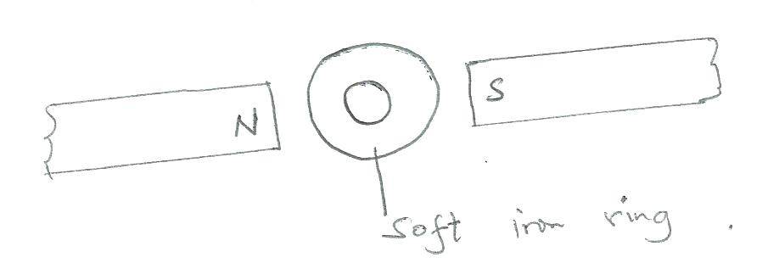
c) Draw the appearance of the wave after passing an obstacle. (1mk)
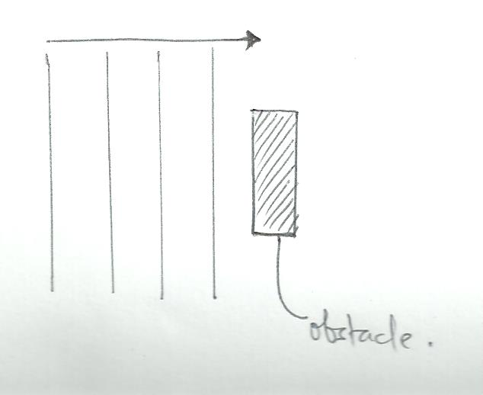

d) Give one use of this property of the soft iron ring. (1mk)
-----------------------------------------------------------------------------------------------------------------------------------------------------------------------------------------------------------------------------------------------------------------------------------------------------------------------------------

- a) State two characteristics of the image formed by concave mirror when the object is placed between the focal point (principal focus) and the pole of the mirror. (2mks)

------------------------------------------------------------------------------------------------------------------------------------------------------------------------------------------------------------------------------------------------------------------------------------------------------------------------------------
b) A vertical object is placed in front of a convex lens of focal length 5cm.
i) Determine
I. The image distance (3mks)
-----------------------------------------------------------------------------------------------------------------------------------------------------------------------------------------------------------------------------------------------------------------------------------------------------------------------------------------------------------------------------------------------------------------------------------------------
II. the magnification (2mks)
----------------------------------------------------------------------------------------------------------------------------------------------------------------------------------------------------------------------------------------------------------------------------------------------------------------------------------
ii) State one characteristics of the image. (1mk)
---------------------------------------------------------------------------------------------------------------------------------------------------------------------------------------------------------------------

SECTION B ( 55 MARKS)

Attempt all the questions in this section.
- a) Two points X and Y have a potential difference of V volts. Q coulombs of charge flows between X and Y for t seconds. Determine:
- the electrical energy transferred between the two points in terms of Q. (1mk)
--------------------------------------------------------------------------------------------------------------------------------------------------------------------------------------------------------------------------------------------------------------------------------------------------------
- The power transformed in terms of Q and t. (1mk)
-------------------------------------------------------------------------------------------------------------------------------------------------------------------------------------------------------------------------------------------------------------------------------------------------------

- show that the power transformed is given by P = IV (2mks)
-----------------------------------------------------------------------------------------------------------------------------------------------------------------------------------------------------------------------------------------------------------------------------------------------------------------------------------------------------------------------------------------------------------
b) The lighting in a house has 20 lamps each rated 60W, 240V. Determine whether a fuse rated 4A can be used in the circuit when all the lamps are put one. (4mks)
------------------------------------------------------------------------------------------------------------------------------------------------------------------------------------------------------------------------------------------------------------------------------------------------------------------------------------------------------------------------------------------------------------------------------------------------------------------------------------
- a) State two conditions necessary for total internal reflection to take place. (2mks)
------------------------------------------------------------------------------------------------------------------------------------------------------------------------------------------------------------------------------------------------------------------------------------------------------------------------------------------------------------

b) The diagram below shows a ray of light incident perpendicularly on a glass prism of refraction index 1.5. Determine the angle of deviation D. (3mks)

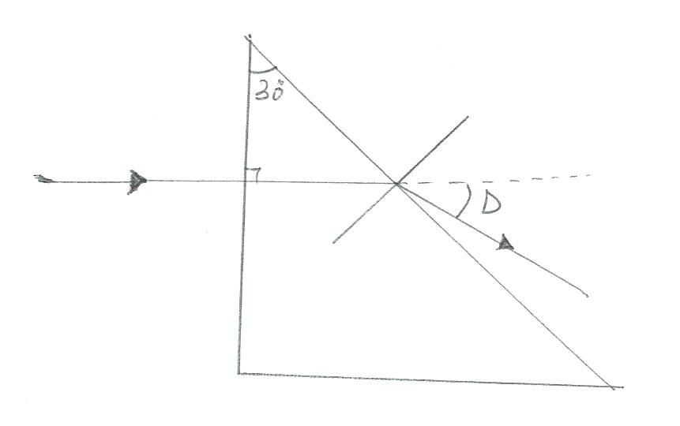

c) Draw a diagram to show how a ray of light can be made to turn through 90º using a glass prism. (1mk)

d) i) When light is reflected by a plane mirror, the angle of incidence is equal to the angle of reflection. State the other law of reflection on the mirror. (1mk)
------------------------------------------------------------------------------------------------------------------------------------------------------------------------------------------------------------------------

ii) Complete the path of a ray of light incident on two mirrors as shown. ( 1mk )

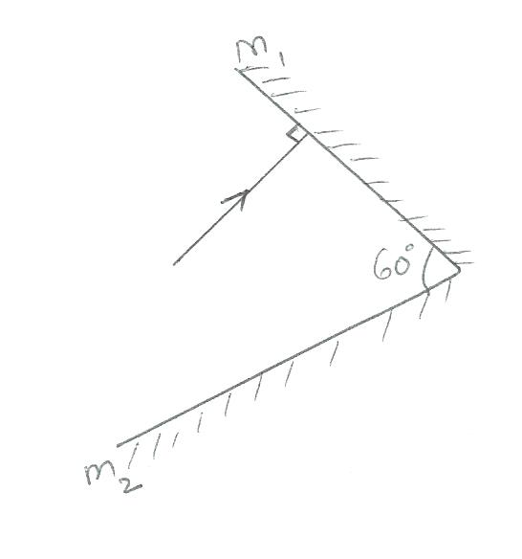

- a) The diagram below shows an electromagnetic spectrum.

Radio waves | A | Infra – red | Visible light | B | x-rays | C

- State any one detector of A ( 1mk)
------------------------------------------------------------------------------------------------------------------------------------------------------------------------------------------------------
- State any one use of B (1mk)
------------------------------------------------------------------------------------------------------------------------------------------------------------------------------------------------------
- State one way in which C is produced. (1mk)
------------------------------------------------------------------------------------------------------------------------------------------------------------------------------------------------------
b) A radio station transmits waves at 5MHz. Determine the wavelength of the waves produced. (3mks)
---------------------------------------------------------------------------------------------------------------------------------------------------------------------------------------------------------------------------------------------------------------------------------------------------------

- a) State two factors that determine the magnitude of force between charged bodies. (2mks)
---------------------------------------------------------------------------------------------------------------------------------------------------------------------------------------------------------------------------------------------------------------------------------------------------------------------------------------------------------------------------------------------------------------------------------------------
b) Figure below shows a positive charge placed near a negatively charge red. Draw the electric field lines. (1mk)

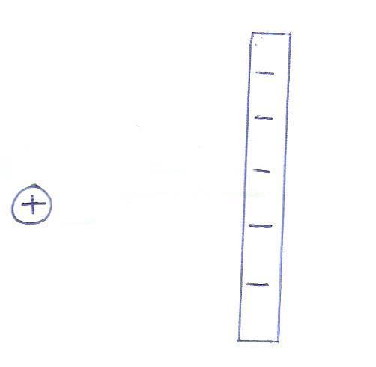
c) Figure below shows capacitors A and B connected in series with a battery of e.m.f 6v.

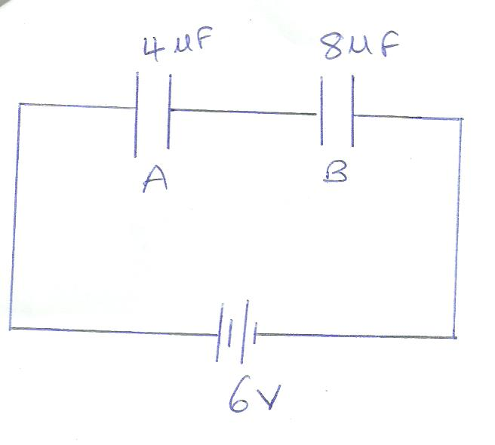

Determine the

- effective capacitance of the current (3mks)
------------------------------------------------------------------------------------------------------------------------------------------------------------------------------------------------------------------------------------------------------------------------------------------------------------------------------------------------------------------------------------------------------------
- Quantity of charge in capacitor A. (2mks)
---------------------------------------------------------------------------------------------------------------------------------------------------------------------------------------------------------------------------------------------------------------------------------------------------------------------------------
- Voltage across capacitor B. (2mks)
---------------------------------------------------------------------------------------------------------------------------------------------------------------------------------------------------------------------------------------------------------------------------------------------------------
d) State the effect of decreasing the distance between the plates of a parallel plate capacitor on the capacitance. (1mk)
--------------------------------------------------------------------------------------------------------------------------------------------------------------------------------------------------------------------------------------------------------------------------------------------------------------------------------------------------------------
- a) Explain how keepers are used to effectively retain magnetic properties of magnets for a longer time. (2mk)
------------------------------------------------------------------------------------------------------------------------------------------------------------------------------------------------------------------------------------------------------------------------------------------------------------------------------------------------------------------------------------------------------------------------------------------------

b) Use the diagram below to answer the questions that follow.

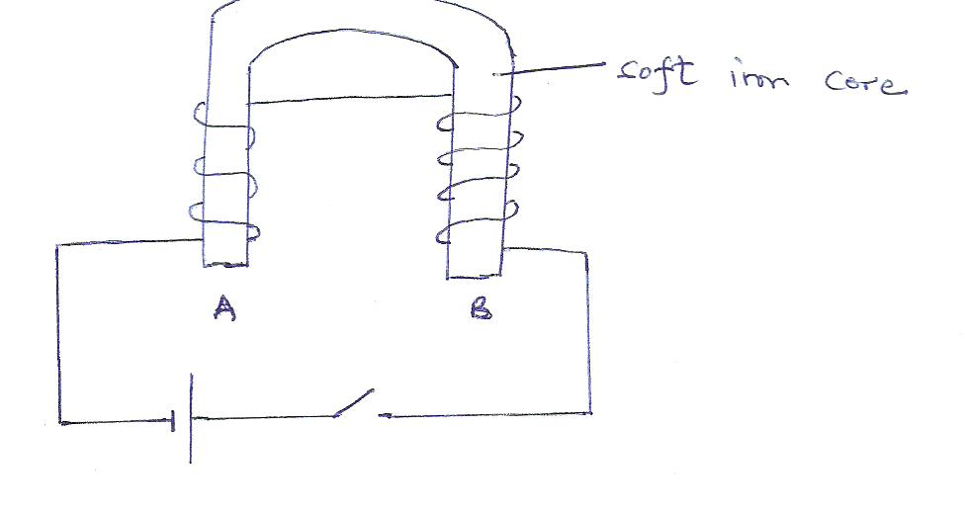
- Identify the method of magnetization above. (1mk)
------------------------------------------------------------------------------------------------------------------------------------------------------------------------------------------------------------------------
- In the same diagram indicate the direction of the flow of electric current. (1mk)
-----------------------------------------------------------------------------------------------------------------------------------------------------------------------------------------------------
- State the polarities:
A ------------------------------------------------------------------------------------ (1mk)
B --------------------------------------------------------------------------------- (1mk)
- Give a reason for your answer in (iii) above. (1mk)
-------------------------------------------------------------------------------------------------------------------------------------------------------------------------------------------------
- a) Differentiate between progressive waves and stationary (standing) waves. (2mks)
------------------------------------------------------------------------------------------------------------------------------------------------------------------------------------------------------------------------------------------------------------------------------------------------------------------------------------------------------------------------------------------------------------------------------------------------

b) The figure below shows this displacement time graph for a wave.
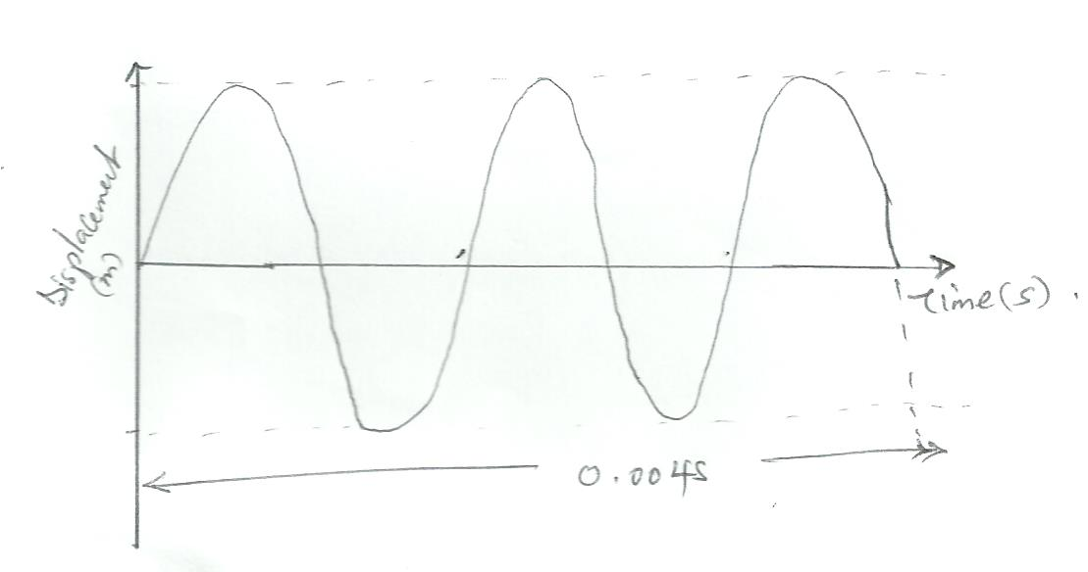
- Determine the frequency of the waveform shown. (2mks)
------------------------------------------------------------------------------------------------------------------------------------------------------------------------------------------------------------------------------------------------------------------------------------------------------------------------------
- On the same diagram draw a waveform of a wave whose frequency is twice and whose amplitude is half the one shown in the diagram. (1mk)
c) A fishing boat uses ultrasonic sound waves of frequency 8 x 10¹⁴Hz to detect fish directly below it. Two echoes are received, one after 0.1s and the other after 0.12S. If the first echo was from a shoal of fish and the second from sea-bed which is 96m below the boat. Calculate:
- Speed of sound (2mks)
---------------------------------------------------------------------------------------------------------------------------------------------------------------------------------------------------------------------------------------------------------------------------------------------------------
- Distance between the shoal of fish and the boat. (1mk)
-------------------------------------------------------------------------------------------------------------------------------------------------------------------------------------------------------------------------------------------------------------------------------------------------------

- Wavelength of sound waves. (2mks)
-------------------------------------------------------------------------------------------------------------------------------------------------------------------------------------------------------------------------------------------------------------------------------------------------------

- a) State ohm’s law (1mk)
------------------------------------------------------------------------------------------------------------------------------------------------------------------------------------------------------------------------------------------------------------------------------------------------------------------------------------
b) The cell in the figure below has an e.m.f of 2.0V and negligible internal resistance.

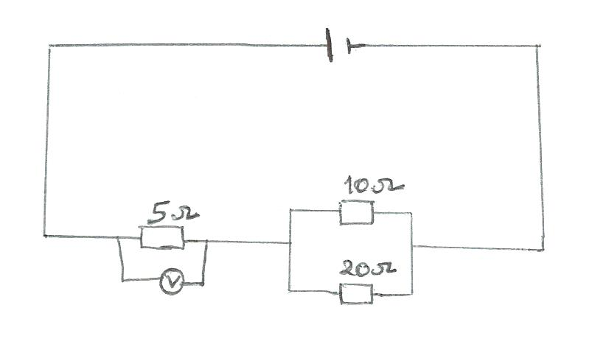
Determine the:

- total resistance in the circuit (2mks)
------------------------------------------------------------------------------------------------------------------------------------------------------------------------------------------------------------------------------------------------------------------------------------------------------------------------------------------------------------------------------------------------------------
- current in the circuit (1mk)
---------------------------------------------------------------------------------------------------------------------------------------------------------------------------------------------------------------------------------------------------------------------------------------------------------

- reading of the voltmeter (2mks)
-----------------------------------------------------------------------------------------------------------------------------------------------------------------------------------------------------------------------------------------------------------------------------------------------------------------------------------------------------------------------------------------------------------

THIS IS THE LAST PRINTED PAGE.

