MAASAI MARA UNIVERSITY
UNIVERSITY EXAMINATIONS 2016/2017 (REGULAR)
SCHOOL OF SCIENCE AND INFORMATION SCIENCES

University EXAMINATIONS FOR THE DEGREE OF BACHELOR OF SCIENCE (COMPUTER SCIENCE)
SECOND YEAR FIRST SEMESTER EXAMINATION

COURSE CODE: COM 215

COURSE TITLE: ELECTRICAL CIRCUITS
DATE: 4/7/2017 TIME: 11:00am-1:00pm

INSTRUCTIONS
Answer Question ONE and any other TWO

QUESTION ONE (30 MARKS)
- Define the following terms as used in electrical circuits
- Electric circuit (1mark)
- Ideal independent source (1mark)
- Ideal dependent source (1mark)
- Alternating current (1mark)
- The total charge entering a terminal is given by q=5tSin4πt mC
Calculate current at t = 0.5s (2marks)
- (i) Briefly explain what is meant by conductance (2marks)
(ii) In the circuit shown below calculate the current i, the conductance G and the power (4marks)
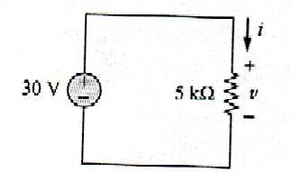

- Define the following concepts (3marks)
- Branch
- Node
- Loop

- Briefly discuss mesh analysis and nodal analysis as used in circuit analysis
(4marks)
- Briefly discuss the following theorems (3marks)
- Superposition
- Norton’s theorems
- Thevenin theorem

- Explain the differences between parallel and series circuit. State three advantages of parallel circuits. [2marks]

- Transform these sinusoids to phasors (4marks)
i) I = 6cos(50t-40º ) A
ii) V= -4 sin(30t +50º) V
- Give difference between open circuit and short circuit (2marks)

QUESTION TWO (20 MARKS )

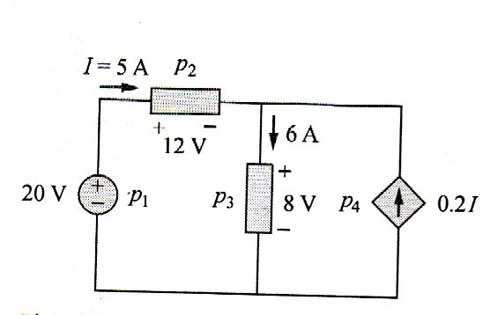
- Calculate the power supplied by each element in the circuit shown below
(5marks)

- i) State Kirchhoff’s laws (2marks)

ii) Determine V_{o} and i in the circuit (5marks)
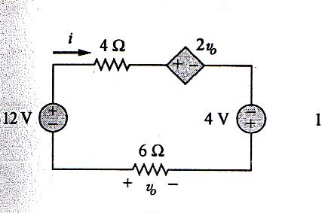

- Find Req for the circuit shown in Fig. 2.34. (8 marks)

QUESTION THREE (20 MARKS )

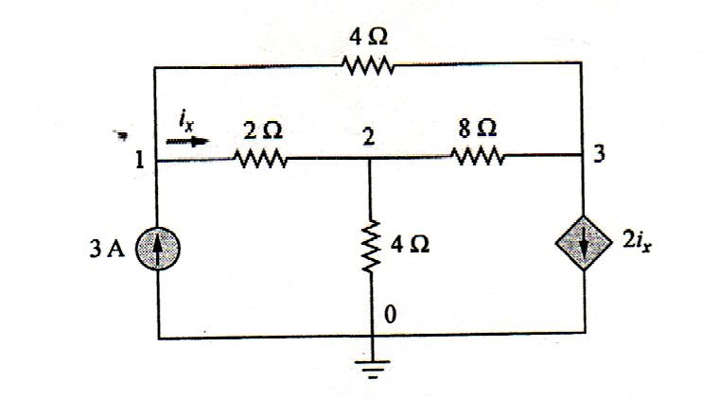
- Determine the voltages at the nodes in the figure below (8marks)

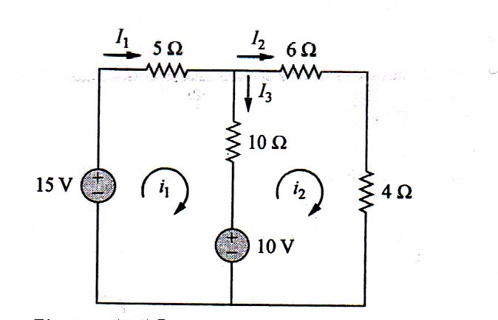
- Find the branch current I, I₂ and I₃ using mesh analysis (8marks)

- Explain how to Nortonize a given circuit (4marks)

QUESTION FOUR (20MARKS)
- State the principle of superposition (2 mark)
- State three steps on how to apply superposition theorem (3 marks)
- Briefly discuss the maximum power transfer theorem (5 marks)
- Explain the following terms used in electric circuits and state two examples for each.
- Passive Element (3 marks)
- Active Element

