NAME_________________________________________________INDEX NO._________
CANDIDATE’SSIGNATURE_________________
DATE:________________________________
231/2
BIOLOGYPAPER 2
THEORY

TIME: 2 HOURS

MOI HIGH SCHOOL - KABARAK
Kenya Certificate of Secondary Education (K.C.S.E.)
231/2
BIOLOGY PAPER 2

INSTRUCTIONS TO CANDIDATES
- Write your name and index number in the spaces provided above.
- Sign and write the date of examination in the spaces provided.
- In Section B answer questions 6 (Compulsory) and either question 7 or 8 in the spaces provided after question 8.
- Answer all the questions in the spaces provided.
- Candidates should answer all the questions in English.

For Examiners’ use ONLY

SECTION | QUESTION | MAXIMUM SCORE | CANDIDATE’S SCORE
A | 1 | 8
 | 2 | 8
 | 3 | 8
 | 4 | 8
 | 5 | 8
 | 6 | 20
 | 7 | 20
 | 8 | 20
TOTAL |  | 80

SECTION A (40 MARKS)

INSTRUCTIONS – Answer ALL the questions in this section in the spaces provided.

1. (a) State the roles of the following organelles. (3 marks)
(i) Ribosome
………………………………………………………………………………………………………………………………………………………………
(ii) Lysosome
………………………………………………………………………………………………………………………………………………………………
(iii) Centriole
………………………………………………………………………………………………………………………………………………………………
(b) Give three differences between a plan and animal cells. (3 marks )
………………………………………………………………………………………………………………………………………………………………………………………………………………………………………………………………………………………………………………………………………………………………………………………………………………………………………………………………………………………………………………………………………………………………………………………………………………………………………
(c) Suggest two ways the sperm cell is specialized. (2 marks)
……………………………………………………………………………………………………………………………………………………………………………………………………………………………………………………………………………………………………………………………………………………………..

2. (a) State three features of the gaseous exchange surface for an aquatic organism. (3 marks)
………………………………………………………………………………………………………………………………………………………………………………………………………………………………………………………………………………………………………………………………………………………………………………………………………………………………………………………………………………………………………………………………………………
(b) Name the form in which the following compounds are transported in blood. (3 marks)
(i) Oxygen
………………………………………………………………………………………………………………………………………………………………
(ii) Carbon (II) oxide
………………………………………………………………………………………………………………………………………………………………
(c) Explain oxygen debt. (2 marks)
………………………………………………………………………………………………………………………………………………………………………………………………………………………………………………………………………………………………………………………………………………………………
(d) Suggest the advantage of transporting most carbon (IV) in red blood cells. (1 mark)
………………………………………………………………………………………………………………………………………………………………………………………………………………………………………………………………………
3. (a) Give three hormones that influences the female reproduction in humans. (3 marks)
………………………………………………………………………………………………………………………………………………………………………………………………………………………………………………………………………………………………………………………………………………………………
(b) State the roles of the following structure in the human male.
(i) Prostate gland (2 marks)
………………………………………………………………………………………………………………………………………………………………………………………………………………………………………………
(ii) Cowper’s gland (1 mark)
………………………………………………………………………………………………………………………………………………………………………………………………………………………………………………
(iii) Epididymis (1 mark)
………………………………………………………………………………………………………………………………………………………………

(c) What is gestation period? (1 mark)
……………………………………………………………………………………………………………………………………………………………………

4. Hemophilia is due to a recessive gene. The gene is sex-linked and located on the
X-chromosome. The figure below shows some offspring from phenotypically normal parents.
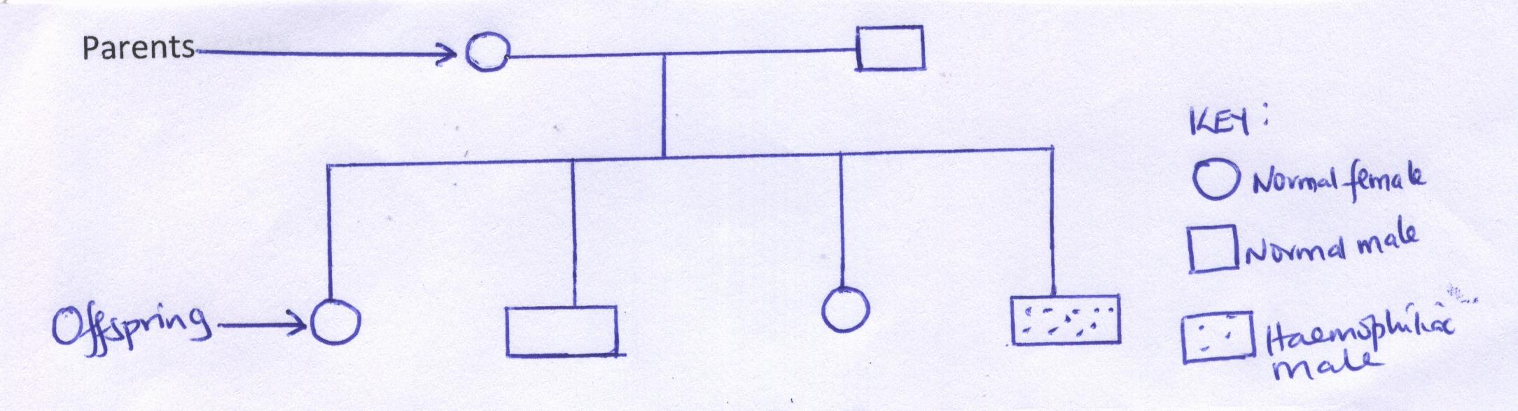
(a) (i) What are the parental genotypes?

Father_____________________Mother_______________ (2 marks)

(ii) Work out the genotypes of the offspring. (4 marks)

(b) State two other disorders in humans that result from gene mutation. (2 marks)
………………………………………………………………………………………………………………………………………………………………………………………………………………………………………………………………………………………………………………………………………………………………
5. (a) Define the phototropism. (1 mark)
…………………………………………………………………………………………………………………………………………………………………………………………………………………………………………………………………………………………………………………………………………
(b) Name the hormone involve in phototropism. (1 mark)
……………………………………………………………………………………………………………………………………………………………………
(c) Explain how the hormone named in 5 (b) above causes phototropism in a shoot of a young seedling. (3 marks)
…………………………………………………………………………………………………………………………………………………………………………………………………………………………………………………………………………………………………………………………………………………………………………………………………………………………………………………………………………………………………………………………………………………………………………………………………

(d) (i) State the function of a klinostat. (1 mark)
………………………………………………………………………………………………………………………………………………………………………………………………………………………………………………………………………………………………………………………………
(ii) Explain how the klinostat works to achieve its function. (2 marks)
……………………………………………………………………………………………………………………………………………………………………………………………………………………………………………………………………………………………………………………………………………………………………………………

SECTION B (40 MARKS)
Answer question 6 (Compulsory) and either question 7 or 8 in the spaces provided
6. The data provided below represent populations of a predator and its prey over a fifty years period.
TIME IN  YEARS | POPULATION IN RELATIVE NUMBERS
 | POPULATION OF  P | POPULATION OF  Q
5 | 24500 | 17000
10 | 30000 | 20500
15 | 33500 | 26000
20 | 33500 | 30000
25 | 31000 | 33000
30 | 27000 | 32000
35 | 25000 | 30000
40 | 29000 | 27500
45 | 32500 | 28000
50 | 34000 | 28500

- (i) Using the same axes, draw graphs of the relative populations of P and Qagainst time. (7 marks)

(ii) With a reason, identify the curve that represents the prey. (2 marks)
…………………………………………………………………………………………………………………………………………………………………………
(iii) Account for the two populations between 25 and 32 years. (2 marks)
……………………………………………………………………………………………………………………………………………………………………………………………………………………………………………………………………………………………………………………………………………………………………………………………………………………………
(iv) Which years were the two populations equal? (2 marks)
………………………………………………………………………………………………………………………………………………………………
(v) Apart from predation, state three biotic factors that may have led to the
decline of the prey population. (3 marks)
………………………………………………………………………………………………………………………………………………………………………………………………………………………………………………………………………
(b) Describe the hazards of air pollution by Sulphur(IV)Oxide. (4 marks)
………………………………………………………………………………………………………………………………………………………………………………………………………………………………………………………………………………………………………………………………………………………………………………………………………………………………………………………………………………………………………………………………………………………………………………………………………………………………………………………………………………………………………………………………………………………………………………………………………………………………………………
7. (a) Explain how water move up the plant from the xylem in roots to the leaves. (8 marks)
(b) Describe the process of digestion of a meal consisting of lean meat and rice. (12 marks)
OR
8. Describe the process of urine formation in man. (20 marks)
……………………………………………………………………………………………………………………………………………………………………………………………………………………………………………………………………………………………………………………………………………………………………………………………………………………………………………………………………………………………………………………………………………………………………………………………………………………………………………………………………………………………………………………………………………………………………………………………………………………………………………………………………………………………………………………………………………………………………………………………………………………………………………………………………………………………………………………………………………………………………………………………………………………………………………………………………………………………………………………………………………………………………………………………………………………………………………………………………………………………………………………………………………………………………………………………………………………………………………………………………………………………………………………………………………………………………………………………………………………………………………………………………………………………………………………………………………………………………………………………………………………………………………………………………………………………………………………………………………………………………………………………………………………………………………………………………………………………………………………………………………………………………………………………………………………………………………………………………………………………………………………………………………………………………………………………………………………………………………………………………………………………………………………………………………………………………………………………………………………………………………………………………………………………………………………………………………………………………………………………………………………………………………………………………………………………………………………………………………………………………………………………………………………………………………………………………………………………………………………………………………………………………………………………………………………………………………………………………………………………………………………………………………………………………………………

