NAME…………..………………ADMNO……………CLASS………….………..DATE...............

CHEMISTRY THEORY 233/2

MARCH/APRIL 2017

TIME: 2 HOURS
SACHO HIGH SCHOOL
Instructions to students:
Answer ALL questions in the spaces provided
Mathematical tables or electronic calculators may be used.
ALL working must be clearly shown where necessary.

FOR EXAMINER’S USE ONLY
QUESTION | MAXIMUM SCORE | CANDIDATE’S SCORE
1 | 12
2 | 13
3 | 11
4 | 11
5 | 10
6 | 08
7 | 11
8 | 11
TOTAL SCORE | 80
This paper consists of 15printed pages. Candidates should check the question paper to ensure that all pages are printed as indicated and no questions are missing.

1. Use the grid below to answer the questions that follow. Letters do not represent actual symbol of elements

F | I |  |  |  | M |  | O
G | J |  | K | L |  | N | P
H |  |  |  |  |  |  |  | Q
a) What family name is given to elements I and J (1 mark)
………………………………………………………………………………………………………………………………………………………………………………………………………………………………………………………………………………………………………...
b) State and explain the difference in reactivity between.
i) G and J (2 marks)
………………………………………………………………………………………………………………………………………………………………………………………………………………………………………………………………………………………………………………………………………………………………………………………………………………………………
ii) N and P (2 marks)
………………………………………………………………………………………………………………………………………………………………………………………………………………………………………………………………………………………………………………………………………………………………………………………………………………………………

c) How does atomic radius of K compare to that of L? Explain. (2 marks)
………………………………………………………………………………………………………………………………………………………………………………………………………………………………………………………………………………………………………………………………………………………………………………………………………………………………………………………………
d) Explain the trend in melting points down the group of elements to which I and J belong. (2 marks)
………………………………………………………………………………………………………………………………………………………………………………………………………………………………………………………………………………………………………………………………………………………………………………………………………………………………………………………………
e) Write down an equation for the reaction between K and P. (1 mark)
…………………………………………………………………………………………………………………………………………………………………………………………………………………………………………………………………………………………………………
f) Give one use of element Q. (1 mark)
…………………………………………………………………………………………………………………………………………………………………………………………………………………………………………………………………………………………………………
i) Write down the electronic arrangement of a stable ion of H. (1 mark)
…………………………………………………………………………………………………………………………………………………………………………………………………………………………………………………………………………………………………………
2. The set-up below was used during the electrolysis of aqueous magnesium sulphate using inert electrodes.
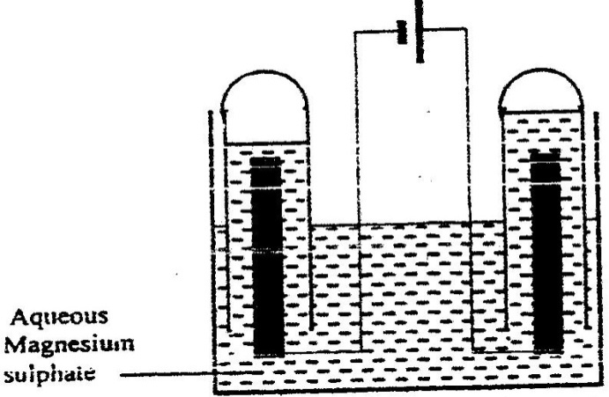

- Name a suitable pair of electrodes for this experiment. (1 mark)

……………………………………………………………………………………………………………………………………………………………………………………………………………………………………………………………………………………
- Identify the anions and cations in the solution. (1 mark)

…………………………………………………..………………………………………………………………………………………………………………………………………………………………………………………………………………………………
- On the diagram label the cathode. (1 mark)
- Write an equation for the reaction that took place at the cathode. (1 mark)

…………………………………………………….……………………………………………………………………………………………………………………………………………………………………………………………………………………………
- Explain the change that occurred to the concentration of magnesium sulphate solution during the experiment. (2 marks)
……………………………………………………………………………………….……………………………………………………………………………………………………………………………………………………………………………………………………………………………………………………………………………………………………………………………………
- During the electrolysis, a current of 2 amperes was passed through the solution for 4 hours. Calculate the volume of the gas produced at the cathode. (1 Faraday= 96500 coulombs , molar volume of a gas at room temperature = 24000cm³).
(3 marks)

v) One of the uses of electrolysis is electroplating. (1mark)
………………………………………………………………………………………………………………………………………………………………………………………………………………………………………………………………………………………………
vi) Give two reasons why electroplating is necessary. (1 mark) ………………………………………………………………………………………………………………………………………………………………………………………………………………………………………………………………………………………………

b) The diagram below is a cross- section of a dry cell. Study it and answer the questions that follow.
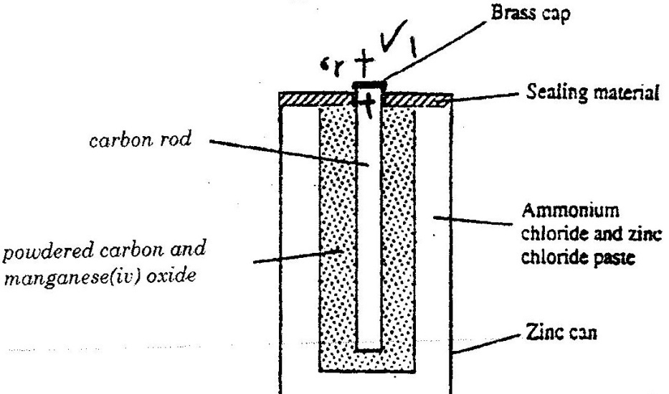

- On the diagram, show with a (+) sign the positive terminal (1 mark)
ii) Write the equation for the reaction in which electrons are produced. (1 mark)
………………………………………………………………………………………………………………………………………………………………………………………………………………………………………………………………………………………………
iii) Give one disadvantage of dry cells. (1 mark)
………………………………………………………………………………………………………………………………………………………………………………………………………………………………………………………………………………………………
3. The scheme below shows the industrial manufacture of sulphuric (VI) acid. Study it and answer the questions that follow.

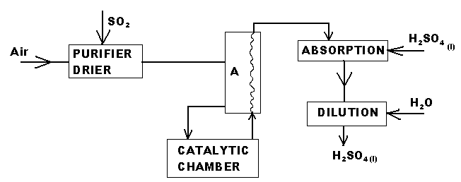

- State two functions of the chamber A. (1mark)

………………………………………………………………………………………………………………………………………………………………………………………………………………………………………………………………………………
- Explain why concentrated Sulphuric (VI) acid is used in the absorption chamber and not water. (1mark)
………...………………………………………………………………………………………….....………...…………………………………………………………………
- Write the equation for the reaction that takes place at the absorption chamber (1mark)
………...………………………………………………………………………………………….......................................................................................................................
iv) Name two catalysts that can be used in the catalytic chamber. (1mark)
………...…………………………………………………………………………………………..………...………………………………………………………………………
(b) Sulphuric (VI) acid is used in making fertilizers. What volume of ammonia gas will be required to make 25kg of ammonium sulphate? N = 14, H = 1.0, S = 32, O = 16.0 Molar gas volume at r.t.p=24.0dm³) (3marks)

………...………………………………………………………………………………………….....………...………………………………………………………………………………………….....………...………………………………………………………………………………………….....……………………………………………………………………...
c) The equation below shows the oxidation of Sulphur (IV) oxide to Sulphur (VI) oxide in the contact process.
2SO_{2(g)} + O_{2(g)} 2SO_{3(g)}∆H = -196kJ/mol⁻
i) State and explain the effect on the yield of Sulphur (IV) oxide when.
a) the temperature increased. (2marks)
………………………………………………………………………………………………..…………………………………………………………….……….…………………………………………………………………………...……….…

b) the amount of oxygen is increase (2marks)
…………………………………………………………………………………………………..…………………………………………………………….……………………………………………………………………………………………
4. Study the following table and then use it to answer the questions that follow.
Hydrocarbon | Boiling point (k)
CH₄  C₂H₆  C₃H₈  C₄H₁₀  C₅H₁₂  C₆H₁₄ | 112  184  231  273  309  342

a) These organic compounds belong to the same homologous series.
i) What is meant by the term homologous series? (1mark)
……………………………………………………………………………………………………………………………………………………………………………………………………………………………………………………….………
- To which homologous series do the above hydrocarbons belong? (1mark)
………………………………………………………………………………………………………………………………………………………………………………………………………………………………………………………………
- Select one hydrocarbon that would be a liquid at room temperature.
(2marks)
………………………………………………………………………………………………………………………………………………………………………………………………………………………………………………………………

iv) Compare the boiling point of CH₄ and C₆H₁₄ ? Explain your answer (2marks)
……………………………………………………………………………………………………………………………………………………………………………………………………………………………………………………………………………………………………………………………………..……………………………………………………………………………………………………
- Give one chemical test to distinguish between C₂H₆ and C₂H₄ (2marks)
…………………………………………………………………………………………………………………………………………………………………………………………………………………………………………………………………………………………………………………………………………………………………………………………………………………………………………
b) Study the scheme below and answer the questions that follow.
C₂H₅COONa
CH≡CH
C₂H₆
Complete
combustion
Step IV
CH₂ = CHCI
Step II
(CH₂-CHCl)_{n}
Step III
Step V

- Name the reagents used in
Step I ……………………………………………………………………..…(^{1/}₂ Mark)
Step II ……………………………………………………………..…….. (^{1/}₂ Mark)
ii) Write an equation for the complete combustion of CH≡CH ( 1 Mark)
.……………………………………………………………………………………………………………………………………………………………………………………..……
iii) Explain one disadvantage of the continued use of items made from the compound formed in Step III (1 Mark)
.……………………………………………………………………………………………………………......................................................……………………………………………………………………………………………………………….………………………
5 .Study the flow diagram below and answer the questions that follow:-
acidifiedWater
Air
Electrolysis
Step 2
Step 1
N_{2(g)}
M
Step 2
Ammonia
Step 4
Rhodium/Platinum
Temperature 900⁰C
Colourless gas Q

Step 5
Nitrogen (IV) Oxide
Step 6
Nitric Acid

Step 7
Ammonium Nitrate

(i) Describe how nitrogen is obtained from air (3 marks)
……………………………………………………………………………………………………………………………………………………………………………………………………………………………………………………………………………………………………………………………………………………………………………………………………………………………………………………………………………………………………….……………………………………………………………………………………...
- Name the element M (1 Mark)
.………………………………………………………………………………………………………………………………………………………………………………….………
(iii) Why is it necessary to use excess air in step 4 (1 Mark)
.……………………………………………………………………………………………………………......................................................……………………………………………………………………………………………………………….………………………
- Write an equation for the reaction in step 7 (1 Mark)
.……………………………………………………………………………………………………………...……………………………………………………………………………………………………………….…………………………………………………………
(IV) State two uses of ammonia gas (2 Marks)
.…………………………………………………………………………………………….…………………………………………………………………...………………………………………………………………………………………………………………………..
(c) State and explain the observations made if a sample of sulphur is heated in concentrated
Nitric(V) Acid (2 Marks)
.…………………………………………………………………………………………………………….......................................................………………………………………………………………………………………………………………………………………………………………….…………………………………………………………………………………………………………

6 a). State Hess’ law of summation (1mark)
………………………………………………………………………………………………………………………………………………………………………………………………
Use the information below to answer the questions that follow:
H_{2(g)} + ½ O_{2(g)} H₂O_{(l)} ∆H₁= -286kJmol⁻¹

C_{(s)} + O_{2(g)} CO_{2(g)} ∆H₂= -394kJmol⁻¹

2C_{(s)} + 3H_{2(g)} + ½ O_{2(g)} C₂H₅OH_{(l)} ∆H₃= -277kJmol⁻¹

- Write a balanced chemical equation for complete combustion of ethanol
(1mark)
………………………………………………………………………………………………………………………………………………………………………….
- Draw an energy level diagram to using the heat of combustion of carbon, hydrogen and ethanol. (1mark)

- Calculate the molar enthalpy of combustion of ethanol.
(2marks)

b) Given the following bond energies. Use it to answer questions below.
Bonds Bond energies
C – C (347kJ molˉ¹)
C – H (413kJ molˉ¹)
C = C (612kJ molˉ¹)
H – H (435.9kJ molˉ¹)

Calculate enthalpy formation of ethyne from its constituent elements. (3marks)

7 a) A student was provided with an ore suspected to contain Fe²⁺ ions, describe an experiment to show how the student can confirm the presence of Fe²⁺ ions in the ore.
(2 marks)
………………………………………………………………………………………………………………………………………………………………………………………………………………………………………………………………………………………………………………………………………………………………………………………………
b) The chart below represents the extraction of iron and some of its uses.
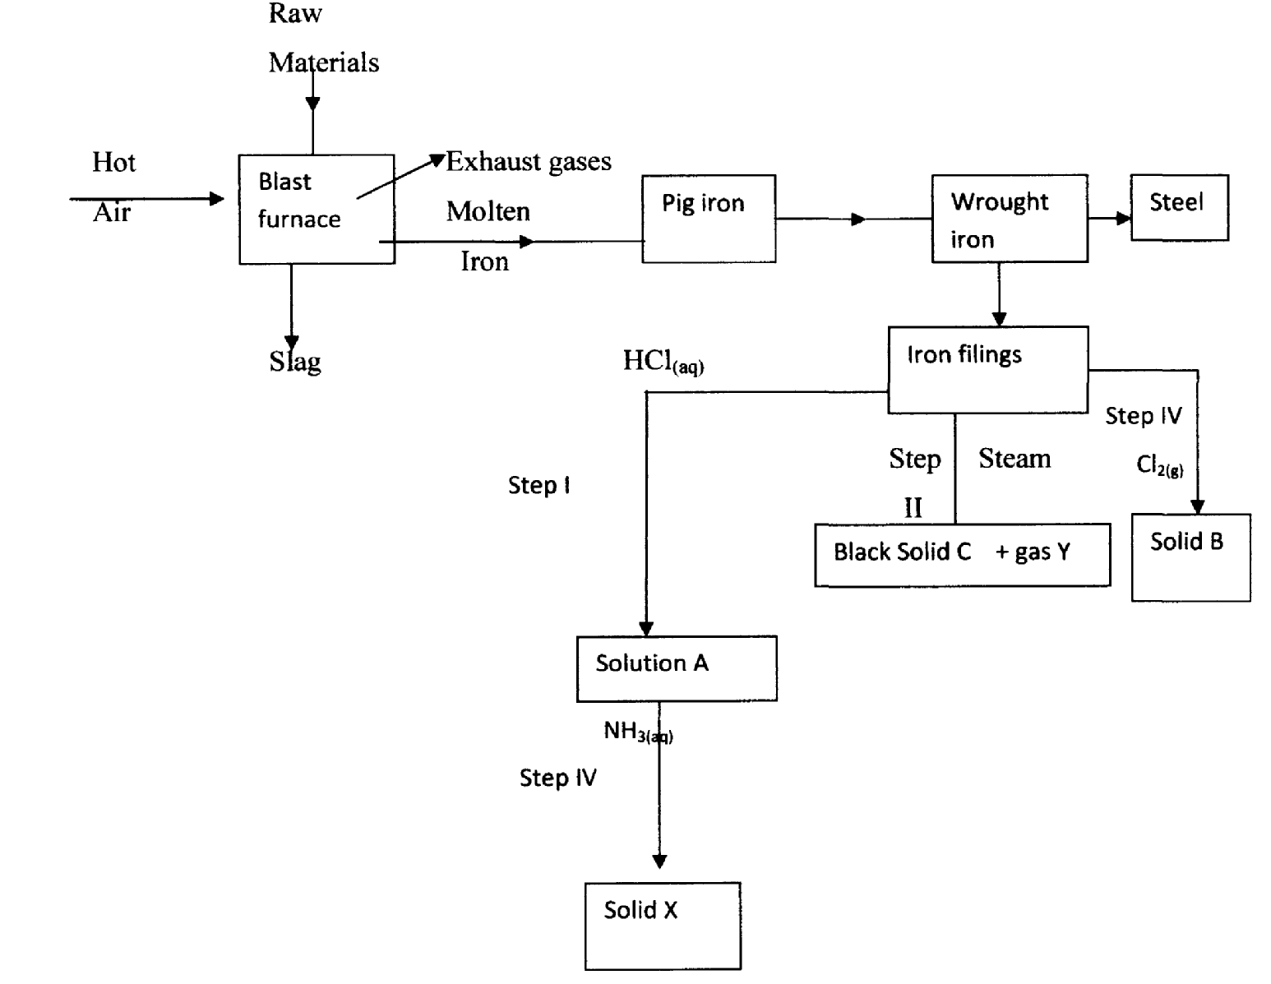

i) Name the chief ore fed into the blast furnace. (1 mark)
……………………………………………………………………………………………………………………………………………………………………………………………....

ii) Name 2 exhaust gases emitted from the blast furnace. (1 mark)
………………………………………………………………………………………………………………………………………………………………………………………………………………………………………………………………………………………………
iii) Why is it necessary to convert pig iron into wrought iron (l mark)
………………………………………………………………………………………………………………………………………………………………………………………………………………………………………………………………………………………………
iv) Name (1 mark)
Solid B ………………………………………………………………………………………………
Solid X ………………………………………………………………………………………………
v) Write equations for reaction in step II (1 mark)
…………………………………………………………………………………………………………………………………………………………………………………………..….
vi) Write an ionic equation for the reaction in step I. (l mark)
………………………………………………………………………………………………………………………………………………………………….
vii) What observations are made in steps I and IV? (1 mark)
I…………………………………………………………………………………………………………………………………………………………………
IV……………………………………………………………………………………………………………………………………………………………….
viii) State one commercial use of iron. (1 mark)
………………………………………………………………………………………………………………………………………………………………… ix) State one environmental effect that may arise from the extraction of iron. (1 mark)
…………………………………………………………………………………………………………………………………………………………………
8 a) Other concentration, name two other factors that affect the rate of a reaction. (1 mark)
…………………………………………………………………………………………………………………………………………………………………………………………………………………………………………………………………………………………………………………………………….
b) In an experiment to determine the rate of reaction between duralumin (an alloy of aluminium, copper and magnesium) and dilute hydrochloric acid, 0.55g of the alloy were reacted with excess 4 M hydrochloric acid. The data in the table below was recorded. Use it to answer the questions that follow.
Time (seconds) | Total volume of hydrogen gas produced (cm³)
0 | 0
60 | 220
120 | 420
180 | 540
240 | 620
300 | 640
360 | 640
420 | 640

i) On the grid provided, plot a graph of total volume of hydrogen gas produced (vertical axis) against time. (3 marks)
ii) From the graph, determine the volume of gas produced at the end of 135 seconds. (1 mark)
…………………………………………………………………………………………………………………………………………………………………
c) Determine the rate of reaction between the 4th and the 5th minute. (2 marks)
…………………………………………………………………………………………………………………………………………………………………………………………………………………………………………………………………………………………………………………………………….
d) Explain why the volume of the gas remain constant after the 300th second. (1 mark)
………………………………………………………………………………………………………………………………………………………………….………………………………………………………………………………………………………………………………………………………………….f) Given that 2.5 cm3 of the total volume of the hydrogen gas was from the reaction between magnesium and dilute hydrochloric acid, calculate the percentage by mass of aluminium present in the 0.55 g of the alloy. (Al=27, Molar Gas Volume at r.t.p =24litres) (3 marks)

