NAME:…………………………………………….INDEX………………..…

SCHOOL:……………………………………SIGNATURE………………

ADM NO…………. CLASS…………

121/1
MATHEMATICS
PAPER 1
MARCH 2017
2½ HOURS

MOKASA EXAMINATIONS
Kenya Certificate of Secondary Education
121/1
MATHEMATICS
PAPER 1
MARCH 2017

INSTRUCTIONS TO CANDIDATES
- Write your name and index number in the spaces provided at the top of this page.
- This paper consists of two sections: Section I and Section II.
- Answer all questions in section I and any five questions from Section II.
- Show all the steps in your calculations, giving your answers at each stage in the spaces below each question.
- Marks may be given for correct working even if the answer is wrong.
- Non- programmable silent electronic calculators and KNEC Mathematical tables may be used.

For Examiner’s Use Only
SECTION I
1 | 2 | 3 | 4 | 5 | 6 | 7 | 8 | 9 | 10 | 11 | 12 | 13 | 14 | 15 | 16 | Total

SECTION II
17 | 18 | 19 | 20 | 21 | 22 | 23 | 24 | Total
Grand
Total

This paper consists of 16 pages. Candidates should check the question paper to ensure that all the pages are printed as indicated and no questions are missing.

- Simplify (3mks)

- Use logarithms table to evaluate (4mks)
$${\left(\frac{0.275×563}{456.5(33+\log{4.5)}}\right)}^{\frac{1}{5}}$$

- Given that $8^{2n}$ × 3^{m} = 36, find the values of n and m. (3mks)

- The perimeter of a triangle is given as 32cm. Two sides of the triangle are 10cm and 8cm respectively, find the length of the third side, hence find the area of the triangle. (3mks)

- Factorize and simplify the expression (3mks)

- Express the inequalities in the form p ≤ x ≤ q hence state the integral values (3mks)

- A number P is formed by writing all the prime numbers between 40 and 50 in descending order. If K is arrived by adding 20 to P. Perform divisibility test of 11 for the number K. . (3mks)

- Twenty one minutes, fifteen minutes and nine minutes are the intervals at which three sirens ring. The sirens will next ring together 5.00 p.m. Find the time the sirens had last rang together. (3mks)

- Two similar cylindrical containers are such that the capacity of the larger container is 5 litres and that of the smaller is 320 millilitres. If the base area of the larger container is 0.25 m². Find the base area of the smaller container. (3mks)

- Ksh 10,000 is invested for a period of 4 years. The total amount accrued is Ksh 14,800. Calculate the rate of simple interest per annum for that investment. (3mks)

- The figure below shows two equal intersecting circles with common chord PQ and centres A and B. Given that AP =PB=10 cm and the common chord PQ = 15 cm. Calculate the area of the shaded part (4mks)
P

Q

- Given that Cos A =, without using mathematical table or calculator find:
- Sin A (2mk)

- Tan (90-A) (1mk)

- Use reciprocal and square root tables to evaluate $\frac{0.3}{0.0351}$ + $\sqrt{0.498}$ (3mks)

- A trader mixes 50 kg of beans costing sh.38 per kilogram with 150 kg of beans costing sh. 34 per kilogram. At what price per kilogram must he sell the mixture to make a profit of 30% (3mks)

- The angle of elevation of the top of a vertical tower from a point A on a horizontal level as the foot of the tower is 40 º. From a point B in direct line between A and the foot of the tower and at a distance 10 m from A the angle of elevation to the top of the tower is 60 º. Find the height of the tower (3mks)

- The figure below shows a triangular prism ABCDEF. Its cross-section is an equilateral triangle of sides 3cm and its length is 5cm. A string runs from F to Q through R and D.

a) Draw a well labelled net of the solid such that the string is not cut (3mks)

- A straight line L₁ passes through the points (-2,4) and (3,0). Find the equation of line L₁ in the form (3mks)

- Another line L₂ passes through the points (5,6) and (3,0). Find the acute angle between lines L₁ and L₂ at the point of intersection. (4mks)

- Find the equation of a line perpendicular to L1 and passing through (2,1) in the form
y=mx+c (3mks)

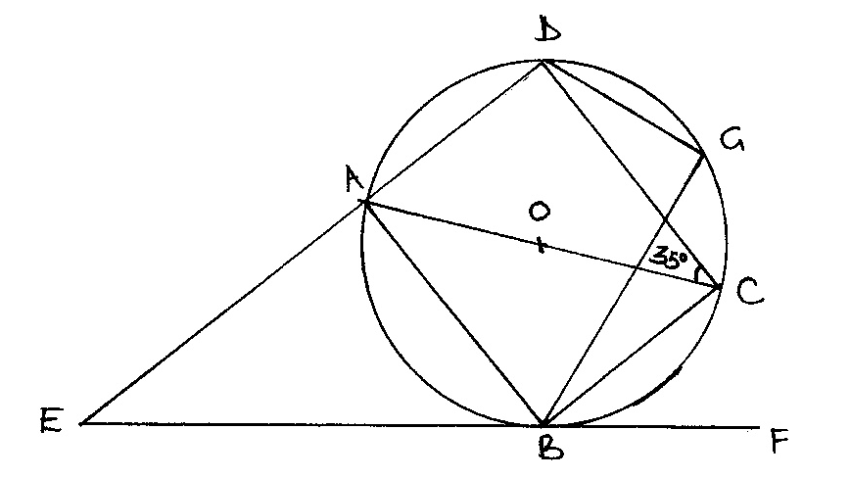
- In the figure below AOC is a diameter of the circle centre O. AB = BC and ∠ACD = 35°, EBF is a tangent to the circle at B. G is a point on minor arc CD.

Calculate the size of the following angles giving reasons in each case.
(a) ∠BCD. (2mks)

(b)Obtuse angle BOD. (2mks)

(c)∠BAD. (2mks)

(d)∠CGD. (2mks)

(e) ∠AEB. (2mks)

- A matatu left town A at 8.00 a.m. and travelled towards town B at an average speed of 75 km/h. At the same time, a car left town B and travelled towards town A at an average speed of 80 km/h. The distance between the two towns is 160 km. Calculate;
(a) The time the matatu arrived at its destinations. (2mks)

(b) After travelling for 30 minutes the car got a puncture which took 30 minutes to repair then it continued with the journey with its initial speed. Find the time they met.(6mks)

(c) find the time the car arrived at its destination. (2mks)

- The right pyramid with a rectangular base below has AB = 12cm and BC = 16cm. O is the centre of the base with OV = 15cm.

V

- Calculate the surface area of the pyramid (5mks)

- The pyramid is chopped at point T to form a frustum such that T divides OV in the ratio 2:1. Find the volume of the frustrum. (5mks)

- The temperature outside a school was measured at regular intervals on 80 occasions. The frequency distribution is as shown.
Temperature x ( ºC) ( f)
30.0 - 30.2 6
30.3 - 30.5 12
30.6 - 30.8 15
30.9 - 31.1 20
31.2 - 31.4 13
31.5 - 31.7 9
31.8 - 32.0 5

- Use the above data to calculate:
- mean (3mks)

- median (3mks)

- Draw a histogram to represent the information on the grid below (4mks)

- A plane B is on a bearing of 080⁰ from airport A and at a distance of 96 km. Another plane is stationed at airport D which is on a bearing of S20⁰W from airport A and a distance of 124 km from B. A plane leaves B and moves directly due south to P which is on a bearing of S40⁰E from A.
- Using a scale of 1 cm rep 20 km, make a scale drawing to show the relative positions of A, B, D and P. (4mks)

- Hence find:
- Distance from A to D (2mks)

- True bearing of D from B (1mk)

- Compass bearing of P from D (1mk)

- Distance from P to D (2mks)
- A triangle ABC A (2, 1) B (3, 3) C (4, 1) is enlarged to A’B’C’ through a scale factor 2 about the origin.
- Draw the triangle ABC and A’B’C’ (3mks)

- A’’B’’C” is the image of A’B’C’ under a rotation of -90º about the origin. On the same axes draw triangle A’’B’’C’’ (2mks)
- A’’’B’’’C’’’ is the image of A’’B’’C’’ under a reflection in the line$x-y=0$. Draw the triangle A’’’B’’’C’’’ (2mks)

- State the coordinates A’’B’’C’’ and A’’’B’’’C’’’. (2mks)

- Describe a single transformation that maps A’’’B’’’C’’’ onto A’B’C’ (1mk)

- a) Complete the table below for y=sin 2x and y=sin ( 2x + 30) giving values to 2d.p
(2mks)
X | 0 | 15 | 30 | 45 | 60 | 75 | 90 | 105 | 120 | 135 | 150 | 165 | 180
Sin 2x | 0 |  |  |  | 0.87 |  |  |  | -0.87 |  |  |  | 0
Sin ( 2x +30) | 0.5 |  |  |  | 0.5 |  |  |  | -1 |  |  |  | 0.5

b) Draw the graphs of y=sin 2x and y = sin (2x + 30) on the grid provided below (3mks)

c)Use the graph to solve sin ( 2x + 30)-sin 2x =0 (2mks)

d) Determine the transformation which maps sin 2x onto sin (2x + 30) (1mk)

e) State the period amplitude of y = sin ( 2x + 30) (2mks)

