Name…………………………………… …………………...Index No:………………………….
231/3 Candidate’s Signature …………..……………
BIOLOGY Date: …………………………..………………
PAPER 3
PRACTICAL
MARCH/APRIL- 2017
TIME: 1 ¾ HOURS
SACHO HIGH SCHOOL
Kenya Certificate of Secondary Education (K.C.S.E.)
231/3
Biology
Paper 3
1 ¾ Hours

INSTRUCTIONS TO CANDIDATES
Write your name and index number in the spaces provided above
Sign and write the date of examination in the spaces provided.
Answer all the questions in the spaces provided.
You are required to spend the first 15 minutes of the 1 ¾ hours allowed for this paper reading the whole paper carefully before commencing your work.
Additional pages must not be inserted.
Candidates should check to ascertain that all pages are printed as indicated and that no questions are missing.
Candidates must answer all questions in English

For Examiners Use Only
Question | Maximum score | Candidate’s score
1 | 14
2 | 13
3 | 12
Total | 40
This paper consists of 6 printed pages. Candidates should check to ascertain that all pages are printed as indicated and that no questions are missing
- You are provided with a food sample labelled solution C. Using the reagents provided; carry out tests to identify the food substances present in the sample. (11marks)
TEST FOR | PROCEDURE | OBSERVATION | CONCLUSION
- Reducing sugars
- Ascorbic acid
- Proteins

From the results above
- State the part of the digestive system where the digestion of the food substance begins. (2marks)
………………………………………………………………………………………………………………………………………………………………………………
- Name the deficiency disease arising from the food substance C. (1mark)
…………………………………………………………………………………………..

- The photographs below show floral structures and germination process. Study them carefully then answer the questions that follow.
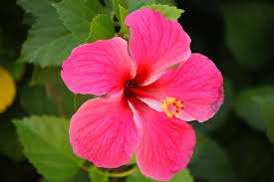
L
D
W
PLATE I
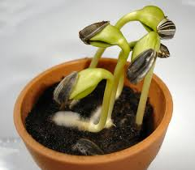
PLATE II
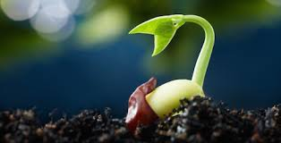
T
Q
R
PLATE III
- (i) Describe the type of the ovary in plate I. (1mark)
……………………………………………………………………………………………….........................................................................................................................
(ii) With reasons name the agent of pollination of the flower in plate I. (1mark)
Agent of pollination ……………………………………………………………………
Reasons. ……………………………………………………………………………………………………………………………………………………………………………………
(3marks)

(iii) Identify the parts labeled in plate I. (3marks)
W …………………………………………………………………………………………
D …………………………………………………………………………………………
L …………………………………………………………………………………………
- Plate III shows a plant obtained from plate II.
- Identify the parts labelled. (3marks)
R ………………………………………………………………………………
T ………………………………………………………………………………
Q ………………………………………………………………………………
- Explain the functions of the parts R and T. (2marks)
R……………………………………………………………………………………………………………………………………………………………………………………………………………………………………………………
T………………………………………….…………………………………………………………………………………………………………………………………………………………………………………………………………
- Below are diagrams labelled (a) and (b) of specimens obtained from an animal. Examine them carefully then answer the questions that follow.
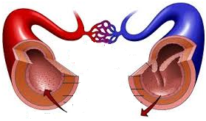
F
3
5
7
Diagram (a)
Hi
Hii
Diagram (b)
- (i) In diagram (a), identify the structures labelled. (3marks)
3…………………………………………………………………………………………
5…………………………………………………………………………………………
7…………………………………………………………………………………………
(ii) Give a reason for the identities 3 and 7 in (i) above. (2marks)
…………………………………………………………………………………………………………………………………………………………………………………………………………………………………………………………………………………………………………………………………………………………………………
(iii) Explain how blood vessel 5 is adapted to its function. (2marks)
…………………………………………………………………………………………………………………………………………………………………………………………………………………………………………………………………………………………………………………………………………………………………………
(iv) State the function of the structure labelled F. (1mark)
……………………………………………………………………………………………………………………………………………………………………………………

(v) Identify the process by which certain materials pass out of structure 5. (1mark)
………………………………………………………………………………………………
- Diagram (b)shows the components in diagram (a).
- Identify structure Hii (1mark)
………………………………………………………………………………………
- Using an observable feature only, explain how the structure named in b(i) above is adapted to its function. (1mark)
………………………………………………………………………………………………………………………………………………………………………………………………………………………………………………………………………
- In what form is carbon(IV) oxide transported in structure Hiiabove.(1mark)
………………………………………………………………………………………
- Name a hereditary disease represented by structure Hi. (1mark)
………………………………………………………………………………………

BIOLOGY PARER 3
CONFIDENTIAL
- @ candidate to have 3 ml of solution C; a mixture of glucose and milk/egg albumen/protein
- 3 test tube in a test tube rack plus a test tube holder
- A 10 ml measuring cylinder
Shared
- Source of heat
- Benedict’s solution
- DCPIP supplied with a dropper
- Cupper II sulphatewith a dropper
- Sodium hydroxide solution

