Name................................................................................................ Index Number........................
Student’s Signature..........................

231/3
BIOLOGY
PAPER 3
PRACTICAL
JUNE, 2017
1 ¾ HOURS

SUNSHINE SECONDARY SCHOOL
Kenya Certificate of Secondary Education
BIOLOGY
Paper 3
Practical
TIME: 1 ¾ Hours

- You are provided with 6 test tubes, solution C, droppers, a white tile, iodine solution, 0.1% sodium chloride, 1.4% sodium chloride, Benedicts solution, solution A, water bath and labels.
- Label three tests S, T and U. Into each test-tube, place 3ml of solution C.
- Put a drop of solution C on a white tile and add a drop of iodine solution.
Record your observation. (1mk)
---------------------------------------------------------------------------------------------------------
C) Add 3 drops of 0.1% sodium chloride solution and 2ml of solution A to test tube T.
To test-tube U add three drops of 1.4% sodium chloride solution and 2ml of solution A. Sodium chloride is a source of sodium ions. Place the test tube S, T and U in a water bath maintained at 37ºC for 30 minutes. Using a drop of the solution from each test-tube repeat the procedure in (a) above and spare the rest for the next question. Record your observation in the table below. (3mks)

Test-tube | Observation at the end of experiment
S
T
U

- i) Put 2cm³ of solution from test-tube S in a clean test-tube and add 2cm³ of Benedict solution, shake then heat the mixture to boil. Record your final observations in the table below. Repeat the procedure for solution T and U. (3mks)

Test-tube | Observation at the end of experiment
S
T
U

ii) Account for your results in test-tube T and U. (3mks)
----------------------------------------------------------------------------------------------------------------------------------------------------------------------------------------------------------------------------------------------------------------------------------------------------------------------------------------------------------------------------------------------------------------------------------------------------------------------------------------------------------------------------------
- Why was the test-tube S included in the experiment? (1mk)
-----------------------------------------------------------------------------------------------------
- Suggest the identity of solution A. (1mk)
-----------------------------------------------------------------------------------------------------
- Why was the water bath maintained at 37ºC. (1mk)
-----------------------------------------------------------------------------------------------------
- You are provided with specimen labelled M.
- Using floral parts and the leaves, classify the plant from which part M was obtained into class and give reasons.

Class ---------------------------------------------------------------------------------------------
Reasons -------------------------------------------------------------------------------------------------------------------------------------------------------------------------------------------------------------------------------------------------------------------------------------- (3mks)
- Suggest the pollinating agent for the specimen M and give reasons.
Pollinating agent ------------------------------------------------------------------------ (1mk)
Reasons -------------------------------------------------------------------------------------------------------------------------------------------------------------------------------------------------------------------------------------------------------------------------------------- (2mks)

- Dissect the flower longitudinally into two equal parts and examine one of the parts using a hand lens.

Describe the following parts
- Androecium (3mks)
------------------------------------------------------------------------------------------------------------------------------------------------------------------------------------------------------------------------------------------------------------------------------------------
- Gynoecium (3mks)
---------------------------------------------------------------------------------------------------------------------------------------------------------------------------------------------------------------------------------------------------------------------------------------
- Use the hand lens to observe the pistil closely, draw the pistil only and label the parts.
(3mks)
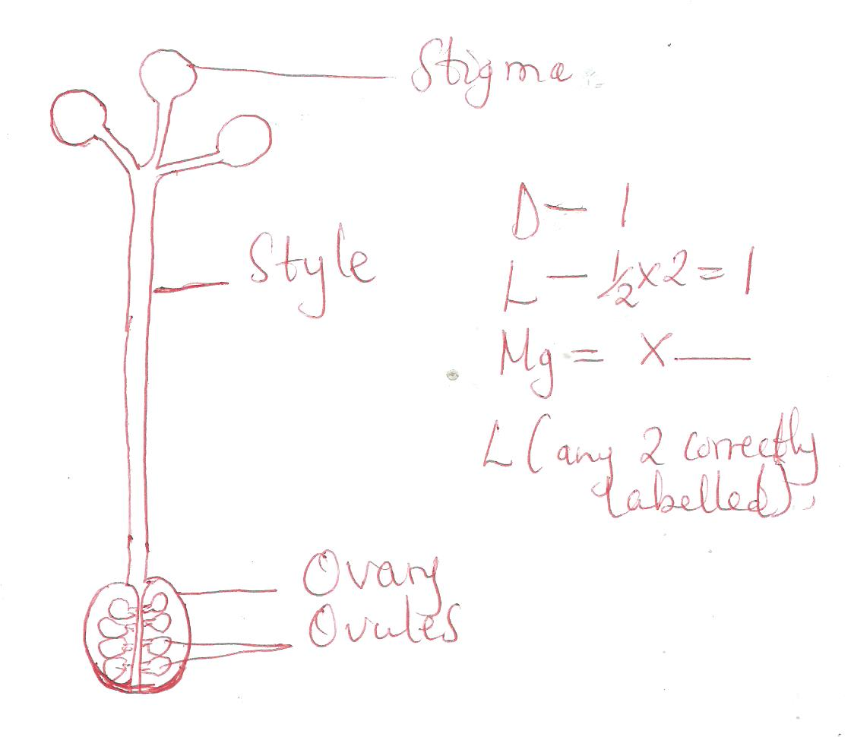
- The photographs below show an experiment that was set to investigate a certain response in bean seedlings. Examine them.

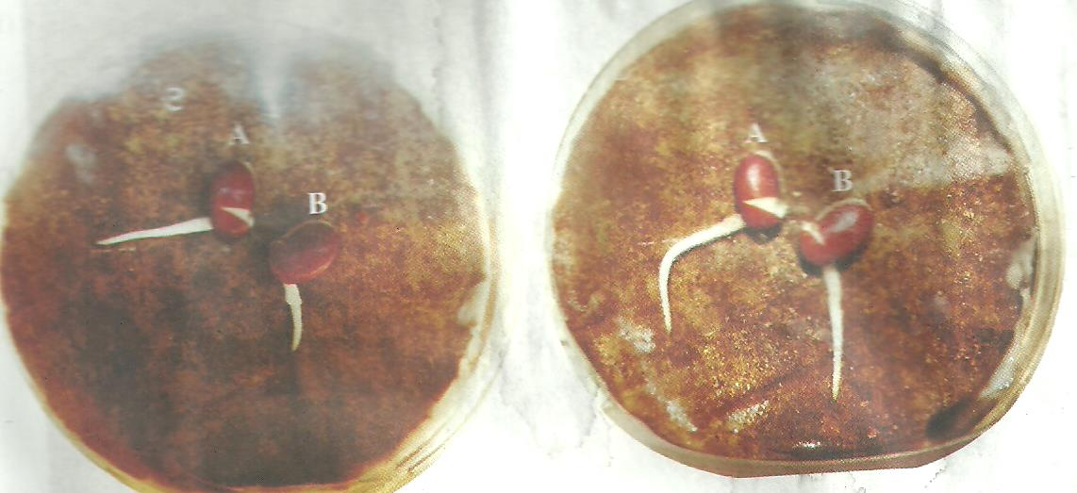
At the beginning after 24 hours

- Which response was being investigated? (1mk)
-------------------------------------------------------------------------------------------------------------------------------------------------------------------------------------------------------------
- Account for the observed results for seedling A after 24 hours. (5mks)
------------------------------------------------------------------------------------------------------------------------------------------------------------------------------------------------------------------------------------------------------------------------------------------------------------------------------------------------------------------------------------------------------------------------------------------------------------------------------------------------------------------------------------------------------------------------------------------------------------------------------------------------------------------------------------------------------------------------------------------------------------------------------------------------------------------------------------------------------------------------------------------------------------------------------------------------------------------------------------------------------------------------------------------------------------------------------------------------------------------------------------------------------------------------------------------------------------------------------------------------------------------------------------
- Explain why in seedling B the root continued growing straight down. (2mks)
--------------------------------------------------------------------------------------------------------------------------------------------------------------------------------------------------------------------------------------------------------------------------------------------------------------------
- Explain the significance of the response you stated in (a) above to the plant. (2mks)
---------------------------------------------------------------------------------------------------------------------------------------------------------------------------------------------------------------------------------------------------------------------------------------------------------------------
b) Below is a photograph of a mammalian bone, labelled Q. 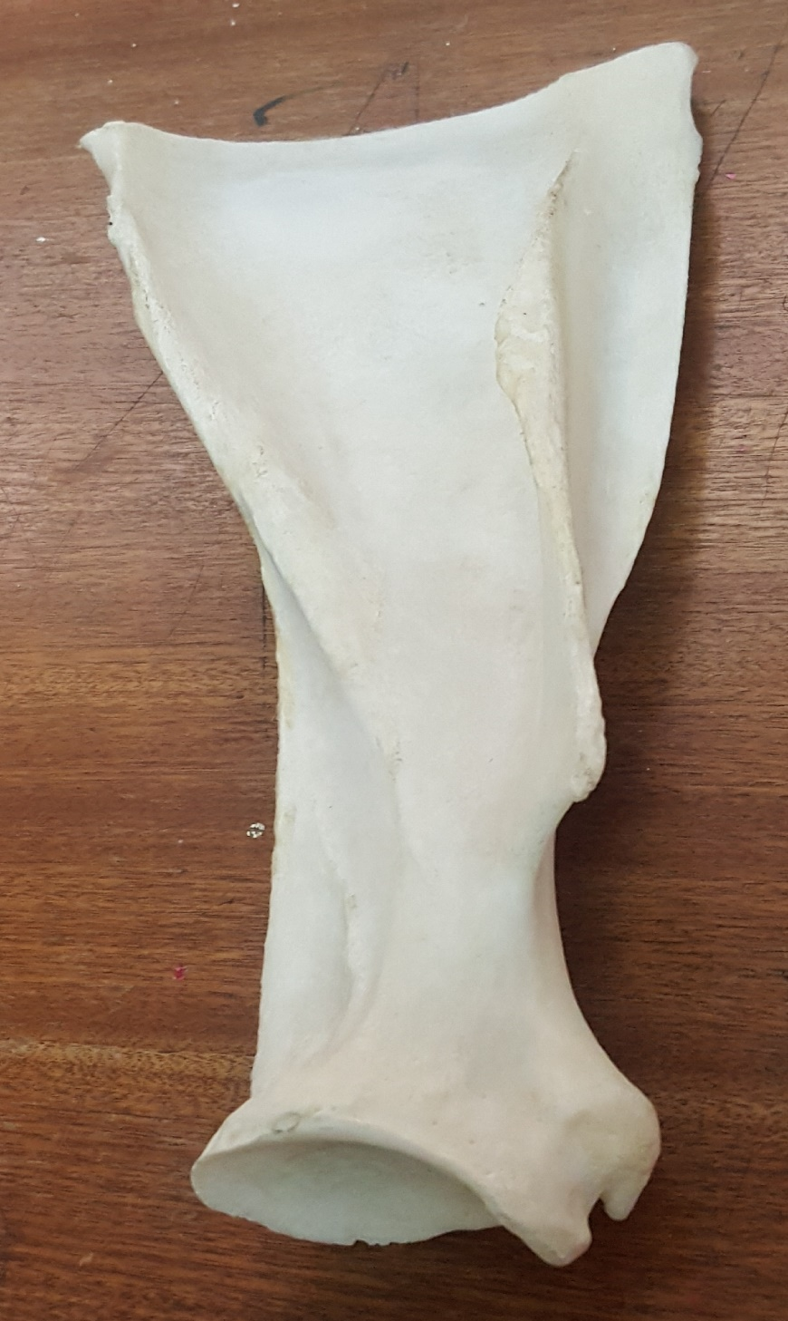
X

- Identify the bone (1mk)
-------------------------------------------------------------------------------------------------------------------------------------------------------------------------------------------

- State how the bone is adapted to its functions. (3mks)
--------------------------------------------------------------------------------------------------------------------------------------------------------------------------------------------------------------------------------------------------------------------------------------------------------------------------------------------------------------------------------------------------------------------------------------------------------------------------------------
- Name the bone that articulates with the bone Q at part labelled X. (1mk)
-------------------------------------------------------------------------------------------
- Name the specific type of joint formed at this articulation. (1mk)
--------------------------------------------------------------------------------------------------------------------------------------------------------------------------------------------

SUNSHINE SECONDARY SCHOOL

BIOLOGY PAPER 3
CONFIDENTIAL
JUNE 2017

REQUIREMENTS
- Test tubes in a rack 6
- 0.1% sodium chloride
- 1.4% sodium chloride
- 3 droppers
- White tile
- Iodine solution
- Benedicts solution
- Amylase / diastase enzyme labelled solution A
- Water bath
- Four labels
- Starch solution labelled solution C
- Thermometer
- Measuring cylinder
- A freshly picked hibiscus twig with a regular flower (should have flower and a leaf or two) labelled M
- Hand lens
- Scalpel

