Name:.................................................................................... Index No.: ........................................
Adm No:…………………………..
Candidate’s Signature: .................
Date: ................................................

233/1
CHEMISTRY
Paper 1
THEORY
JUNE 2017
Time: 2 hours

SUNSHINE SECONDARY SCHOOL
Kenya Certificate of Secondary Education
CHEMISTRY
Paper 1

Instructions to Candidates

- Write your name and index number in the spaces provided above.
- Sign and write the date of the examination paper.
- Answer ALL the questions in the spaces provided in the question paper.
- ALL working MUST be clearly shown where necessary.
- Mathematical tables and silent electronic calculators may be used.
- Candidates should check the paper to ascertain that all the pages are printed as indicated and that no questions are missing.

- Name the following apparatus and state their use (2mks)
- b)
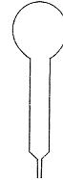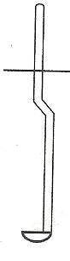
- --------------------------------------------------------------------------------------------------------------------------------------------------------------------------------------------------------------
- --------------------------------------------------------------------------------------------------------------------------------------------------------------------------------------------------------------
- The diagram below shows an experiment for investigating electrical conduction in lead (II) fluoride. Study it and answer the questions that follow.
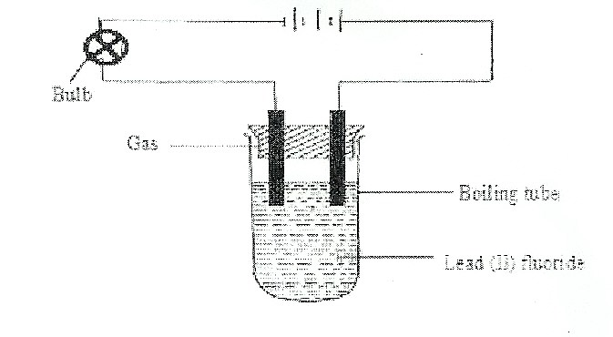
- Complete the diagram by indicating the condition that is missing and must be present for electrical conductivity to take place. (1mk)
------------------------------------------------------------------------------------------------------------------------------------------------------------------------------------------------------------------------
- State the observation made at the anode. (1mk)
-----------------------------------------------------------------------------------------------------------------------------------------------------------------------------------------------------------------------
- On the diagram show the direction of movement of electrons (1mk)

- Use the scheme below to answer the following questions
PbO
Gaseous mixture
Conc.H₂SO₄
Ethan -1,2 - dioic acid (H₂ C₂O₄)
Conc. KOH

E
Gas C

- Name the type of reaction which takes place between Ethan -1,2 – dioic acid and concentrated sulphuric (VI) acid (1mk)
……………………………………………………………………………………………………………………………………………………………………………………………..
- Why is the gaseous mixture passed through concentrated KOH. (1mk)
………………………………………………………………………………………………………………………………………………………………
- Write the equation for the reaction producing C and E (1mk)
………………………………………………………………………………………………………………………………………………………………
- Describe how you would prepare crystals of sodium sulphate starting with 200 cm³ of 2 M sodium hydroxide. (3mks)
……………………………………………………………………………………………………………………………………………………………………………………………………………………………………………………………………………………………………….....………………………………………………………………………………………………………………………………………………………………………………

- Using dots (.) and cross (X) diagrams show the bonding in the following;
- Phosphonium ion (PH₄⁺) ( P=15,H=1) (1mk)

- Compound formed between element A and B given the atomic numbers of
( A= 11,B = 8 ) (1mk)

- A sample of hydrogen chloride was dissolved in water to make 250 cm³ of a solution. 25cm³ of the solution required 1M sodium hydroxide for complete neutralization. Determine the mass of hydrogen chloride gas dissolved to make 250 cm³ of solution
(H = 1 ,Cl = 35.5) (3mks)

- Draw the structures of the following compounds. (2mks)
- Ethylbutanoate

- 3-ethyl – 3 – methyl hexane

- The structure below represents a portion of a polymer.
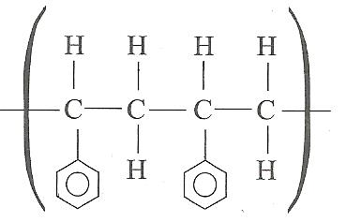

Draw the structure of the monomer and name it. (1mk)

- The apparatus below was set up to show the catalytic oxidation of ammonia. Study it and answer the questions that follow.
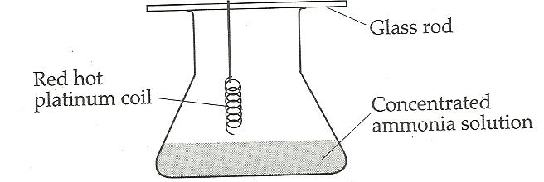
- State and explain two observations made in the above experiment. (2mks)
………………………………………………………………………………………………………………………………………………………………………………………………………………………………………………………………………………………………………………………………………………………………………………………………………………………………………………………………………………………………
- Write the equation for the reaction that took place during oxidation of ammonia. (1mk)
………………………………………………………………………………………………………………………………………………………………………………………………………………
- Write the formula of the complex ion formed when excess ammonia gas is passed through a solution containing Zn²⁺. (1mk)
………………………………………………………………………………………………………
- The molecular mass of water is 18 and that of hydrogen sulphide is 34. Boiling point of water is 100˚C and that of hydrogen sulphide is -61˚C . Explain the difference in the boiling point for the two compounds. (2mks)
……………………………………………………………………………………………………………………………………………………………………………………………………………………………………………………………………………………………………….....…………………………………………………………………………………………………………………………………………………………………………………………………
- When 0.11 mole of a certain hydrocarbon was burnt in oxygen,19.36 g of carbon(IV) and 5.94 g of water were formed. Determine the molecular formula of the hydrocarbon.
(C =12,O=16,H=1) (3mks)

- The diagrams below were used to investigate the effect of Sulphur (IV) oxide.
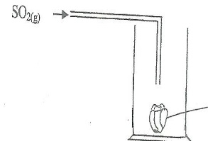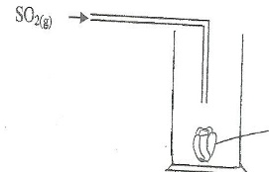
Red dry flower
Red fresh flower
State and explain the observations made in diagrams (I) and (II) (3mks)
……………………………………………………………………………………………………………………………………………………………………………………………………………………………………………………………………………………………………….....…………………………………………………………………………………...………………………………………………………………………………………………

- In the equation below identify the reagent that act as an acid and give a reason. (2mks)
H₂O_{(l)} + H₂O_{2(aq)} H₃O⁺_{(aq)} + HO_{2(aq)}
………………………………………………………………………………………………………………………………………………………………………………………………………………………………………………………………………………………………
13. A fixed mass of gas has a volume of 150 cm³ at 25 ˚C and 650 mmHg. Calculate the temperature at which the gas will have a volume of 75 cm³ and a pressure of 700 mmHg. (3mks)

- Below is a formula of a cleansing agent obtained from alkylcarboxylic acid H₃(CH₂)₁₅COONa. Would it be possible to use this cleansing agent to wash clothes containing a dissolved bleaching powder, calcium hypochlorite (CaOCl₂)? (2mks)
……………………………………………………………………………………………………………………………………………………………………………………………………………………………………………………………………………………………………….....…………………………………………………………………………………..
- In preparation of bleaching agent excess chlorine gas was bubbled into 15 litres of cold 2 M sodium hydroxide.
- Write an equation for the reaction between chlorine gas and cold dilute sodium hydroxide. (1mk)
…………………………………………………………………………………………………………………………………………………………………………………….
- Calculate the mass in kilograms of the bleaching agent formed. (2mks)

- Study the information in the table below and answer the questions that follow (The letters do not represent the actual symbols of the elements)
 |  | Ionization Energy_kJ/Mole
Element | Electronic configuration | 1st ionization energy | 2nd ionization energy
A | 2.2 | 900 | 1800
B | 2.8.2 | 736 | 1450
C | 2.8.8.2 | 590 | 1150

- What is ionization energy (1mk)
………………………………………………………………………………………………
………………………………………………………………………………………………………………………………………………
- Explain why the 2nd ionization energy is higher than the 1st ionization energy. (1mk)
………………………………………………………………………………………………………………………………………………………………………………………………………………………………………………………………………………………………
- An element K has relative atomic mass of 40.2. It has two isotopes of masses 39 and 42. Calculate the relative abundance of each isotope. (3mks)
- The equation below represents the contact process for the manufacture of Sulphuric (VI) acid.

2SO_{2(g)} + O_{2(g)} 2SO_{3(g)} H = -197 Kj/mol
K⁺_{(g)} + Cl⁻_{(g)}
Suggest two changes that can improve the yield of SO₃ (2mks)
………………………………………………………………………………………………………………………………………………………………………………………………………………………………………………………………………………………………

- In a experiment involving the reaction between magnesium and 1 M HCl, the volume (cm³) of hydrogen gas produced after t (seconds) was measured. The experiment was repeated using the same amount of magnesium reacting with 2 M HCl. On the axis below draw and label the two curves that would be obtained from the two experiments. (2mks)

Volume (cm³)

Time (sec)

- A radio isotope X decays by emitting two alpha (α) particles and one beta (β) particle to form ${}_{83}^{214}{Bi}$.

- What is the atomic number of X. (1mk)
………………………………………………………………………………………………………………………………………………………………………………………………………………………………………………………………………………………………
- After 112 days $1/{16}$ of the mass of X remained. Determine the half-life of X. (2mks)

- Use the equations below to answer questions that follow.
K⁺_{(g)} + Cl⁻_{(g)} KCl_{(s)} H₁ = -70kJ/mol
KCl_{(s)} K⁺_{(aq)} + Cl⁻_{(aq)} H₂ = +15kJ/mol
- What name is given to H₁ (1mk)
……………………………………………………………………………………………
- Calculate the heat change for the process (2mks)
H₂O
K⁺_{(g)} + Cl⁻_{(g)} K⁺_{(aq)} + Cl⁻_{(aq)}

- Use the diagram below to answer the questions that follow.
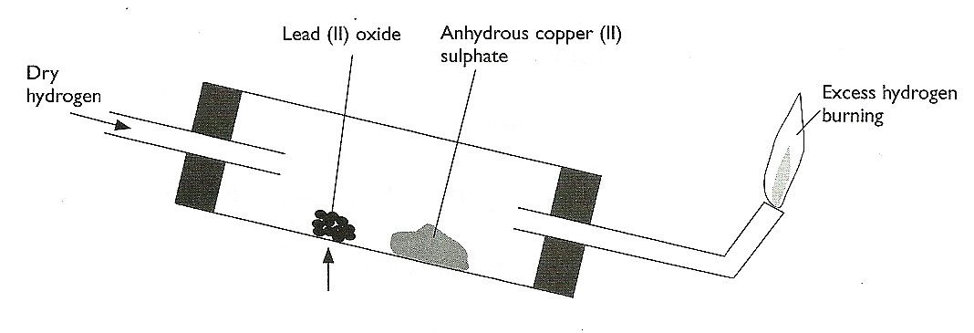

- After the experiment has been running for some time, record two major observations made in the tube. (2mks)
……………………………………………………………………………………………………………………………………………………………………………………………………………………………………………………………………………..
- Write an equation for the reaction that takes place in the dish containing lead (II) oxide. (1mk)
…………………………………………………………………………………………………………………………………………………………………………………….
- A piece of burning Sulphur was lowered into a gas jar filled with oxygen and containing aqueous litmus solution as shown.
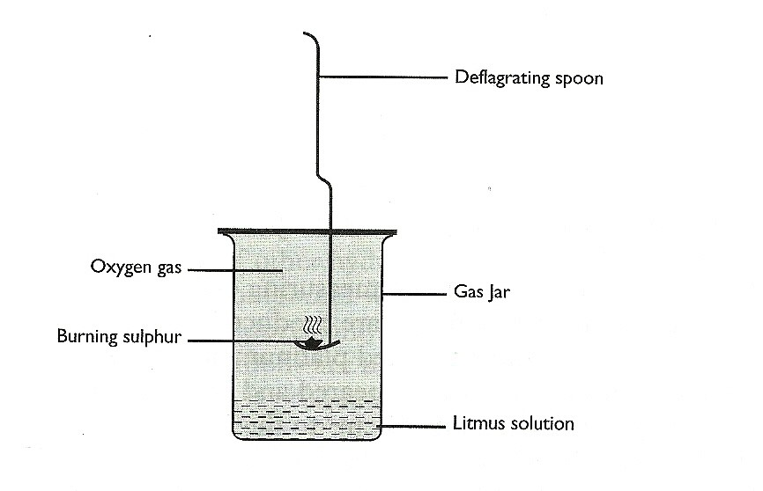
- State two observations made during the experiment. (2mks)
………………………………………………………………………………………………………………………………………………………………………………………………………………………………………………
- Write an equation for the burning of Sulphur in air. (1mk)
……………………………………………………………………………………………………………………………………………………………….
- A solution containing 9.2 g 0f solute A in 30 cm³ of water. When cooled, crystals begin to appear at 25˚C . Calculate the solubility of solute A at 25 ˚C. (2mks)

- The chromatogram below shows the constituents of flower extract using an organic solvent.

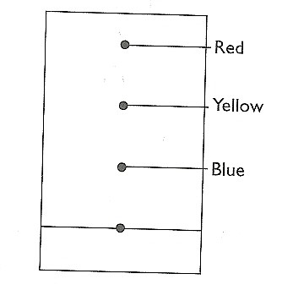
- Describe how you would obtain a solid sample of the red pigment. (2mks)
…………………………………………………………………………………………………………………………………………………………………………………………………………………………………………………………………………………………………………………………………………………………………………………..
- State one property that makes the red pigmet move the furthest. (1mk)
……………………………………………………………………………………………………………………………………………………………………………………….
- a) Name two ores of iron. (2mks)
……………………………………………………………………………………………………………………………………………………………………………………………………………………………………………………………………………………………...
b) Give the name of the suitable method used in extracting iron from the ore. (1mk)
………………………………………………………………………………………………………………………………………………………………................................................
- Name one impurity present in pig iron and state one effect of the impurity in the physical property of the physical properties of iron. (2mks)
…………………………………………………………………………………………………………………………………………………………………………………………

- Give a reason for the following safety precautions in the laboratory. (1mk)
- Why water should not be poured directly to concentrated sulphuric(VI)acid during dilution.
……………………………………………………………………………………………………………………………………………………………………………………..
- Why sodium metal should not be handled with bare hands.
……………………………………………………………………………………………………………………………………………………………………………………..

- Catalytic converters found in car exhaust system converts pollutant gases to relatively harmless gases.
- Name two pollutant gases and the harmless gases they are converted to. (2mks)
…………………………………………………………………………………………………………………………………………………………………………………………………………………………………………………………………………………………………………………………………………………………………………..
- Use the diagram below to answer the questions that follow.

- In which set – up will the iron – nail rust? Explain (2 mks)
………………………………………………………………………………………………………………………………………………………………………………………………………………………………………………………………………………………………………

- A group of students dissolved 20cm³ of 2M HCl in water and methylbenzene respectively.
The resulting solutions were shaken thoroughly and used for reactions with various reagents.

(a) Fill the table below with the correct observations that were made during the experiment.

 | Reagent | Solution of hydrogen chloride in water | Solution of hydrogen chloride in methylbenzene
(i) | Methyl orange | ( ½ mk) | ( ½ mk )
(ii) | Anhydrous sodium carbonate | ( ½ mk) | ( ½ mk)

(ii) Explain the difference in the observations made for the two solutions. (1 mk)
………………………………………………………………………………………………
…………………………………………………………………………………………………
…………………………………………………………………………………………………...

