Name: …………………………………………………………………………….. Class: ……………. Adm.No……………..

School: …………………………………………………………………………… Index No. ………………………………….. Sign :……………………………………………..

**233/2**

**CHEMISTRY**

**Paper 2**

**JUNE/JULY 2017**

**Time: 2 hours**

**MOI HIGH SCHOOL - KABARAK**

**Kenya Certificate to Secondary Education**

**CHEMISTRY PAPER 2**

**TIME: 2 HOURS**

**INSTRUCTIONS TO CANDIDATES**

* *Write your name, admission number, date and school in the spaces provided.*
* *Answer* ***all*** *the questions in the spaces provided.*
* *All working must be clearly shown where necessary.*
* *Scientific calculators may be used.*

**For examiners use only**

|  |  |  |
| --- | --- | --- |
| **Question number** | **Marks** | **Candidates score** |
| 1 | 10 |  |
| 2 | 12 |  |
| 3 | 12 |  |
| 4 | 13 |  |
| 5 | 12 |  |
| 6 | 10 |  |
| 7 | 12 |  |
| **Total** | **80** |  |

This paper consists of **16** printed pages. Candidates are advised to check and to make sure all pages are as indicated and no question is missing.

1. The table below gives several samples of mixtures. Study the table and answer the questions that follow

|  |  |  |  |
| --- | --- | --- | --- |
| **Mixture 1 components** | **Mixture 2 components** | **Mixture 3 components** | **Mixture 4 components** |
| Magnesium Sulphate | Water | Silver Chloride | Iron (III) Chloride |
| Water | Magnesium Sulphate | Lead Chloride | 1ron (III) Oxide |
| Silver Chloride | Magnesium Nitrate | water | - |

a). state **one** way in which the composition of a mixture differs from that of a compound (1mk)

………………………………………………………………………………………………………

……………………………………………………………………………………………………..

b) Describe how **Mixture 1** and **Mixture 2** can be separated into its components

1. Mixture **1** (2mks)

………………………………………………………………………………………………………

………………………………………………………………………………………………………

………………………………………………………………………………………………………

1. Mixture **2**  (2mks)

………………………………………………………………………………………………………

………………………………………………………………………………………………………

………………………………………………………………………………………………………

c). State the main property that makes components of **Mixture 3** separable (1mk)

………………………………………………………………………………………………………

d). Draw a well labeled diagram of a simple laboratory set up which can be used to separate the components of **Mixture 4** (2mks)

………………………………………………………………………………………………………

………………………………………………………………………………………………………

e). the chart below gives a summary of steps which can be used to separate the components of mixture 3. Study it and answer the questions that follow

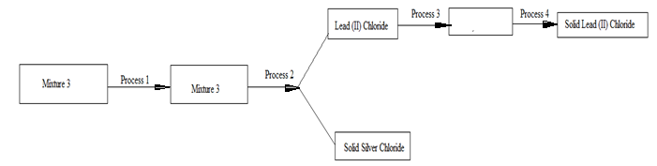

Identify the processes labeled 1,2,3,4

Process 1 ( ½mk)

………………………………………………………………………………………………………

Process 2 (½ mk)

………………………………………………………………………………………………………

Process 3 (½mk) ………………………………………………………………………………………………………

Process 4 (½mk) ………………………………………………………………………………………………………

2. Ethan dioic acid can be used in the laboratory preparation of Carbon (II) Oxide.

a). Name the other reagent and the condition required for the production of Carbon (II) Oxide

in this process.

1. Name of reagent (1mk)

………………………………………………………………………………………………………

1. Condition (1mk)

………………………………………………………………………………………………………

b) The volume of gas produced reduces when the gas is passed through an aqueous solution of

Potassium hydroxide

1. Explain why the volume reduces (1mk)

………………………………………………………………………………………………………

………………………………………………………………………………………………………

1. What will be the total volume of carbon (II) Oxide produced if 0.6moles of Ethan dioic acid is used in the reaction (all volumes measured at s.t.p, molar gas volume = 22.4dm3) (2mks)

………………………………………………………………………………………………………

………………………………………………………………………………………………………

………………………………………………………………………………………………………

iii). State two reasons as to why Carbon (II) Oxide is not easy to detect (1mk)

………………………………………………………………………………………………………

c). Using dots (●) and crosses (x) to represent electrons, show how bonding occurs

between Carbon and Oxygen in Carbon (II) Oxide (1mk) ………………………………………………………………………………………………………

………………………………………………………………………………………………………

d). i). Carbon (II) Oxide can be converted into Carbon (IV) Oxide, state one observation made

when Carbon (II) Oxide is being converted to Carbon (IV) Oxide (1mk)

………………………………………………………………………………………………………

ii). What is the role of carbon (IV) Oxide in the Solvay process (1mk)

………………………………………………………………………………………………………

iii). Besides Carbon (IV) Oxide, name another gaseous substance that is used in the

Solvay process (1mk) ………………………………………………………………………………………………

e). Sodium Carbonate is extracted from Trona which is a double salt with the formula

Na2CO3.NaHCO3.2H2O

i). write down a balanced equation to show how Sodium Carbonate is obtained from trona (1mk)

………………………………………………………………………………………………………

ii). State why trona is classified as a double salt (1mk)

………………………………………………………………………………………………………

3. a). A compound **D** of molar mass 88 was found to have the following composition by mass.

Carbon = 54.54 %, Hydrogen =9.09 % and the rest was Oxygen. Find the molecular formula

of the compound. (3mks)

……………………………………………………………………………………………………....

……………………………………………………………………………………………………....

……………………………………………………………………………………………………....

………………………………………………………………………………………………………

b). Draw the structural formula of compound **D** (1mk)

……………………………………………………………………………………………………....

c). Describe how compound **D** can be used to distinguish between Calcium Carbonate and

Calcium Sulphate (1mk)

……………………………………………………………………………………………………....

d). i). Name and give the molecular formula of the next member of the homologous series to

which compound **D** belongs (2mks)

……………………………………………………………………………………………………....

……………………………………………………………………………………………………....

e). compound **D** reacted with another compound with the formula NH2CONH2.

i). Name two by-products of the reaction (2mks)

……………………………………………………………………………………………………....

……………………………………………………………………………………………………....

ii). Draw the structural formula of the organic compound formed (1mk)

……………………………………………………………………………………………………....

f). About 5 cm3 of compound **D** was added into a boiling tube containing a mixture of distilled water and pentane. The mixture was shaken and then allowed to stand for about 2 hours. The figure below represents the set up at the end of the 2 hours.

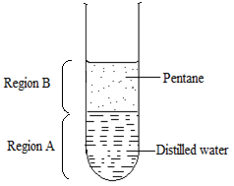

The PH of the liquid obtained from region **B** at the end of the experiment was found to be 7.0. Explain this observation (2mks)

……………………………………………………………………………………………………....

……………………………………………………………………………………………………....

4. Zinc metal can be extracted from its ores by reduction using carbon or through electrolytic

process.

a). Apart from Zinc blende, name another ore from which Zinc metal is extracted (1mk)

……………………………………………………………………………………………………....

b). In the electrolytic process, an electric current is passed through a series of cells containing

aqueous solution of pure Zinc Sulphate. The figure below represents one of the cells used in

the electrolytic process

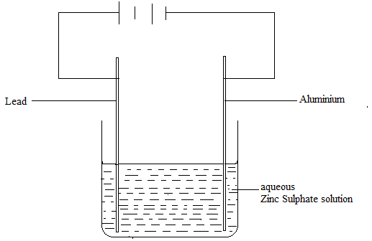

i). Write down a balanced equation of reaction that takes place at the:

Anode (1mk)

……………………………………………………………………………………………………....

Cathode (1mk)

……………………………………………………………………………………………………....

ii). Name one major by-product of this electrolytic process (1mk)

……………………………………………………………………………………………………....

iii). A current of 15 Amperes was passed through the cell for 24 hours and 16 minutes. Calculate the moles of the product at the cathode (I F=96500C) (2mks)

……………………………………………………………………………………………………....

……………………………………………………………………………………………………....

iv). State **one** environmental effect which can be associated with the extraction of Zinc

from its ores (1mk)

……………………………………………………………………………………………………....

c). The equation given below represents a redox reaction involving elements **X** and **Y**.

**Y2+** (aq) + **X** (s) **Y**(s) + **X2+** (aq)

i). with a reason, identify the reduced species (1mk)

……………………………………………………………………………………………………....

ii). Write down the cell representation for the cell that will formed between the two elements **X** and **Y (**1mk)

……………………………………………………………………………………………………....

iii). Draw an electrochemical cell involving the half cell of element **X** and the half cell of

Hydrogen (2mks)

……………………………………………………………………………………………………....

……………………………………………………………………………………………………....

……………………………………………………………………………………………………....

d). The reaction between Chlorine and aqueous Potassium Iodide can be resented as shown by

the equation below

Cl2 (g) + 2KI (aq)  2KCl (aq) + I2(s)

i). Explain why formation of Iodine is described as an Oxidation process (1mk)

……………………………………………………………………………………………………....

……………………………………………………………………………………………………....

5. The figure below represents trends of some properties of period three elements. Study it answer the questions that follow.

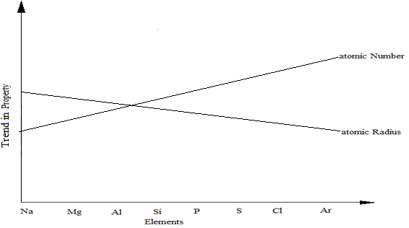

a). explain the trends shown by the atomic numbers and the atomic radii

i). Atomic number (1mk)

……………………………………………………………………………………………………....

ii). Atomic radii (2maks)

……………………………………………………………………………………………………....

……………………………………………………………………………………………………....

b). on the same axes, sketch the trend of reactivity across the period (1mk)

c). write down the electronic configuration of phosphorous and sulphur in the following compounds

i). H3PO4 (P=15) (1 mk)

……………………………………………………………………………………………………....

ii).Na2S2O3 (S=16) (1mk)

……………………………………………………………………………………………………....

d). i). One of the elements given in the figure above is stored under water. Identify the element

and give a reason as to why it is stored under water (1mk)

……………………………………………………………………………………………………....

……………………………………………………………………………………………………....

ii). State **one** use of aluminium that can be associated with its malleability (1mk)

……………………………………………………………………………………………………....

e). Explain the observation that would be made if the chloride of Phosphorous is exposed

to moist air (2mks )

……………………………………………………………………………………………………....

……………………………………………………………………………………………………....

f). distinguish between the terms electro negativity and electron affinity as used in chemistry (2mk)

……………………………………………………………………………………………………....

……………………………………………………………………………………………………....

6. A radioactive isotope of Uranium ${}_{92}^{238}{U }$ Undergoes decay by emitting a beta particle.

a). write down a balanced nuclear equation to show this decay process (1mk)

……………………………………………………………………………………………………....

b). i). The half life of Uranium -238 is 4.5 x109 years.

What is meant by the term half -life (1mk)

……………………………………………………………………………………………………....

……………………………………………………………………………………………………....

ii). A sample of Uranium with 720 radioactive atoms decayed for 22.5 x 109 years. On the grid provided, plot a graph of number of radioactive atoms of uranium -238 against time in years (3mks)



iii). Use the graph to determine the number of radioactive atoms when time is 16.0 x 10 9 years (1mk)

……………………………………………………………………………………………………....

c). Describe **two** ways in which a nuclear reactions differ from a chemical reaction (2mks) ……………………………………………………………………………………………………....

……………………………………………………………………………………………………....

d). Explain the source of electrons in a radioactive process (1mk)

……………………………………………………………………………………………………....

e). state one application of half life (1mk)

…………………………………………………………………………………………………...

7. In a class experiment to study the rate of reaction between Sodium Sulphite and dilute Hydrochloric acid, 1.26g of Sodium Sulphite was reacted with excess 2M Hydrochloric acid. The volume of Sulphur (IV) Oxide evolved was plotted against time as shown in the graph below.

a). Name one piece of apparatus that can be used to measure accurate volume of gas collected. (1mk)

……………………………………………………………………………………………………....

b). What volume of 1.5M Hydrochloric acid would be needed to produce 4.76 litre of Sulphur

(IV) Oxide (all volumes measured at r.t.p, molar gas volume = 24.0dm3) (2mks)

……………………………………………………………………………………………………....

……………………………………………………………………………………………………....

………………………………………………………………………………………………………

c). Use the graph to determine

i). The rate of production of gas at 120 seconds (2mks)

……………………………………………………………………………………………………....

……………………………………………………………………………………………………....

ii). the rate of production of gas between 30 seconds and 140 seconds (2mks)

……………………………………………………………………………………………………....

……………………………………………………………………………………………………

d). On the same axes, sketch the graph obtained if the experiment was repeated using 15 cm3 of

1.5M Hydrochloric acid. (1mk)

e). The reaction between Nitrogen and Hydrogen can be represented as shown in the energy

cycle given below

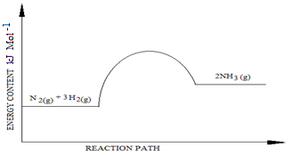

Explain how the yield of Ammonia would be affected if

i). Temperature was reduced (2mks)

……………………………………………………………………………………………………....

……………………………………………………………………………………………………....

ii). Pressure was increased (2mks)

……………………………………………………………………………………………………....

……………………………………………………………………………………………………....