312/1
GEOGRAPHY
Paper 1
JUNE 2017
Time: 2¾ hours

KASSU-JET JOINT EXAMINATION
Kenya Certificate of Secondary Education
312/1
Paper 1
GEOGRAPHY

INSTRUCTIONS TO STUDENTS

- This paper has two sections A and B
- Answer ALL the questions in section A. In section B answer questions 6 and any other TWO questions.

SECTION A
Answer all the questions in this section.
1. (a) Name any two constituents of the atmosphere. (2 marks)
(b) The diagram below represent the structure of the earth. Use it to answer the questions that follow.
L
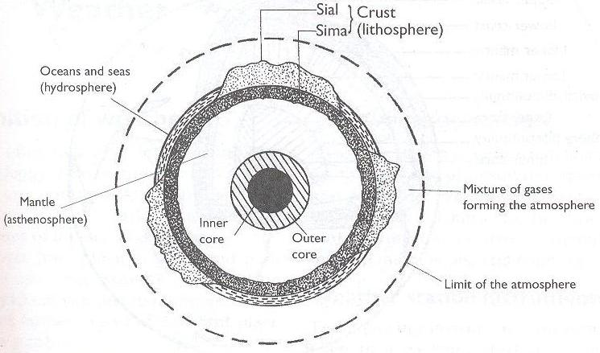
K
M
Name the parts markedK, Land M. (3 marks)
2. (a) State three characteristics of extrusive igneous rocks. (3 marks)
(b) Name the metamorphic equivalent of the following rocks. (2 marks)
- Peridotite
- Mud stone
3. Use the diagram below to answer the questions that follows.
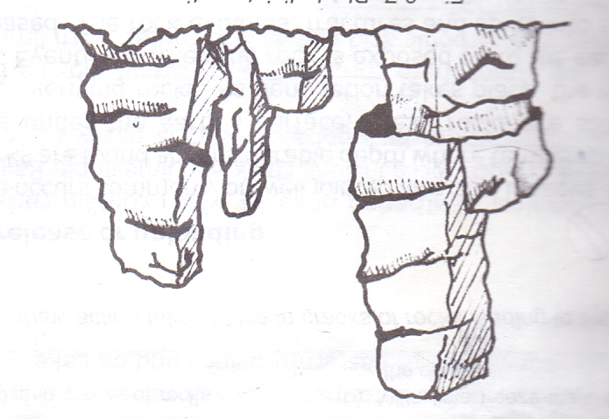
(a) Identify the weathering process shown above. (1 mark)
(b) Describe how rocks are weathered through the above process. (4 marks)
4. (a) Differentiate between till deposits and fluvio-glacial deposits. (2 marks)
(b) Describe how roche mountonee is formed. (4 marks)
5. (a) State two conditions which influence wind erosion. (2 marks)
(b) Name two features from water deposition in arid areas. (2 marks)
SECTION B
Answer question 6 and any other TWO questions from this section.
6. Study the map of Migwani 1:50,000 (sheet 151/1) provided and answer the questions that follow.
(a) (i) Give the six figure grid reference of Itoloni dam. (1 mark)
(ii) What is the bearing and direction of Muanzoa rock outcrop from Nzeluni school? (1 mark)
(iii) Give the position of Nzia hill by latitude and longitude. (2 marks)
(b) (i) Measure the distance of the All Weather Road loose surface from Migwani to the end in the North West near Thokoa. Give your answer in metres. (2 marks)
(ii) Calculate the area bounded by the dry weather road and the All Weather Road loose surface to the North West. (2 marks)
(c) (i) Name the three social functions of Migwani town. (3 marks)
(ii) Draw a sketch section along line JK. (2 marks)
On it, mark and name the following features:
- Dry weather road (1 mark)
- Steep slope (1 mark)
- Hill (1 mark)
(d) (i) Describe the relief of the area shown on the map extract. (5 marks)
(ii) Citing evidence from the map explain three factors that favour livestock keeping. (6 marks)
7. (a) (i) What is a weather station? (2 marks)
(ii) Explain two characteristics of Stevenson screen. (4 marks)
(b) (i) Describe how a hygrometer is used to measure relative humidity. (3 marks)
(ii) State two reasons why the recording of data at the school weather station may be inaccurate. (2 marks)
(iii) Give the reason why air cools as it rises. (2 marks)

(c) The graphs below shows climate characteristics of two stations in Africa. Use them to answer questions (i) and (ii).
GRAPH 1
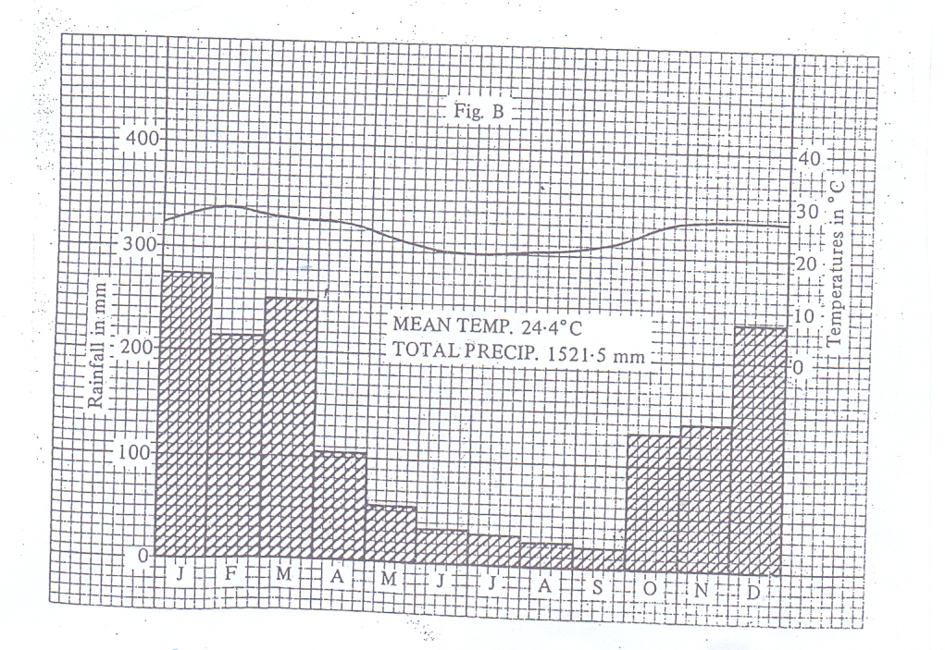
GRAPH 2
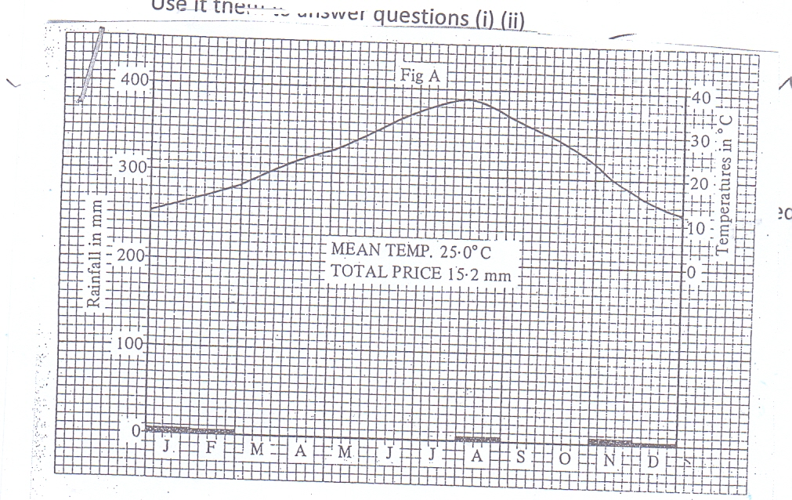
(i) Name the type of climate represented by each graph. (2 marks)
(ii) Describe the characteristics of the climate represented by each graph. (8 marks)
(iii) State two negative effects of desertification. (2 marks)
8. (a) Distinguish between orogenic and epeirogenic earth movements. (2 marks)
(b) Describe the origin of African plate according to the theory of continental drift. (4 marks)
(c) Explain how the following causes earth movement
- Convectional currents in the mantle (3 marks)
- Gravitative pressure (3 marks)
(d) State three factors influencing folding of sedimentary rocks. (3 marks)
(e) Identify the fold mountain ranges formed during the following orogenies.
- Alpine (1 mark)
- Hercynian (1 mark)
(f) With the aid of well labelled diagrams, describe how fold mountains are formed. (8 marks)
9. (a) Distinguish between river regime and river discharge. (2 marks)
(b) (i) State three factors influencing river transport. (3 marks)
(ii) Describe three processes through which a river transports its load. (6 marks)
(c) With the aid of a well labelled diagram, describe how a river braid is formed. (6 marks)
(d) Students of Sabaki Secondary School carried out a field study on river rejuvenation on River Athi.
(i) State three causes of river rejuvenation they found out. (3 marks)
(ii) Name three features formed by river rejuvenation they are likely to have identified. (3 marks)
(iii) Identify two problems they may have encountered during the field study. (2 marks)
10. (a) (i) What is soil? (2 marks)
(ii) Identify two components of soils. (2 marks)
(iii) Differentiate between soil structure and soil texture. (2 marks)
(iv) Nametwo types of soil according to soil texture. (2 marks)
(b) Explain how the following factors influence the formation of soil.
(i) Climate (2 marks)
(ii) Topography (2 marks)
(c) The diagram below shows a soil catena.

HILL TOP |  |  | VALLEY BOTTOM
W | X | Y | Z

(i) Name the type of soils found in position W and Z. (2 marks)
(ii) State two characteristics of soils found in section marked W and Z. (4 marks)
(d) Explain two causes of chemical soil degeneration. (4 marks)
(e) State three measures of conserving soils. (3 marks)

