Name……………………………………………….Adm No………..Class……
Index No……………………….. Signature…………………………

121/2
Mathematics Paper 2
June Exams
Form 4
2 ½ Hours
Term 2, 2017
MOI HIGH SCHOOL KABARAK
Kenya Certificate of Secondary Education (K.C.S.E)
INSTRUCTIONS TO CANDIDATES
- Write your name and Admission number in the spaces provided at the top of this page.
  - This paper consists of two sections: Section I and Section II.
  - Answer ALL questions from section I and ANY FIVE from section II
  - All answers and workings must be written on the question paper in the spaces provided
below each question.
  - Show all the steps in your calculation, giving your answer at each stage in the spaces
below each question.
  - Non – Programmable silent electronic calculators and KNEC mathematical tables may be
used, except where stated otherwise.

FOR EXAMINERS USE ONLY

SECTION I
1 | 2 | 3 | 4 | 5 | 6 | 7 | 8 | 9 | 10 | 11 | 12 | 13 | 14 | 15 | 16 | TOTAL

17 | 18 | 19 | 20 | 21 | 22 | 23 | 24 | TOTAL
SECTION II

GRAND TOTAL

SECTION I
(Answer all the questions in the spaces provided)
- Use tables of logarithms to evaluate (3marks)
$$\frac{4.28 X 0.01677}{tan {20}^{O}}$$

- All prime numbers between ten and twenty are arranged in descending order to form a number.
    - Write down the number. (1mark)

    - State the total value of the third digit of the number formed in (i) above. (1mark)

- The diagram below shows a sector of a circle centre O with arc AB=7 cm and subtends an angle of 1^{c} at the centre. Calculate the shaded area to 4 s.f. ( Take π$=\frac{22}{7}$ ). (3marks)
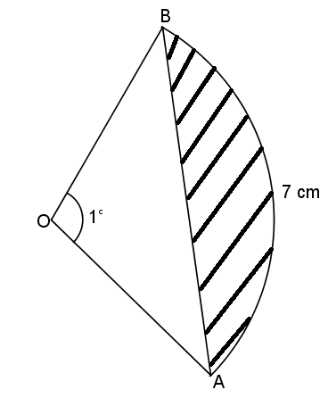

- Expand${ \left(1+\frac{1}{x}\right)}^{9}$ up to the term x³ hence use your expansion to find the estimate value of 100(1.05)⁹ correct to 4 significant figures. (4marks)

- In the figure below it shows a triangle ABC not drawn to scale. Calculate the value of b given that AB =240m $<BAC={30}^{0} and <ACB={45}^{0}$ (3marks)
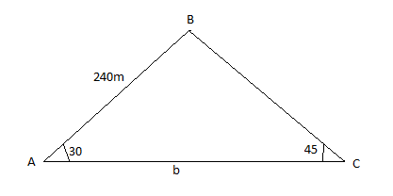

- Kipkemboi running at 10m/s starts 5 m ahead of Mutola who is running at 12m/s. How far from Kipkemboi’s starting point does Mutola overtake him? (3marks)

- Make L the subject given that H = $\sqrt{\left(\frac{3d \left(L-d\right)}{10L}\right)}$ (3marks)

- Without using a mathematical tables or calculators, simplify $\frac{3}{\sqrt{7}-\sqrt{2}}-\frac{2}{\sqrt{2}+\sqrt{7}}$ (3marks)

- The volume of cuboid A is 64 cm³ while that of a similar cuboid B is 8 cm³. If the width of cuboid A is 2 cm, find the width of cuboid B. (3marks)

- Show that 4y² + 4x² = 12x – 12y + 7 is the equation of a circle, hence find the co-ordinates of the centre and the radius. (3marks)

- The dimensions of a rectangle are given as 4.1cm by 2.8cm. Calculate the relative error in the area. (3marks)

- If $2.\dot{5}×0.\dot{4}\dot{5}=\frac{a}{b}$ where a and b are in their simplest forms. Find the values of a and b.
(3marks)

- The seventh term of an arithmetic sequence is 17, three times the third term is 3. Calculate the first term and the common difference of the sequence. (3marks)

- At the start of the 1st year, Mr Chepyator, deposited Ksh. 180,000 in a bank which gives an interest of 12% p.a, compounded quarterly. Find the interest earn by Mr. Chepyator at the start of the 4rd year. (3marks)

- A quantity P varies partly as n and partly as the square of n. When P= -3, n= -1 and
when P= 18, n=2. Find P when n =1 (3marks)

- Find the inverse of $\left(\begin{aligned}5 -2 \\ 2 -1\end{aligned}\right)$ hence find the point of intersection of the lines whose equations are (4marks)
$5x – 2y = 5$
$y= 2x – 3$

SECTION II
(Answer ANY FIVE questions in the spaces provided)

- In the cuboid below, AB = 8cm, BC = 6cm, AE = 4cm
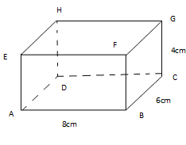
Calculate,
- The length BD (2marks)

- The angle which BH makes with the plane ABCD. (2marks)

- The angle between EC and the plane ADHE (2marks)

- The angle between EA and AG (2marks)

e) The angle between planes ABCD and EBCH (2marks)

- There are 2 bags A and B. Bag A has 4 white balls and 6 red balls. Bag B has 2 white balls and 3 red balls. Each bag has an equal chance of being picked. If a bag is selected randomly and 2 balls picked with replacement in bag A and without replacement in bag B. Find the probability that:
- They are both white. (2marks)

- They are of different colours. (3marks)

- At least one ball is red. (2marks)

- None of the balls is white. (3marks)

- The table below shows marks obtained by form three students in Kiswahili third term exam.
Marks | 20-25 | 26-30 | 31-39 | 40-45 | 46-51 | 52-59 | 60-68 | 69-75 | 76-80
Frequency | 2 | 8 | 14 | 24 | 30 | 20 | 10 | 8 | 4

- Calculate the mean (2marks)

- Draw an ogive (3marks)

- From the ogive curve in (b) above
- estimate the median. (1mk)

- estimate the quartile deviation. (2mark)

- if 40% of the students are to pass, determine the pass mark (2marks)
- (a) Integrate the function $y=(x-1)(x-3)$ (2marks)

(b) Find the exact area bounded by the curve$y=(x-1)(x-3)$, y-axis, x-axis and the line $x=3$ (3marks)

(c) Use trapezium rule with three trapezia to estimate the area bounded by the curve
$y=(x-1)(x-3),$ y-axis, x-axis and the line $x=3.$ (3marks)

- Calculate the percentage error introduced by using the trapezium rule in (c) above.(2marks)

- Triangle ABC has A(1,4), B(1,1) and C(3,3). Draw $△$ABC on the grid provided.(1 mark

- $△$ ABC is reflected in the line x = 0 to give $△$ A₁ B₁ C₁. Draw $△$A₁ B₁ C₁ on the same grid and state its coordinates. (3marks)

- $△$A₂B₂C₂ is the image of $△$A₁B₁C1 under a stretch with x- axis invariant and scale factor 2. Determine the coordinates of $△$A₂B₂C₂ and draw it on the same grid. (3 marks)

- A₃(-1,7) and B₃(-1,1) are the images of A₂ and B₂ respectively under a shear with y-axis invariant. Determine the coordinates of C₃ and draw$△$ A₃B₃C₃ on the same grid. (3 marks)

- Use a pair of compass and ruler only in this question
a) Construct a parallelogram ABCD in which AB = 6cm, AD = 4cm and angle BAD = 60º
(3marks)
b) Measure the length AC (1mark)

c) Show the locus of point P which moves so that it is equidistant from A and C (3marks)
d) The locus of point Q which moves so that angle BQD = 90º (3marks)

- A plane leaves an airport P (10⁰S, 62⁰E) and flies due north at 800km/h.
(a) Find its position after 2 hours (3marks)

(b) The plane turns and flies at the same speed due west. It reaches longitude Q, 12⁰W.
(i) Find the distance it has traveled in nautical miles. (3marks)

(ii) Find the time it has taken (Take $π=\frac{22}{7}$, the radius of the earth to be 6370km and 1 nautical mile to be 1.853km) (2marks)

(c)If the local time at P was 1300 hours when it reached Q, find the local time at Q when it landed at Q (2mks)

24 In the figure below AB and AC are tangents to the circle center O at B and C respectively, the angle AOC = 60⁰, radius of the circle 5cm.
•
60⁰
B
A
C
O

Calculate;
a) The length of AC (2marks)

b) The area of triangle OAC (2marks)

c) The area of minor sector COD (2marks)

d) The area of the shaded region (4marks)

