SUNSHINE SECONDARY SCHOOL
232/2
PHYSICS
PAPER 2
June 2017
2 hours
Name...................................................................................Index Number......................../............
Admission Number.Class: ……....Candidate’s Signature....................Date...............
INSTRUCTIONS TO CANDIDATES
- Write your name, admission number and index number in the spaces provided above.
- Sign and write the date of examination in the spaces provided above
- This paper consists of TWO sections A and B
- Answer ALL the questions in section A and B in the spaces provided
- All working MUST be clearly shown
- Electronic calculators and mathematical tables may be used.
- ALL numerical answers must be expressed in decimal notation.
- This paper has 15pages. It is the responsibility of the candidate to ascertain that all the pages are printed as indicated and that no questions are missing.
- Candidates should answer the questions in English.
For Examiners Use Only

Section | Question | Maximum Score | Candidate’s Score
A | 1 – 13 | 25
B | 14 | 10
 | 15 | 08
 | 16 | 09
 | 17 | 10
 | 18 | 10
 | 19 | 08
TOTAL |  | 80

SECTION A (25 marks)
Answer ALL the questions in this section in the spaces provided.

1. Figure 1 shows a current-carrying conductor AB in a magnetic field..

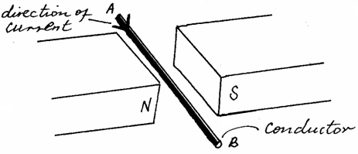

Figure 1

- Indicate the direction of force F acting on the conductor. (1mark)

- State one factor that determine the magnitude of the force F other than current. (1mark)

…………………………………………………………………………………………………………………………………………………………………………………………
2. A girl standing at a distance claps her hands and hears an echo from a tall building 2 seconds later. Determine how far the building is. (Take the speed of sound in air =340m/s) (2marks)

………………………………………………………………………………………………………………………………………………………………………………………………………………………………………………………………………………………………………………………………………………………………………………..…
3. State two ways in which one can increase the strength of an electromagnet. (2 marks)

…………………………………………………………………………………………………………………………………………………………………………………………
4. Figure 2 show two mirrors inclined at 60º to each other.
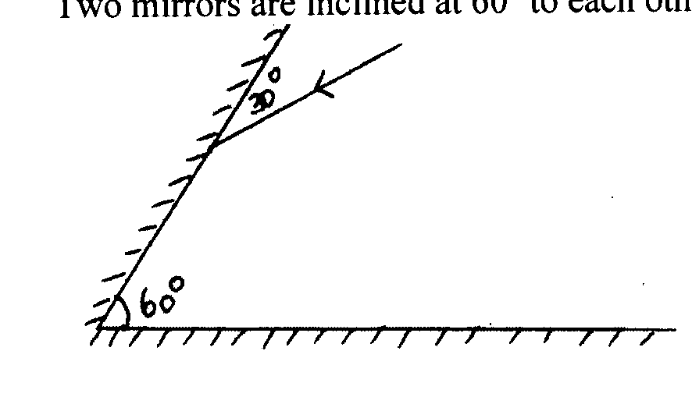

Figure 2
Complete the ray diagram to show how it travels after striking the two mirrors and find the angle of reflection on each surface. (2marks)

5. An electric heater rated 240V, 3000W is to be connected to a 240V mains supply through a 10A fuse. Determine whether the fuse is suitable or not. (3 marks)

……………………………………………………………………………………………………………………………………………………………………………………………………………………………………………………………………………………………………………………………………………………………………………………
6. State the reason why long distance power transmission is done at a very high
voltage. (1 mark)
…………………………………………………………………………………………………………………………………………………………………………………………………………………………………………………………………………………………………..…
7. One of the defects of a simple cell is local action. Explain how this defect is minimized
(1mark)
……………………………………………………………………………………………………………………………………………………………………………………………………

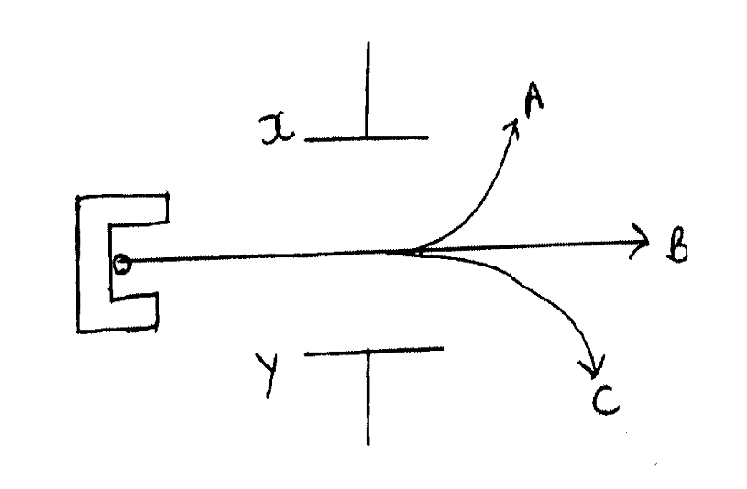8. Figure 3 shows paths taken by three radiations A,B and C from a radioactive isotope through an electric field.
X
A
B
C
Y

Figure 3

(i) State the charge on plate Y (1mark)

…………………………………………………………………………………………
(ii) Identify the radiation B (1mark)
…………………………………………………………………………………………………………………………………………………………………………………………
(iii) Give a reason why A deviates more than C (1mark)
……………………………………………………………………………………………………………………………………………………………………………………..…
9. A wave travels across water at a particular place with a velocity of 2m/s, period 0.15s and amplitude 0.2cm.
(i) Determine the frequency of the wave. (1mark)

…………………………………………………………………………………………………………………………………………………………………………………..……

(ii) Determine the wavelength of the wave. (1mark)

………………………………………………………………………………………………………………………………………………………………………………………………………………………………………………………………………………………
(iii) Using a suitable scale, sketch a complete diagram of the displacement – time graph (1mark)

……………………………………………………………………………………………………………………………………………………………………………………………………………………………………………………………………………………………………………………………………………………………………………………
10. Figure 4 shows two parallel magnets with unlike poles adjacent to each other. Sketch the magnetic field pattern around the magnets (1mark)

S N

N S

Figure 4

11. Give a reason why diffraction of light is not a common phenomenon in everyday life.
(1mark)
……………………………………………………………………………………………………………………………………………………………………………………………………

12. Figure 5 shows an object placed in front of a concave mirror. By use of correct ray diagram, locate the position of image. (2 marks)

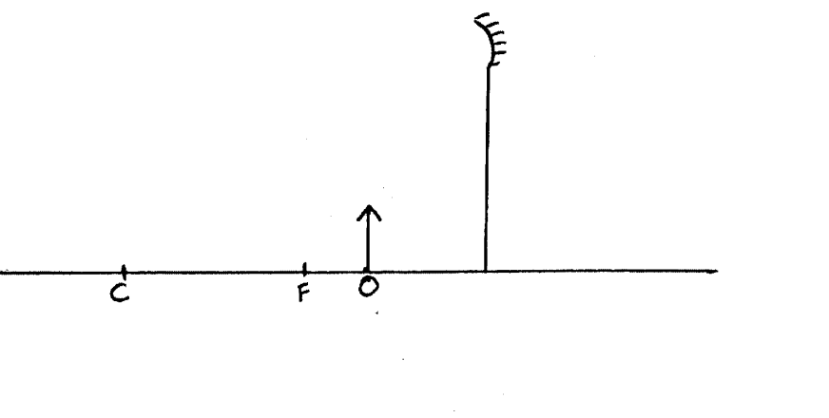

Figure 5

13. (i)An uncharged metal rod close but not touching the cap of a charged electroscope causes a decrease in the divergence of the leaf. Explain. (1mark)
………………………………………………………………………………………………………………………………………………………………………………………………………………………………………………………………………………………
(ii) Figure 6 shows a capacitor connected to a battery such that the plates P and R acquire the charges shown.

P R
+ -
+ -
+ -
+ -
+ -

Battery

Figure 6

Indicate on the diagram (with an arrow), the direction of the flow of electrons during the process of charging (1mark)
SECTION B (55 marks)
Answer ALL the questions in this section in the spaces provided.

14. a) State Lenz’s a law of electromagnetic induction. (1mark)

…………………………………………………………………………………………………………………………………………………………………………………………
…………………………………………………………………………………………………………………………………………………………………………………………
b) Figure 7 shows a bar magnet moved into a coil of insulated copper wire connected to a centre-zero galvanometer.

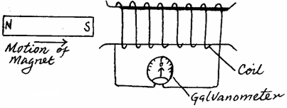

Figure 7

Show on the diagram the direction of induced current in the coil. (1mark)

(c) A transformer with 2000 turns in the primary circuit and 150 turns in the secondary circuit has its primary circuit connected to a 800Va.c. source. It is found that when a heater is connected to the secondary circuit it produces heat at the rate of 1000W. Assuming 100% efficiency, determine the:
(i) voltage in the secondary circuit. (2 marks)
……………………………………………………………………………………………………………………………………………………………………………………………………………………………………………………………………………………………………………………………………………………………………………………
(ii) current in the primary circuit. (2 marks)

……………………………………………………………………………………………………………………………………………………………………………………………………………………………………………………………………………………………………………………………………………………………………………………
(iii) current in the secondary circuit. (1 mark)

……………………………………………………………………………………………………………………………………………………………………………………………………………………………………………………………………………………………………………………………………………………………………………………
(d) Determine the cost of using the following appliances in one month (30 days) given that the cost of electricity is Ksh.9.50 per kWh.
I A 2000W water heater for 2 hours per day.
II A 75W bulb for 10 hours per day.
III A 1500W electric iron for 1 hour per day. (3 marks)

…………………………………………………………………………………………………………………………………………………………………………………………………………………………………………………………………………………………………………………………………………………………………………………………………………
……………………………………………………………………………………………………………………………………………………………………………………………………
15. a) (i)State the purpose of cooling fins in the X-ray tube. (1 mark)

…………………………………………………………………………………………………………………………………………………………………………………………
(ii) The accelerating potential of a certain X-tube is decreased. State the change observed on the X-rays produced. (1 mark)

…………………………………………………………………………………………………………………………………………………………………………………………

b) State one difference between X-rays and cathode rays. (1 mark)

…………………………………………………………………………………………………………………………………………………………………………………………………………………………………………………………………………………………………………………………………………………………………………………………………………
c) Figure 8 shows a simple cathode ray tube.
Electron
gun
Y
X
Y
X
Fluorescent screen
gun

Figure 8

(i) Explain how the electrons are produced in the tube. (2 marks)

…………………………………………………………………………………………………………………………………………………………………………………………………………………………………………………………………………………………………………………………………………………………………………………………………………
(ii) State one function of the anode. (1 mark)

……………………………………………………………………………………………………………………………………………………………………………………………………

(iii) At what part of the cathode ray tube would the time base be connected? 1 mark)

…………………………………………………………………………………………………………………………………………………………………………………………
(iv)Why is a vacuum created in the tube? (1 mark)

…………………………………………………………………………………………………………………………………………………………………………………………

16. (a) A cell drives a current of 5A through a 1.6Ω resistor. When connected to a 2.8Ω resistor, the current that flows in 3.2A. Determine electromotive force E and internal resistance r of the cell. (3 marks)

………………………………………………………………………………………………………………………………………………………………………………………………………………………………………………………………………………………………………………………………………………………………………………………………………………………………………………………………………………………………………..…
(b) Determine the length of a nichrome resistance wire of cross-sectional area 7 ×10ˉ⁸m² required to make a resistor of 10Ω. (Take resistivity of nichrome = 1.10 × 10ˉ⁶Ωm). (2 marks)

…………………………………………………………………………………………………………………………………………………………………………………………………………………………………………………………………………………………………………………………………………………………………………………………………………

- Figure 9 shows a current of 2A through 10 Ω resistor. Determine the value of
resistor R. (2 marks)
2A
3A
10Ω
R

Figure 9

……………………………………………………………………………………………………………………………………………………………………………………………………………………………………………………………………………………………………………………………………………………………………………………
d) The amount of current flowing through a conductor in 2.5 minutes is 2.0A. Determine the quantity of charge. (2 marks)
……………………………………………………………………………………………………………………………………………………………………………………………………………………………………………………………………………………………………………………………………………………………………………………
17. a)Define photoelectric emission. (1mark)

……………………………………………………………………………………………………………………………………………………………………………………………………………………………………………………………………………………………………………………………………………………………………………………

(b) Figure 10 shows ultraviolet light striking a clean zinc plate on a positively charged leaf electroscope.

Figure 10

Explain why the leaf does not fall. (2marks)

…………………………………………………………………………………………………………………………………………………………………………………………………………………………………………………………………………………………………………………………………………………………………………………………………………

c) A certain metal has a work function of 2.3eV. (Take 1eV = 1.6 × 10⁻¹⁹ J, Planck’s constant h = 6.63 × 10⁻³⁴Js, and velocity of light in vacuum C = 3.0 × 10⁸m/s ) determine:
(i) its threshold frequency. (2marks)

…………………………………………………………………………………………………………………………………………………………………………………………………………………………………………………………………………………………………………………………………………………………………………………………………………

(ii) the maximum kinetic energy of the photoelectrons produced when the metal is illuminated by light of wavelength 5.0 × 10⁻⁷m. (3marks)
………………………………………………………………………………………………………………………………………………………………………………………………………………………………………………………………………………………………………………………………………………………………………………………………………………………………………………………………………………………………….………..
(d) The chart below shows an arrangement of different parts of the electromagnetic spectrum.

Radio wave | A | B | Visible light | C | D | Gamma Rays

(i) Name the radiation represented by C. (1 mark)

…………………………………………………………………………………………………
(ii)Name a device that can be used to detect radiation A. (1 mark)

……………………………………………………………………………………………
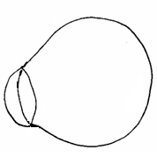
18. (a) Figure 11 shows a diagram of the human eye.

Figure 11
Sketch a ray diagram to show long sightedness. (1 mark)

(b) An object placed 10cm from a convex lens is magnified three times. Determine the focal length of the lens. (4 marks)
……………………………………………………………………………………………………………………………………………………………………………………………………………………………………………………………………………………………………………………………………………………………………………………………………..…

(c) (i) Figure 12 shows a ray of light travelling between water-glass interface.
Water

Glass
i
28º

Figure 12

Determine the value of i given that _{a}n_{g}=1.52 and _{a}n_{w} =1.33. (3 marks)
…………………………………………………………………………………………………………………………………………………………………………………………………………………………………………………………………………………………………………………………………………………………………………………………………………
(ii) State two conditions for total internal reflection to occur. (2 marks)

………………………………………………………………………………………………………………………………………………………………………………………………………………………………………………………………………………………
……………………………………………………………………………………………
19. (a) Define doping (1mark)

………………………………………………………………………………………………………………………………………………………………………………………………………………………………………………………………………………………………………

(b) Differentiate between a p-type and n-type semi conductors in terms of charge carriers. (2marks)
…………………………………………………………………………………………………………………………………………………………………………………………………………………………………………………………………………………………………………………………………………………………………………………………………………
(c) Explain what happens to the depletion layer when a diode is reverse biased. (2 marks)

………………………………………………………………………………………………………………………………………………………………………………………………………………………………………………………………………………………………………
- Figure 13 shows a circuit with two diodes A and B and a battery.
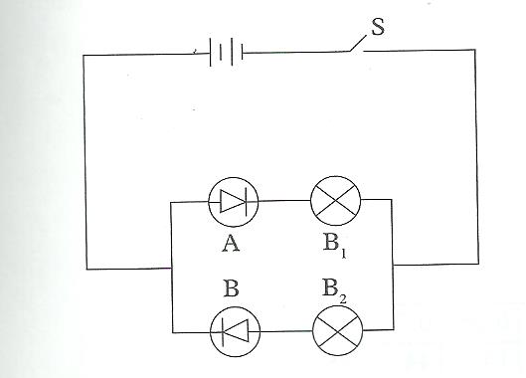
Figure 13
State with reason the observation made when S is closed. (2 marks)
………………………………………………………………………………………………………………………………………………………………………………………………………………………………………………………………………………………………………
- Name one application of diodes. (1 mark)
…………………………………………………………………………………………………
THIS IS THE LAST PRINTED PAGE

