**THE 2017 K.C.S.E CONTINUOUS ASSESSMENT EXAMINATION**

Kenya Certificate of Secondary Education.

**233/2 FORM FOUR PREMOCK EXAMINATIONS**

**CHEMISTRY PAPER 2 MARCH/APRIL 2017**

**TIME: 2 HOURS**

**Instructions to Candidates**

Answer **all** questions

**Advice to Candidates**

Candidates may be penalized for writing irrelevant information, wrong spelling especially of technical terms.

**Information to Candidates**

Marks for individual questions are indicated in round brackets. The total mark for this paper is80.

This paper consists of **14 printed** pages. *Candidates to ascertain that* ***all*** *pages are printed as indicated***.**

**For examiners Use only**

|  |  |  |
| --- | --- | --- |
| **Question** | **Score** | **Candidates Score** |
| **1** | **12** |  |
| **2** | **13** |  |
| **3** | **12** |  |
| **4** | **07** |  |
| **5** | **12** |  |
| **6** | **11** |  |
| **7** | **13** |  |
| **Total** | **80** |  |

**Candidates Name: ………………………………………………….….Adm. No:……………………………**

School: …………………………………...Date Done: …………...Returned: …………….Revised:…………

Teachers Remarks:………………………………………………………………………………………………...

**R**

**9**

**7**

**8**

**9**

**9**

**6**

**6**

**7**

**5**

**6**

**8**

**9**

**3**

1. a)The table below shows the elements in the same group of the periodic table and

their average atomic radii, measured in the usual atomic measurements. The symbols do not represent the 1. Use the diagram below to answer the questions that follow.( the letters below do not represent the actual symbols of the elements.

|  |  |
| --- | --- |
| Element | Atomic radius |
| P | 0.18 |
| Q | 0.22 |
| R | 0.14 |

(i) If the elements are in group 1, which element would most likely be potassium? (1 mark)

--------------------------------------------------------------------------------------------------------------------------------------------------------------------------------------------------------------------------------------

(ii) Using the letters given, which element has the highest ionisation

energy? Give a reason for your answer (1 mark)

--------------------------------------------------------------------------------------------------------------------------------------------------------------------------------------------------------------------------------------

b) The table below shows some properties of substances V, W, X and Z. Study them and answer the questions that follow. Letters do not represent the actual symbols of the substances.

|  |  |  |  |  |
| --- | --- | --- | --- | --- |
| **Elements** | **Solubility in Water** | **Boiling Point** | **Electrical conductivity** | |
| **V** | Insoluble | 2955 | Good | Good |
| **W** | Soluble | 1413 | Poor | Good |
| **X** | Insoluble | -90 | Poor | Poor |
| **Z** | Insoluble | 4827 | Poor | Poor |

(i) Which substance is likely to have giant atomic structure? Explain. (2 marks)

---------------------------------------------------------------------------------------------------------------------------------------------------------------------------------------------------------------------------------------------------------------------------------------------------------------------------------------------------------

(ii) Identify the particles responsible for conduction of electricity in V in solid and in molten states.

Solid state____________________________________ (1 mark)

Molten_______________________________________ (1 mark)

(iii) Which substance has electrovalent bond? Explain (1 mark)

--------------------------------------------------------------------------------------------------------------------------------------------------------------------------------------------------------------------------------------

(iv) Which substance is a gas at room temperature. Explain. (1 mark)

--------------------------------------------------------------------------------------------------------------------------------------------------------------------------------------------------------------------------------------

c) The table below shows some properties of halogens. Use it to answer the questions below.

|  |  |  |  |
| --- | --- | --- | --- |
| **Halogen** | **Atomic radius (nm)** | **Appearance** | **Boiling point (0C)** |
| Fluorine | 0.064 | Pale - yellow gas | - 188 |
| Chlorine | 0.094 | Greenish - yellow gas | - 35 |
| Bromine | 0.114 | Brown liquid | 59 |
| Iodine | 0.133 | Shiny dark solid | 184 |

(i) State and explain the trend in boiling points down the group (2 marks)

---------------------------------------------------------------------------------------------------------------------------------------------------------------------------------------------------------------------------------------------------------------------------------------------------------------------------------------------------------

(ii) State what would be observed when bromine water is added to

potassium iodide solution. (1 mark)

-------------------------------------------------------------------------------------------------------------------------------------------------------------------------------------------------------------------------------------

(iii) Give a reason why iodide sublimes. (1 mark)

--------------------------------------------------------------------------------------------------------------------------------------------------------------------------------------------------------------------------------------

2. A form two student was asked to prepare a sample of copper (II) sulphate crystals using the procedure below.

* Measure 100cm3 of 2M sulphuric (VI) acid then warm. Add excess copper (II) oxide powder.
* Filter the resulting mixture.
* Heat the filtrate and leave it overnight.

1. Why was the acid heated before the start of the reaction? (1 mark)

------------------------------------------------------------------------------------------------------------------------------------------------------------------------------------------------------------------------------------------------------------

1. Why was excess copper (II) oxide used. (1 mark)

------------------------------------------------------------------------------------------------------------------------------------------------------------------------------------------------------------------------------------------------------------

1. What was observed when copper (II) oxide was added to the warm acid? (2 marks)

------------------------------------------------------------------------------------------------------------------------------------------------------------------------------------------------------------------------------------------------------------------------------------------------------------------------------------------------------------------------------------------

1. Write and equation for the reaction that took place in (c) above. (1 mark)

------------------------------------------------------------------------------------------------------------------------------------------------------------------------------------------------------------------------------------------------------------

1. Give reasons for carrying out the following processes.
2. Filtration of the mixture. (1 mark)

--------------------------------------------------------------------------------------------------------------------------------------------------------------------------------------------------------------------------------------

1. Heating the filtrate and leaving it overnight. (2 marks)

---------------------------------------------------------------------------------------------------------------------------------------------------------------------------------------------------------------------------------------------------------------------------------------------------------------------------------------------------------

1. Explain how dry crystals of copper (II) sulphate are finally obtained. (1mark)

------------------------------------------------------------------------------------------------------------------------------------------------------------------------------------------------------------------------------------------------------------------------------------------------------------------------------------------------------------------------------------------

1. State and explain the observations that would be made when concentrated

sulphuric (IV) acid is added to the crystals formed in (f) above in a test tube. (2 marks)

------------------------------------------------------------------------------------------------------------------------------------------------------------------------------------------------------------------------------------------------------------------------------------------------------------------------------------------------------------------------------------------

1. Write the formula of the complex ion formed with excess ammonia solution

is added to copper (II) sulphate solution. (1 mark)

------------------------------------------------------------------------------------------------------------------------------------------------------------------------------------------------------------------------------------------------------------------------------------------------------------------------------------------------------------------------------------------

1. Explain why it would not be possible to prepare copper sulphate salt by

reaction of dilute sulphuric (IV) acid with copper metal? (1 mark)

------------------------------------------------------------------------------------------------------------------------------------------------------------------------------------------------------------------------------------------------------------------------

3. (a) Give the systematic names of the following compounds.

(i) CH3CH2CH2OH (1 mark)

--------------------------------------------------------------------------------------------------------------------------------------------------------------------------------------------------------------------------------------

(ii) CH3CH2COOH (1 mark)

--------------------------------------------------------------------------------------------------------------------------------------------------------------------------------------------------------------------------------------

(b) Study the information in the table below and answer the questions that follow.

|  |  |
| --- | --- |
| No. of carbon atoms per molecule | Relative molecular mass of hydrogen |
| 2 | 28 |
| 3 | 42 |
| 4 | 56 |

(i) Write the general formula of the hydrocarbons in the table. (1 mark)

--------------------------------------------------------------------------------------------------------------------------------------------------------------------------------------------------------------------------------------

(ii) Predict the relative molecular mass of the hydrocarbon with 5

carbon atoms. (1 mark)

--------------------------------------------------------------------------------------------------------------------------------------------------------------------------------------------------------------------------------------

(iii) Determine the molecular formula of the hydrocarbon in (ii) and

draw its structural formula. (2 marks)

---------------------------------------------------------------------------------------------------------------------------------------------------------------------------------------------------------------------------------------------------------------------------------------------------------------------------------------------------------

(c) Study the scheme given below and answer questions that follow.

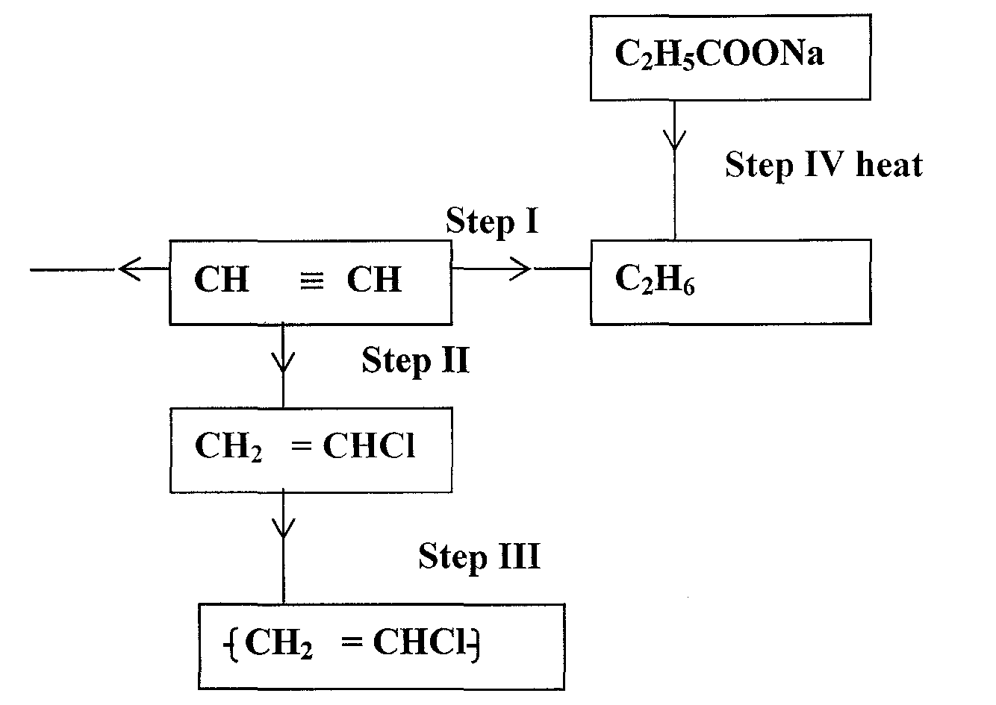

(i) Name the reagent used in

Step I -------------------------------------------------------------------------------------------(1mark)

Step II -------------------------------------------------------------------------------------------(1mark)

Step III------------------------------------------------------------------------------------------(1mark)

(ii) Write an equation for complete combustion of CH ≡ CH. (1mark)

--------------------------------------------------------------------------------------------------------------------------------------------------------------------------------------------------------------------------------------

(iii) Explain one disadvantage of the continued use of items in step III. (1 mark)

--------------------------------------------------------------------------------------------------------------------------------------------------------------------------------------------------------------------------------------

4. The diagram below represents the extraction of Sulphur by the Frasch process.

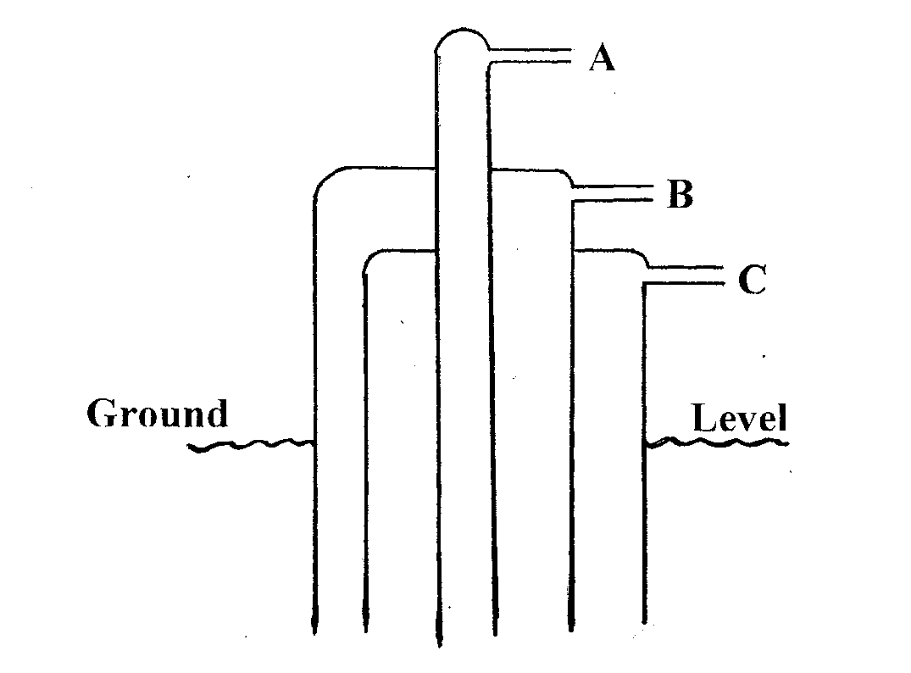

(i) Identify and state the use of the substances that pass through tubes A and C. (2 marks)

A------------------------------------------------------------C----------------------------------------------------------

(ii) Rhombic and monoclinic are Allotropes of sulphur. They are inter convertible as shown below.

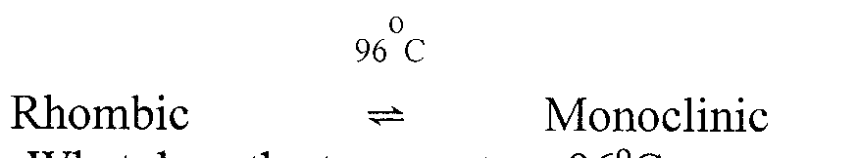

I. What does the temperature 96°C represent. (1 mark)

--------------------------------------------------------------------------------------------------------------------------------------------------------------------------------------------------------------------------------------

II. State the differences in crystalline appearances between rhombic and monoclinic crystals. (l mark)

--------------------------------------------------------------------------------------------------------------------------------------------------------------------------------------------------------------------------------------

(b) The following scheme represents the steps followed in the contact process, study it and answer the questions which follow.

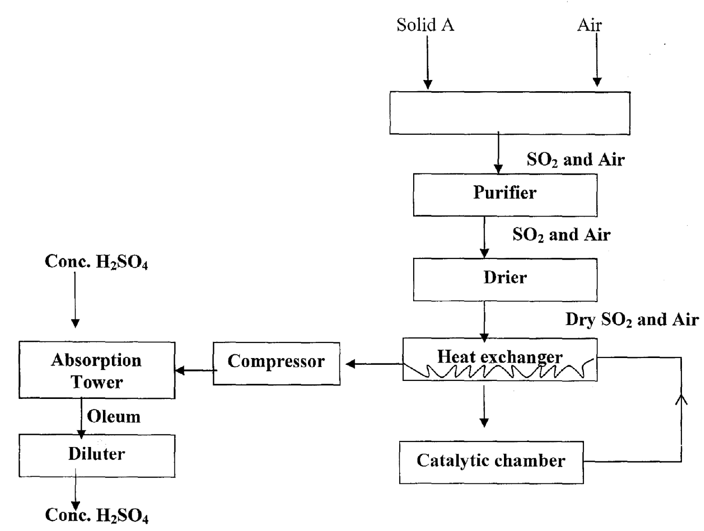

(i) Name two possible identities of solid A. (1 mark)

--------------------------------------------------------------------------------------------------------------------------------------------------------------------------------------------------------------------------------------

(ii) Name two impurities removed by the purifier. (1 mark)

--------------------------------------------------------------------------------------------------------------------------------------------------------------------------------------------------------------------------------------

(iii) Why is it necessary to remove impurities? (1 mark)

-------------------------------------------------------------------------------------------------------------------

-------------------------------------------------------------------------------------------------------------------

5. (I) Sulphuric (VI) acid was electrolysed using inert electrodes as shown on the

diagram below

Gas L

Gas K

Bulb

2M H2SO4 (aq)

1. Write the equations for the reactions taking place on the electrodes (2 marks)

Anode:----------------------------------------------------------------------------

Cathode: --------------------------------------------------------------------------

(b) How can gas K be identified? (1 mark)

------------------------------------------------------------------------------------------------------------------------------------------------------------------------------------------------------------------------------------------------------------

(c) Explain the difference in the volumes of the gases produced at the

electrode? (2 marks)

------------------------------------------------------------------------------------------------------------------------------------------------------------------------------------------------------------------------------------------------------------------------------------------------------------------------------------------------------------------------------------------

(d) Give two reason why electroplating is a necessity. (2 marks)

-------------------------------------------------------------------------------------------------------------------------------------------------------------------------------------------------------------------------------------------------------------------------------------------------------------------------------------------------------------------------------------------

(II) During electrolysis of a metal sulphate, 0.18g of the metal was deposited when a current of 3.2A passed for 10 minutes.

(a) Calculate the quantity of electricity used in Faradays (1F=96000C) (1 mark)

------------------------------------------------------------------------------------------------------------------------------------------------------------------------------------------------------------------------------------------------------------

(b) If the metal ion has the formula M3+, calculate the R.A.M of metal M.

(2marks)

------------------------------------------------------------------------------------------------------------------------------------------------------------------------------------------------------------------------------------------------------------------------------------------------------------------------------------------------------------------------------------------

(c) When the same quantity of electricity of electricity was passed through a nitrate salt of metal Z of R.A.M 108, 2.16g of Z was deposited.

(i) Find the formula of the ion of metal Z (2 marks)

------------------------------------------------------------------------------------------------------------------------------------------------------------------------------------------------------------------------------------------------------------------------------------------------------------------------------------------------------------------------------------------

(ii) Write the formula of the carbonate of element Z. (1mark)

------------------------------------------------------------------------------------------------------------------------------------------------------------------------------------------------------------------------------------------------------------

6. Oxygen is obtained on large scale by fractional distillation of air as shown on the flow chart below.

Air Dust free CO2

Process A

B

Condensation chamber

Process C

Compressor 200 atm

-200 0C

Oxygen

-1860C

X

-1830C

Y

-1960C

Air free air

Air free of

Water vapour

1. (i) Identify processes. (2 marks)

A_____________________________C____________________________

(ii) Identify gases: (1 mark)

X______________________________Y____________________________

1. Explain why Carbon (IV) oxide and water are removed before liquefaction of

air. (1 mark)

------------------------------------------------------------------------------------------------------------------------------------------------------------------------------------------------------------------------------------------------------------------------

1. State two uses of Argon. (2 marks)

------------------------------------------------------------------------------------------------------------------------------------------------------------------------------------------------------------------------------------------------------------------------------------------------------------------------------------------------------------------------------------------------------------------

1. The diagram below shows a set up used to investigate the process of rusting.

Study it and answer the questions that follow.

Distilled

water

**Test tube A**

**Test tube B**



Boiled Water

Oil

Iron nails 

State and explain the observation made on the iron nails in test tube B at the end

of the experiment. (3 marks)

--------------------------------------------------------------------------------------------------------------------------------------------------------------------------------------------------------------------------------------------------------------------------------------------------------------------------------------------------------------------------------------------------------------------------------------------------------------------------------------------------------------------------------------------------------

1. Name two conditions that accelerate rusting. (2 marks)

------------------------------------------------------------------------------------------------------------------------------------------------------------------------------------------------------------------------------------------------------------------------------------------------------------------------------------------------------------------------------------------------------------------

7. a) Use the bond energies given in the table below to calculate the enthalpy

change for the reaction. (2marks)

|  |  |  |  |  |  |
| --- | --- | --- | --- | --- | --- |
| **Bond** | **C – H** | **C –Br** | **Br – Br** | **H - Br** | **C-C** |
| Bond energy KJ/mol | 413 | 280 | 193 | 365 | 343 |

C2H6(g) + Br2(g) →C2H5Br(g) + HBr(g)

b) Hydrogen peroxide decomposes according to the equation below;

H2O(l) →H2O(l) + ½ O2(g) ; ∆H = -98KJ/mol.

If 6.8g of hydrogen peroxide contained 75cm3 of solution with water were completely decomposed, determine the rise in temperature due to the reaction.(Specific heat capacity of water =4.2Jg-1K-1 , density of water = 1g/cm3 , O = 16 , H = 1). (2 marks)

------------------------------------------------------------------------------------------------------------------------------------------------------------------------------------------------------------------------------------------------------------------------------------------------------------------------------------------------------------------------------------------------------------------------------------------------------------------------------------------------------------------------

c) On the space provided below sketch the cooling curve that would be

obtained when a boiling tube containing water at 800C is immersed in a freezing mixture maintained at -100C. (3 marks)

d) Butane C4H10 cannot be prepared directly from its elements but its standard heat of formation (∆Hf) can be obtained directly. The following heats of combustion are given.

∆Hc carbon (s) = -393KJ/mol

∆Hc H2(g) = -286KJ/mol

∆Hc C4H10 = -2877KJ/mol

1. Draw an energy circle diagram linking the heat of formation of

butane with its heat of combustion and the heat of combustion of its constituents elements. (2 marks)

ii) Calculate the heat of formation of butane ∆Hf(C4H10). (2marks)

e) Given that the lattice enthalpy of potassium chloride is +690KJ/mol and

hydration enthalpies of K+ and Cl- are -322KJ and -364KJ respectively. Calculate the enthalpy of solution of potassium chloride. (2 marks)

------------------------------------------------------------------------------------------------------------------------------------------------------------------------------------------------------------------------------------------------------------------------------------------------------------------------------------------------------------------------------------------------------------

This is the last printed page