SUKEMO MOCK 2017
AGRICULTURE
443/1
PAPER 1
TIME : 2HRS
NAME…………………………………………….…..…CLASS…… INDEX NO…………………….
SIGN ……………………...
DATE ……………………..

INSTRUCTIONS TO CANDIDATES
- Write your name, sign and index number in the space provided above
- This paper consist of 3 sections, A,B and C
- Answer all questions in section A and B
- Answer any 2 questions of your choice in section C
- All answers should be written in the spaces provided
- Candidates should check the question paper to ascertain that all pages are printed as indicated and that no questions are missing.

FOR EXAMINERS USE ONLY
SECTION | MAXIMUM SCORE | CANDIDATES SCORE
A | 20
B | 30
C | 40
TOTAL SCORE | 90

1
SECTION A (20mks)
1. Give two precautions taken to ensure good crop establishment during planting. (1mk)
………………………………………………………………………………………………………………………………………………………………………………………………………………………………………………………………………………………………………………………….
2. Name the classes of weeds according to plant morphology. (1mks) ……………………………………………………………………………………………………………………………………………………………………………………………………………………………………………………………………………………………………………………………………
…………………………………………………………………………………………………………………………………………………………….
3. Name two areas of scientific study which show that Agriculture is a science (1mk)
…………………………………………………………………………………………………………………………………………………………………………………………………………………………………………………………………………………………………………………………………..
…………………………………………………………………………………………………………………………………………………………….
4. State any two symptoms that can be observed in cereal crops that are deficient in nitrogen. (1mk)
………………………………………………………………………………………………………………………………………………………………………………………………………………………………………………………………………………………………….......…………………………
…………………………………………………………………………………………………………………………………………………………….
5. State two factors that determine the scale of production. (1mk)
…………………………………………………………………………………………………………………………………………………………………………………………………………………………………………………………………………………………………………………………………..
…………………………………………………………………………………………………………………………………………………………….
6. Explain the following terms as used in soil structure (1 ½ )
i) Structure class
…………………………………………………………………………………………………………………………………………………………………………………………………………………………………………………………………………………………………………………………………
ii) Structure type
………………………………………………………………………………………………………………...........................................................................................................................................................................................................................
iii) Structure grade
…………………………………………………………………………………………………………………………………………………………………………………………………………………………………………………………………………………………………………………………………..

7. Give two characteristics of a perfect market (1mks)
……………………………………………………………………………………………………………………………………………………………………………………………………………………………………………………………………………………………………………………………………
2
8. a) What is multi-storey cropping? (1mk)
…………………………………………………………………………………………………………………………………………………………………………………………………………………………………………………………………………………………………………………………………..
(b) State two benefits of multi-storey cropping (2mks)
…………………………………………………………………………………………………………………………………………………………………………………………………………………………………………………………………………………………………………………………………………………………………………………………………………………………………………………………………………………………………….

9. Distinguish between the two micro-catchments for water conservation.

(a)Negarims (1mk)
…………………………………………………………………………………………………………………………………………………………………………………………………………………………………………………………………………………………………………………………………
(b) Semicircular bunds (1mk)
………………………………………………………………………………………………………………………………………………………………………………………………………………………………………………………………………………………………………………………………….

10. Give 2 methods that can be used in carrying out topping in forage crops (1mk)
……………………………………………………………………………………………………………………………………………………………………………………………………………………………………………………………………………………………………………………………………
…………………………………………………………………………………………………………………………………………………………….

11. State 3 problems farmers encounter when sourcing for Agricultural credit. (1 ½ mks)
…………………………………………………………………………………………………………………………………………………………………………………………………………………………………………………………………………………………………………………………………………………………………………………………………………………………………………………………………………………………………………………………………………………………………………………………………………………………………………………………………………

12. Give one reason why phosphatic fertilizers benefit subsequent crop in Second and third year after application (1mk)
…………………………………………………………………………………………………………………………………………………………………………………………………………………………………………………………………………………………………………………………...........
…………………………………………………………………………………………………………………………………………………………….
13. State two reasons why cassava should be grown as last crop in crop rotation programme.
(1mk)
…………………………………………………………………………………………………………………………………………………………………………………………………………………………………………………………………………………………………………………………………………………………………………………………………………………………………………………………………………………………………..

3
14. Distinguish the following terms as used in pasture management. (1mks)
a) Intensity of defoliation
……………………………………………………………………………………………………………………………………………………………………………………………………………………………………………………………………………………………………………………………………………………………………………………………………………………………………………………………………………………………………
b) Frequency of defoliation
…………………………………………………………………………………………………………………………………………………………………………………………………………………………………………………………………………………………………………………………………………………………………………………………………………………………………………………………………………………………………….

15. Give two agricultural practices, which will lead to water pollution. (1mk)
……………………………………………………………………………………………………………………………………………………………………………………………………………………………………………………………………………………………………………………………………
…………………………………………………………………………………………………………………………………………………………….
16. State two problems associated with the use of manures by small-scale farmers. (1mk)
……………………………………………………………………………………………………………………………………………………………………………………………………………………………………………………………………………………………………………………………………
…………………………………………………………………………………………………………………………………………………………….
17. Given that maize is planted at a spacing of 75cm x 25cm. Calculate the plant population in a plot of land measuring ½ ha . (Show your working). (2mks)
……………………………………………………………………………………………………………………………………………………………………………………………………………………………………………………………………………………………………………………………………
……………………………………………………………………………………………………………………………………………………………………………………………………………………………………………………………………………………………………………………………………
……………………………………………………………………………………………………………………………………………………………………………………………………………………………………………………………………………………………………………………………………
18. Calculate the number of 50kg SA fertilizer bags that would be applied in one hectare of land that requires 60kg of Nitrogen per hectare. SA fertilizer contains 20% Nitrogen. (2mks)
……………………………………………………………………………………………………………………………………………………………………………………………………………………………………………………………………………………………………………………………………
……………………………………………………………………………………………………………………………………………………………………………………………………………………………………………………………………………………………………………………………………

4
19. State TWO importance of sub-soiling in land preparation . (1mks)
……………………………………………………………………………………………………………………………………………………………………………………………………………………………………………………………………………………………………………………………………
…………………………………………………………………………………………………………………………………………………………………
20. Define the term agricultural Economics as used in agriculture (1mk)
……………………………………………………………………………………………………………………………………………………………………………………………………………………………………………………………………………………………………………………………………
21. Apart from damage by birds, name two other serious pests which can attack sorghum in the field. (1mk)
……………………………………………………………………………………………………………………………………………………………………………………………………………………………………………………………………………………………………………………………………
…………………………………………………………………………………………………………………………………………………………………

22. State four importance of raising crops in nursery before transplanting. (2mks)
……………………………………………………………………………………………………………………………………………………………………………………………………………………………………………………………………………………………………………………………………
……………………………………………………………………………………………………………………………………………………………………………………………………………………………………………………………………………………………………………………………………
23. Name two conditions that may lead to subdivision of agricultural land. (1mark)
……………………………………………………………………………………………………………………………………………………………………………………………………………………………………………………………………………………………………………………………………
……………………………………………………………………………………………………………………………………………………………………………………………………………………………………………………………………………………………………………………………………

5
SECTION B (30 mks)
24. Form two student put some soil sample in a measuring cylinder, added some water and sodium carbonate and then covered the cylinder with the hand and shook the cylinder for about two minutes. He left the cylinder on the bench for one hour. The result was as shown below.
(i). Name the layers marked a,b,c, and d. (2mks)
a ……………………………………………………………………………………………………
b ……………………………………………………………………………………………………
c …………………………………………………………………………………………………….
d………………………………………………………………………………………………….

(ii) What was the function of sodium carbonate in this experiment? (1mk)
…………………………………………………………………………………………………………………………………………………………………………………………………………………………………………………………………………………………………………………………………………………………………………………………………………………………………………………………………………………………………………………………………………………………………………………………………………………………………………………………………………

(iii). What was the aim of this experiment ? (1mk)
……………………………………………………………………………………………………………………………………………………………………………………………………………………………………………………………………………………………………………………………………
………………………………………………………………………………………………………………………………………………………………………………………………………………………………………………………………………………………………………………………………………………………………………………………………………………………………………………………………………………………………………

6
25. The diagram below shows a method of prunning in tea production. Use it to answer the questions that follow.
Tea plant
Peg
(a) Identify the method shown in the diagram (1mk)
……………………………………………………………………………………………………………………………………………………………………………………………………………………………………………………………………………………………………………………………………

(b) Outline the procedure of carrying out the method on a tea bush (4mks)
……………………………………………………………………………………………………………………………………………………………………………………………………………………………………………………………………………………………………………………………………
…………………………………………………………………………………………………………………………………………………………………
……………………………………………………………………………………………………………………………………………………………………………………………………………………………………………………………………………………………………………………………………
…………………………………………………………………………………………………………………………………………………………………
……………………………………………………………………………………………………………………………………………………………………………………………………………………………………………………………………………………………………………………………………
…………………………………………………………………………………………………………………………………………………………………

(c) State two precautions that must be observed when plucking tea leaves (2mks)
……………………………………………………………………………………………………………………………………………………………………………………………………………………………………………………………………………………………………………………………………
…………………………………………………………………………………………………………………………………………………………………
……………………………………………………………………………………………………………………………………………………………………………………………………………………………………………………………………………………………………………………………………
…………………………………………………………………………………………………………………………………………………………………
7
26. The diagram below shows a weed study it carefully then answer the questions that follow.
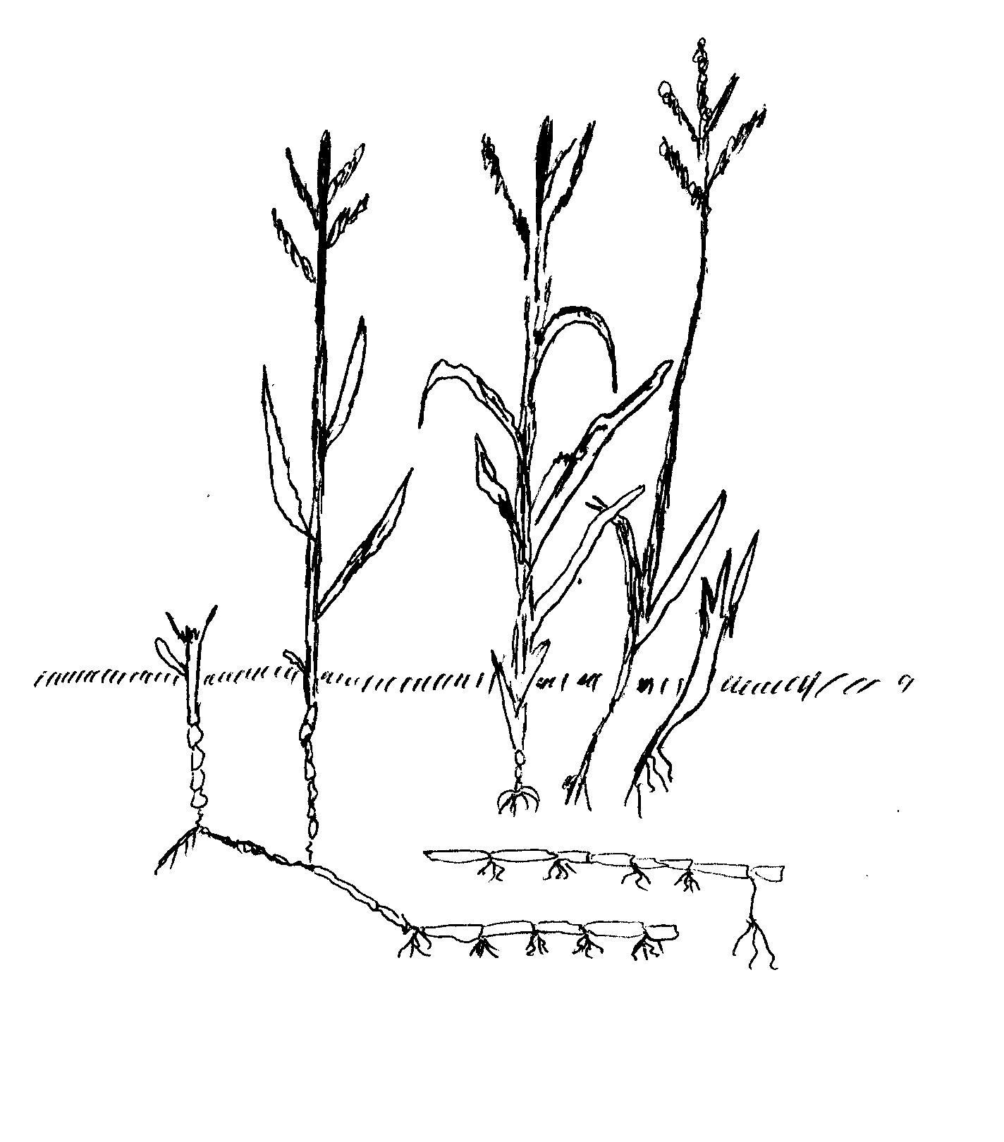
a) Identify the weed. (1mk)
……………………………………………………………………………………………………………………………………………………………………………………………………………………………………………………………………………………………………………………………………
(b) State 2 economic importance of the weed. (2mks)
……………………………………………………………………………………………………………………………………………………………………………………………………………………………………………………………………………………………………………………………………
…………………………………………………………………………………………………………………………………………………………………
(c) Why is it difficult to control the weed? (1mk)
……………………………………………………………………………………………………………………………………………………………………………………………………………………………………………………………………………………………………………………………………
…………………………………………………………………………………………………………………………………………………………………
…………………………………………………………………………………………………………………………………………………………………

8
27. The diagrams below labelled A,B,C, and D illustrates some pest. Study the diagrams carefully and answer the questions that follow.
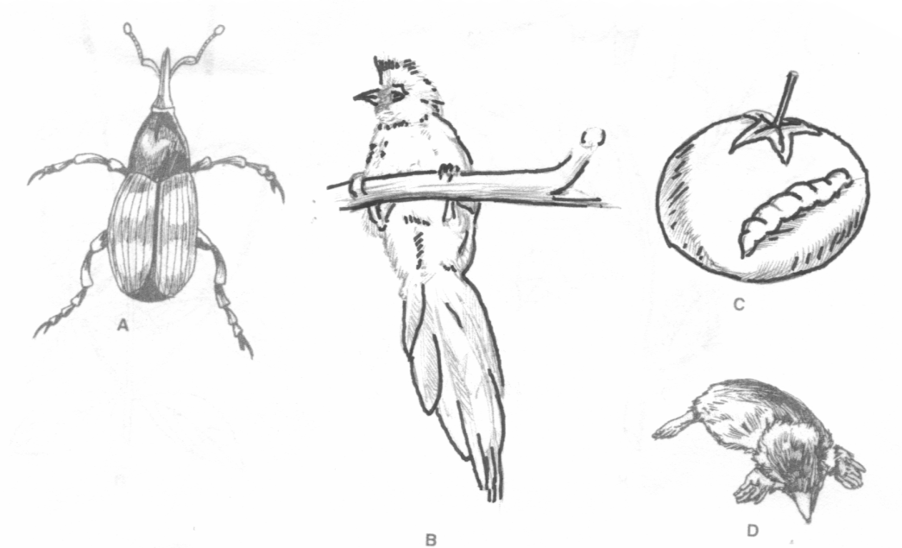
D
C
B
A

(a) Identify the pests labelled A,B,C and D. (2mks)

A …………………………………………………………………………………………………
B …………………………………………………………………………………………………
C …………………………………………………………………………………………………
D …………………………………………………………………………………………………

(b) Name the crop attacked by the pest A,B and D. ( 1 ½ mks)
A ………………………………………………………………………………..
B ………………………………………………………………………………..
D ………………………………………………………………………………..

(c ) Give one physical measures of each pests B and D. (1mk)

A ………………………………………………………………………………………………….

B …………………………………………………………………………………………………
C …………………………………………………………………………………………………

9
SECTION C (40mks)
28. Study the tables on demand and supply schedules of tomatoes in a town market.
Tomatoes bought Price per kg
(In (kg) (sh).

75 8.00
- 6.70
- 5.50
- 4.10
- 3.20
- 2.40
- 1.80
- 1.30
- 1.10
- 0.80

Tomato supplied Price per kg
(in kg) (sh).

200 7.00
- 5.20
- 4.80
- 4.00
- 3.70
- 2..80
- 1.60
- 1.40
- 1.20
75 1.10

- On the same axis, draw the graphs of supply and demand of tomatoes in the market. 8mks

- What is the equilibrium price? (1mk)
……………………………………………………………………………………………………………………………………………………………………………………………………………………………………………………………………………………………………………………………………
- What would be the price if 150kg of tomatoes were supplied? (1mk)
…………………………………………………………………………………………………………………………………………………………………………………………………………………………………………………………………………………………………………………………………

- If the price per kg was Kshs. 3.70, how many kilograms of tomatoes would be bought? (1mk)
…………………………………………………………………………………………………………………………………………………………………………………………………………………………………………………………………………………………………………………………………
- Calculate the elasticity of supply when price changed from Kshs. 7.00 to Kshs. 4.00 per kg of tomatoes. (3mks)
………………………………………………………………………………………………………………………………………………………………………………………………………………………………………………………………………………………………………………………………………………………………………………………………………………………………………………………………………………………………………………………………………………………………………………………………………………………………………………………………………
……………………………………………………………………………………………………………………………………………………………………………………………………………………………………………………………………………………………………………………………………
……………………………………………………………………………………………………………………………………………………………………………………………………………………………………………………………………………………………………………………………………
10

- Other than change in price, list other factors that will influence the supply of tomatoes in the market. 6mks.
……………………………………………………………………………………………………………………………………………………………………………………………………………………………………………………………………………………………………………………………………
…………………………………………………………………………………………………………………………………………………………………………………………………………………………………………………………………………………………………………………………………………………………………………………………………………………………………………………………………………………………………………………………………………………………………………………………………………………………………………………………………………
29. a) Describe the biological control measures in soil and water conservation (10mks)
…………………………………………………………………………………………………………………………………………………………………………………………………………………………………………………………………………………………………………………………………………………………………………………………………………………………………………………………………………………………………………………………………………………………………………………………………………………………………………………………………………………………………………………………………………………………………………………………………………………………………………………………………………………………………………………………………………………………………………………………………………………………………………………………………………………………………………………………………………………………………………………………………………………………………………………………………………………………………………………………………………………………………………………………………………………………………………………………………………………………………………………………………………………………………………………………………………………………………………………………………………………………………………………………………………………………………………………………………………………………………………………………………………………………………………………………………………………………………………………………………………………………………………………………………………………………………………………………………………………………………………………………………………………………………………………………………………………………………………………………………………………………………………………………………………………………………………………………………………………………………………………………………………………………………………………………………………………………………………………………………………………………………………
b) Discuss onions under the following sub-headings
i) Varieties (2mks)
…………………………………………………………………………………………………………………………………………………………………………………………………………………………………………………………………………………………………………………………………………………………………………………………………………………………………………………………………………………………………………………………………………………………………………………………………………………………………………………………………………

11
ii) Ecological requirements (3mks)
……………………………………………………………………………………………………………………………………………………………………………………………………………………………………………………………………………………………………………………………………
…………………………………………………………………………………………………………………………………………………………………………………………………………………………………………………………………………………………………………………………………………………………………………………………………………………………………………………………………………………………………………………………………………………………………………………………………………………………………………………………………………
iii) Field practices (3mks)
………………………………………………………………………………………………………………………………………………………………………………………………………………………………………………………………………………………………………………………………………………………………………………………………………………………………………………………………………………………………………………………………………………………………………………………………………………………………………………………………………………………………………………………………………………………………………………………………………………………………………………………………………………………………………………………………………………………………………………………………………………
iv) Marketing (2mks)
…………………………………………………………………………………………………………………………………………………………………………………………………………………………………………………………………………………………………………………………………………………………………………………………………………………………………………………………………………………………………………………………………………………………………………………………………………………………………………………………………………
30. a) Explain the importance of drainage as a land reclamation method. (6mks)
……………………………………………………………………………………………………………………………………………………………………………………………………………………………………………………………………………………………………………………………………………………………………………………………………………………………………………………………………………………………………………………………………………………………………………………………………………………………………………………………………………………………………………………………………………………………………………………………………………………………………………………………………………………………………………………………………………………………………………………………………………………………………………………………………………………………………………………………………………………………………………………………………………………………………………………………………………………………………………………………………………………
b) Explain the following financial documents and state the use of each.
i) Invoice (2mks)
…………………………………………………………………………………………………………………………………………………………………………………………………………………………………………………………………………………………………………………………………………………………………………………………………………………………………………………………………………………………………………………………………………………………………………………………………………………………………………………………………………
12
ii) Ledger (2mks)
…………………………………………………………………………………………………………………………………………………………………………………………………………………………………………………………………………………………………………………………………………………………………………………………………………………………………………………………………………………………………………………………………………………………………………………………………………………………………………………………………………
iii) Cash analysis (2mks)
…………………………………………………………………………………………………………………………………………………………………………………………………………………………………………………………………………………………………………………………………………………………………………………………………………………………………………………………………………………………………………………………………………………………………………………………………………………………………………………………………………
c) i) What is green manure? (2mks)
………………………………………………………………………………………………………………………………………………………………………………………………………………………………………………………………………………………………………………………………………………………………………………………………………………………………………………………………………………………………………
ii) Give characteristics of plants used as green manure (4mks)
………………………………………………………………………………………………………………………………………………………………………………………………………………………………………………………………………………………………………………………………………………………………………………………………………………………………………………………………………………………………………………………………………………………………………………………………………………………………………………………………………………………………………………………………………………………………………………………………………………………………………………………………………………………………………………………………………………………………………………………………………………
iii) Explain why green manure is not commonly used. (2mks)
……………………………………………………………………………………………………………………………………………………………………………………………………………………………………………………………………………………………………………………………………………………………………………………………………………………………………………………………………………………………………………………………………………………………………………………………………………………………………………………………………………………………………………………………………………………………………………………………………………………………………………………………………………………………………………………………………………………………………………………………………………………………………………………………………………………………………………………………………………………………………………………………………………………………………………………………………………………………………………………………………………………

13

