Name: ……………………………………………………… Adm No ………index No. ………

CLASS. ………………………… Candidate’s Signature. ……………Date: ………..…
231/3
BIOLOGY PRACTICAL
Paper 3
Time: 1 ³/₄ Hours

SUKEMO JET EXAMINATION 2017
INSTRUCTIONS TO CANDIDATES:
- Write your name and index number in the spaces provided at the top of this page.
- Sign and write date of examination in the spaces provided above
- Answer all the questions
- You are required to spend the first 15 minutes of the 1³/₄ hours allowed for this paper reading the whole paper carefully before commencing your work.
- Answers must be written in the spaces provided in the question paper.
- Additional page must not be inserted.
For Examiner’s Use Only
QUESTIONS | MAXIMUM SCORE | CANDIDATES SCORE
1 | 15
2 | 12
3 | 13
TOTAL | 40

This paper consists of 7printed pages. Candidates should check to ascertain that all pages are printed as indicated and that no question is missing

- You are provided with
- Specimen S
- Specimens Z
- 10cm³ of hydrogen peroxide
- Food substance J
- Cut a cube of specimen S measuring 1cm by 1cm by 1cm and place in a boiling tube labeled A. Repeat the procedure using specimen Z and place in a second boiling tube labeled B. To each of the boiling tubes add 5cm³ of hydrogen peroxide provided. Record your observations. Test the gas produced with a glowing splint. (2marks)
Test tube | Observation
A

B

- Write an equation for the reaction taking place in boiling tube A and (1mark)

- Explain the difference in the observations made between the reactions in test tube A and B (3marks)
…………………………………………………………………………………………………………………………………………………………………………………………………………………………………………………………………………………………………………………………………………………………………………………………………………………………………………………………………………………………………………………………………………………………………………………………………………………………………………………………………………………………………………………………………

- Using the reagents and filter paper provide carry out the tests in substance J: ( 9 marks)
Food substance | procedure | observation | Conclusion
- You are provided with photographs of specimens K, L, M, N and P
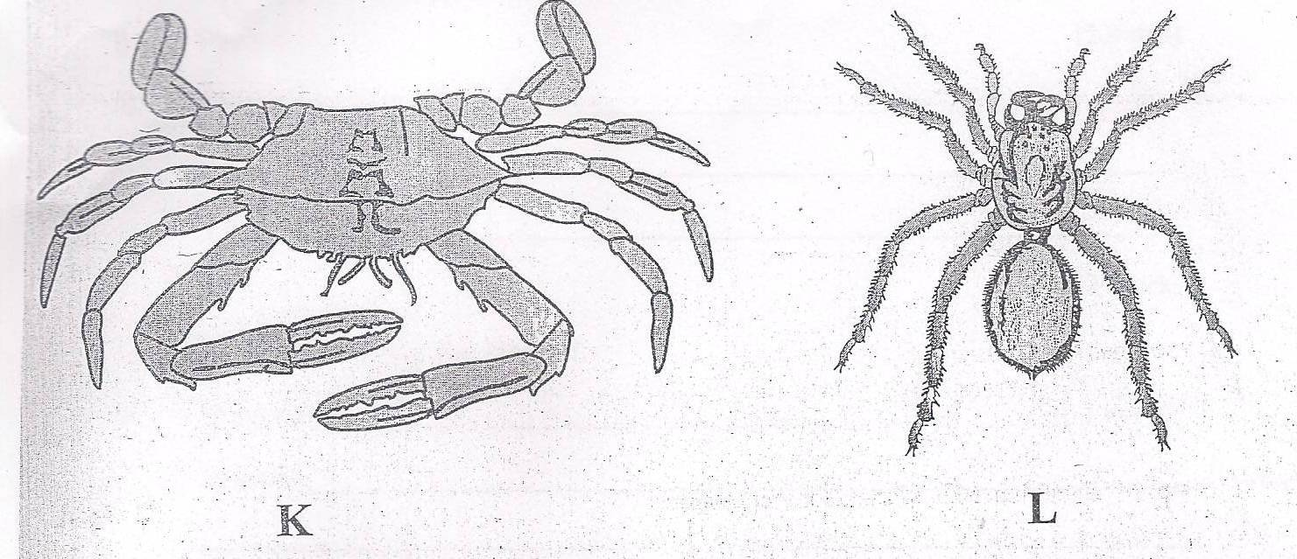
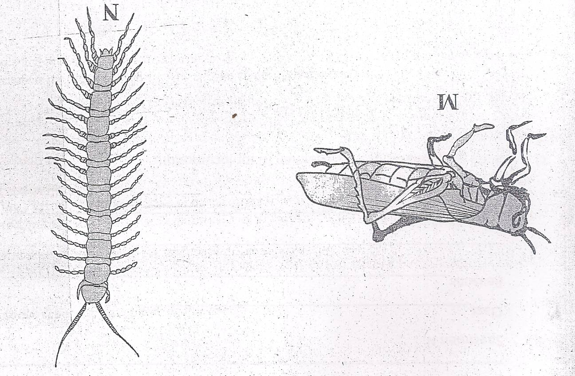

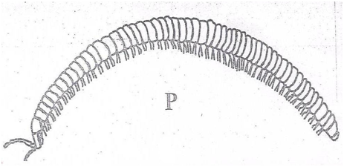

Using observable features answer the questions that follow:
- With reasons state the phylum of the organisms:
- Phylum ( 1 mark)
…………………………………………………………………………
- Reasons ( 2marks)
…………………………………………………………………………………………………………………………………………………………………………
- With a reason in each case give the class of:
- Specimen K ( I mark)
Class
…………………………………………………………………………………………………
Reason (1 mark)
…………………………………………………………………………………………………
- Specimen N ( 1 mark)
Class
…………………………………………………………………………………………………
Reason (1 mark)
…………………………………………………………………………………………………
- State two adaptations of specimen M for locomotion( 4 marks)
…………………………………………………………………………………………………………………………………………………………………………………………………………………………………………………………………………………………………………………………………………………………………………………………………………………………………………………………………………………………………………………………
- State one economic importance of specimen P ( 1 mark)
……………………………………………………………………………………………………………………………………………………………………………………………………

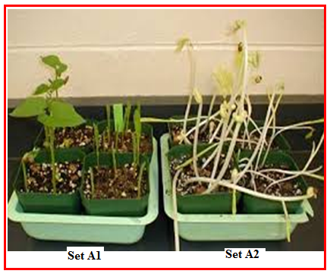
- You are provided with three sets of seedlings, labeled; Set A_{1,} Set A₂ and Set B examine them and use them to answer the questions that follow.

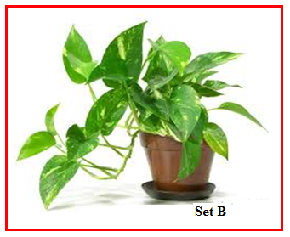

- Name the phenomenon exhibited by seedlings in set A₂ (1mark)
……………………………………………………………………………………….………
- Give a reason why plants exhibit the phenomenon named in (i) above. (1mark)
………………………………………………………………………………………………
- Name the response exhibited by the seedlings in set B (1mark)
…………………………………………………………………………………………………………
- Explain how the response named in (iii) above occurred. (3 marks)
……………………………………………………………………………………………………………………………………………………………………………………………………………………………………………………………………………………………………………………………………………………………………………………………………………………………………………………………………………………………………………………………………………………
- State five differences between seedlings in set A₁ and A₂. (5 marks)
Set A₁ | SET A₂

- State the conditions under which the seedlings in set A₁ and A₂ were grown. (2 marks)
…………………………………………………………………………………………………………………………………………………………………………………………………………………..

SUKEMOJET CONFIDENTIAL

231/3
BIOLOGY CONFIDENTIAL
JULY 2017

INSTRUCTIONS TO SCHOOLS

The information contained in this paper is to enable the head of the school and the teacher in charge of Biology to make adequate preparations for this year’s Biology practical examinations. NO ONE ELSE should have access to this paper or acquire knowledge of its contents. Great care MUST be taken to ensure that the information herein does not reach the candidate either directly or indirectly. The teacher in charge of Biology should NOT perform any of the experiments or give any information related to these instructions to the candidates.

Each candidate will require the following:
- 4 test tubes
- Test tube rack
- 3 droppers
- Means of labeling
- Means of heating/ Bunsen burner
- 10 mls solution J ( Fresh milk)
- Filter paper
- Benedicts solution
- 10 % sodium hydroxide solution.
- 1 % copper sulphate solution
- A ruler 30cm long
- Medium sized irish potato labeled specimen S supplied in a Petri dish
- a piece of fresh liver labeled specimen Z enough to obtain cube of 1 cm by 1cm by 1cm.
- 10ml hydrogen peroxide
- scapel
- 2 boiling tube
- Glowing splint

