**Name……………………………………............................. Index number …………..…**

**Class……………….. Adm no…………….…….Candidate’s signature ………………….**

**School …………………………………………**

233/1

**CHEMISTRY**

Paper 1

**THEORY**

July 2017

**2 Hours**

**SUKEMO MOCK 2017**

Kenya Certificate of Secondary Education

**CHEMISTRY**

Paper 1

**THEORY**

**Instruction to Candidates**

* Write your name, index number class and admission number in the spaces provided
* Sign and write the date of examination in the spaces provided.
* Answer **all** the questions in the spaces provided.
* Mathematical tables and silent electronic calculators may be used.
* All working **must** be clearly shown where necessary.
* This paper consists of 13 printed pages
* Candidates should check the question paper to ascertain that all the pages are printed as indicated and no questions are missing.
* Candidates should answer the questions in English.

**For Examiner’s Use Only**

|  |  |  |
| --- | --- | --- |
| **Questions** | **Maximum Score** | **Candidates Score** |
| 1-28 | 80 |  |

1. Solutions can be classified as acids bases or neutral. The table below shows solutions and their pH values.

|  |  |
| --- | --- |
| **Solution**  **K**  **L**  **M** | **pH values**  **1.5**  **7.0**  **14.0** |

(i) Select any pair that would react to form a solution of pH 7 (1mk)

…………………………………………………………………………………………………

(ii) Identify **two** solutions that would react with Aluminium hydroxide. Explain. (2mks)

………………………………………………………………………………………………………….……………………………………………………………………………………………………………….……………………………………………………………………………

1. Consider the following reactions for a fuel cell

2H2(g) + O2 (g) 2H2O(l)

1. Write the reaction at the positive terminal (1mk)

…………………………………………………………………………………………………

b) Discuss the advantage of a fuel cell pound vehicle over an internal combustion powered vehicle by comparing products formed (2mks)

………………………………………………………………………………………………………….……………………………………………………………………………………………………………….……………………………………………………………………………

1. The flow chart below shows some processes involved in the extraction of Lead metal, starting with its ore, Galena.

Coke

CO2(g)

SO2(g)

Unit I

Roasting Chamber

Y

**UNIT II**

Pb(l)

Hot air

(a). Explain what takes place in roasting furnace. (1mk)

……………………………………………………………………………………………

(b). Write a chemical equation for reaction taking place in unit II. (1mk)

……………………………………………………………………………………………

(c). State one use of Lead other than in making lead pipes. (1mk)

………………………………………………………………

1. In the set-up in figure was used to separate a mixture of sulphur (IV) oxide and ammonia gases

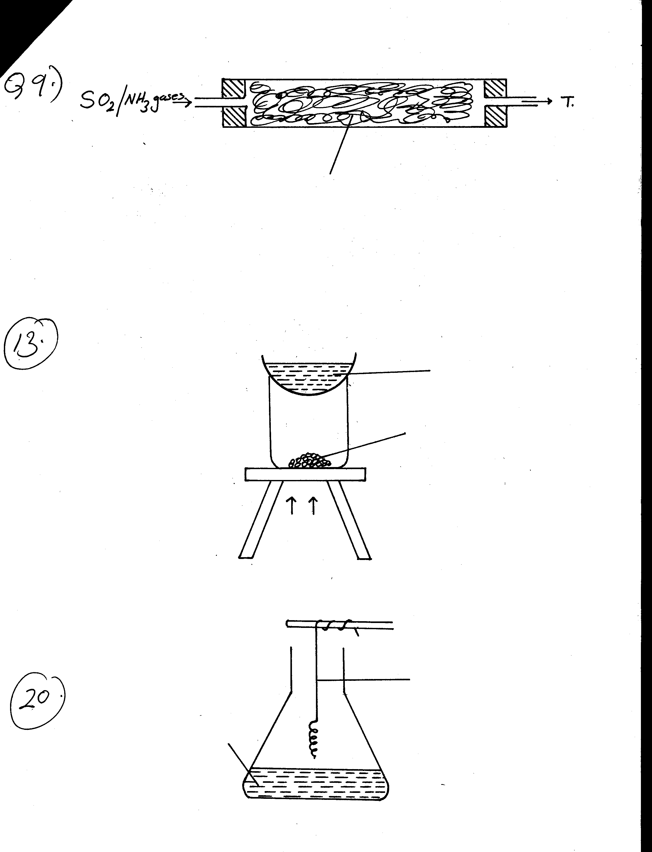

T

SO2/NH3 gases

Anhydrous calcium chloride

a) Name gas T. (1mark)

…………………………………………………………………………………………………

b) What is the intended function of anhydrous calcium chloride? (1mark)

…………………………………………………………………………………………………

1. A flame test is carried out on three metal solutions of Sodium chloride, Potassium chloride and calcium chloride. The diagram shows the apparatus used

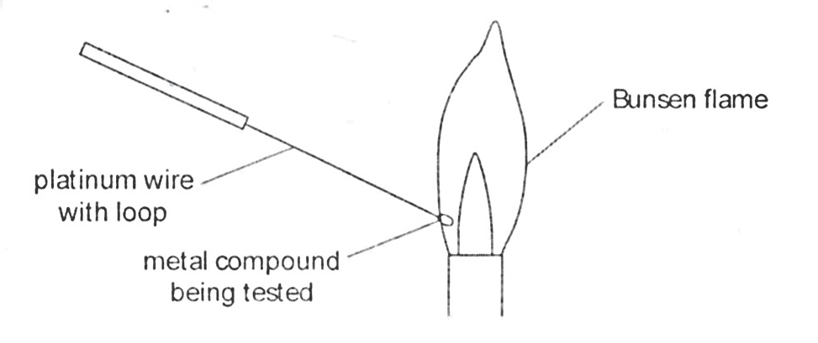

1. i) Suggest two reasons why platinum is a suitable metal to use as the wire in this test. (2mks)

………………………………………………………………………………………………………….……………………………………………………………………………………………………………….………………………………………………………………………………………………………………………………………………………………………………

ii) Why is a luminous Bunsen flame not suitable for carrying out a flame test? (1mk)

………………………………………………………………………………………………………….……………………………………………………………………………………………………………….……………………………………………………………………………

1. Ethanol and pentane are miscible liquids. Explain how water can be used to separate a mixture of ethanol and pentane. (2mks)

………………………………………………………………………………………………………………………………………………………………………………………………………………………………………………………………………………………………………………………………………………………………………………………………………………………………………………………………………………………………………………………………………………………………………………………………………………

1. A warm red phosphorous was lowered into a gas jar of chlorine using a deflagrating spoon.

(i) State **one** observation made in the experiment. (1mk)

……………………………………………………………………………………………………………………………………………………………………………………………………

(ii) Identify the substance formed in the above reaction. (1mk)

……………………………………………………………………………………………………………………………………………………………………………………………………

1. (a) Give the structural formula of 3, 3-dimethly pent-l-yne (1mk)

(b) Name the following compounds using the IUPAC system.

(i) CH3CH2CH2OOCCH3  (1mk)

…………………………………………………………………………………………………

(ii) CH3 CH2 CH C= CH (1mk)

| |

Br CH3

…………………………………………………………………………………………………

1. Use the chart below to answer the questions that follow.

**Magnesium**

**Gas P**

**Solid R**

**Copper (II) oxide heat**

**Solid T**

**Liquid S**

**Steam**

**+**

**+**

Identify: (4mks)

Gas **P** …………………………….

Solid **R** …………………………….

Solid **T** …………………………….

Liquid **S** …………………………….

1. Calculate the solubility of sugar in water at 40oC from the following information. Mass of evaporating dish = 23.0g

Mass of evaporating dish + sample of saturated solution = 192.0g

Mass of evaporation dish + solid after evaporating of solution = 142.0g (3mks)

1. Use the bond energy value given below for the question that follows

Bond Bxond energy (kJmol-1)

H – H 432

C = C 610

C – C 346

C – H 413

Determine the enthalpy change for the conversion of butene to butane by hydrogen. (3mks)

1. Using reagents provided only, explain by means of balanced chemical equations how you could prepare a salt of Zinc carbonate solid. (3mks)

* Zinc powder
* Nitric (V) acid (dilute)
* Water
* Solid sodium carbonate

………………………………………………………………………………………………………….……………………………………………………………………………………………………………….……………………………………………………………………………………………………………………………………………………………………………………….……………………………………………………………………………………………………………….……………………………………………………………………………

………………………………………………………………………………………………….

1. Below is part of the Thorium decay series.

${}_{90}^{232}{Th}$ ${}_{88}^{228}{Ra}$ ${}_{89}^{228}{Ac }$ ${}_{90}^{228}{Th}$ ${}_{88}^{224}{Ra}$

1. Write an overall nuclear equation for the conversion of ${}_{90}^{232}{Th}$ to ${}_{88}^{224}{Ra}$ (1mk)

………………………………………………………………………………………………………….…………………………………………………………………………………………

(ii) Give **two** uses of radio isotopes in medicine (2mk)

………………………………………………………………………………………………………….……………………………………………………………………………………………………………….……………………………………………………………………………

1. Element **A** has atomic mass 23 and element **B** atomic mass 7 and also have 12 neutrons and 4 neutrons respectively.

a) Write the electron arrangement of **A** and **B** (1mks)

**A**……………………………

**B**……………………………

b) Which element has higher ionization energy? Explain (2mks)

……………………………………………………………………………………………………………………………………………………………………………………………………

......................................................................................................................................................

1. D grams of potassium hydroxide were dissolved in distilled water to make 100cm3 of solution. 50cm3 of the solution required 50cm3 of 2.0M nitric acid for complete neutralization. Calculate the mass D of potassium hydroxide.(H=1,N=14,O=16,K=39)

KOH(aq) + HNO3(aq) KNO3(aq) + H2O(l) (3mks)

1. The peaks below show the mass spectrum of element X

9.1

82.8

Intensity (% abundance)

8.1

Isotopic mass

24

25

26

Calculate the relative atomic mass of X (2mks)

1. The chemical equations below are the main reactions in large scale manufacture of sodium carbonate.

NH3 (g) + CO2 (g) + H2O(l) NH4HCO3 (aq)

NH4HCO3 (aq)  + NaCl(aq) NaHCO3(s) + NH4Cl(aq)

a) State how the **two** products, NaHCO3 and NH4Cl are separated. (1mk)

…………………………………………………………………………………………………

b) (i) How is sodium carbonate finally obtained? (1mk)

…………………………………………………………………………………………………

(ii) Write an equation to show how ammonia is regenerated? (1mk)

……………………………………………………………………………………………………………………………………………………………………………………………………

1. 20cm3 of an unknown gas Q takes 12.6 seconds to pass through small orifice.10cm3 of oxygen gas takes 11.2 seconds to diffuse through the same orifice under the same conditions of temperature and pressure. Calculate the molecular mass of unknown gas Q ( O=16) (3mks)
2. . The formula given below represents a portion of polymer

H H H H

| | | |

C C C C

| | | |

H H

O

O

a) Give the name of the polymer (1mk)

…………………………………………………………………………………………………

b) Draw the structure of the monomer used to manufacture the polymer. (1mk)

c) State one environmental effect of the polymer (1mk)

1. .The graphs below were drawn when 15g of marble chips in different physical states were reacted with 50cm3 of 2M Hydrochloric acid. They are drawn by measuring the volume of carbon (iv) oxide produced with time.



1. Which curves corresponds to the reactions involving powdered calcium carbonate with the dilute acid (1mrk)

......................................................................................................................................................

...................................................................................................................................................... ii) All the graphs eventually flatten out at the same level but at different time. Why do the graphs flatten out at the same level? (1mrk)

............................................................................................................................................................................................................................................................................................................ iii) Why is curve A very steep at any given point compared to the other curves (1mrk)

..................................................................................................................................................................................................................................................................................................................................................................................................................................................................

1. a) State the Le Chatelier’s principle. (1mrk)

………………………………………………………………………………………………………….……………………………………………………………………………………………………………….……………………………………………………………………………

b)When aqueous solution of Iron (III) Chloride and potassium thiocyanate are mixed, the equilibrium below is setup.

Fe3+ (aq) + CNS- (aq) [Fe(CNS)]2+

(yellow (colourless) (red)

State and explain the effect of decreasing the concentration of iron (III) ions for the equilibrium mixture. (2 mks)

………………………………………………………………………………………………………….……………………………………………………………………………………………………………….……………………………………………………………………………

1. 100cm3 of air is continuously passed through a combustion tube connected to two syringes as shown below. The combustion tube contains some clean granules of copper metal which are heated. The process is repeated until there is no further change in the volume of air. The volume of air remaining is 80cm3



1. State one observation made in the combustion tube (1mrk)

...................................................................................................................................................... ii) Work out the percentage of air used after the reaction (1mrk)

1. List two gases remaining after the reaction (2mrks)
2. In the chemical equation below identify the base and give a reason for your choice. (2mks)

C2H5O- (aq) + H2O(l) → C2H5OH(aq) + OH—(aq)

………………………………………………………………………………………………………….……………………………………………………………………………………………………………….……………………………………………………………………………

1. A green rocky material is suspected to be the ore malachite, CuCO3.Cu (OH) 2. Describe how you could establish the presence of copper in the ore. (3mks)

………………………………………………………………………………………………………….……………………………………………………………………………………………………………….………………………………………………………………

………………………………………………………………………………………………………………………………………………………………………………………………

1. The structures shown below represents two cleansing agents A and B.

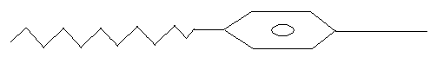

COO-Na+ SO3-Na+

A B

(i) Which cleansing agent would be more suitable for washing in water containing

Magnesium Sulphate? Explain your answer. (2 mks)

………………………………………………………………………………………………………….……………………………………………………………………………………………………………….……………………………………………………………………………

(ii) State any advantage that A has over B. (1mk)

………………………………………………………………………………………………………….…………………………………………………………………………………………

1. Study the standard reduction potentials given below and answer the questions that follow. (The letter do not represent the actual symbols of the element)

E Ø (volts)

P2+ (aq) + 2e- P(s) - -0.76

Q2+ (aq) + 2e- Q(s) - -2.37

R+ (aq) + e- R(s) - + 0.34

S2+ (aq) + 2e- S(s) - -0.14

T2 (g) + 2e- 2T-(aq) - +2.87

(a) The standard reduction potential for Fe2+(aq) is -0.44 volts. Select the element which would best protect iron from rusting. (1mk)

………………………………………………………………………………………………………….…………………………………………………………………………………………

(b) Calculate the EØ value for the cell represented by S2+ (aq) |S(s) ||T2 (g) |T-(aq) (1mk)

(c) Using the standard reduction potentials above, state and explain the element that would be the strongest reducing agent. (1mks)

………………………………………………………………………………………………………….…………………………………………………………………………………………

1. The diagram below was used to explain the movement of ions in the electrolytes, when an electric current is passed through them.





Y

Connecting wire

Lead (II) Nitrate solution

Potassium Iodide solution

From the diagram, state and explain the observation expected at Y. (2mks)

………………………………………………………………………………………………………….……………………………………………………………………………………………………………….……………………………………………………………………………

1. Sulphur (IV) oxide and Nitrogen (IV) oxide react as shown in the equation below

SO2 (g) + NO2 (g)  SO3 (g) + NO (g)

(i) Using oxidation numbers of either sulphur or Nitrogen show that this is a **redox** reaction. (2mks)

………………………………………………………………………………………………………….……………………………………………………………………………………………………………….……………………………………………………………………………

(ii) **Identify** the reducing agent. (1mk)

………….………………………………………………..……………………………………

**THIS IS THE LAST PRINTED PAGE**