**Name: ………………………………………………Index No. ……………………………**

**School: ………………………………………………Candidate’s Sign. …………..............**

**Date: ………………………………..........................**

**233/2**

**CHEMISTRY**

**PAPER 2**

**JULY/AUGUST 2017**

**TIME: 2 HOURS**

**SUKEMO MOCK 2017**

***Kenya Certificate of Secondary Education (K.C.S.E.)***

**Chemistry**

**Paper 2**

**INSTRUCTIONS TO CANDIDATES:**

* *Write your* ***name*** *and* ***index*** *on the space provided above*
* *Answer* ***all*** *the questions in the spaces provided.*
* *All working* ***must*** *be clearly shown where necessary.*
* *Mathematical tables and non-programmable electronic calculators may be used.*

***For Examiners Use Only***

|  |  |  |
| --- | --- | --- |
| **Question** | **Maximum score** | **Candidate’s score** |
| 1 | 12 |  |
| 2 | 12 |  |
| 3 | 12 |  |
| 4 | 11 |  |
| 5 | 11 |  |
| 6 | 10 |  |
| 7 | 12 |  |
| **Total** | **80** |  |

*This paper consists of 12 printed pages. Candidates should check to ascertain that all pages are printed as indicated and that no questions are missing.*

1. a) Study the information given below and answer the questions that follow.

|  |  |  |  |  |
| --- | --- | --- | --- | --- |
| Element | Atomic radius (nm) | Ionic radius (nm) | Formula of oxide | Melting point of oxide (‘C) |
| P  Q  R  S  T | 0.364  0.830  0.592  0.381  0.762 | 0.421  0.711  0.485  0.446  0.676 | A2O  BO2  E2O3  G2O5  JO | -119  837  1466  242  1054 |

1. Which elements are non-metals? Give a reason. (2mks)

...........................................................................................................................................................

............................................................................................................................................................

1. Explain why the melting point of the oxide of R is higher than that of the oxide of S. (2mks)

...........................................................................................................................................................

............................................................................................................................................................

........................................................................................................................................................................................................................................................................................................................

1. Give **two** elements that would react vigorously with each other. Explain your answer. (2mks)

...........................................................................................................................................................

............................................................................................................................................................

............................................................................................................................................................

b) Study the information in the table below and answer the questions that follow (The letters do not represent the actual symbols of the elements)

|  |  |  |  |
| --- | --- | --- | --- |
|  | | Ionization Energy (I.E) in kJ/Mole | |
| Element | Electronic configuration | 1st I.E | 2nd I.E |
| A | 2.2 | 900 | 1800 |
| B | 2.8.2 | 736 | 1450 |
| C | 2.8.8.2 | 590 | 1150 |

1. What chemical family do the elements A, B and C belong? (1mk)

............................................................................................................................................................

........................................................................................................................................................................................................................................................................................................................

1. What is meant by the term ionization energy? (1mk)

............................................................................................................................................................

........................................................................................................................................................................................................................................................................................................................

1. The 2nd ionization energy is higher than the 1st ionization energy of each. Explain (1mk)

............................................................................................................................................................

........................................................................................................................................................................................................................................................................................................................

1. Aluminium chloride and sodium chloride are both chlorides of period 3 elements. Use this information to explain the following observations:
2. A solution of Aluminium chloride in water turns blue litmus paper red while that of sodium chloride does not. (1½mks)

............................................................................................................................................................

........................................................................................................................................................................................................................................................................................................................

............................................................................................................................................................

1. The melting point of sodium chloride (801°C) is higher than that of Aluminium chloride (180°C). (1½mks)

............................................................................................................................................................

............................................................................................................................................................ ............................................................................................................................................................

............................................................................................................................................................

1. The scheme below shows a series of reactions starting with ethanol. Study it and answer the questions that follow

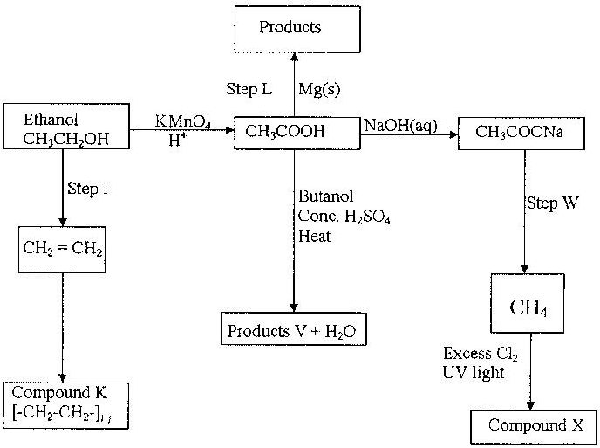

*n*

1. (i) Name the type of reaction in step 1. (1 mk)

............................................................................................................................................................

(ii) Give the reagent and condition necessary for step 1 to take place. (2 mks)

Reagent..............................................................................................................................................Condition...........................................................................................................................................

1. Write the equation for the reaction that takes places in step L. (1mk)

............................................................................................................................................................

............................................................................................................................................................

1. Name product V and give the equation responsible for its formation (2 mks)

............................................................................................................................................................

............................................................................................................................................................

1. Give the IUPAC name and structural formula of compound X (2 mks)

............................................................................................................................................................

............................................................................................................................................................

1. State the type of reaction involved in the formation of compound K. (1 mk)

............................................................................................................................................................

1. Give the reagent necessary for step W to take place. (1 mk)

............................................................................................................................................................

1. If the relative molecular mass of compound K is 44800, determine the value of ***n***. (2 mks)

............................................................................................................................................................ ............................................................................................................................................................

............................................................................................................................................................

............................................................................................................................................................

1. Aqueous copper (II) sulphate was electrolyzed using the set-up represented by the diagram below.

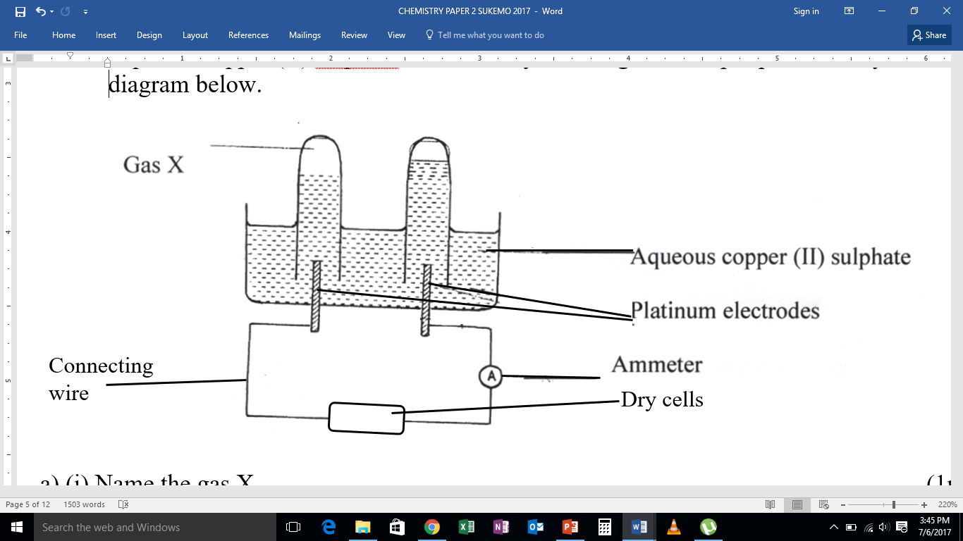

a) (i) Name the gas X. (1mk)

...........................................................................................................................................................

(ii) Write an ionic equation for the reaction that produces gas X. (1mk)

...........................................................................................................................................................

...........................................................................................................................................................

b) What happens to the pH of the electrolyte during electrolysis? Explain your answer. (2mks)

...........................................................................................................................................................

...........................................................................................................................................................

c) If in the above set-up, copper electrodes were used instead of platinum electrodes.

i) Write the electrode half- equations for the reactions at the anode and the cathode. (2mks)

Anode:................................................................................................................................................

Cathode:.............................................................................................................................................

ii) What happens to the color of the electrolyte during electrolysis? Explain your answer. (2mks)

...........................................................................................................................................................

...........................................................................................................................................................

1. During the electrolysis of copper (II) sulphate solution using copper electrodes, a current of 0.2A was passed through the cell for 5 hours.

(i) What is the observation made on the anode electrode? (1mk)

...........................................................................................................................................................

* 1. Determine the change in mass of the cathode which occurred as a result of the electrolysis process. (Cu = 64, 1F = 96,500C). (3mks)

...........................................................................................................................................................

...........................................................................................................................................................

...........................................................................................................................................................

...........................................................................................................................................................

...........................................................................................................................................................

1. (a) In an experiment for the manufacture of ammonia from the Haber process, Nitrogen is

obtained from liquid air by fractional distillation while hydrogen is obtained from Napha which is a mixture of hydrocarbons containing 5-9 Carbon atoms.

The equations are as shown below:

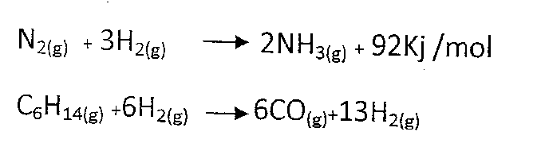

∆H = -92 kJ/mol

Use the above information to answer the questions that follow.

1. Why is it necessary to purify the gases used in the Haber process? Name one

impurity present in these gases other than Carbon (II) oxide and water vapour. (2 mks)

…………………………………………………………………………………………………

…………………………………………………………………………………………………

…………………………………………………………………………………………………

(ii) In Haber process finely divided iron is used as a catalyst. How is the efficiency of

the catalyst improved? (2 mks)

…………………………………………………………………………………………………

…………………………………………………………………………………………………

(iii) Write the equation for the laboratory preparation of ammonia. (1 mk)

…………………………………………………………………………………………………

…………………………………………………………………………………………………

(iv) With reasons state the operating conditions of the Haber industries. (2 mks)

…………………………………………………………………………………………………

…………………………………………………………………………………………………

…………………………………………………………………………………………………

(b) One uses of ammonia is in the manufacture of nitric (V) acid through catalytic oxidation.

(i) Name the catalyst used. (1 mk)

…………………………………………………………………………………………………

1. Write an equation for the catalytic oxidation of ammonia. (1 mk)

…………………………………………………………………………………………………

…………………………………………………………………………………………………

1. Nitric (V) acid obtained in this process is about 60% pure. State how this purity could be increased. (1 mk)

…………………………………………………………………………………………………

…………………………………………………………………………………………………

1. State one use of Nitric (V) acid other than the manufacture of ammonium nitrate.

(1 mk)

…………………………………………………………………………………………………

…………………………………………………………………………………………………

1. The flow chart below shows a flow chart that outlines some of the processes involved in the extraction of copper from copper pyrite. Study it and answer the questions that follow.

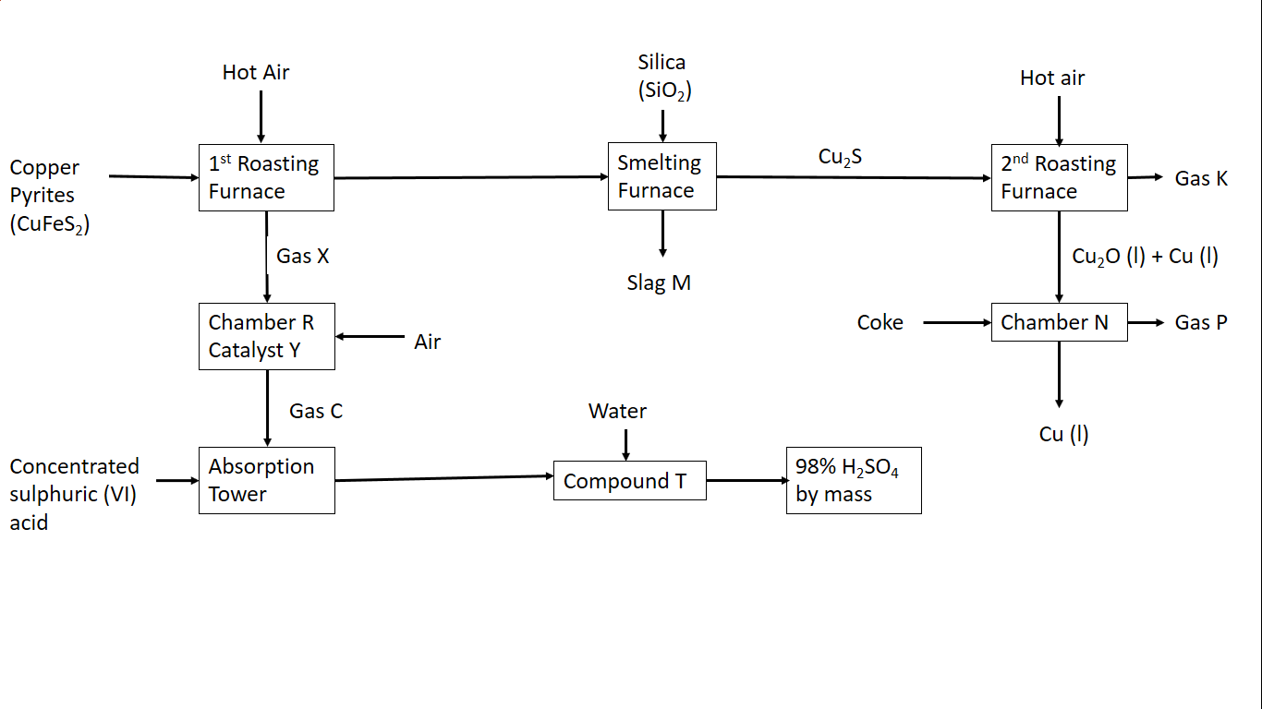

1. Write the equations for the reactions that take place in the: (2 mks)
2. 1st roasting furnace

…………………………………………………………………………………………………

…………………………………………………………………………………………………

1. Chamber N

…………………………………………………………………………………………………

…………………………………………………………………………………………………

1. (i) Write the formula of the cation present ion the slag M. (1 mk)

…………………………………………………………………………………………………

…………………………………………………………………………………………………

1. What name is given to the reaction that takes place in chamber N? Give a reason for your answer. (2 mks)

…………………………………………………………………………………………………

…………………………………………………………………………………………………

…………………………………………………………………………………………………

1. (i) Name the catalyst Y. ( ½ mk)

…………………………………………………………………………………………………

(ii) State one commercial use of sulphuric (VI) acid. (½ mk)

…………………………………………………………………………………………………

1. (i) The copper obtained from chamber N is not pure. Draw a labeled diagram to

show the set-up you would use to refine the copper by electrolysis. (2 mks)

(ii) Given that the mass of copper obtained from the above extraction was 210 kg,

determine the percentage purity of the ore (copper pyrites) if 810 kg of it was fed to the 1st roasting furnace. (Cu = 63.5, Fe = 56.0, S = 32.0) (3 mks)

…………………………………………………………………………………………………

…………………………………………………………………………………………………

…………………………………………………………………………………………………

…………………………………………………………………………………………………

1. The table below shows the volumes of nitrogen (IV) oxide gas produced when 4M nitric (V) acid were reacted with 0.635g of copper at room temperature.

|  |  |
| --- | --- |
| **Time (seconds)** | **Volume of Nitrogen (IV) oxide gas (cm3)** |
| 5 | 60 |
| 15 | 160 |
| 25 | 240 |
| 35 | 320 |
| 45 | 380 |
| 55 | 430 |
| 65 | 470 |
| 75 | 490 |
| 85 | 500 |
| 95 | 500 |

a) On the grid provided below, plot a graph of the volume of the gas produced against time. (3 mks) 

1. Using the graph, determine the volume of nitrogen (IV) oxide after 30 seconds. (1 mk)

………………………………………………………………………………………………………

1. On the grid, sketch a graph for the volume of gas against time if the experiment was repeated at 15oC. (1 mk)

……………………………………………………………………………………………………..

1. Use the graph to determine the rate of reaction at the 65th second. (2 mks)

………………………………………………………………………………………………………

………………………………………………………………………………………………………

………………………………………………………………………………………………………

1. Give a reason why hydrochloric acid cannot be used instead of nitric (V) acid. (1 mk)

………………………………………………………………………………………………………

………………………………………………………………………………………………………

1. Explain how the rate of the reaction between copper and nitric acid would be affected if the temperature of the reaction mixture was raised. (2 mks)

………………………………………………………………………………………………………

………………………………………………………………………………………………………

1. (a) (i) What is a fuel? (1 mk)

………………………………………………………………………………………………………………………………………………………………………………………………………………

(ii) Calculate the heating value of propane, C3H8, given that its molar enthalpy of   
combustion is 2,200 kJ mol-1. (C=12, H=1) (2 mks)

………………………………………………………………………………………………………

………………………………………………………………………………………………………………………………………………………………………………………………………………………………………………………………………………………………………………………

………………………………………………………………………………………………………

………………………………………………………………………………………………………

(b) (i) Define molar enthalpy of combustion. (1 mk)

………………………………………………………………………………………………………

………………………………………………………………………………………………………

(ii) Use the information provided by the thermochemical equations below to calculate the   
 molar enthalpy of combustion of ethyne. (3 mks)

C(s) + O2(g) CO2(g) ∆H= -394 kJ mol-1

H2(g) + ½O2(g) H2O(g) ∆H= -286 kJ mol-1

2C(s) + H2(g) C2H2(g) ∆H= +226 kJ mol-1

………………………………………………………………………………………………………

………………………………………………………………………………………………………

………………………………………………………………………………………………………

………………………………………………………………………………………………………

………………………………………………………………………………………………………

(c) Study the data given below and answer the questions that follow.

|  |  |
| --- | --- |
| Substance/ion | Enthalpy change |
| CaCl2(s) | Lattice energy = -2,237 kJ mol-1 |
| Ca2+(g) | Hydration energy = -1,650 kJ mol-1 |
| Cl-(g) | Hydration energy = -364 kJ mol-1 |

1. Determine the molar enthalpy of solution of calcium chloride in water. (2 mks)

………………………………………………………………………………………………………

………………………………………………………………………………………………………

1. Draw an energy level diagram for the dissolution of calcium chloride in water. (3 mks)

**This is the last printed page**