Name………………………………………………………………………………………………. Index No……………………………..
School………………………………………………………………………….…………… Candidate’s sign…………………….
Date………………………………….

451/2
COMPUTER STUDIES
PAPER 2
2 ½ hrs

SUKEMO JOINT EXAM

COMPUTER STUDIES
PAPER 2
2 ½ hrs

Instruction to candidates.
- Write your name and index number at the top right hand corner of each printout.
- Write your name and index number on the diskette/Removable media.
- Write the name and version of the software used for each question attempted in the answer sheet.
- Answer all the questions.
- All questions carry equal marks.
- Passwords should not be used while saving in the diskette/Removable media.
- All answers must be saved in your diskette/Removable media.
- Make a printout of the answers on the answer sheets provided.
- Arrange your printouts and tie/staple them together.
- Hand in all the printouts and the diskette/Removable media.

1 a) using a Word Processor, type the document as it appears and save it as BiogasMain (27marks)
BIOGAS PLANT
1.0 Domestic biogas presentation
1.1 Value chain
1.1.1 General presentation
B
iogas is a gas produced through the digestion of organic materials in anaerobic conditions by specific bacteria, called methanogenic bacteria, or methanogens
Biogas is mainly composed of methane (CH₄), and is thus a flammable gas. It can therefore be used as a fuel for heating, cooking and lighting. Biogas can also be used to feed engines to produce electricity. For information, the following table compares the equivalence between biogas and other possible fuels in terms of heating value:
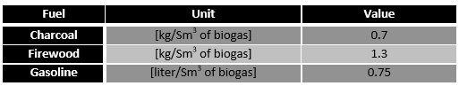

2.0 Potential impacts
The dissemination of biogas plants has various environmental, social and economic benefits.

2.1 Environmental impacts
- Reduction of the biomass resource depletion
- Reduction of Green House Gases (GHG) emissions
2.2 Social Impacts
- Biogas plants help improve beneficiaries’ quality of life by reducing the workload usually required for typical tasks such as firewood collection and fire tending.
- Improved gender equality
Women can spend more time on other activities and on education, hence a reduction of gender disparities.
- Health and sanitation
Bio-digesters reduce the pathogen content of organic materials.
- Education
The installation of a biogas lamp can enable children to study later in the evening.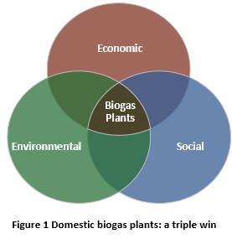
2.3 Economic impacts
- Economic impacts for beneficiaries
By displacing the use of firewood or charcoal, biogas can help to reduce households’ energy expenses.
3.0 Technologies
3.1 Possible technologies for domestic biogas
The most common technologies for domestic biogas – biogas production at a household scale – are:
- Plastic Tube Digester or Polyethylene Tube Digester (PTD):
- Plastic tank digester:
- Technologies based on the Fixed Dome model:
- Floating drum digester:
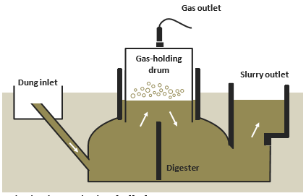
Floating drum technology [11][12]

b) i) Use a function to calculate sum of the fuel value in the table (2marks)
ii) Create a pie chart showing Fuel values below the table. Insert an appropriate title.(5marks)
c) Insert the following
i) Page number at the bottom center of page (1mark)
ii)“Biogas Technology is Eco-friendly” as a footer (1mark)
ii) Your index number, name and school as a header (1mark)
d) Using the marked Headings (1.0….etc) insert TableOf Content (TOC) after the header “BIOGAS PLANT” (5marks)
e) i) Insert “Biogas Production System” as Diagonal semitransparent watermark (3marks)
ii) Insert Art page border of your choice around the First Page Only (3marks)
f) Print Biogas Main (1marks)
Question 2
2. UMA SCHOOL has employed several workers, In order for it to monitor the performance of its workers and the different duties assigned to its workers, the company needs a database to organize the information.
Required;
(a) Create a database file and name it UMA DATABASE. (2mks)
(b) i) Using the table below create the appropriate fields and split the data into two tables and set the primary key (s) (14mks)
EMP NO. | NAME | DEPARTMENT | SALARY | PAID | AGE | DATE OF PAYMENT
0021 | JOY | HUMANITIES | 50,000 | YES | 42 | 28/3/2017
0022 | RUTH | MATHEMATICS | 40,000 | YES | 38 | 28/3/2017
0023 | MARY | APPLIED SCIENCE | 42,000 | NO | 33 | 27/3/2017
0024 | CATE | ENGLISH | 38,000 | NO | 28 | 26/3/2017
0025 | ALEX | MATHEMATICS | 42,000 | YES | 33 | 28/3/2017
0026 | MARY | HUMANITIES | 40,000 | YES | 38 | 27/3/2017
0027 | ISAAC | APPLIED SCIENCE | 50,000 | YES | 42 | 26/3/2017
0028 | FATH | ENGLISH | 60,000 | YES | 47 | 26/3/2017
0029 | JUDE | MATHEMATICS | 57,000 | YES | 49 | 27/3/2017
0030 | PETER | HUMANITIES | 50,000 | NO | 44 | 28/3/2017
0021 | JOY I | HUMANITIES | 50,000 | YES | 42 | 26/3/2017
0024 | CATE | ENGLISH | 38,000 | YES | 28 | 28/3/2017
0029 | JUDE | MATHEMATICS | 57,000 | YES | 49 | 27/3/2017
0030 | PETER | HUMANITIES | 50,000 | NO | 44 | 28/3/2017

ii) Create screens for each table for inputting the data in the tables (10mks)
iii) Create relationships between the tables (2mks)
iv) Set the appropriate field size for the department column (2mks)
v) Validate marital paid field to allow text that either begin with Y or N. (2mks)
b. i) Create a query to calculate the amount earned by each employee on the month of January if the employer decides to increase the salary by 10%. Save the query as Increment (3mks)
ii) Create a database object that will store data for all the paid employees. Save the query as paid (2mks)
iii) Create a query that will assign digit 1 to the Paid employees and digit 0 to the unpaid employees; the data should appear on a new field. (3mks)

C) i. Generate a tabular report with landscape orientation from the tables to display the fields in the following order. (6mks)
EMP NO. NAME DEPARTMENT SALARY PAID
ii) Sort the records in the report in alphabetical order of name field (2mks)
iii) Add a header and a footer on the report; Header SALARY REPORT footer INDEX NUMBER
iv) Compute total salary for all employees and place it below salary column; Save the report as Salary Report.

