FORM 3
BIOLOGY PRACTICAL
END TERM EXAM – MARCH 2016
TIME: 1 HR 30 MINS

NAME: …………………………………………………….ADM NO:……….CLASS:……….

INSTRUCTIONS

- Answer all questions in the spaces provided.
- Wrong spelling especially for biological terms will be penalized.

QUESTIONS | MAXIMUM SCORE | CANDIDATES SCORE
1 | 15
2 | 16
3 | 12
TOTAL SCORE | 40

This paper consist of 5 printed pages

- The diagrams below are drawings of leaves from five different plants.
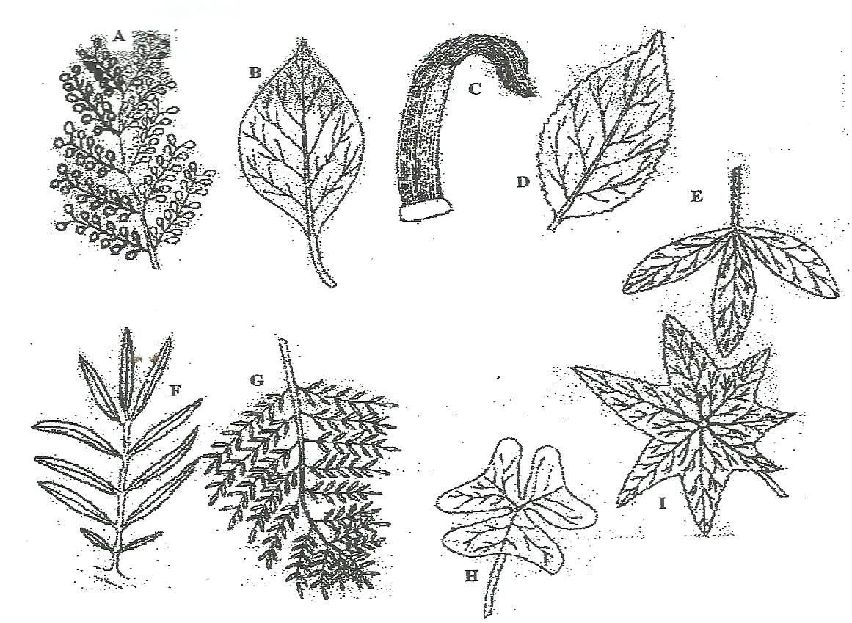

Using the key provided identify the plants from which the leaves were obtained and fill the table below. (10 mks)

KEY

- (a) Leaf simple ……………………………………………………….. Got to 2
(b) Leaf compound…………………………………………………….. Go to 5
- (a) Leaf with parallel veins …………………………………………… Maize
(b) Leaf with network of veins …………………………………………Go to 3
- (a) Leaf lobed …………………………………………………………. Castor oil
(b) Leaf not lobbed …………………………………………………… Go to 4
- (a) Leaf with a smooth margin ……………………………………….. Bougainvillea
(b) Leaf with a serrated margin ………………………………………. Hibiscus
- (a) Leaflets arising from the same point at the tip of petiole ………… Go to 6
(b) Leaflets arising at different points along the common stalk ……… Got to 7
- (a) Leaflets triangular with narrow base and broad end ……………... Oxalis
(b) Leaflets broad in the middle and narrow at both ends……………. Crotalaria
7. (a) All the leaflets attached to one main stalk ………………………. Mexican marigold
(b) Leaflets attached to several small stalks arising from the main stalk…Go to 8
8. (a) Leaflets rounded at the end and no terminal leaflet ……………… Flambouyant
(b) Leaflets points at the end terminal leaflet present ………………… Jacaranda

Leaf | Steps | Identify
A

B

C

D

E

(b) Using observable features only state the classes to which leaves C and D belong.
Leaf C
Class………………………………………………………………………………(1 mk)
Reason
……………………………………………………………………………………………..
……………………………………………………………………………………(1 mk)
Leaf D
Class ………………………………………………………………………………(1 mk)
Reason
……………………………………………………………………………………………..
…………………………………………………………………………………….(1 mk)

(c) Give the adaptation of leaf D to its photosynthesis functions. (1 mk)

…………………………………………………………………………………………………..
…………………………………………………………………………………………………..
- You are provided with food substance labelled X.
(a) Using the reagents and materials provided, carry out the appropriate food tests on food substances X. record in the table below. (12 mks)

Food substance | Procedure | Observation | Conclusion

(b) Give one end products of digestion of food substance X. (1 mk)
…………………………………………………………………………………………………..
(c) Name the regions in the alimentary canal where substance X is enzymatically digested. (3 mks)

…………………………………………………………………………………………………..
…………………………………………………………………………………………………..
…………………………………………………………………………………………………..
…………………………………………………………………………………………………..
…………………………………………………………………………………………………..
…………………………………………………………………………………………………..
…………………………………………………………………………………………………..
- Photographs J and K1 represent specimens which are obtained from different habitats. K2 represents the features of the stem of K1.
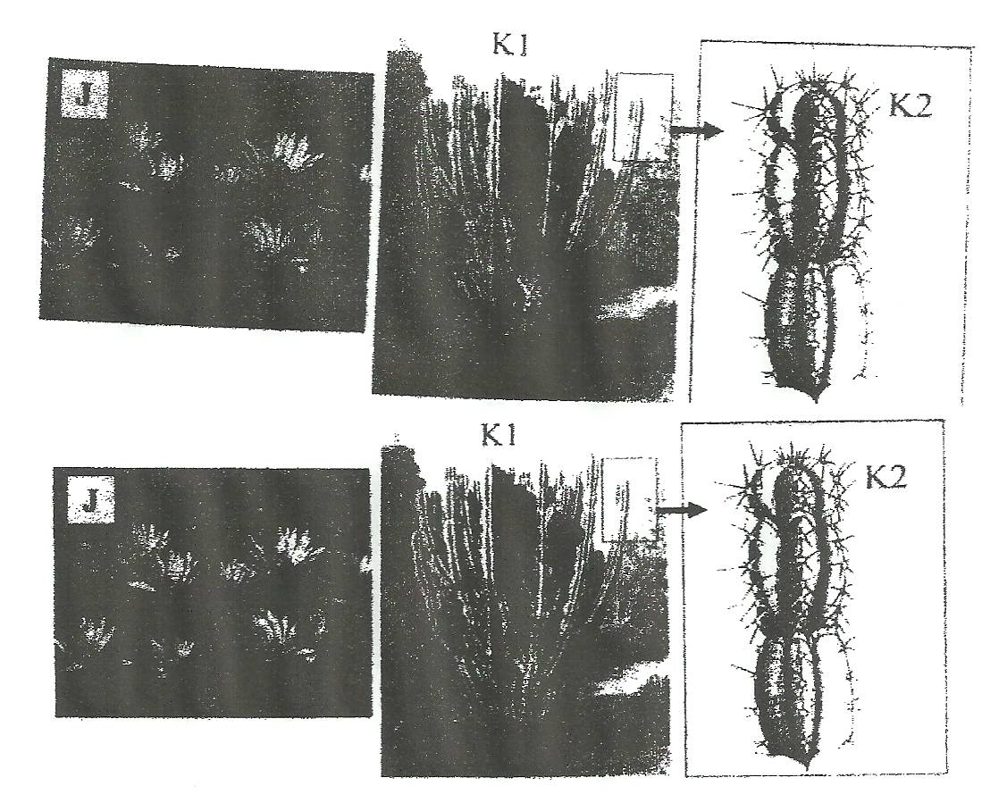

- With reasons, identify the habitat where each specimen is found. (4 mks)
…………………………………………………………………………………………………..
…………………………………………………………………………………………………..
…………………………………………………………………………………………………..
…………………………………………………………………………………………………..
…………………………………………………………………………………………………..
…………………………………………………………………………………………………..
…………………………………………………………………………………………………..
- Describe the observable features which adapt specimen K1 to its habitat. (2 mks)
…………………………………………………………………………………………………..
…………………………………………………………………………………………………..
…………………………………………………………………………………………………..
…………………………………………………………………………………………………..
…………………………………………………………………………………………………..
- State the significance of the numerous leaves in specimen J. (3 mks)
…………………………………………………………………………………………………..
…………………………………………………………………………………………………..
…………………………………………………………………………………………………..
…………………………………………………………………………………………………..
…………………………………………………………………………………………………..
…………………………………………………………………………………………………..
- Suggest expected differences between root systems of specimen J am K1. (2 mks)
…………………………………………………………………………………………………..
…………………………………………………………………………………………………..
…………………………………………………………………………………………………..
…………………………………………………………………………………………………..
…………………………………………………………………………………………………..
- Give the term used to describe plants found in the same habitat with specimen K1. (1 mk)
…………………………………………………………………………………………………..
…………………………………………………………………………………………………..

