NAME ____________________________________ INDEX NO._______________
SCHOOL _______________________________ SIGNATURE_______________ DATE _______________

312/2
GEOGRAPHY

PAPER 2

JULY/ AUGUST, 2017

TIME: 2¾ HOURS

Kenya Certificate of Secondary Education (K.C.S.E)

312/2
GEOGRAPHY
PAPER 2
TIME: 2¾ HOURS

INSTRUCTIONS TO CANDIDATES
- This paper has two sections: A and B.
- Answer all the questions in section A.
- Answer question 6 and any other two questions from Section B.
- Each question in section B must be answered in separate foolscaps.
- This paper consists of 4 printed pages.
- Candidates should check the question paper to ascertain that all pages are printed as indicated and that no questions are missing.

SECTION A
Answer all questions in this section on the foolscaps provided.
- a) Name three main mining methods. (3marks)
b) Name two places where Gold is mined in Tanzania. (2marks)

- a) Outline three characteristics of coniferous forests. (3marks)
b) Identify two fibre crops found in the tropical forests. (2marks)

- a) Apart from rivers, identify other types of inland waterways used for transport in Africa. (2marks)

b) State three reasons why there is limited use of river transport in Africa. (3marks)

- a) Name three international airports in Kenya. (3marks)
b) What is visible trade (2marks)

- a) Give three ways through which Nairobians pollute water resources within the city (3marks)
b) Identify two natural hazards that take place in Nairobi. (2marks)

SECTION B

- Study the data below and answer the questions that follow.
LEADING EXPORT CROPS FROM KENYA BY VALUE ( K SHS MILLIONS)
CROPS | HORTICULTURE | TEA | UNROASTED COFFEE
2000 | 21216 | 35150 | 11707
2001 | 19846 | 34485 | 7460
2002 | 28334 | 34376 | 6541
2003 | 36485 | 33005 | 6286
2004 | 39541 | 36072 | 6944
- i) Calculate the percentage increase in value of each export commodity between 2003 and 2004. (3marks)

ii) Using the scale 1cm represents 5 million draw a compound bar graph on crop Exports between 2000 to 2003. (6marks)

- i) State four human requirements for successful production of maize in Kenya. (4marks)
ii) List three counties in Kenya where maize is grown on large scale. (3marks)

- Explain three reasons why Kenya imports maize and wheat yet she is a producer of the same commodities. (6marks)

- State the role of the National Cereals and Produce Board (NCPB) to the agricultural sector. (3marks)

- a) i) Distinguish between land reclamation and land rehabilitation. (2marks)

ii) Apart from irrigation, name two other methods of rehabilitating land in Kenya.
(2 marks)

b) State three disadvantages of the springler method of irrigation. (3marks)

c) i) Describe the steps involved in the reclamation of land in the Netherlands used by the Zuyder Ze project. (5marks)

ii) The outline map provided shows the polders in the Netherlands.
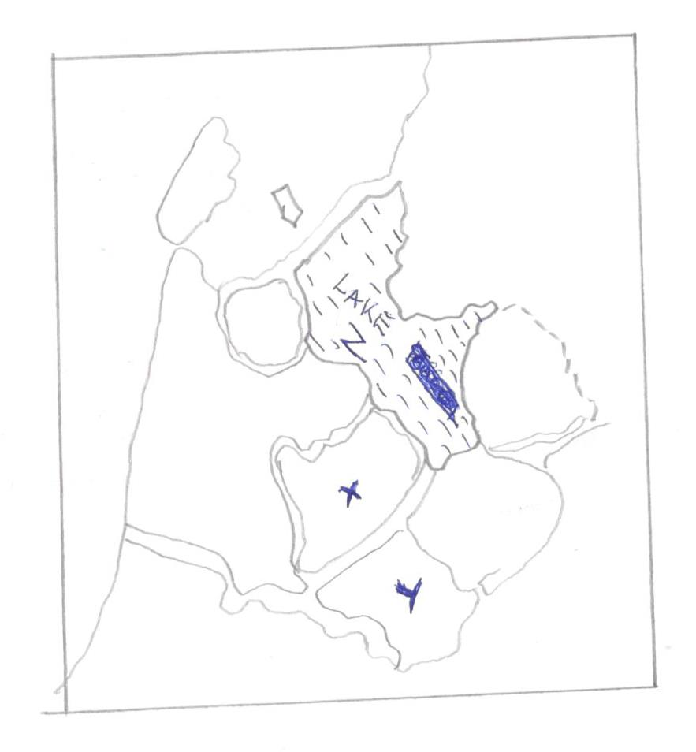
Name the polders marked X and Y (2marks)

Name the Lake marked Z (1mark)

- i) State four similarities of land reclamation in Kenya and the Netherlands. (4marks)

ii) Explain three physical reasons why Mwea is a suitable location for an irrigation scheme. (6marks)

- a) i) State two characteristics of anadromous fish. (2marks)
ii) Give three differences between demersal and pelagic fish. (6marks)

b. Explain how the following factors negatively affect fishing in Kenya

i) agricultural activities (4marks)
ii) water weeds (4marks)

c. You intend to carry out a field study on fishing in a Lake. During the study you identified the following fishing methods

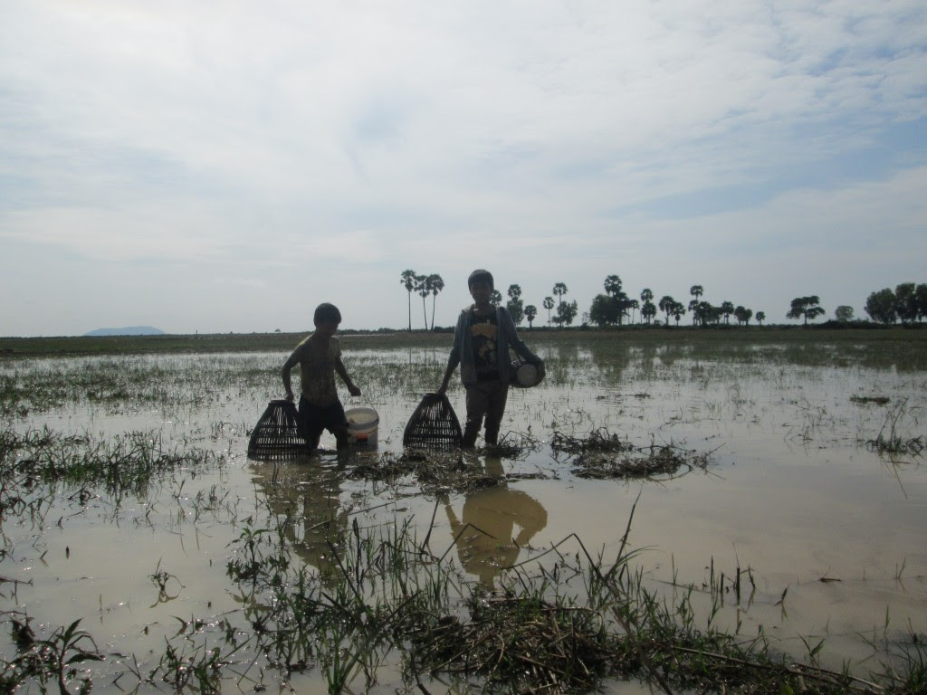
A

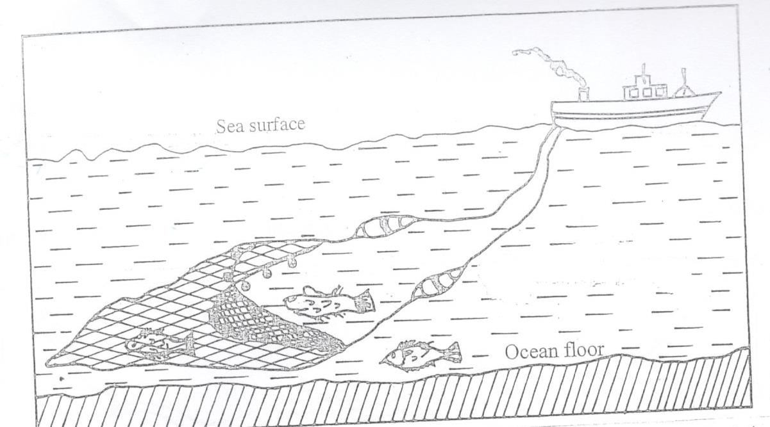
- Give two main disadvantage for each method of fishing. (4marks)
- Describe how method marked A is used in catching fish (4marks)
- State one objective which you could have set for the study (1mark)

- a) i) Identify two forms of wildlife in East Africa. (2marks

ii) State three differences between a National Park and a Game Reserve. (3marks)

b) i) Draw a sketch map of Kenya (1mark)

On the sketch map, mark and name the following

- Marsabit National Park (1mark)
- Maasai Mara Game Reserve (1mark)
ii) State four problems associated with wildlife. (4marks)
- i) Identify two inland tourist attractions in Kenya (2marks)
ii) State three factors that hinder development of domestic toursim. (3marks)
- Explain four differences between tourism in Kenya and Swizerland. (8marks)

- Study the map of the Ruhr Industrial Region below and answer the questions that follow
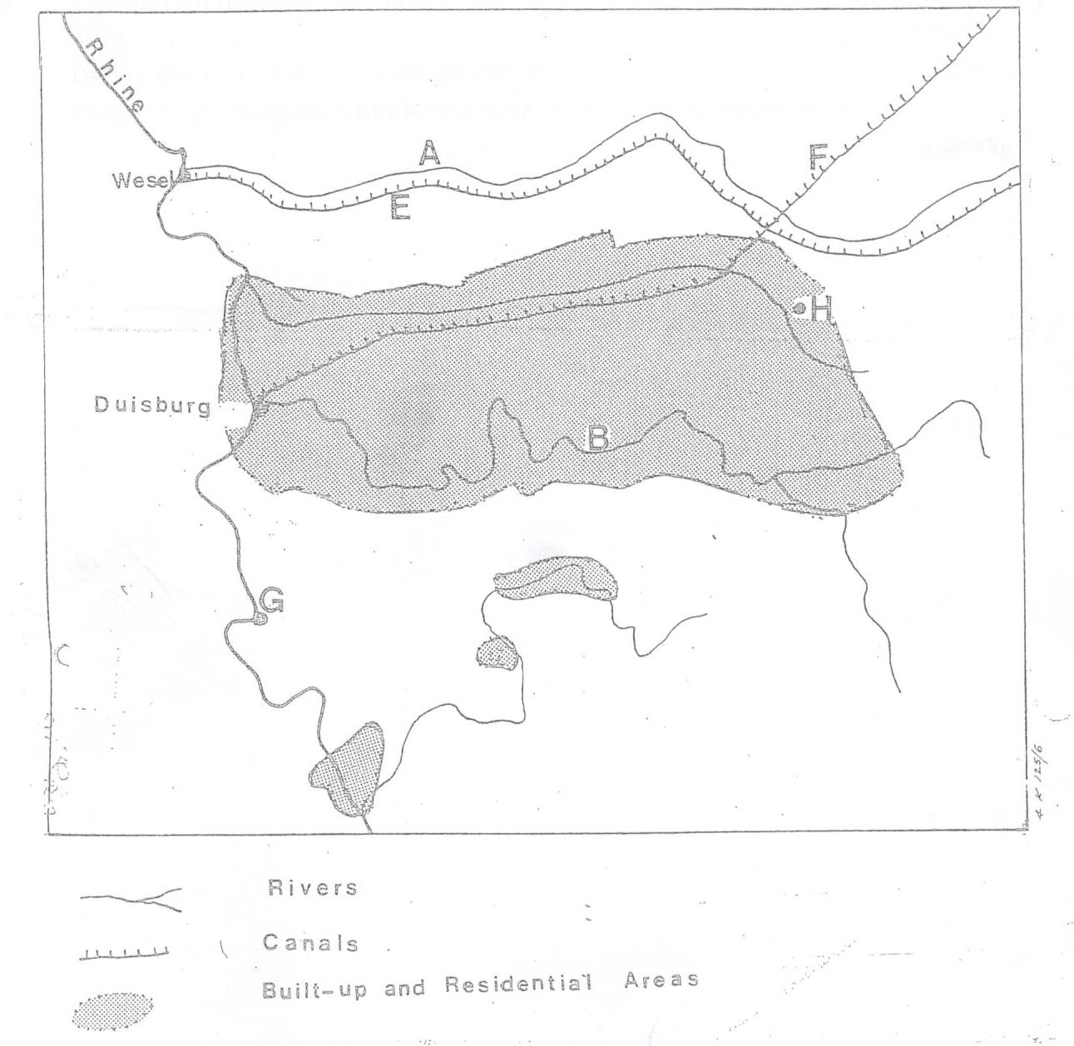
a) i) The river marked A and B (2marks)
ii) The canals marked E and F (2marks)
b) i) Why is the oil refining industry located in Changamwe Mombasa ? (2marks)
ii) Explain three reasons a government may have for influencing the location of an industry in rural areas. (6marks)
iii) Explain three reasons that infuence the development of light industries more than heavy industries in East Africa. (6marks)
c. i) Give four broad categories of tertiary industries in Kenya (4marks)
ii) State three features of cottage industries in India. (3marks)

