NAME:………………………………………….. INDEX NO……………………………………..
SCHOOL:……………………………………… CANDIDATE’S SIGN ………………………..
DATE …………………………………………..
121/1
MATHEMATICS
Paper 1
July/August - 2017
Time: 2 ½ Hours

SUKEMO JOINT EVALUATION TEST- 2017
Kenya Certificate of Secondary Education (K.C.S.E)

121/1
MATHEMATICS
Paper 1
July/August - 2017
Time: 2 ½ Hours

INSTRUCTIONS TO CANDIDATES
1. Write your name and index number in the spaces provided above.
2. The paper contains two sections, Section I and II
3. Answer all questions in section I and ONLY any FIVE questions from section II.
4. All answers and working must be shown on the question paper in the spaces below each question
5. Show all steps in your calculations, giving answers at each stage
6. Marks may be given for each correct working even if the answer is wrong
7. Non-programmable silent electronic calculators and KNEC mathematical tables may be used.

FOR EXAMINERS USE ONLY

Section I
1 | 2 | 3 | 4 | 5 | 6 | 7 | 8 | 9 | 10 | 11 | 12 | 13 | 14 | 15 | 16 | Total

Section II Grand Total
17 | 18 | 19 | 20 | 21 | 22 | 23 | 24 | Total

This paper consists of 16 printed pages. Candidates should check the question paper to ensure that all pages are printed as indicated and no questions are missing.

SECTION I (50 MARKS)
Answer all questions in this Section

- Evaluate : (3 marks)

2. Simplify completely (3mks)
$\frac{12x^{2}-11xy+2y^{2}}{18x^{3}-8{xy}^{2}}$

3. Use the exchange rates below to answer this question.
Buying Selling
1 US dollar 63.00 63.20
1 UK £ 125.30 125.95
A tourist arriving in Kenya from Britain had 9600 UK Sterling pounds (£). He converted the pounds to Kenya shillings at a commission of 5%. While in Kenya, he spent ¾ of this money. He changed the balance to US dollars after his stay. If he was not charged any commission for this last transaction, calculate to the nearest US dollars, the amount he received. (3mks)

4. Solve for x in the following equation. (3mks)
4^{x} (8^{x - 1}) = tan 45º

5. The sum of interior angles of two regular polygons of sides; n and n + 2 are in the ratio 3:4. Calculate the sum of the interior angles of the polygon with n sides. (3mks)

6. Use logarithms to evaluate the following correct to 4 decimal places.
(3mks)

7. Find the region defined by the following inequalities (3mks)
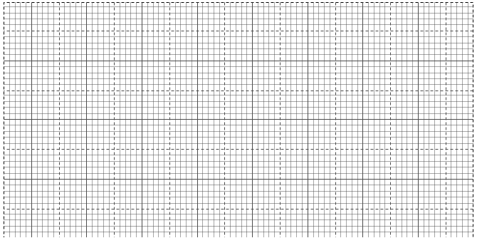
2y < x + 4; 4y ≥ -x – 4; x ≤ 2

8. Find the equation of locus of points equidistant from A (6, 5) and B (-2, 3) (3mks)

9. The GCD three numbers is 6 and their LCM is 900. If two of the numbers are 36 and 60, find the least possible third number. (3mks)

10. Use the tables of squares, cube roots and reciprocals to evaluate (3mks)
$$\frac{\sqrt[3]{0.008}}{0.375}- \frac{10}{{37.5}^{2}}$$

11. Solve the following pair of simultaneous equations using substitution method (3mks)
$4b+3t-475=0$
$5t+2b=325$

12. Given that Sin θ = 4/5 and θ is an acute angle, find without using tables or calculators
(a) Tanθ (2mks)

- Cos (180 - θ) (1mk)

13. The figure below is a triangular prism of uniform cross-section in which AF = FB =3cm,
AB = 4cm and BC = 5cm. Draw a clearly labeled net of the prism. (3mks)
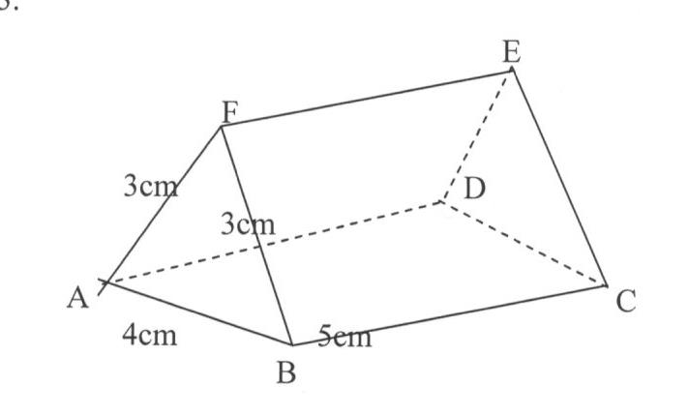

14. The mass of two similar cans is 960g and 15000g. If the total surface area of the smaller can is 144cm², determine the surface area of the larger can. (3mks)

15. In the circle O is the centre, angle DAB = 87⁰ Arc AB is twice arc AD.TD is a tangent to the circle at D. Giving reasons, Calculate
(i) Angle AOB. (2mks)

(ii) Angle ADT (2mks)

T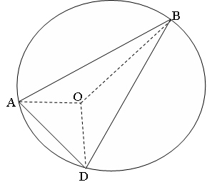

16. A sector of a circle of radius 42cm subtends an angle of ${120}^{0}$ at the centre of the circle. The sector is folded into an inverted right cone. Calculate
(i) The base radius of the cone (3mks)

(ii) To one decimal place the vertical height of the cone (1mk)

SECTION II: 50 MARKS
Answer any FIVE questions in this section

- A bus and a Nissan left Nairobi for Eldoret, a distance of 340 km at 7.00 a.m. The bus travelled at 100km/h while the Nissan travelled at 120km/h. After 30 minutes, the Nissan had a puncture which took 30 minutes to mend
- Find how far from Nairobi the Nissan caught up with the bus (5marks)

- At what time of the day did the Nissan catch up with the bus? (2marks)

- Find the time at which the bus reached Eldoret (3marks)

- In the diagram below OA = a, OB = b the points P and Q are such that AP = ²/₃ AB, OQ = ¹/₃ OA

(a) Express OP and BQ in terms of a and b (2 mks)

(b) If OC = hOP and BC = kBQ, Express OC in two different way and hence
(i) Deduce the value of h and k. (5 mks)

(ii) Express vector OC in terms of a and b only. (2 marks)

(iii) State the ratio in which C divides BQ (1 mk)

- The table alongside shows the marks scored in a Chemistry test.

- Calculate the mean mark (3mks)
Marks | Frequency
5 – 14 | 3
15 – 34 | 19
35 – 54 | 50
55 – 84 | 26
85 – 94 | 2

- Draw a histogram to represent the above information (4mks)
- Using the histogram, find the median mark (3mks)

20. Given the quadratic function y = 3x² + 4x - 2
a) Complete the table below for values of x ranging - 4 < x < 3. (2mks)

x | -4 | -3 | -2 | -1 | 0 | 1 | 2 | 3
y
b) Using the grid provided draw the graph of y = 3x² + 4x – 2 for -4 < x < 3 (3mks)

c) Using the graph, find the solution to the equations.
i) 3x² + 4x – 2 = 0 (2mks)

ii) 3x² + 7x + 2 = 0 (3mks)

21. A triangle ABC has vertices A(2,1), B(5,2) and C(0,4).

(a) On the grid provided plot the triangle ABC. (2 mks)
(b) A¹B¹C¹ is the image of ABC under a translation $\left(\begin{matrix}2 \\ -5\end{matrix}\right)$. Plot A¹B¹C¹ and state its coordinates.(2mks)
(c) Plot A¹¹B¹¹C¹¹ the image of A¹B¹C¹ after a rotation about the origin through a negative quarter turn. State its coordinates. (3 mks)
(d) A¹¹¹B¹¹¹C¹¹¹ is the image of A¹¹B¹¹C¹¹ after a reflection on the line y = 0.
Plot A¹¹¹B¹¹¹C¹¹¹ and state its coordinates. (3 mks)


22. Two bus stations P and Q are such that Q is 500km due East of P. Two buses M and N
Leave from P and Q respectively at the same time. Bus M moves at 360km/h on a bearing of
N 30⁰E. Bus N moves at a speed of 240km/h on a bearing of N45⁰W. The two buses stop after 1 ½ hrs.
Using a scale of
a) Show the relative positions of the buses after 1 ½ hrs. (6mks)

(b) Find the distance between the buses after 1 ½ hrs. (2mks)

(c) Find the true bearing of;
i) M from N

ii) N from M after 1 ½ hrs. (2mks)

23. The diagram below represents square based pyramid standing vertically. AB = 12cm, PQ = 4cm and the height of pyramid PQSV is 10cm.
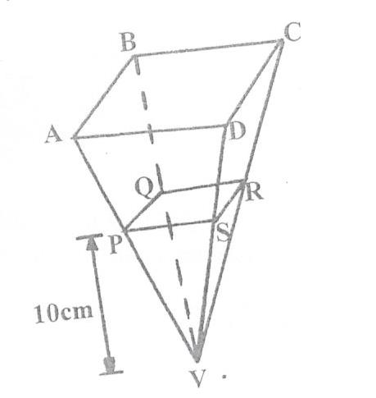

V

- If PQRSV is a solid, find the volume of material used to make it. (2mks)

- Find the
- height of the frustrum ABCDPQRS (2mks)

- Volume of the frustrum (3mks)

- The liquid from a hemisphere is poured into PQRS. Find radius correct to 4 significant figures of the hemisphere if the liquid from hemisphere filled the solid completely.$Use π=\frac{22}{7}$ (3mks)

- The displacement h metres of a particle moving along a straight line after t seconds
is given by h = -2t³ + ³/₂ t² + 3t
(a) Find the initial acceleration. (3mks)

(b) Calculate
(i) The time when the particle was momentarily at rest. (3mks)

(ii) Its displacement by the time it comes to rest momentarily. (2mks)

(c ) Calculate the maximum speed attained. (2mks)

