NAME………………………….………………. DATE ……………………

INDEX NO. ……….……….…………………. SIGNATURE ……………………

232/1
PHYSICS
PAPER 1
TIME: 2 HOURS.
FORM FOUR
SUKEMO JOINT MOCK 2017
Kenya Certificate of Secondary Education.

INSTRUCTIONS TO CANDIDATES
- Write your name and your index number in the spaces provided above.
- This paper consists of two sections A and B
- Answer all questions in section A and B in the space provided
- All working must be shown in the spaces provided in this booklet.
- Mathematical tables and silent electronic calculators may be used

FOR OFFICIAL USE

Section | Question | Max. score | Candidate’s score
A | 1-11 | 25
B | 12 | 11
 | 13 | 12
 | 14 | 10
 | 15 | 9
 | 16 | 13
TOTAL SCORE |  | 80

This paper consists of 11 printed pages. Candidates should check to ensure that all pages are printed as indicated and that no questions are missing

SECTION A (25 MARKS)
Answer all the questions in this section in the spaces provided
- The figure below shows the change in volume of a liquid in a measuring cylinder when an irregular solid is immersed in it.
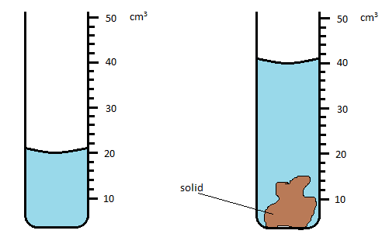
Given that the mass of the solid is 75.0 g, determine the density of the solid in SI units. (2 marks)
……………………………………………………………………………………………………………………………………………………………………………………………………………………………………………………………………………………………………………………………………………………………………………………………………………………………………………………
- The figure below shows a vernier caliper scale.
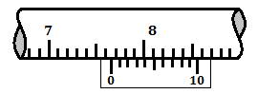
State the correct reading of scale if the instrument has a zero error of -0.02cm. (2 marks)
………………………………………………………………………………………………………………………………………………………………………………………………………………………………………………………………………………………………………………………………………
- The air pressure at sea level is 75cm of mercury. Given the density of mercury is 13600 kg/m³ and the average density of air is 1.25 kg/m³. Calculate the air pressure in cm of mercury at the top of a mountain of height 1600m. (3 marks)
……………………………………………………………………………………………………………………………………………………………………………………………………………………………………………………………………………………………………………………………………………………………………………………………………………………………………………………
- A student observed the smoke particles in a smoke cell and noted that they moved in a random way. Explain this observation. (2 marks)
………………………………………………………………………………………………………………………………………………………………………………………………………………………………………………………………………………………………………………………………………
- The figure below shows a glass tumbler partly filled with water at room temperature
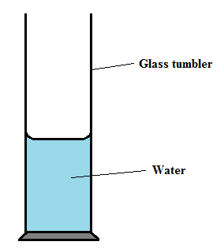
Briefly explain what happens to the stability of the tumbler when water is cooled to a temperature of 0⁰C from 5⁰C (2 marks)
………………………………………………………………………………………………………………………………………………………………………………………………………………………………………………………………………………………………………………………………………
- Two similar cans are partly filled with equal quantities of water. Each holds a thermometer and are placed at equal distances from a radiant heater as shown in the figure below.
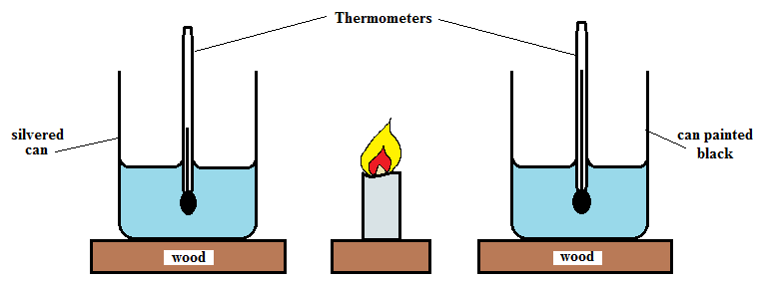
State with reason, the container in which the temperature is likely to be higher after a few minutes. (2 marks)
…………………………………………………………………………………………………………………………………………………………………………………………………………………………
- After a piece is cut off from a uniform metre rule, the remainder of it was found to balance at 46 cm mark. To make it, balance at 50cm, a 20g mass was suspended at the 75-cm mark. Find the mass of the shortened rule. (3 marks)
………………………………………………………………………………………………………………………………………………………………………………………………………………………………………………………………………………………………………………………………………………………………………………………………………………………………………………………………………………………………………………………………………………………………………………………………………………………………………………………………………………
- Calculate the total extension for the system below
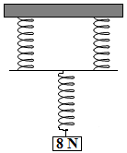
Given that the spring constant for each spring is 40 N/m. (2 marks)
…………………………………………………………………………………………………………………………………………………………………………………………………………………………………………………………………………………………………………………………………………………………………………………………………………………………………………………………………………………………………………………………………………………………………
- The figure below represents an aerofoil plate moving through air. The speed of the plate is initially very high in the horizontal direction.
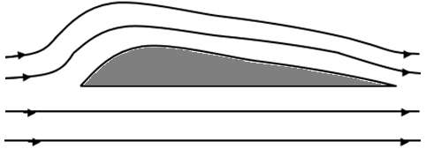
- Indicate on the diagram region experiencing high pressure (1 mark)

- Explain your answer above (1 mark)

……………………………………………………………………………………………………………………………………………………………………………………………………………………
- A body is dropped from a height of 90 m from the ground. At the same time another body is projected vertically upwards from the ground with a velocity of 30m/s. After how long will the two bodies pass each other. (3 marks)
………………………………………………………………………………………………………………………………………………………………………………………………………………………………………………………………………………………………………………………………………………………………………………………………………………………………………………………………………………………………………………………………………………………………………………………………………………………………………………………………………………
- The figure below shows a glass tube containing enclosed air in the closed end of a horizontal tube of mercury. The length of the trapped air is 150mm while that of mercury is also 150mm.
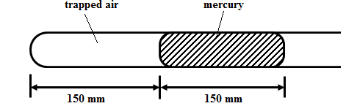
The other end of the tube is open and the atmospheric pressure is 750 mmHg. Calculate the length of the enclosed air if the tube is turned until it is vertical with open end up. (2 marks)
………………………………………………………………………………………………………………………………………………………………………………………………………………………………………………………………………………………………………………………………………………………………………………………………………………………………………………………………………………………………………………………………………………………………………………………………………………………………………………………………………………

SECTION B 55 (MARKS)
Answer all the questions in this section in the spaces provided
- (a) Distinguish between perfect elastic and inelastic collision (1 mark)
………………………………………………………………………………………………………………………………………………………………………………………………………………………………………………………………………………………………………………………………………
(b) A car of mass 1000kg moving with a speed of 10m/s crushes into a wall and comes to rest in 0.4 s. Find
- the impulse (2 marks)
………………………………………………………………………………………………………………………………………………………………………………………………………………………………………………………………………………………………………
- the average force exerted by the wall. (2 marks)
…………………………………………………………………………………………………………………………………………………………………………………………………………………………………………………………………………………………………………………………………………………………………………………………………………
(c) A bullet of mass 30 g is fired at a speed of 600m/s from a gun of mass 5.0 kg at rest. Calculate the recoil velocity of the gun when the bullet is fired. (3 marks)
……………………………………………………………………………………………………………………………………………………………………………………………………………………………………………………………………………………………………………………………………………………………………………………………………………………………………………………………………………………………………………………………………………………
(d) A mass of 100g falls 5 m from rest and stops after penetrating 0.5 m in the sand, show that the force exerted on it by the sand is 11N. (3 marks)
……………………………………………………………………………………………………………………………………………………………………………………………………………………………………………………………………………………………………………………………………………………………………………………………………………………………………………………………………………………………………………………………………………………

- (a) Name a device used to convert light energy directly into electrical energy. (1 mark)
……………………………………………………………………………………………………………………………………………………………………………………………………………………………………………………………………………………………………………………………………………………………………………………………………………………………………………………………………………………………………………………………………………………
(b) A girl whose mass is 60 kg runs up a flight of 20 steps each 15 cm in 40 seconds. Calculate the power developed by the girl. (2 marks)
……………………………………………………………………………………………………………………………………………………………………………………………………………………………………………………………………………………………………………………………………………………………………………………………………………………………………………………………………………………………………………………………………………………
(c) (i) The figure below shows an incomplete arrangement of the pulley. Draw on the diagram the string arrangement that would give a velocity ratio of 3. (1 mark)
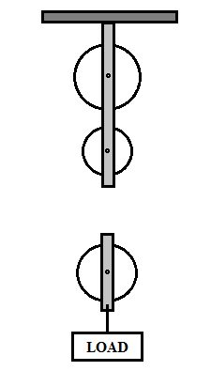
(ii) The pulley system is used to raise a load of 160 N through a distance of 40m. If the effort applied is 80N, determine
- Mechanical advantage (2 marks)
………………………………………………………………………………………………………………………………………………………………………………………………………………………………………………………………………………………………………………………………………………………………………………………………
- Efficiency of the pulley system (3 marks)
………………………………………………………………………………………………………………………………………………………………………………………………
(d) A wooden plank 10m long was used to raise a load to a platform 4 m high as shown in the diagram.
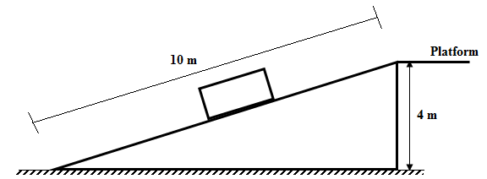
- Indicate on the diagram with an arrow the direction of effort (1 mark)
- Determine the velocity ratio of the arrangement (2 marks)
………………………………………………………………………………………………………………………………………………………………………………………………………………………………………………………………………………………………………………
- (a) Define the term heat capacity (1 mark)
…………………………………………………………………………………………………………………………………………………………………………………………………………………………
(b) In an experiment to determine the specific latent heat of vaporization L_{V} of water, steam was passed into cold water in a copper calorimeter. The following data was obtained.
Mass of the calorimeter = 105.2 g
Mass of the calorimeter + water =228g
Mass of the calorimeter + water + steam = 231.2 g
Temperature of the cold water =18.0⁰C
Final temperature of the water =29.0⁰C
Temperature of the steam = 100⁰C
- Determine the mass of steam that condensed (1 mark)
…………………………………………………………………………………………………………………………………………………………………………………………………………
- Calculate the amount of heat lost by the condensed steam (specific heat capacity of water 4200J/kgK) (3 marks)
………………………………………………………………………………………………………………………………………………………………………………………………………………………………………………………………………………………………………………………………………………………………………………………………………………………………………………………………………………………………………………………………………………………………………………………………………………………………
- Calculate the amount of heat absorbed by water and the calorimeter (specific heat capacity of copper =390 J/kgK) (3 marks)
……………………………………………………………………………………………………………………………………………………………………………………………………………………………………………………………………………………………………………………………………………………………………………………………………………………………………………………………………………………………………………………………………………………………………………………………………………………………………………………………………………………………………………………………………
- Calculate the specific latent heat of vaporization L_{V} of water (2 marks)
…………………………………………………………………………………………………………………………………………………………………………………………………………………………………………………………………………………………………………………………………………………………………………………………………………………………………………………………………………………………………………………………
- (a) Define angular velocity of a body moving in a circular path (1 mark)
……………………………………………………………………………………………………………………………………………………………………………………………………………………
(b) An object of mass 500g tied to the end of a rope is rotated in a horizontal circle of radius 2.0 m at a frequency of 2 Hz. Determine;
- the uniform speed of the mass. (3 marks)
…………………………………………………………………………………………………………………………………………………………………………………………………………………………………………………………………………………………………………………………………………………………………………………………………………………………………………………………………………………………………………………………
- the tension developed in the rope (2 marks)
…………………………………………………………………………………………………………………………………………………………………………………………………………………………………………………………………………………………………………………………………………………………………………………………………………………………………………………………………………………………………………………………

(c) If the same object is now rotated in a vertical circle of the same radius with the same speed, determine the
- maximum tension (2 marks)
……………………………………………………………………………………………………………………………………………………………………………………………………………………………………………………………………………………………………………………………………………………………………………………………………………………
- minimum tension in the rope (1 mark)
…………………………………………………………………………………………………………………………………………………………………………………………………………

- (a) State the law of floatation (1 mark)
……………………………………………………………………………………………………………………………………………………………………………………………………………………
(b) The figure below shows a block of mass 250g and density 200 kg/m³ submerged in a certain liquid and suspended from a homogenous horizontal beam by means of a thread. A mass of 200g is suspended from the beam as shown in the figure below.
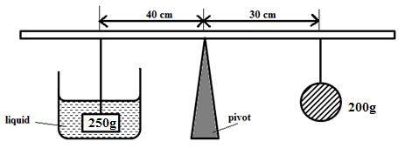
- Determine the upthrust force acting on the block (3 marks)
…………………………………………………………………………………………………………………………………………………………………………………………………………………………………………………………………………………………………………………………………………………………………………………………………………………………………………………………………………………………………………………………

- Calculate the density of the liquid (3 marks)
………………………………………………………………………………………………………………………………………………………………………………………………………………………………………………………………………………………………………………

(c) The figure below shows a piece of alluminium suspended from a string and completely immersed in a container of water. The mass of the alluminium is 1kg and its density is 2.7 × 10³ kg/m³. Take density of water 1000kg/m³
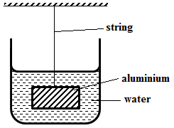
Calculate the tension in the string. (3 marks)
………………………………………………………………………………………………………………………………………………………………………………………………………………………………………………………………………………………………………………………………………………………………………………………………………………………………………………………………………………………………………………………………………………………………………………………………………………………………………………
(d) The figure below shows a ball fully immersed in water and held with a string attached at the bottom.
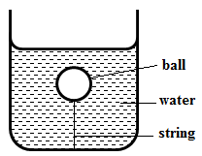

- Indicate on the diagram two forces acting on the ball (2 marks)

- If the mass of the ball is 0.5 kg, calculate the upthrust on the ball given that the tension on the string is 2 N. (1 mark)
………………………………………………………………………………………………………………………………………………………………………………………………………………………………………………………………………………………………………………………………………………………………………………………………………………………………

