SUKEMO JET - 2017

PHYSICS
PAPER 2
(Theory)
JULY/AUG. 2017
2 HOURS

Name...................................................................................Index Number......................../............
Adm……Class: ……....Candidate’s Signature..........................................Date...........................

INSTRUCTIONS TO CANDIDATES
- Write your name, admission number and index number in the spaces provided above.
- Sign and write the date of examination in the spaces provided above
- This paper consists of TWO sections A and B
- Answer ALL the questions in section A and B in the spaces provided
- All working MUST be clearly shown
- Electronic calculators and mathematical tables may be used.
- ALL numerical answers must be expressed in decimal notation.
- This paper has 13 pages. It is the responsibility of the candidate to ascertain that all the pages are printed as indicated and that no questions are missing.
- Candidates should answer the questions in English.
For Examiners Use Only

Section | Question | Maximum Score | Candidate’s Score
A | 1 – 12 | 25
B | 13 | 08
 | 14 | 09
 | 15 | 09
 | 16 | 13
 | 17 | 07
 | 18 | 09
TOTAL |  | 80

SECTION A
Answer ALL the questions in this section in the spaces provided
- Figure 1 below shows a ray of light incident on a mirror at an angle of 45º. Another mirror is placed at an angle of 45º to the first one as shown.
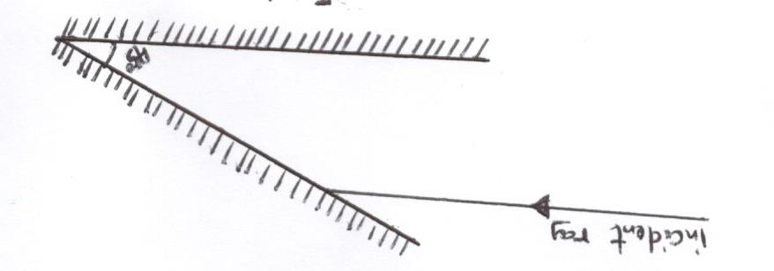

Indicate on the diagram the path of the reflected ray after passing between the mirrors. (2mks)

- a) State the reason why primary cells are said not to be rechargeable. (1mk)
-----------------------------------------------------------------------------------------------------------------------------------------------------------------------------------------------------------------------------------------------------------------------------------------------------------------------------------------------
b) A current of 4mA passes a circuit for 20 minutes. How much charge passes through a point in the circuit. (2mks)
-----------------------------------------------------------------------------------------------------------------------------------------------------------------------------------------------------------------------------------------------------------------------------------------------------------------------------------------------------------------------------------------------------------------------------------------------------------------------------------
- a) Define an echo as used in physics (1mk)
------------------------------------------------------------------------------------------------------------------------------------------------------------------------------------------------------------------------------------------
b) A girl standing 600m away from a cliff bangs two pieces of wood together and hears an echo 3.5 seconds later. Determine the speed of sound in air. (2mks)
-----------------------------------------------------------------------------------------------------------------------------------------------------------------------------------------------------------------------------------------------------------------------------------------------------------------------------------------------------------------------------------------------------------------------------------------------------------------------------------
- Figure 2 shows the cross-section of a conductor held between two magnets and carrying a current into the paper.
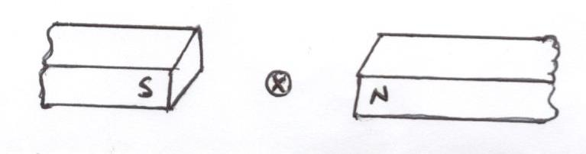
Indicate with an arrow (F) the direction in which the conductor will move to when released.
(1mk)

- Figure 3 shows a vertical object, O, placed in front of a concave mirror.(not drawn to scale)
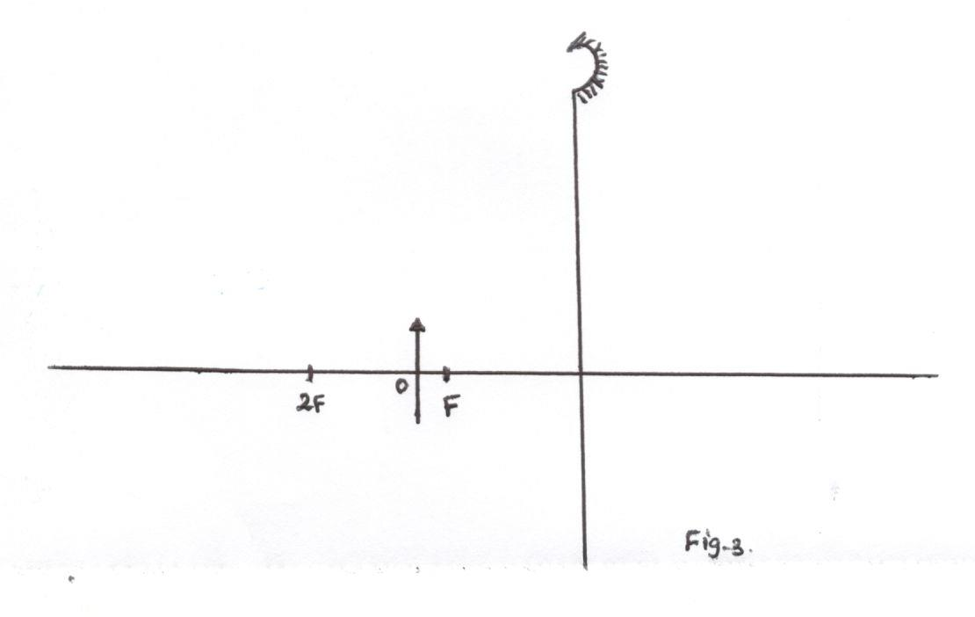
On the same diagram, draw the appropriate rays and locate the position image formed. (3mks)
b) The power of the lens (concave) is given as 15 dioptres. Determine its focal length (f). (1mk)
------------------------------------------------------------------------------------------------------------------------------------------------------------------------------------------------------------------------------------------
- The figure 4 below represents a displacement-time graph for a wave.
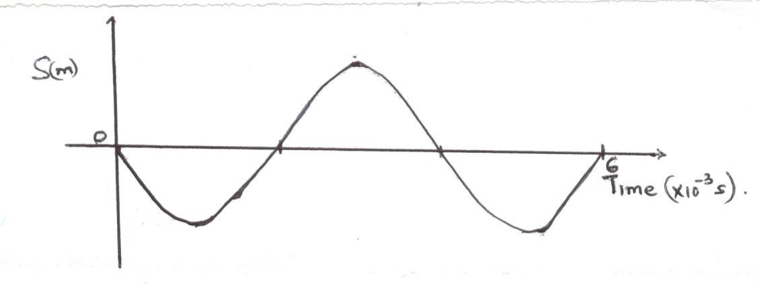
Determine the frequency of the wave. (3mks) ----------------------------------------------------------------------------------------------------------------------------------------------------------------------------------------------------------------------------------------------------------------------------------------------------------------------------------------------------------------------------------------------------------------------------------------------------------------------------------------------------------------------------------------------------------------------------7. Other than same frequency, state any other condition for the formation of standing wave.
(1mk)
----------------------------------------------------------------------------------------------------------------------------------------------------------------------------------------------------------------------------------------

- Figure 5 below shows a semicircular glass prism. A ray of light is incident as shown.
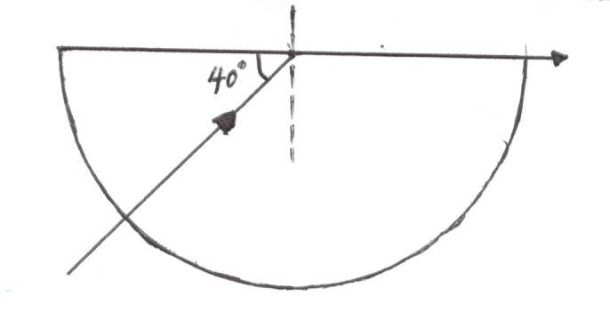
Calculate the refractive index of the glass prism. (2mks)
------------------------------------------------------------------------------------------------------------------------------------------------------------------------------------------------------------------------------------------------------------------------------------------------------------------------------------------------------------------------------------------------------------------------------------------------------------------------------------
- State the adjustment on the x-ray tube to produce a more intense beam of x-rays.
(1mk)
---------------------------------------------------------------------------------------------------------------------------------------------------------------------------------------------------------------------------------------
- A coil wire is connected in series with a battery, a switch in figure 6 below.
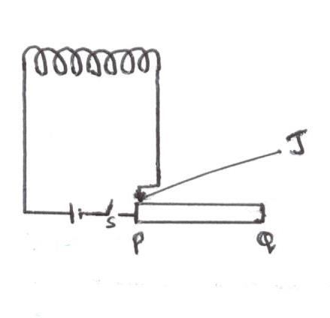
If the jockey J on the rheostat is moved towards Q what is the effect on: -
- The resistance of the circuit (1mk)
---------------------------------------------------------------------------------------------------------------------------------------------------------------------------------------------------------------------------------------
- The current through the coil (1mk)
----------------------------------------------------------------------------------------------------------------------------------------------------------------------------------------------------------------------------------------

- A form four student made a circuit (a) and (b) below and used them to investigate diode characteristics.
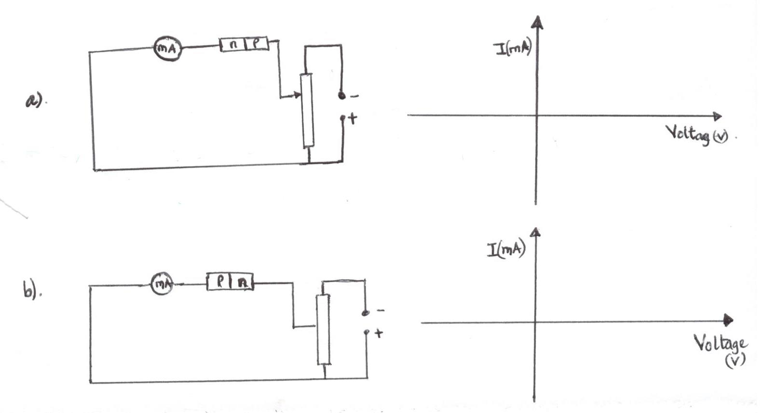

Sketch how the current varied with voltage in both (a) and (b) on the axes provided. (2mks)
- Arrange the following in order of increasing energy.
Visible light, infra-red, radiation, x-rays, u.v radiation, radio waves (1mk)
------------------------------------------------------------------------------------------------------------------------------------------------------------------------------------------------------------------------------------------------------------------------------------------------------------------------------------

SECTION B (55 MARKS)

Answer ALL the questions in this section in the spaces provided.

- a) An electric bulb is rated 210w, 240v what does it mean. (1mk)
------------------------------------------------------------------------------------------------------------------------------------------------------------------------------------------------------------------------
b) Two light bulbs x and y are rated 60w, 220v and 80w, 220v respectively.
- Which of the bulbs draws more current. (1mk)
--------------------------------------------------------------------------------------------------------------------------------------------------------------------------------------------------------------------------------
- Calculate the cost of using the two bulbs, if the bulbs above are used for 10 hours daily for 10 days. (1kwhr = ksh.7.20). (2mks)
--------------------------------------------------------------------------------------------------------------------------------------------------------------------------------------------------------------------------------------------------------------------------------------------------------------------------------------------------------------
c) A cell supplies a current of 2.4 A through a 2.4Ω resistor and a current of 4A through a 1.4 Ω resistor. Calculate the e.m.f ( E ) and the internal resistance ,r, of the cell. (3mks)
-----------------------------------------------------------------------------------------------------------------------------------------------------------------------------------------------------------------------------------------------------------------------------------------------------------------------------------------------------------------------------------------------------------------------------------------------------------------------------------d) State reasons why in modern domestic wiring circuit breakers are preferred to fuses. (1mk)
------------------------------------------------------------------------------------------------------------------------------------------------------------------------------------------------------------------------------------------

- a) Define cathode rays (1mk)
---------------------------------------------------------------------------------------------------------------------s------------------------------------------------------------------------------------------------------------------------------------------------------------------------------------------------------------------------------------------

b) Explain clearly the function of the grid in the cathode ray oscilloscope. (2mks)
---------------------------------------------------------------------------------------------------------------------------------------------------------------------------------------------------------------------------------------------------------------------------------------------------------------------------------------------------------------
c) The figure 7 shows a display of an a.c signal on the CRO screen.
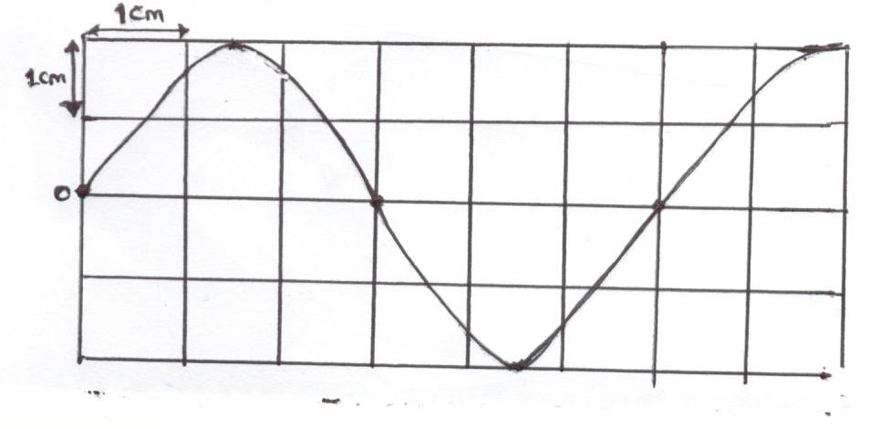
Given that the time-base setting is 100mS per division and y-gain (sensitivity) is 25v/division. Determine:
- the frequency of the wave (3mks)
------------------------------------------------------------------------------------------------------------------------------------------------------------------------------------------------------------------------------------------------------------------------------------------------------------------------------------------------------------------------------------------------------------------------------------------------------------------------------------
- the peak-voltage (3mks)
------------------------------------------------------------------------------------------------------------------------------------------------------------------------------------------------------------------------------------------------------------------------------------------------------------------------------------------------------------------------------------------------------------------------------------------------------------------------------------
d) State reason why magnetic fields are preferred to electric fields in deflecting the beam of electrons in CRT television set. (1mk)
---------------------------------------------------------------------------------------------------------------------------------------------------------------------------------------------------------------------------------------------------------------------------------------------------------------------------------------------------------------
- a) State how intensity of an incident radiation affects the number of photoelectrons emitted from a metal surface. (1mk)
--------------------------------------------------------------------------------------------------------------------------------------------------------------------------------------------------------------------------------------------------------------------------------------------------------------------------------------------------------------
b) Figure 8 is a graph of the stopping potential, Vs against frequency in an experiment on photoelectric effect.
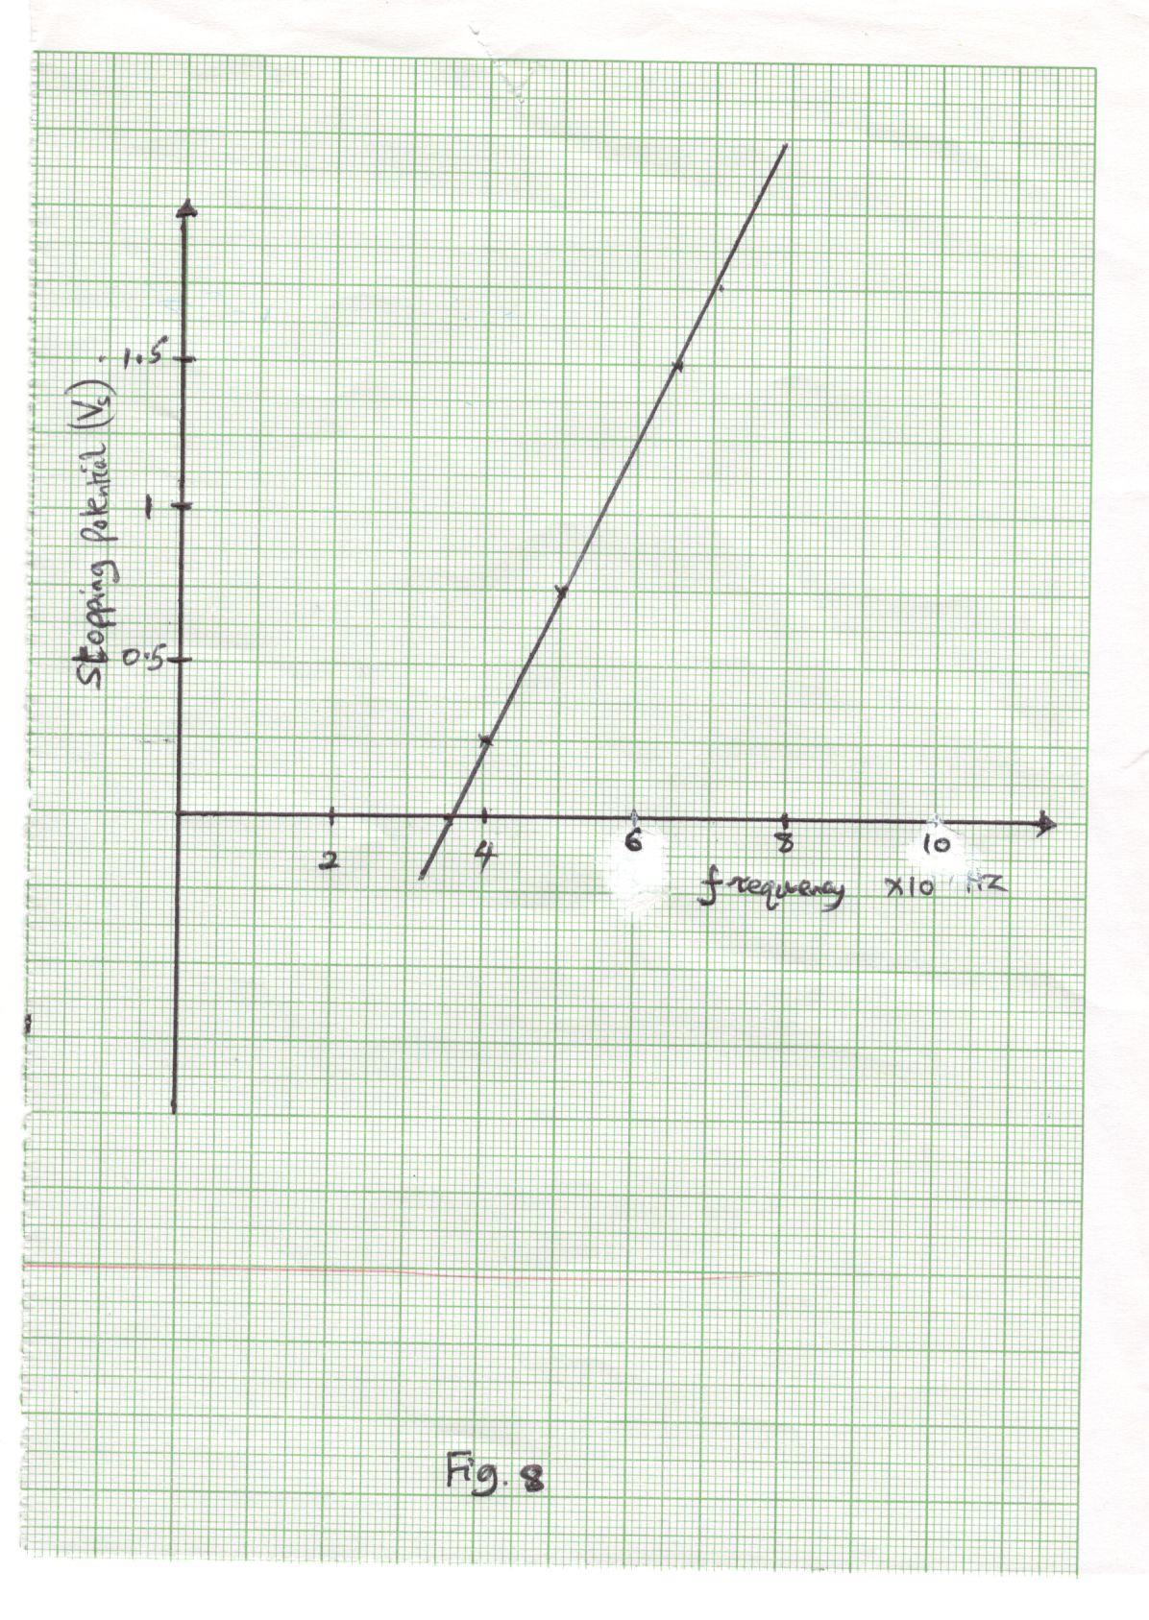

- Define the term stopping potential (Vs) (1mk)
-------------------------------------------------------------------------------------------------------------------------------------------------------------------------------------------------------------------------------------------------------------------------------------------------------------------
- Given that the stopping potential, Vs is related to the frequency by the equation Vs = $\frac{h}{e}f- \frac{∅}{e}$ where e = 1.602 x 10⁻¹⁹C. Calculate
- Plank’s constant, h (4mks)
------------------------------------------------------------------------------------------------------------------------------------------------------------------------------------------------------------------------------------------------------------------------------------------------------------------------------------------------------------------------------------------------------------------------------------------------------------------------------------------------------------------------------------------------------------------------------------------------------------------------------------------------------------------------------------------------
- The work function, $∅$, of the metal in ev. (2mks)
---------------------------------------------------------------------------------------------------------------------------------------------------------------------------------------------------------------------------------------------------------------------------------------------------------------------------------------------------------------------------------------------------------------------------------------------------------------
- a) Define half-life of an element. (1mk)

b) Figure a shows a Guiger uller (G.M) tube use it to answer the questions that follow.

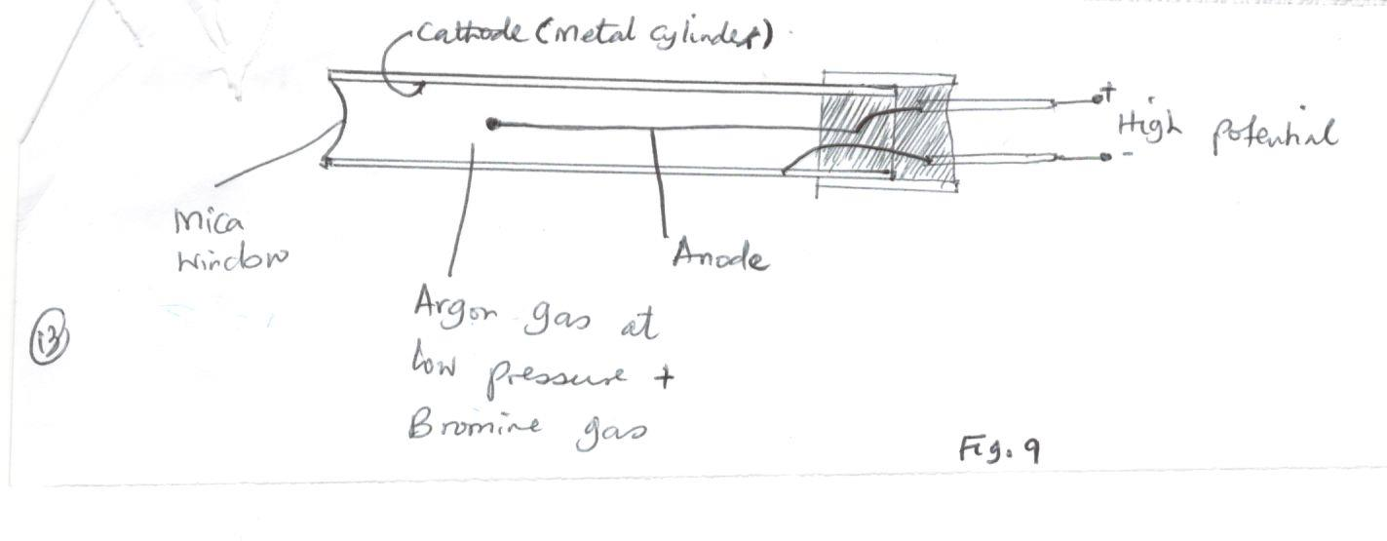
- Give a reason why the mica window is made thin. (1mk)
------------------------------------------------------------------------------------------------------------------------------------------------------------------------------------------------------------------------
- Explain how the radiation entering the tube through the mica window is detected by the tube. (3mks)
---------------------------------------------------------------------------------------------------------------------------------------------------------------------------------------------------------------------------------------------------------------------------------------------------------------------------------------------------------------------------------------------------------------------------------------------
- What is the purpose of bromine gas. (1mk)
------------------------------------------------------------------------------------------------------------------------------------------------------------------------------------------------------------------------------------------------------------------------------------------------------------------------------------
c) The initial mass of a radioactive substance is 40g, the substance has a half-life of 5 years. Determine the mass that would have decayed after 15 years. (3mks)
---------------------------------------------------------------------------------------------------------------------------------------------------------------------------------------------------------------------------------------------------------------------------------------------------------------------------------------------------------------------------------------------------------------------------------------------------------------------------------------------------------------------------------------------------------------------------------------------------------
d) i) Define the term principal focus for a convex lens. (1mk)
------------------------------------------------------------------------------------------------------------------------------------------------------------------------------------------------------------------------------------------
ii) The figure 10 below shows an object T and its image T₁ when an optical device is placed between T and T₁.

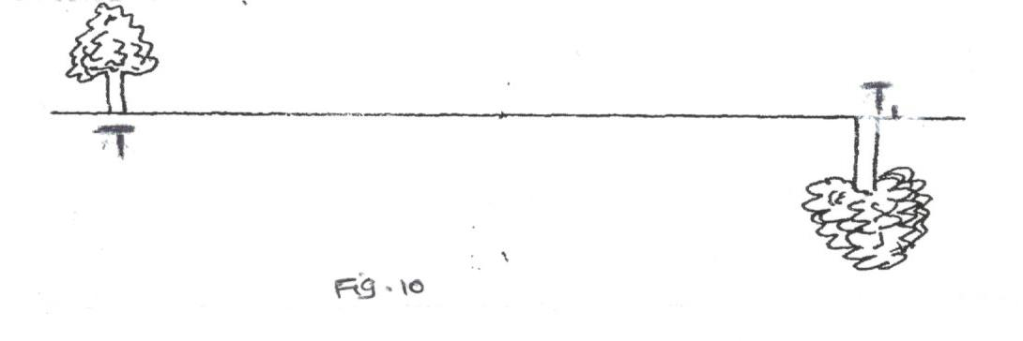

- State two characteristics of the image formed. (2mks)
------------------------------------------------------------------------------------------------------------------------------------------------------------------------------------------------------------------------------------------------------------------------------------------------------------------------------------------------------------------------------------------------------------------------------------------------
- Name the optical device that should be placed before T to produce image T₁. (1mk)
------------------------------------------------------------------------------------------------------------------------------------------------------------------------------------------------------------------------------------------------------------------------------------------------------------------------------------
- State one possible cause of short sightedness (myopia) as an eye defect.
(1mk)
------------------------------------------------------------------------------------------------------------------------------------------------------------------------------------------------------------------------------------------------------------------------------------------------------------------------------------------------
- a) State Faraday’s law of electromagnetic induction.
(1mk)
----------------------------------------------------------------------------------------------------------------------------------------------------------------------------------------------------------------------------------------------------------------------------------------------------------------------------------------------------------------------------------------------------------------------------------------------------------------
b) A transformer with 1500 turns in the primary circuit and 150 turns in the secondary circuit has its primary circuit connected to a 600v a.c source. It is found that when a heater is connected to a secondary circuit, it produces heat at the rate of 800W.
Assuming the transformer is ideal, determine the
- voltage in the secondary circuit. (2mks)
---------------------------------------------------------------------------------------------------------------------------------------------------------------------------------------------------------------------------------------------------------------------------------------------------------------------------------------------------------------
- current in the primary circuit (2mks)
-----------------------------------------------------------------------------------------------------------------------------------------------------------------------------------------------------------------------------------------------------------------------------------------------------------------------------------------------
- the current in the secondary circuit (2mks)
----------------------------------------------------------------------------------------------------------------------------------------------------------------------------------------------------------------------------------------------------------------------------------------------------------------------------------------------
- a) Brass rod cannot be charged by rubbing while held in the hand. Give a reason.
(1mk)
----------------------------------------------------------------------------------------------------------------------------------------------------------------------------------------------------------------------------------------------------------------------------------------------------------------------------------------------
b) i) State two factors that affect the capacity of a parallel -plate capacitor. (2mks)
----------------------------------------------------------------------------------------------------------------------------------------------------------------------------------------------------------------------------------------------------------------------------------------------------------------------------------------------
- Figure II below shows three capacitors connected to a 100V supply.
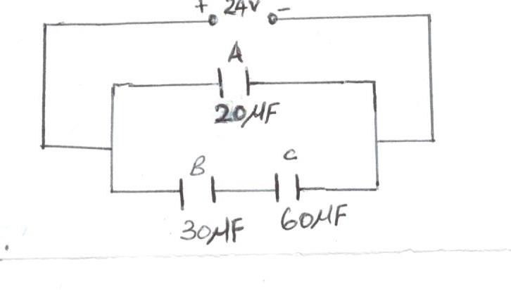

Determine
- The combined capacitance of the three capacitors A, B and C. (3mks)

----------------------------------------------------------------------------------------------------------------------------------------------------------------------------------------------------------------------------------------------------------------------------------------------------------------------------------------------------------------------------------------------------------------------------------------------------------------
- The p.d across capacitor C. (3mks)

----------------------------------------------------------------------------------------------------------------------------------------------------------------------------------------------------------------------------------------------------------------------------------------------------------------------------------------------------------------------------------------------------------------------------------------------------------------

This is the last printed page

