Name: …………………………………………………………… Index no ……..…...................................

School: ……………………………………………………....…. Candidate’s sign ……………………....

Date: ……………………………………………………………

231/1
BIOLOGY
PAPER 1
JUNE 2016
TIME: 2 HOURS

KASSU JOINT EXAMINATION

Kenya Certificate of Secondary Education (K.C.S.E.)

Biology
Paper 1

INSTRUCTIONS TO CANDIDATES:
- Write your name and index number in the spaces provided.
- Sign and write date of examination in the spaces provided above
- Answer all the questions in the spaces provided;

For Examiner’s Use Only:

QUESTIONS | MAXIMUM SCORE | CANDIDATES SCORE
1- 30 | 80

This paper consists of 8 printed pages. Candidates should check to ascertain that all papers are printed as indicated and that no questions are missing

1. State the function(s) of the following cell structures during cell division. (2mks)
(i) Centriole
…………………………………………………………………………………………………..………
(ii) Centromere
…………………………………………………………………………………………………..………
2. (a) State the function of co-factors in cell metabolism. (1mk)
…………………………………………………………………………………………………..………
(b) Give one example of a metabolic co-factor. (1mk)
…………………………………………………………………………………………………..………
3. Industrial wastes may contain metabolic pollutants. State how such pollutants may indirectly reach
and accumulate in the human body if the wastes were dumped into rivers. (3mks)
…………………………………………………………………………………………………..………
……………………………………………………………………………………………………....….
…………………………………………………………………………………………………..………
……………………………………………………………………………………………………....….
4. In an investigation the pancreatic duct of a mammal was blocked. It was found that the blood sugar
regulation remained normal while , food digestion was impaired. Explain these observations. (2mks)
…………………………………………………………………………………………………..………
……………………………………………………………………………………………………....….
…………………………………………………………………………………………………..………
……………………………………………………………………………………………………....….
5. The diagram below represents a transverse section through a plant organ.
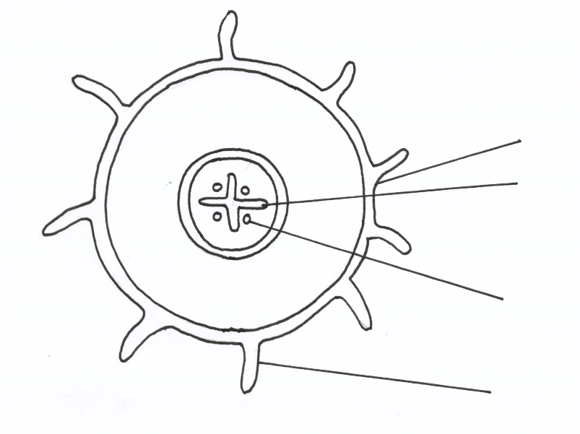
J
L
K
M

(a) From which plant organ was the section obtained. (1mk)
…………………………………………………………………………………………………..………
(b) Give two reasons for your answer in (a) above. (2mks)
…………………………………………………………………………………………………..………
……………………………………………………………………………………………………....….

6. State two structural differences between ribonucleic acid(RNA) and deoxyribonucleic acid
(DNA). (2mks)
RNA DNA
(i)

(ii)

7. (a) Explain why glucose does not appear in urine of a healthy person even though it is filtered in the
Bowman’s capsule of a mammal. (2mks)
…………………………………………………………………………………………………..………
……………………………………………………………………………………………………....….
…………………………………………………………………………………………………..………
…………………………………………………………………………………………………..………
(b) In a certain person, glucose appeared in urine. State the disease the person was suffering
from. (1mk)
…………………………………………………………………………………………………..………
……………………………………………………………………………………………………....….
8. State the stage in cell division in which the following events occurs:-
(i) Replication of the genetic material. (1mk)
…………………………………………………………………………………………………..………
(ii) Exchange of genetic material (1mk)
…………………………………………………………………………………………………..………
9. In a blood test, a few drops of anti-B serum were added to two samples of blood. It was noted that
agglutination occurred. What were the possible blood groups of the two blood samples. (2mks)
…………………………………………………………………………………………………..………
……………………………………………………………………………………………………....….
10. Explain what would happen when a marine amoeba is transferred to a fresh water environment.
(3mks)
…………………………………………………………………………………………………..………
……………………………………………………………………………………………………....….
……………………………………………………………………………………………………....….
…………………………………………………………………………………………………..………
…………………………………………………………………………………………………..………
11. A small amount of chemical M was put on one side of maize celeoptiles. After some days, it was
noted that the celeoptiles curved away from the side to which the chemical was applied.
(a) Suggest the possible identity of chemical substance M (1mk)
…………………………………………………………………………………………………..………
(b) Explain how this chemical might have caused the celeoptiles to curve. (2mks)
…………………………………………………………………………………………………..………
……………………………………………………………………………………………………....….
…………………………………………………………………………………………………..………
12. Name the division of the Kingdom plantae with the following spore producing bodies. (2mks)
(i) Sori
…………………………………………………………………………………………………..………
(ii) Capsule
…………………………………………………………………………………………………..………
13. (a) Name two fins in a bony fish which perform the following functions:-
Changing direction, control pitching. (2mks)
…………………………………………………………………………………………………..………
……………………………………………………………………………………………………....….
(b) State the role of the swim bladder in a fish. (1mk)
…………………………………………………………………………………………………..………
14. (a) In which part of the spinal cord is the cell body of the motor neurone found. (1mk)
…………………………………………………………………………………………………..………
(b) Below are two features which make a neurone a specialised cell. State their roles. (2mks)
(i) Axon.
…………………………………………………………………………………………………..………
(ii) Dendrites.
…………………………………………………………………………………………………..………
15. (a) What is a natural selection? (1mk)
…………………………………………………………………………………………………..………
(b)Distinguish between convergent and divergent evolution. (1mk)
…………………………………………………………………………………………………..………
……………………………………………………………………………………………………....….
16. (a) Explain how the following parts of a mammalian reproductive system are adapted to their
functions. (2mks)
(i) Testis
…………………………………………………………………………………………………..………
(ii) Uterus
…………………………………………………………………………………………………..………
(b) Explain why removal of the ovary after four months of pregnancy does not terminate pregnancy.
(1mk)
…………………………………………………………………………………………………..………
……………………………………………………………………………………………………....….
…………………………………………………………………………………………………..………

17. Active yeast cells were added to a dilute sugar solution in a container. The mixture was kept in a warm room. After a few hours bubbles of gas were observed escaping from the mixture.
(a)Write an equation to represent the chemical reaction above. (1mk)

(b) What is the economic importance of this type of chemical reaction in industry. (1mk)
…………………………………………………………………………………………………..………
……………………………………………………………………………………………………....…
18. What are the functions of the odontoid process found on the axis bone of the cervical vertebra.
(2mks)
…………………………………………………………………………………………………..………
……………………………………………………………………………………………………....….
19. The diagram below represents a simple endocrine feedback mechanism in a human male.

PITUITARY GLAND

HORMONE X
HORMONE Y

TESTES

(a) Name the hormone labeled X (1mk)
…………………………………………………………………………………………………..………
(b) State two differences that may be observed between a normal male and one who is incapable
of producing hormone labeled Y (2mks)
…………………………………………………………………………………………………..………
……………………………………………………………………………………………………....….
…………………………………………………………………………………………………..………
…………………………………………………………………………………………………..………

20. (a) What is meant by double fertilization in flowering plants? (2mks)
…………………………………………………………………………………………………..………
……………………………………………………………………………………………………....…
…………………………………………………………………………………………………..………
(b) State two advantages of cross pollination in a flowering plant. (2mks)
…………………………………………………………………………………………………..………
……………………………………………………………………………………………………......
21. The diagram below shows part of a mammalian respiratory system.
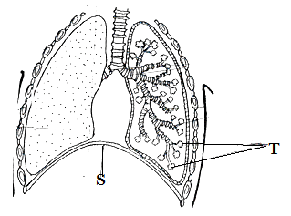
(a) Explain two ways in which the part labeled T is adapted to its functions. (2mks)
…………………………………………………………………………………………………..………
……………………………………………………………………………………………………....….
…………………………………………………………………………………………………..………
…………………………………………………………………………………………………..………
- How does the part labeled S facilitate breathing in? (2mks)
…………………………………………………………………………………………………..………
……………………………………………………………………………………………………....….
…………………………………………………………………………………………………..………
22. Define the term alleles. (1mk)
…………………………………………………………………………………………………..………
23. (a) Explain why the body temperature of a healthy human being must rise upto 39ºC on
humid day. (2mks)
…………………………………………………………………………………………………..………
……………………………………………………………………………………………………....….
…………………………………………………………………………………………………..………
…………………………………………………………………………………………………..………
(b) In an experiment a piece of brain was removed from a rat. It was found that the rat had large
fluctuations of body temperature. Suggest the part of the brain that had been removed. (1mk)
…………………………………………………………………………………………………..………
24. The chart below shows a feeding relationship in a certain ecosystem.
Green Plants

Mice
Grasshopper

Domestic
Cat
Lizards

Snakes
Hawks

- Construct the food chains ending with a tertiary consumer in each case. (2mks)

- Suggest three ways in which the ecosystem would be affected if there was prolonged
drought. (3mks)
…………………………………………………………………………………………………..………
……………………………………………………………………………………………………....….
…………………………………………………………………………………………………..……………………………………………………………………………………………………………....….
…………………………………………………………………………………………………..………
25. A student set up an experiment as shown in the diagram below.
Cotton wool
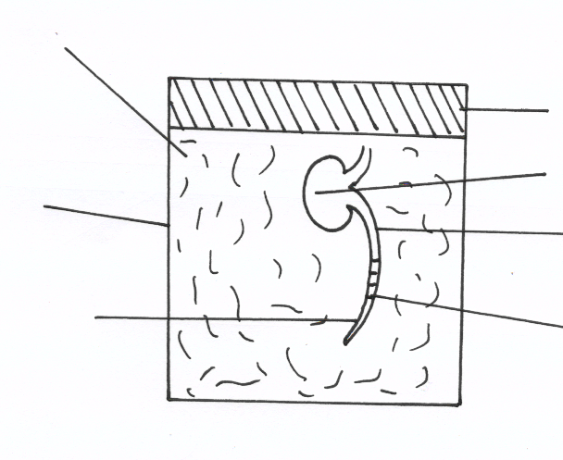
Cork
Cotyledons

Bean seedlings
Glass Container

Marking
Radicle

AT THE START
- (i) What was being investigated in the experiment? (1mk)
…………………………………………………………………………………………………..………
(ii) Draw a diagram to indicate the expected results of the experiment after three days. (1mk)

(iii) Why was it necessary to have wet cotton wool in the container (1mk)
…………………………………………………………………………………………………..………
……………………………………………………………………………………………………....….
(b) What is the role of the following in a germinating seed.
(i) Oxygen (1mk)
…………………………………………………………………………………………………..………

(ii) Cotyledons (1mk)
…………………………………………………………………………………………………..………
26. Give a reason why it its only mutations in genes of gametes that influence evolution. (1mk)
…………………………………………………………………………………………………..………
……………………………………………………………………………………………………....…
27. A person was able to read a book clearly at arms length, but not at normal distance.
(a) State the eye defect the person suffered from. (1mk)
…………………………………………………………………………………………………..………
……………………………………………………………………………………………………....….
(b) Why was he unable to read the book clearly at normal distance. (1mk)
…………………………………………………………………………………………………..………
……………………………………………………………………………………………………....….
(c) How can the defect be corrected. (1mk)
…………………………………………………………………………………………………..………
……………………………………………………………………………………………………....….
28 Some form three students took a germinating maize grain and placed it in a starch paste in a petri dish and put the Petri dish in a water bath maintained at 30ºC. After 48 hours the starch paste was irrigated with iodine solution .The area around the maize grain changed to the colour of iodine solution while the rest turned blue –black.
(a) Account for the observation (2mks)
…………………………………………………………………………………………………..………
……………………………………………………………………………………………………....….
(b) Why was the Petri dish put in a water bath maintained at 30ºC? (1mk)
…………………………………………………………………………………………………..………
……………………………………………………………………………………………………....….
29. State two functions of muscles found in the alimentary canal of mammals. (2mks)
…………………………………………………………………………………………………..………
……………………………………………………………………………………………………....….
30. Explain two ways in which xylem vesseles are adapted to their function. (2mks)
…………………………………………………………………………………………………..………
……………………………………………………………………………………………………....….…………………………………………………………………………………………………..………
……………………………………………………………………………………………………....….

THIS IS THE LAST PRINTED PAGE

