Name: …………………………………………………………… Index no ……..…...................................

School: ……………………………………………………....…. Candidate’s sign ……………………....

Date: ……………………………………………………………
231/2
BIOLOGY
PAPER 2
JUNE 2016
TIME: 2 HOURS
KASSU JET EXAMINATION
Kenya Certificate of Secondary Education (K.C.S.E.) 2016
Biology
Paper 2
INSTRUCTIONS TO CANDIDATES:
- Write your name and index number in the spaces provided.
- Answer all the questions in Section A in the spaces provided.
- In section B answer questions 6 (compulsory) and either question 7 or 8 in the spaces provided

For Examiner’s Use Only:
SECTION | QUESTIONS | MAXIMUM SCORE | CANDIDATES SCORE
A | 1 | 8
 | 2 | 8
 | 3 | 8
 | 4 | 8
 | 5 | 8
B | 6 | 20
 | 7 | 20
 | 8 | 20
 | TOTAL | 80

This paper consists of 10 printed pages. Candidates should check to ascertain that all papers are printed as indicated and that no questions are missing

SECTION A ( 40 MARKS)
Answer all the questions in this section in the spaces provided
- A couple has three children, the mother had blood group A and the father had blood group B while one of the children had blood group 0.
(a) (i) What were the genotypes of the parents? (1mark)
Father
…………………………………………………………………………………………………………
Mother
…………………………………………………………………………………………………………
(ii) What was the genotype of the child with blood group 0? (1mark)
…………………………………………………………………………………………………………
(b) Work out using a punnet square the genotypes of the other children. (4 marks)

(c) Which child can receive blood from any member of the family? (1mark)
…………………………………………………………………………………………………………
(d) State the percentage of children who can donate blood to all blood groups. (1mark)
…………………………………………………………………………………………………………
- Below is a diagram of a structure found in Eukaryotic cells? Study it and answer the questions that follow
. 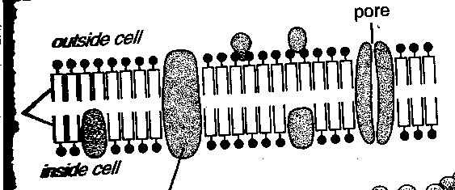
a) Identify the structure (1 mark)
……………………………………………………………………………………………….…………
b) State two functions of the structure (2 marks)
i. …………………………………………………………………………………………………………
ii.
…………………………………………………………………………………………………………
c) (i) Name one organelle found in animal cells but absent in plant cells (1 mark)
………………………………………………………………………………………..…………………
ii) State one function of the organelle you have named in(c) above (1 mark)
…………………………………………………………………………………………………………
d) Briefly explain cell biology as an evidence of evolution (3 marks)
………………………………………………………………………………………………………………………………………………………………………………………………………………………………………………………………………………………………………………………………………………………………………………………………………………………………………… …………………………………………………………………………………………………………………………………………………………………………………………………………………………………………………………………………………………………………………………………………………………………………………………………………………………………………

- Below is a diagram of a plant a form three student collected while carrying out an ecological study?
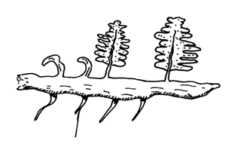
Adventitious root
- With reasons identify the division into which the students classified the plant.
Division (1mark)
……………………………………………………………………………………………………...
Reasons (2marks)
………………………………………………………………………………………………………………………………………………………………………………………………………………….…
b) (i) Name the structure that produces spores in this plant. (1mark)
………………………………………………………………..…………………………………………………………………………………………………………………………………………….………
- State two differences between the plant division above and that of the division spermatophyta. ( 2 marks)
Spermatophyte

c) Give two distinguishing features of class Amphibia (2marks)
a) ………………………………………………………………………………………………

b) ………………………………………………………………………………………………
- The diagram below represents human foetus in a uterus.
Placenta
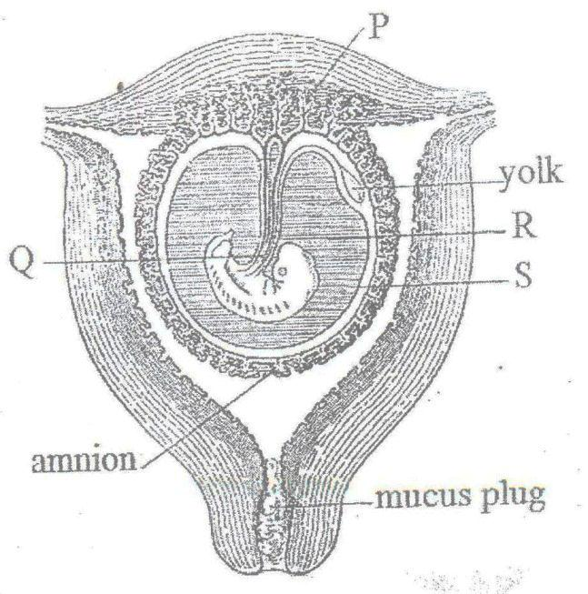
Chorion
C

D
B
Mucus plug

- Name the part labeled D. (1 mark)
……………………………………………………………………………………………………………
- i) Name the types of blood vessels found in the structure labeled C. (2 marks)
…………………………………………………………………………………………………………….
ii) State the differences in composition of blood found in the vessels named in (b) (i) above. (2 marks)
iii) State two importance of the fluid found in part B (2 marks)
………………………………………………………………………………………………………………………………………………………………………………………………………………………………………………………………………………………………………………………………………..iv) State the role of progesterone during pregnancy (1 mark)
………………………………………………………………………………………………………………………………………………………………………………………………………………………………………………………………………………………………………………………………………
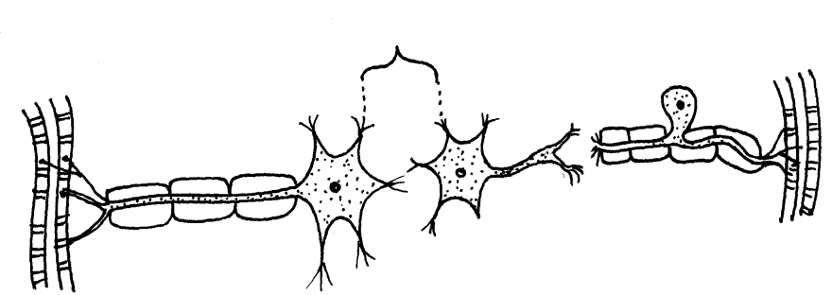
- The diagram below represents three types of neurons found in a mammalian body.
W
M

Y
Z
X

(a) Name the neurons X, Y and Z (3marks)
X………………………………………………………………………………………………………..
Y……………………………………………………………………………………………………….
Z………………………………………………………………………………………………………
(b) Name the chemical substance responsible for the transmission of an impulse across the gap
labelled W. (1mark)
……………………………………………………………………………………………………....….
(c) State two functions of the part labelled M. (2marks)
…………………………………………………………………………………………………..………
……………………………………………………………………………………………………....….
(d) In which part of the spinal cord is neurone Y located? (1mark)
……………………………………………………………………………………………………....….
(e) Using arrows indicate on the diagrams the direction followed by nerve impulse leading to a
response. (1mark)

SECTION B (40MARKS)
Answer questions 6(compulsory) and either questions 7 or 8 in the spaces provided
- During germination and growth of a cereal, the dry weight of endosperm, the embryo and total dry weight were determined at two – day intervals. The results are shown in the table below.
Time after planting(days) | Dry weight of endosperm | Dry weight of embryo (mg ) | Total dry weight (mg)
0 | 43 | 2 | 45
2 | 40 | 2 | 42
4 | 33 | 7 | 40
6 | 20 | 17 | 37
8 | 10 | 25 | 35
10 | 6 | 33 | 39

a) Using the same axes, draw graphs of dry weigh of endosperm, embryo and the total dry weight against time (8marks)

b) What was the dry weight of the endosperm and embryo on the 5th day? (2marks)
Endosperm
……………………………………………………………………………………………………....….Embryo
……………………………………………………………………………………………………....….
c) Account for:
i) Decrease in dry weight of endosperm from day 0 to 10 (2marks)
………………………………………………………………………………………………………… ………………………………………………………………………………………………………… …………………………………………………………………………………………………………
ii) Increase in dry weight of embryo from day 0 day 10 (2marks) ………………………………………………………………………………………………………… ………………………………………………………………………………………………………… …………………………………………………………………………………………………………
iii) Decrease in total dry weight from day 0 to day 8 (2marks) ………………………………………………………………………………………………………… ………………………………………………………………………………………………………… …………………………………………………………………………………………………………
d) State the role of the following in germination (2marks)
i) Glucose
………………………………………………………………………………………………………… …………………………………………………………………………………………………………
ii) Enzymes
………………………………………………………………………………………………………… …………………………………………………………………………………………………………
e) How are the foliage leaves adapted to their function (2 marks) ………………………………………………………………………………………………………… ………………………………………………………………………………………………………… …………………………………………………………………………………………………………
7 (a) Describe the role of hormones in blood sugar regulation (10 marks)
(b) Explain how halophytes are adapted to their habitat (10 marks)
8 (a) Explain the adaptations of thoracic, cervical and lumbar vertebrae to their functions (12 marks)
(b) Describe the structural factors affecting transpiration (8 marks)
…………………………………………………………………………………………………………………………………………………………………………………………………………………………………………………………………………………………………………………………………………………………………………………………………………………………………………………………………………………………………………………………………………………………………………………………………………………………………………………………………………………………………………………………………………………………………………………………………………………………………………………………………………………………………………………………………………………………………………………………………………………………………………………………………………………………………………..…………………………………………………………………………………………………………………………………………………………………………………………………………………………………………………………………………………………………………………………………………………………………………………………………………………………………………………………………………………………………………………………………………………………………………………………………………………………………………………………………………………………………………………………………………………………………………………………………………………………………………………………………………………………………………………………………………………………………………………………………………………………………………………………………………………………………………..…………………………………………………………………………………………………………………………………………………………………………………………………………………………………………………………………………………………………………………………………………………………………………………………………………………………………………………………………………………………………………………………………………………………………………………………………………………………………………………………………………………………………………………………………………………………………………………………………………………………………………………………………………………………………………………………………………………………………………………………………………………………………………………………………………………………………………..…………………………………………………………………………………………………………………………………………………………………………………………………………………………………………………………………………………………………………………………………………………………………………………………………………………………………………………………………………………………………………………………………………………………………………………………………………………………………………………………………………………………………………………………………………………………………………………………………………………………………………………………………………………………………………………………………………………………………………………………………………………………………………………………………………………………………………..………………………………………………………………………………………………………………………………………………………………………………………………………………………………………………………………………………………………………………………………………………………………………………………………………………………………………………………………………………………………………………………………………………………………………………………………………………………………………………………………………………………………………………………………………………………………………………………………………………………………………………………………………………………………………………………………………………………………………………………………………………………………………………………………………………………………………………………………………………………………………………………………………………………………………………………………………………………………………………………………………………………………………………………………………………………………………..…………………………………………………………………………………………………………………………………………………………………………………………………………………………………………………………………………………………………………………………………………………………………………………………………………………………………………………………………………………………………………………………………………………………………………………………………………………………………………………………………………………………………………………………………………………………………………………………………………………………………………………………………………………………………………………………………………………………………………………………………

