Name................................................................................................ Index Number........................
Student’s Signature..........................

231/3
BIOLOGY
PAPER 3
PRACTICAL
JUNE, 2016
1 ¾ HOURS

KASSU JOINT EXAMINATION
Kenya Certificate of Secondary Education
BIOLOGY
Paper 3
Practical
TIME: 1 ¾ Hours

Q1. You are provided with Four Test-tubes label as A, B, C and D. You are required to prepare the contents of test tube A, B, C and D as follows.

To test tube A add 2cm³ of solution R provided and test using the provided reagent.

To test tube B add 2cm³ of solution T provided and test using the provided reagent.
(5 marks)
(a)
Test tube | Procedure | Observation | Conclusion
A
B

(b) To test tube C and D, prepare them as follows:

To test tube C add 2cm³ of R and 2cm³ of solution H provided boil it and allow it to stand for 5 minutes.

To test tube D add 2cm³ of R and 2cm³ of solution T boil and allow it to stand for 30 minutes. For both C and D test using the provided reagents and tabulate your results below.
(5 marks)

Test tube | Procedure | Observation | Conclusion
C

D

(c) To the provided visking tubing tie one end with the provided string and add solution R. Tie the remaining end and immerse it in a solution of iodine solution in a beaker (50ml). After 2 minutes remove it from the beaker and observe.
(i) What was your observation of the contents of the visking tubing atthe end of experiment? (1 mark)

…………………………………………………………………………………………………………………………………………………………………………………………………………………………………………
(ii) Account for your results in (i) above. (3 marks)
…………………………………………………………………………………………………………………………………………………………………………………………………………………………………………
…………………………………………………………………………………………………………………………………………………………………………………………………………………………………………

2. Study the kidney diagrams below:
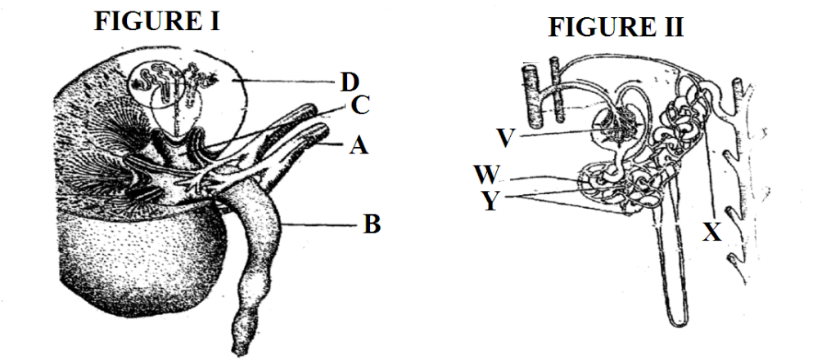
a) i) Name the part labeled A in figure 1 (1mark)
A ……………………………………………………………………….……………………
ii) Name the process that takes place in the parts labeledV.
V ……………………………………………………………………………………………
(1 mark)

b) State two homeostatic functions of the organ in the diagram above.
(2marks)
……………………………………………………………………………………………………………………
……………………………………………………………………………………………………………………
c) Explain what will happen to the process of urine formation in absence of ADH. (3marks)
……………………………………………………………………………………………………………………
……………………………………………………………………………………………………………………
……………………………………………………………………………………………………………………
……………………………………………………………………………………………………………………
d) Below are photographs labeled B and C of organs obtained from different animals. The organs perform similar functions. Examine them and answer the questions that follow.
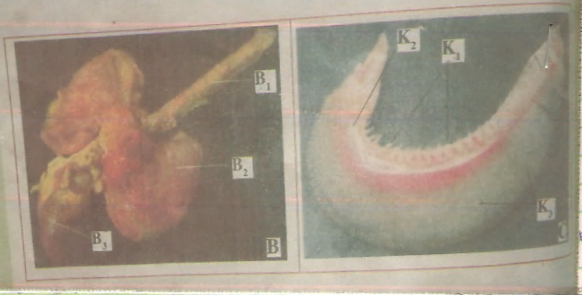
(i) Name the parts labeled B1, B2 and B3 in photographs B (3marks)
B1 ……………………………………………………………………………………………………………………
B2 ……………………………………………………………………………………………………………………
B3 ……………………………………………………………………………………………………………………
(ii) Identify the parts labeled K1, K2 and K3 in photograph C (3marks)
K1 ……………………………………………………………………………………………………………………
K2 ……………………………………………………………………………………………………………………
K3 ……………………………………………………………………………………………………………………
3. Study the diagrams set A₁, set E₁, set M₁ and set B carefully and answer the questions below
(a) State the conditions under which each set up was grown. (3mks)
Set A₁ ___________________________________________________
Set E₁ ___________________________________________________
Set B ____________________________________________________
(b) (i) Name the phenomenon exhibited by seedlings in set E₁(1mk)
_____________________________________________________________
(ii) Give a reason why plants exhibit the phenomenon named in (b) (i) above (1mk)
_____________________________________________________________________________________
_____________________________________________________________________________________

(c) (i) Name the response exhibited by the seedlings in set B. (1mk)
____________________________________________________________________________
____________________________________________________________________________
(ii) Explain how the response named in (c) (i) above occurred (2mks)
____________________________________________________________________________
____________________________________________________________________________
(d) (i) State the type of germination exhibited by seedlings in set A₁ and set M₁. (2mks)
Set A1 ___________________________________________________________________________________________________________________
Set M1 ___________________________________________________________________________________________________________________
(ii) Give a reason for your answer in (d) (i) above (2mks)
Set A1 ____________________________________________________________________________________________________________________
Set M₁ __________________________________________________________________________
(iii) State the mode of dispersal in set A above when mature. (1 mk)
__________________________________________________________________________________________
(iv) Name the type of fruit formed by M1 on maturity. (1 mk)

