Name……………………………………………………… Adm No……………Class………
121/2
MATHEMATICS
PAPER 2
2 ½ HOURS
JUNE 2016

KASSU JOINT EVALUATION TEST (J.E.T)
Kenya Certificate of Secondary Education (K.C.S.E)

INSTRUCTIONS TO CANDIDATES

1. Write your name, Admission Number, Class and Index Number.
2. The paper contains two sections: Section I and II
3. Answer ALL questions in section I and ANY FIVE questions from section II.
4. All working and answers must be written on the question paper in the spaces provided below each question.
5. Marks may be awarded for correct working even if the answer is wrong.
6. Negligent and untidy work will be penalized.
7. Non-programmable silent electronic calculators and four figure mathematical tables are allowed for use.
8. This paper consists of printed pages. Candidates should check the question paper to ensure that all the pages are printed indicated and no questions are missing.

FOR EXAMINER’S USE ONLY

SECTION 1

1 | 2 | 3 | 4 | 5 | 6 | 7 | 8 | 9 | 10 | 11 | 12 | 13 | 14 | 15 | 16 | TOTAL
GRAND TOTAL
SECTION II

17 | 18 | 19 | 20 | 21 | 22 | 23 | 24 | TOTAL

SECTION A 50 MARKS
1. Use logarithm tables to evaluate; (3mks)

2. The middle digit of a number between 100 and 1000 is zero, and the sum of the other digits is 11. If the digits are reversed the number so formed exceeds the original by 495. Find the number. (3 mks)

3. Without using mathematical tables or a calculator evaluate
$\sqrt{\frac{0.3-0.098 ÷ (0.84 - 0.14 )}{\left(0.28+0.12\right)÷ 0.8 x 0.5}}$
Leaving the answer as a decimal (3 marks)

4. Expand (0.07)⁵ using binomial theorem giving your answer to four significant figures
(3marks)

5. Solve for θ in the equation Sin (3θ + 120⁰) = $\frac{\sqrt{3}}{2}$ in the range 0 $≤$θ$≤$ 180^{0.} (3 mks)

6. Rationalize the denominator leaving your answer in the form a + b$\sqrt{c}$ wherea, b and c are constants $\frac{5 - 2\sqrt{3}}{2 + 3\sqrt{3}}$ (3marks)

- A farmer bought a machine at a current price of Ksh 224,000. If the depreciation rate is 5% in every 3 months. Calculate the sum of its value in 3 years ago and 3 years’ time. (3mks)

8. Without using logarithm table or calculators, find the value of p in the equation.
Log n³ + log 4n = 10 log2 – log ($2/8$) (3mks)

9. Using mid-ordinates rules, estimate the area under the curve y= ½ x²-2, using six strips between x=2 and x=8 and x-axis (3mks)

10. (a) Using a pair of compass and a ruler only Construct a triangle PQR in which PQ=QR=4cm and angle QPR= 30⁰. (2mks)
(b) A point T is always on the same side of PQ as R and angle PRQ=angle PTQ. Construct the locus of T and describe it. (2mks)

11. R is partly constant and partly varies as the square of q. when R = 5, q = q and R = 21, when q = 3. Find the value of R when q = 5. (3mks)

12. The first, the third and the seventh term of an increasing arithmetic progression are three consecutive terms of a geometric progression. If the first term of the arithmetic progression is 10, find the common difference of the arithmetic progression (3mks)

13. The equation of a circle is x² – 8x + y² + 12y + 16 = 0
Determine the coordinates of the Centre of the circle and its radius. (3 Marks)

14.
A

F E E
D

C
In the diagram above CD is a tangent to the circle at C. AC and FD intersect at B. FED is a straight line. Given that CD = 10 cm, AB = 2 cm AC = 8 cm, FB = 3 cm. Find the length ED. 4mks

15. The cost of 2 brands of coffee A and B per kilogram are 59.40 and Sh.72 respectively. The two brands are mixed in the ratio x:y and sold at a profit o9f 20% above the cost. If the selling price per kilogram mixture is Ksh.72. find the value of x and y (3mks)

16. Evaluate (3mks)

SECTION B 50 MARKS
17. In the trapezium shown below$\vec{PQ}=3\vec{ST}$. T divides SR in the ratio 4 :1 and U is the midpoint of QT. PU and QR intersect at X. PX = hPU and QX = kQR.
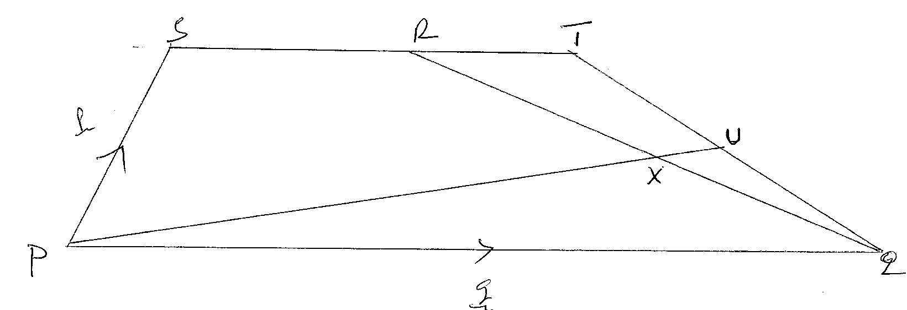
Given that PQ = q and PS = p
- Express QR in terms of P and q (1mk)
- Express PX in terms of P, q and h. (2mks)
- Express PX in terms of P, q and k. (3mks)
- Hence; obtains the values of h ad k. (3mks)
- Determine the ratio in which X divides QR. (1mk)

18. The table below shows the distribution of marks of 40 candidates in a test
Marks | 1-10 | 11-20 | 21-30 | 31-40 | 41-50 | 51-60 | 61-70 | 71-80 | 81-90 | 91-100
Frequency | 2 | 2 | 3 | x | 12 | 5 | 2 | 3 | 1 | 1
(a)(i) Find the value of x (1mk)

(ii) State the modal class (1mk)

(iii) Calculate the median (4mks)

(iv) Calculate the mean. (4marks)

19. The figure below is a frustum of a rectangular pyramid with AB=12CM, EF=8CM,BC=9CM and height of 6 CM
G
H
E
A
D
F
B
C
6cm
9cm

9cm
12cm

Calculate:
- the full height of the pyramid 2 marks
- angle that the plane ABFE makes with the base ABCD 2marks
- angle that AG makes with the base ABCD 3marks
- angle that AC makes with line AE 1mark
- angle that plane BCGF makes with the base ABCD 2marks

20. (a) A point a (35⁰ N, 40⁰W) and b (40⁰S, 40⁰W), Calculate the distance between A and B in
Kilometers. Take earth radius o be 6370 km. answer to 1 d.p. (3mks)

(b) A and B are points on latitude 70⁰C. Their longitudes are 62⁰W and 118⁰ E respectively. Find the distance from A to B along a parallel of latitude. (4mks)

(c) Peter was in Mombasa 39⁰E and Mary was in Banju 17⁰W. Calculate the time difference between the two. (3mks)

21. ABCD is a quadrilateral with vertices as follows: A (3, 1), B (2, 4) C (4, 3) and D (5, 1)
- (i) On the grid provided draw the quadrilateral ABCD and the image A'B'C'D' under a transformation
With matrix. Find the co-ordinates of A'B'C'D' (3mks)
0

Describe the transformation that maps ABCD onto A'B'C'D' fully (1mk)
0
- A transformation represented by the matrix maps A'B'C'D' onto A''B''C''D'' find the co-ordinates of A''B''C''D''. Plot A''B''C''D'' on the same grid. (3mks)

- Determine a single transformation that maps A''B''C''D'' onto ABCD. Describe this transformation fully. (3mks)

- The table below shows the income tax rates in Kenya.
Income in K£ per month Rate in Ksh / K£
1 - 325 2
326 - 975 3
976 - 1300 5
1301 - 1625 6
Over 1625 7.5

- Mr. Sigei is a public servant who lives in a government house and pays a nominal rent of Ksh. 1220 per month. He earns a basic salary of Ksh. 24,800 and taxable allowances of Ksh. 13,380 per month. He is entitled to a monthly tax relief of Ksh. 1120. Calculate his monthly
i) Taxable income in K£. (2mks)

ii) Gross tax. (3mks)

iii) Tax due (2mks)

- Apart from income tax, the following monthly deductions are made from his salary.
i) HELB loan repayment Ksh. 2400
ii) NHIF Ksh 320
iii) 2% basic salary as union dues.
Calculate Mr. Sigei’s monthly net salary. (3mks)

23. An airline has to fly 1000 passengers and 35000 kg of luggage from Nairobi to Kampala. Two types of aircrafts are available. Type A takes 100 passengers and 2000 kg of luggage. Type B takes 60 passengers and 3000 kg of luggage. The airline must not use more than 16 aircrafts altogether.
(a) if the airline hires x type A aircrafts and y type B aircrafts, write down 3 inequalities to represent the information above. (3mks)

(b) Draw the inequalities on a grid. (3mks)

(c) Find the minimum number of aircrafts the airline could use. (1mk)

(d) If the cost of hiring charges for each aircraft is sh 100,000 and sh 120,000 for type A and b respectively, find:
(i) The number of planes of each type that should minimize the cost (2mks)

(ii) Minimum cost (1mk

24. In a mathematics test, the probability of 3 students, Kamau, Otieno and Mwala passing are
⅔, ¾ and ⅚ respectively
(a) Draw a tree diagram to represent this information (3 marks)

(b) Use the tree diagram to find the probability that:
(i) All the three students will fail (2 marks)

(ii) At least two students will pass. (3 marks)

(iii) Only one student will pass (2 marks)

