NAME……………………………………………… INDEX NO………………….
CAND. SIGN………………
DATE……………………….

443/1 AGRICULTURE
JULY/AUGUST 2016 2 HOURS
BARINGO COUNTY EDUCATIONAL IMPROVEMENT EXAMINATION
AGRICULTURE PAPER 1

INSTRUCTIONS TO CANDIDATES

[a] Write your name and index number in the spaces provided above.
[b] Sign and write the date of examination in the spaces provided above.
[c] This paper consists of three sections A, B, and C.
[d] Answer all the questions in sections A and B.
[e] Answer any two questions in section C.
[f] The answers should be written in the spaces provided.

FOR EXAMINERS USE ONLY

SECTION | QUESTIONS | MAX. SCORE | CAND. SCORE
A | 1---17 | 30
B | 18---21 | 20
C | 22 ,23 ,24 | 20
 | 22 ,23 ,24 | 20
TOTAL SCORE |  | 90

SECTION A [30 MARKS]
Answer ALL the questions in the spaces provided.
1. Give four methods of applying fertilizers to crops. [2marks]
………………………………………………………………………………………………………………………………………………………………………………………………………………………………………………………………………………………………………………………………………………………………………………………………………………………………………………………………………………………………………………………………
2. State four beneficial biotic factors that influence agriculture. [2marks]
………………………………………………………………………………………………………………………………………………………………………………………………………………………………………………………………………………………………………………………………………………………………………………………………………………………………………………………………………………………………………………………………
3. Give four branches of Agriculture. [2marks]
………………………………………………………………………………………………………………………………………………………………………………………………………………………………………………………………………………………………………………………………………………………………………………………………………………………………………………………………………………………………………………………………
4. State four advantages of co-operative land tenure system. [2marks]
……………………………………………………………………………………………………………………………………………………………………………………………………………………………………………………………………………………………………………………………………………………………………………………………………………………………………………………………………………………………………………………………..
5. State four benefits of organic mulch in crop production. [2marks]
………………………………………………………………………………………………………………………………………………………………………………………………………………………………………………………………………………………………………………………………………………………………………………………………………………………………………………………………………………………………………………………………
6. State four conditions under which shifting cultivation is practiced. [2marks]
………………………………………………………………………………………………………………………………………………………………………………………………………………………………………………………………………………………………………………………………………………………………………………………………………………………………………………………………………………………………………………………………
7. Give four effects of mass wasting. [2marks]
………………………………………………………………………………………………………………………………………………………………………………………………………………………………………………………………………………………………………………………………………………………………………………………………………………………………………………………………………………………………………………………………
8. Give four factors that affect the rooting of cuttings. [2marks]
………………………………………………………………………………………………………………………………………………………………………………………………………………………………………………………………………………………………………………………………………………………………………………………………………………………………………………………………………………………………………………………………
9. Name four details that are included in a farm marketing record. [2marks]
……………………………………………………………………………………………………………………………………………………………………………………………………………………………………………………………………………………………………………………………………………………………………………………………….
10. Give four examples of product-product relationship in the management of agricultural enterprises. [2marks]
………………………………………………………………………………………………………………………………………………………………………………………………………………………………………………………………………………………………………………………………………………………………………………………………………………………………………………………………………………………………………………………………

11. State three benefits of tissue culture in crop propagation. [1.5 marks]
………………………………………………………………………………………………………………………………………………………………………………………………………………………………………………………………………………………………………………………………………………………………………………………………
12. Give two reasons for cutting back pyrethrum. [1 mark]
………………………………………………………………………………………………………………………………………………………………………………………………………………………………………………………………
13. State three methods of classifying herbicides. [1.5 marks]
……………………………………………………………………………………………………………………………………………………………………………………………………………………………………………………………………………………………………………………………………………………………………………………………..
14. State four symptoms of viral diseases in crops. [2 marks]
………………………………………………………………………………………………………………………………………………………………………………………………………………………………………………………………………………………………………………………………………………………………………………………………………………………………………………………………………………………………………………………………
15. Give four reasons for draining land as part of land reclamation. [2 marks]
………………………………………………………………………………………………………………………………………………………………………………………………………………………………………………………………………………………………………………………………………………………………………………………………………………………………………………………………………………………………………………………………
16. State two reasons for topping a pasture. [1 mark]
……………………………………………………………………………………………………………………………………………………………………………………………………………………………………………………………….

17. State two advantages of metal pipes over plastic pipes in piping water in the farm. [1 mark]
………………………………………………………………………………………………………………………………………………………………………………………………………………………………………………………………
SECTION B [20 MARKS]
Answer ALL the questions in the spaces provided.
18. The following diagrams illustrate two methods of soil sampling .Study them and answer questions that follow .
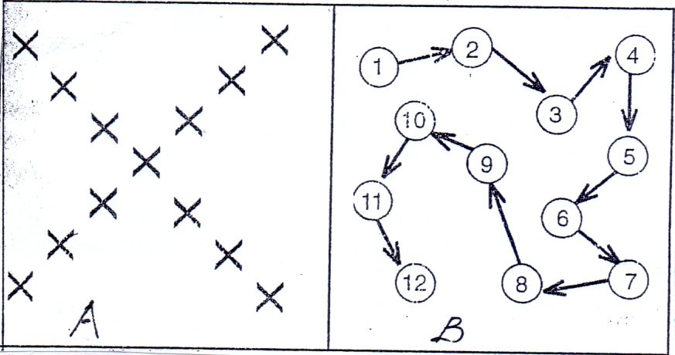
B
A
[a] What do diagrams A and B represent? [2 marks]
A…………………………………………………………………………
B…………………………………………………………………………
[b] Describe the procedure of soil sampling. [3 marks.]
…………………………………………………………………………………………………………
…………………………………………………………………………………………………………
…………………………………………………………………………………………………………
…………………………………………………………………………………………………………
…………………………………………………………………………………………………………
…………………………………………………………………………………………………………
…………………………………………………………………………………………………………
…………………………………………………………………………………………………………
………………………………………………………………………………[0.5 x 6 = 3 marks]
19. Study the following weeds and answer questions that follow .
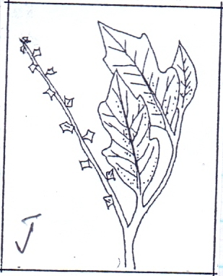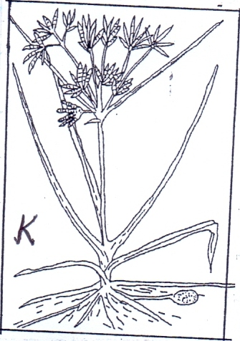
K
J
[a] Give the identity of weeds J and K [2 marks]
J……………………………………………………………………
K…………………………………………………………………..
[b] What makes weed K difficult to control. [1 mark]
…………………………………………………………………………………………………………
…………………………………………………………………………………………………………

[c] Give the economic importance of weed J [1 mark]
…………………………………………………………………………………………………………
…………………………………………………………………………………………………………

[d] State one reason that makes weeds excellently adapted to various environments. [1 mark]
…………………………………………………………………………………………………………
…………………………………………………………………………………………………………

20. Study the diagram below of a planting material of sugar cane and answer questions that follow .
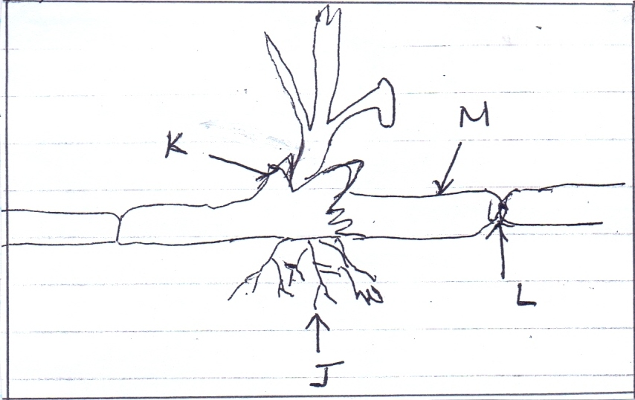
[a] Identify the parts J , K , L and M. [2 marks]
J…………………………………………………. K…………………………………………….
L ………………………………………………. M…………………………………………. [0.5 X 4 = 2 Marks.]
[b] State the functions of the parts labeled J, K and L . [3 marks]
J ………………………………………………………………………………………………………..
K ………………………………………………………………………………………………………..
L ………………………………………………………………………………………………………..

21. Study the crop pest below and answer questions that follow.
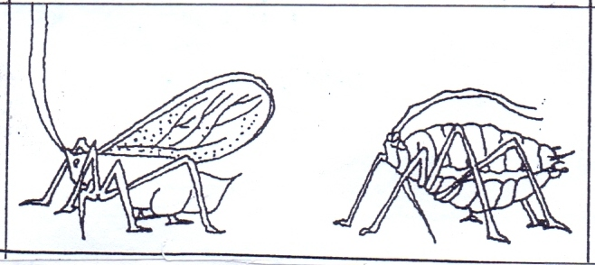
[a] Give the identity of the pest above. [1 mark]
…………………………………………………………………………………………………………
…………………………………………………………………………………………………………

[b] State two effects that are caused by the above pest to crops. [2 marks]
…………………………………………………………………………………………………………
…………………………………………………………………………………………………………
…………………………………………………………………………………………………………
[c] Give two control measures of the pest. [2 marks]
…………………………………………………………………………………………………………
…………………………………………………………………………………………………………

SECTION C [40MARKS]
Answer any two questions from this section in the spaces provided after question 24 .
22. [a] Describe the growing of dry bean seeds under the following sub headings .
- Selection and preparation of planting materials. [3 marks]
- Planting. [4 marks]
- Weeding. [3 marks]
[b] Describe the environmental conditions that may lead to low crop yields [10 marks]

23. [a] Explain seven ways in which farmers adjust to risks and uncertainties in farming . [7 marks]
[b] Explain five qualities of a good farm manager. [5 marks]
[c] The following are expenses of Pioneer Farm in the year 2014.
Concentrates shillings 5500
Seeds shillings 4500
Fertilizer shillings 7000
Fuel shillings 2000
Disc harrow 175000
The farmer sold wheat to millers for shillings 120000
Sold cabbages to the market for shillings 40000
Sold milk to school for shillings 30000
Sold poles to a saw mill for shillings 25000
The opening valuation was shillings 150000
The closing valuation was shillings 250000
- Prepare a profit and loss account for Pioneer farm for the year ending 2014 [7 marks]

- Did the farm make a profit or a loss and of how much? [1 mark]
24. [a] Describe seven cultural or biological methods of soil and water conservation. [7 marks]
[b] Describe agro forestry under its importance to the country. [7 marks]
[c] Explain six objectives of the million acre scheme of land settlements. [6 marks.]
…………………………………………………………………………………………………………………………………………………………………………………………………………………………………………………………………………………………………………………………………………………………………………………………………………………………………………………………………………………………………………………………………………………………………………………………………………………………………………………………………………………………………………………………………………………………………………………………………………………………………………………………………………………………………………………………………………………………………………………………………………………………………………………………………………………………………………………………………………………………………………………………………………………………………………………………………………………………………………………………………………………………………………………………………………………………………………………………………………………………………………………………………………………………………………………………………………………………………………………………………………………………………………………………………………………………………………………………………………………………………………………………………………………………………………………………………………………………………………………………………………………………………………………………………………………………………………………………………………………………………………………………………………………………………………………………………………………………………………………………………………………………………………………………………………………………………………………………………………………………………………………………………………………………………………………………………………………………………………………………………………………………………………………………………………………………………………………………………………………………………………………………………………………………………………………………………………………………………………………………………………………………………………………………………………………………………………………………………………………………………………………………………………………………………………………………………………………………………………………………………………………………………………………………………………………………………………………………………………………………………………………………………………………………………………………………………………………………………………………………………………………………………………………………………………………………………………………………………………………………………………………………………………………………………………………………………………………………………………………………………………………………………………………………………………………………………………………………………………………………………………………………………………………………………………………………………………………………………………………………………………………………………………………………………………………………………………………………………………………………………………………………………………………………………………………………………………………………………………………………………………………………………………………………………………………………………………………………………………………………………………………………………………………………………………………………………………………………………………………………………………………………………………………………………………………………………………………………………………………………………………………………………………………………………………………………………………………………………………………………………………………………………………………………………………………………………………………………………………………………………………………………………………………………………………………………………………………………………………………………………………………………………………………………………………………………………………………………………………………………………………………………………………………………………………………………………………………………………………………………………………………………………………………………………………………………………………………………………………………………………………………………………………………………………………………………………………………………………………………………………………………………………………………………………………………………………………………………………………………………………………………………………………………………………………………………………………………………………………………………………………………………………………………………………………………………………………………………………………………………………………………………………………………………………………………………………………………………………………………………………………………………………………………………………………………………………………………………………………………………………………………………………………………………………………………………………………………………………………………………………………………………………………………………………………………………………………………………………………………………………………………………………………………………………………………………………………………………………………………………………………………………………………………………………………………………………………………………………………………………………………………………………………………………………………………………………………………………………………………………………………………………………………………………………………………………………………………………………………………………………………………………………………………………………………………………………………………………………………………………………………………………………………………………………………………………………………………………………………………………………………………………………………………………………………………………………………………………………………………………………………………………………………………………………………………………………………………………………………………………………………………………………………………………………………………………………………………………………………………………………………………………………………………………………………………………………………………………………………………………………………………………………………………………………………………………………………………………………………………………………………………………………………………………………………………………………………………………………………………………………………………………………………………………………………………………………………………………………………………………………………………………………………………………………………………………………………………………………………………………………………………………………………………………………………………………………………………………………………………………………………………………………………………………………………………………………………………………………………………………………………………………………………………………………………………………………………………………………………………………………………………………………………………………………………………………………………………………………………………………………………………………………………………………………………………………………………………………………………………………………………………………………………………………………………………………………………………………………………………………………………………………………………………………………………………………………………………………………………………………………………………………………………………………………………………………………………………………………………………………………………………………………………………………………………………………………………………………………………………………………………………………………………………………………………………………………………………………………………………………………………………………………………………………………………………………………………………………………………………………………………………………………………………………………………………………………………………………………………………………………………………………………………………………………………………………………………………………………………………………………………………………………………………………………………………………………………………………………………………………………………………………………………………………………………………………………………………………………………………………………………………………………………………………………………………………………………………………………………………………………………………………………………………………………………………………………………………………………………………………………………………………………………………………………………………………………………………………………………………………………………………………………………………………………………………………………………………………………………………………………………………………………………………………………………………………………………………………………………………………………………………………………………………………………………………………………………………………………………………………………………………………………………………………………………………………………………………………………………………………………………………………………………………………………………………………………………………………………………………………………………………………………………………………………………………………………………………………………………………………………………………………………………………………………………………………………………………………………………………………………………………………………………………………………………………………………………………………………………………………………………………………………………………………………………………………………………………………………………………………………………………………………………………………………………………………………………………………………………………………………………………………………………………………………………………………………………………………………………………………………………………………………………………………………………………………………………………………………………………………………………………………………………………………………………………………………………………………………………………………………………………………………………………………………………………………………………………………………………………………………………………………………………………………………………………………………………………………………………………………………………………………………………………………………………………………………………………………………………………………………………………………………………………………………………………………………………………………………………………………………………………………………………………………………………………………………………………………………………………………………………………………………………………………………………………………………………………………………………………………………………………………………………………………………………………………………………………………………………………………………………………………………………………………………………………………………………………………………………………………………………………………………………………………………………………………………………………………………………………………………………………………………………………………………………………………………………………………………………………………………………………………………………………………………………………………………………………………………………………………………………………………………………………………………………………………………………………………………………………………………………………………………………………………………………………………………………………………………………………………………………………………………………………………………………………………………………………………………………………………………………………………………………………………………………………………………………………………………………………………………………………………………………………………………………………………………………………………………………………………………………………………………………………………………………………………………………………………………………………………………………………………………………………………………………………………………………………………………………………………………………………………………………………………………………………………………………………………………………………………………………………………………………………………………………………………………………………………………………………………………………………………………………………………………………………………………………………………………………………………………………………………………………………………………………………………………………………...............................................

