312/1
GEOGRAPHY
Paper 1
JULY/AUGUST 2016
Time: 2¾ hours

BARINGO COUNTY EDUCATIONAL IMPROVEMENT EXAMINATION - 2016
Kenya Certificate of Secondary Education
312/1
Paper 1
GEOGRAPHY

INSTRUCTIONS TO STUDENTS

- This paper has two sections A and B
- Answer ALL the questions in section A. In section B answer questions 6 and any other TWO questions.

SECTION A
Answer all the questions in this section.

1. The diagram below shows a weather instrument. Use it to answer the question below.
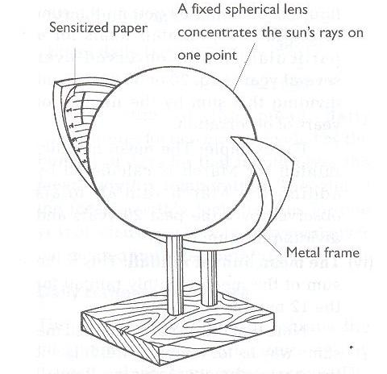
(a) Identify the weather instrument shown above. (1 mark)
(b) Describe how the instrument is used to measure the weather conditions of the day. (4 marks)
2. (a) What are hypabyssal rocks? (2 marks)
(b) State three characteristics of sedimentary rocks. (3 marks)
3. (a) Give two examples of features resulting from fissure eruption. (2 marks)
(b) With aid of a diagram, describe how a basic lava dome is formed. (3 marks)

4. (a) State three conditions necessary for a river capture to occur. (3 marks)
(b) Use the diagram below to answer the questions that follow.
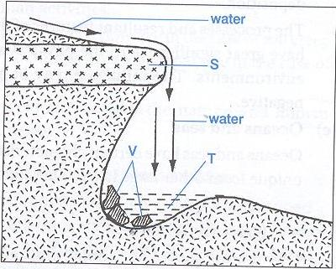
Name the parts labeled E and F. (2 marks)
5. (a) Differentiate between a soil profile and a soil catena. (2 marks)
(b) Give three ways in which soil is degenerated. (3 marks)
SECTION B
Answer question 6 and any other TWO questions from this section.

6. Study the map of Busia 1:50,000 (sheet 101/1) provided and answer the following questions.
(a) (i) What is the vertical interval of the map? (1 mark)
(ii) Give the height of Burende Hill on grid square 3135. (2 marks)
(iii) Identify two man made features on grid square 2431. (2 marks)
(iv) Measure the distance of the All Weather loose surface road from the junction at Odiado southwards to Ukwala. (Give your answer in kilometers).
(b) (i) Draw a cross section from grid reference 260330 to 340330. Use a vertical scale of 1cm to represent 40m. On it mark and name; (8 marks)
- Odiodo Hill.
- All weather road loose surface
- A river
(ii) Calculate the vertical exaggeration of the section. (2 marks)
(ii) Are the two points intervisible? Give a reason. (2 marks)
(c) Citing evidence from the map, explain three factors that have influenced the distribution of settlement in the area covered by the map. (6 marks)
7. (a) (i) What is folding? (2 marks)
(ii) Name three fold mountains formed during the Alpine Oregeny. (3 marks)
(b) State four characteristics of a folded landscape. (4 marks)
(c) The diagram below shows a type of fold.
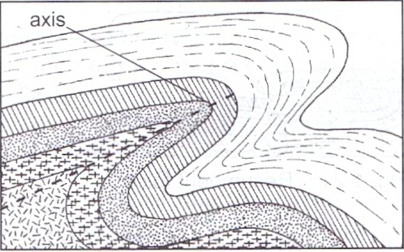
(i) Name the type of fold. (1 mark)
(ii) Describe how the above type of fold is formed. (7 marks)
(d) Explain four effects of fold mountains on human activities. (8 marks)
8. (a) (i) What is vegetation? (2 marks)
(ii) Describe the variation of vegetation types along a mountain slope from the bottom to the top. (5 marks)
(b) Explain two ways in which relief influences the distribution of vegetation. (4 marks)

(c) Study the world map below and answer the questions that follow:
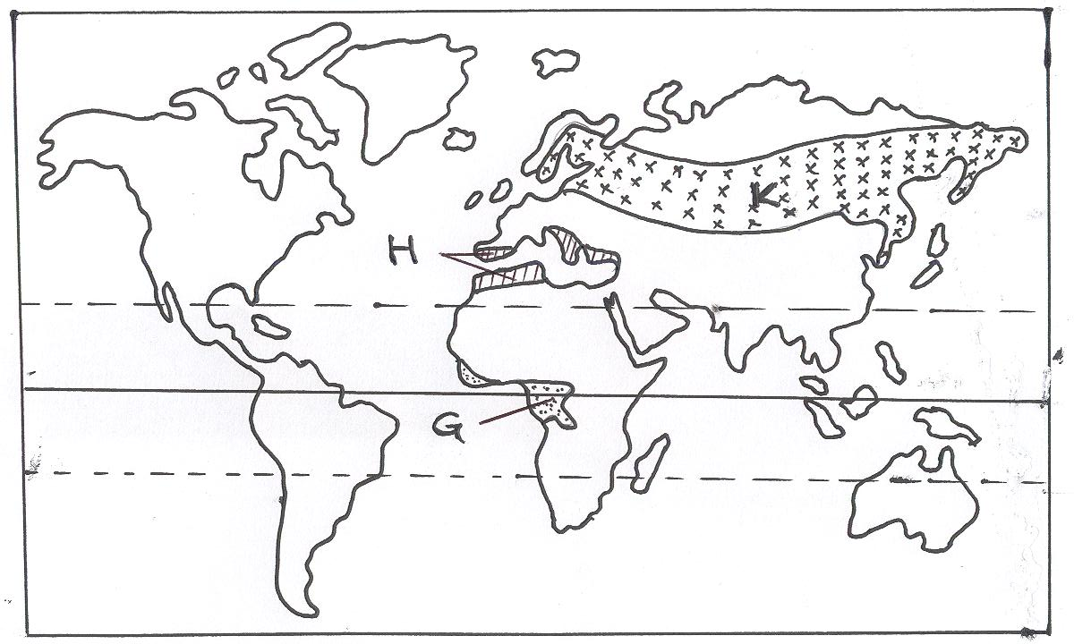
Y
Y
X
W
(i) Name the vegetation types labeled W, X and Y. (3 marks)
(ii) Explain three ways in which desert vegetation has adapted to the climatic conditions of the region it is found. (6 marks)
(d) Students are planning to undertake a field study in a forest near their school. They are required to prepare a working schedule.
(i) What is a working schedule? (2 marks)
(ii) Why is it important for the students to prepare a working schedule? (3 marks)
9. (a) (i) Apart from rainfall, list two other forms of precipitation. (2 marks)
(ii) State three factors that influence the occurrence of surface run off. (3 marks)
(b) (i) What is a lake? (2 marks)
(ii) Give five reasons why some lakes have fresh water. (5 marks)
(iii) State three characteristics of lakes formed due to faulting. (3 marks)
(c) (i) Describe how lake Victoria influence the weather of the surrounding lands. (4 marks)
(d) Give two factors which determine the size of a lake. (2 marks)
10. (a) (i) Give two sources of mineral salts in Ocean water. (2 marks)
(ii) Describe three processes involved in marine erosion. (6 marks)
(b) Using well labeled diagrams, describe how a stack is formed. (6 marks)
(c) Describe three ways in which Islands are formed. (6 marks)
(d) State five ways in which Kenya benefits from her coastal features. (5 marks)

