NAME………………………………………………………….. ADM. NO……………………

SIGNATURE………………………………………………….. DATE………………………..

END OF TERM EXMANINATION
TERM ONE, 2018
FORM THREE
BIOLOGY

ITETANI GIRLS’ HIGH SCHOOL
P.O. BOX 2220 – 90100
MACHAKOS

231/3
BIOLOGY
(PRACTICAL)
PAPER 3
TIME: 1 ¾ HOURS
INSTRUCTION TO CANDIDATES
- Write your name and index number in the spaces provided, sign and write the date
- Answer ALL the question in the spaces provided
- Answer all questions in English
- Candidates may be penalized for wrong spellings of technical terms.

QUESTION | TOTAL MARKS | CANDIDATE’S SCORE
1 | 13
2 | 17
3 | 10
TOTAL | 40

1. You are provided with:
- Solid R (a simple sugar)
- Substance D (Yeast)
- Substance E (Oil)
- Boiled water
- Dissolve all Solid R in 2ml of boiled water provided. Pour the Solution in a boiling tube. To the boiling tube, add all substance D and shake. Add all substance E. Dip the boiling tube into a water bath at 40⁰C. Leave the set up for 20 minutes and make observations.
- State the observations made in the boiling tube (1 Marks)
………………………………………………………………………………………………

………………………………………………………………………………………………

………………………………………………………………………………………………
- Explain the observations made in the boiling tube (2 Marks)
………………………………………………………………………………………………

………………………………………………………………………………………………

………………………………………………………………………………………………
- Name the physiological process that was being investigated (1 Marks)
………………………………………………………………………………………………

………………………………………………………………………………………………

………………………………………………………………………………………………
- Write a word equation for the physiological process being investigated (2 Marks)

- Why was the warm water bath used in the experiment (2 Marks)
………………………………………………………………………………………………

………………………………………………………………………………………………

………………………………………………………………………………………………
- What would be the effect if the warm water bath had a temperature of 100ºC (3 Marks)
……………………………………………………………………………………………....

................................................................................................................................................
- What was the aim of;
- Dissolving substance R in boiled water (1 Mark)
………………………………………………………………………………………………

………………………………………………………………………………………………
- Adding a layer of oil to boiling tube A (1 Mark)
………………………………………………………………………………………………

………………………………………………………………………………………………

2. Study the leaves below and use them to answer the questions that follow:
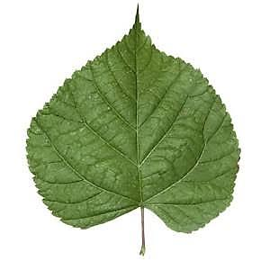
Leaf A Leaf B Leaf C
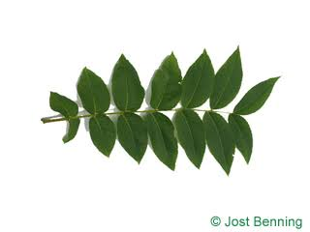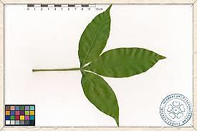
Leaf D Leaf E
- Fill in the blank spaces in the dichotomous key below: (4 Marks)
1 a) Leaf is simple………………………………………………..
b)Leaf is compound……………………………………………. Go to 3

2 a) Leaf margin is serrated……………………………………...
b)Leaf margin is not serrated…………………………………. Leaf A

3 a) Leaf with three leaflets…………………………………….. Leaf E
b) Leaf with more than three leaflets………………………… Go to 4

4 a) Leaf pinnate………………………………………………...
b) Leaf bipinnate………………………………………………
- Fill in the identification table below to identify each leaf. (5 Marks)
LEAF | STEPS | IDENTITY
A |  | Mango tree
B |  | Jacaranda tree
C |  | Lantana camara
D |  | Nandi flame
E |  | Cow peas

- Identify one mistake in the dichotomous key provided and suggest its possible correction. (2 Marks)
………………………………………………………………………………………………………………………………………………………………………………………………………………………………………
- Classify the Mango tree up to class level. (2 Marks)
Kingdom- ……………………………………………………………….
Division - ………………………………………………………………..
Sub-division- ……………………………………………………………
Class- ……………………………………………………………………

e) The scientific name of Plant C is Lantana camara.
i) What does Lantana refer to? (2 Marks)

…………………………………………………………………………………….
f) Rewrite the name following the correct rules of binomial nomenclature (2 Marks)
………………………………………………………………………………………………

………………………………………………………………………………………………

3. You are provided with Specimen F, Solution G and Solution H. Cut out two thin strips of Specimen F measuring 1cm x 3cm as shown below:
1cm
3cm

a) Place one strip in the beaker containing Solution G and the other in the beaker containing Solution H. Leave the set-up for 30 minutes. Save the remaining specimen for question (b)
i) Measure the length of the two strips and record your observations. (2 Marks)
…………………………………………………………………………………………………

…………………………………………………………………………………………………

…………………………………………………………………………………………………
ii) Account for your observations in (i) above (4 Marks)
…………………………………………………………………………………………………

…………………………………………………………………………………………………

…………………………………………………………………………………………………

…………………………………………………………………………………………………

…………………………………………………………………………………………………
iii) What type of a solution is Solution G (1 Mark)

…………………………………………………………………………………………………

b) Crush the remaining part of the specimen in a mortar and pestle. Add 4ml of distilled water. Using the solutions provided, conduct a food test (3 Marks)
FOOD | PROCEDURE | OBSERVATION | CONCLUSION
Reducing Sugars

ITETANI GIRLS’ HIGH SCHOOL
P.O. BOX 2220 – 90100
MACHAKOS
END OF TERM EXAM
TERM ONE, 2018
FORM THREE
BIOLOGY 231/3
CONFIDENTIAL
EACH STUDENT WILL REQUIRE:
- Solid R – Glucose
- Substance D – yeast
- Substance E – Oil
- Specimen F – Potato strips
- Solution H – distilled water
- Solution G – 10% Sodium Chloride
- 2 boiling tubes
- 2 test tubes
- 250ml glass beaker
- Measuring cylinder
- Warm water bath
- 8ml of boiled distilled water
- Scalpel
- Ruler
- 100ml beaker
- Mortar and pestle
- Benedict’s solution supplied with a dropper

