NAME………………………………………………………….. ADM. NO……………………

END OF TERM EXAMINATION
TERM ONE, 2018
FORM TWO
CHEMISTRY

ITETANI GIRLS’ HIGH SCHOOL
P.O. BOX 2220 – 90100
MACHAKOS

233
CHEMISTRY
TIME: 2 HOURS
INSTRUCTION TO CANDIDATES
- Answer ALL the question in the spaces provided
- Answer ALL questions in English

QUESTION | TOTAL MARKS | CANDIDATE’S SCORE
1-9 | 100

1. a) Form One Students dipped a blue litmus paper in a solution and the colour of the litmus paper changed to red. They concluded that the solution had pH 1.
i) Why was their conclusion wrong? (1 Mark)
………………………………………………………………………………………………………
………………………………………………………………………………………………………
ii) Describe an experiment that they would use to correct their conclusion. (2 Marks)
………………………………………………………………………………………………………
………………………………………………………………………………………………………
………………………………………………………………………………………………………
b) A compound DX was dipped in a beaker containing dilute sulphuric acid and it produced bubbles of a colourless gas.
i) Given that D is the cation and X is the anion, give two possible identities of X (2 Marks)
………………………………………………………………………………………………………
………………………………………………………………………………………………………
ii) When DX was burned in a flame, it burnt with a brick red flame. What is the identity of D? (1 Mark)
………………………………………………………………………………………………………
iii) Given that X does not contain hydrogen, write the chemical formula of DX (2 Marks)

iv) Write a well-balanced chemical equation between the compound named in iii) above and dilute sulphuric acid. (2 Marks)

2. The grid below represents a part of the periodic table. Letters do not represent real symbols of elements.
 |  |  |  |  |  |  | Q
P
R |  |  | T |  |  | U
S

a) Name the elements labeled: (6 Marks)
P-………………………………………………………………………………………………………
Q-………………………………………………………………………………………………………
R-………………………………………………………………………………………………………
S-………………………………………………………………………………………………………
T-………………………………………………………………………………………………………
U-………………………………………………………………………………………………………

b) Compare the atomic radius of elements P, R and S. Give a reason for your answer. (3 Marks)
………………………………………………………………………………………………………
………………………………………………………………………………………………………
………………………………………………………………………………………………………
………………………………………………………………………………………………………
c) Give two reasons as to why element Q is in group VIII although it has two electrons in the outermost energy level. (2 Marks)
………………………………………………………………………………………………………
………………………………………………………………………………………………………
………………………………………………………………………………………………………
d) Element F is in Period 2 and group IV.
i) On the grid above, show the position of element F. (1 Mark)
ii) Element F has two isotopes. One has 6 neutrons while the other has 8 neutrons. Given that the two isotopes occur in the ratio 3:2 respectively, determine the RAM of element F. (4 Marks)
………………………………………………………………………………………………………
………………………………………………………………………………………………………
………………………………………………………………………………………………………
………………………………………………………………………………………………………
……………………………………………………………………………………………………....
e) An atom is said to be electrically neutral. Explain. (4 Mark)
………………………………………………………………………………………………………
………………………………………………………………………………………………………
………………………………………………………………………………………………………
3. Study the diagrams below and answer the questions that follow:

a) Compare the rate of rusting between test tube i and test tube iii (2 Marks)
………………………………………………………………………………………………………
………………………………………………………………………………………………………
………………………………………………………………………………………………………
b) Explain why rusting did not occur in test tube ii (2 Marks)
………………………………………………………………………………………………………
………………………………………………………………………………………………………
c) What was the purpose of using boiled water in test tube iv (1 Mark)
………………………………………………………………………………………………………
………………………………………………………………………………………………………
d) Below are some characteristics of elements D, E, F and G
- E reacts with both water, dilute acids and steam
- D can remove combined oxygen from an oxide of G, reacts with dilute acids but does not react with water
- F does not react with dilute acids
- G reacts with dilute acids
i) Arrange the elements from the least reactive to the most reactive (3 Marks)
………………………………………………………………………………………………………
………………………………………………………………………………………………………
ii) Can F remove oxygen from an oxide of G? Give a reason for your answer. (2 Marks)
………………………………………………………………………………………………………
………………………………………………………………………………………………………
4. a) What are the products produced when kerosene burns in air (2 Marks)
………………………………………………………………………………………………………
………………………………………………………………………………………………………
b) Explain how you would test for the presence of one of the products named in a) above (2 Marks)
………………………………………………………………………………………………………
………………………………………………………………………………………………………
………………………………………………………………………………………………………
………………………………………………………………………………………………………
c) Study the diagram below and answer the questions that follow:

i) Write a well-balanced chemical equation for the reaction in the combustion tube (2 Marks)

ii) Write a well-balanced chemical equation for the reaction in the blue flame (2 Marks)

d) State any two industrial uses of hydrogen gas (2 Marks)
………………………………………………………………………………………………………
………………………………………………………………………………………………………
5. a) The graph below represents the heating curve of substance Q
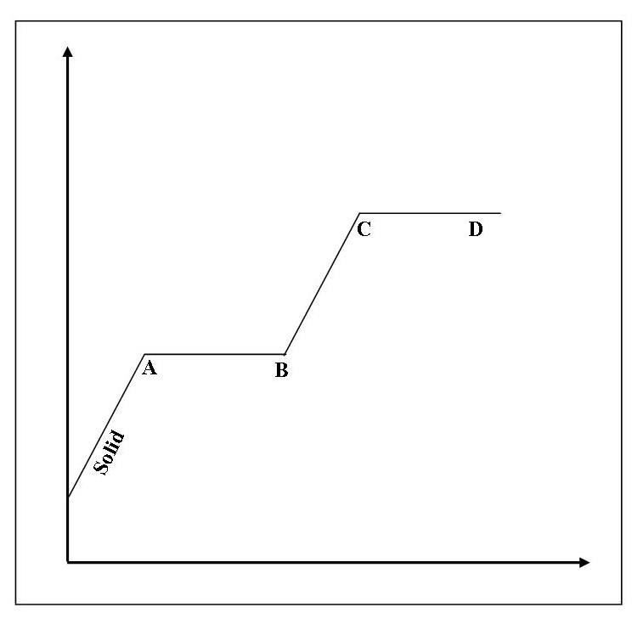
TIME
TEMPERATURE
i) What is the state of substance Q between B and C (1 Mark)
………………………………………………………………………………………………………
ii) Using the kinetic theory of matter, explain what happens at the part labeled A (2 Marks)
………………………………………………………………………………………………………
………………………………………………………………………………………………………
iii) State any two changes would occur on the graph if impurities were introduced in substance Q (2 Marks)
………………………………………………………………………………………………………
………………………………………………………………………………………………………
………………………………………………………………………………………………………
d) The table below shows some properties of sugar, naphthalene and camphor.
SOLID | SOLUBILITY IN ETHANOL | SOLUBILITY IN ETHER
Naphthalene | Insoluble | Insoluble
Sugar | Soluble | Insoluble
Camphor | Soluble | Soluble
i) Explain how you would obtain solid sugar from a mixture of naphthalene, sugar and camphor (3 Marks)
………………………………………………………………………………………………………
………………………………………………………………………………………………………
………………………………………………………………………………………………………
………………………………………………………………………………………………………
………………………………………………………………………………………………………
………………………………………………………………………………………………………
ii) Give two reasons as to why ice cream vendors prefer to use dry ice as a coolant compared to ordinary ice (2 Marks)
………………………………………………………………………………………………………
………………………………………………………………………………………………………
………………………………………………………………………………………………………
6. a) State four apparatus which can be used to measure accurate volume in the laboratory (4 Marks)
………………………………………………………………………………………………………
………………………………………………………………………………………………………
………………………………………………………………………………………………………
………………………………………………………………………………………………………
b) Give two reasons why many apparatus in the laboratory are made up glass (2 Marks)
………………………………………………………………………………………………………
………………………………………………………………………………………………………
………………………………………………………………………………………………………
c) Explain why the bright yellow zone of a luminous flame produces a lot light (2 Marks)
………………………………………………………………………………………………………
………………………………………………………………………………………………………
………………………………………………………………………………………………………
d) Give two reasons as to why a non-luminous flame should be put off after use or changed to a luminous flame (2 Marks)
………………………………………………………………………………………………………
………………………………………………………………………………………………………
7. a) Two ions; X³⁺ and Y²⁻ have the electron configuration of 2.8 and 2.8.8 respectively.
i) Write the electron configuration of elements X and Y (2 Marks)
X-………………………………………………………………………………………………………
Y-………………………………………………………………………………………………………
ii) Write the chemical formula of the compound formed when element X and Y combine (2 Marks)

b) The ion of aluminium can be represented as shown below
26
Al³⁺
13
i) Calculate the number of electrons in an aluminium ion (2 Marks) ………………………………………………………………………………………………………
………………………………………………………………………………………………………
ii) Calculate the number of neutrons in an aluminium ion (2 Marks)
………………………………………………………………………………………………………
………………………………………………………………………………………………………
c) Element T has an octet electron configuration. Explain why Element T does not react with other substances (2 Marks)
………………………………………………………………………………………………………
8. a) Acneiform is a chemical substance which causes pimples on the skin. A chromatography of three lotions gave the results below:
Lotion C
Lotion B
Lotion A
Acneiform

i) Which of the three lotions is not fit for human consumption? Give a reason for your answer. (2 Marks)
………………………………………………………………………………………………………
………………………………………………………………………………………………………
ii) Is Acneiform a pure substance? Give a reason for your answer. (1 Mark)
………………………………………………………………………………………………………
………………………………………………………………………………………………………
b) Explain why a compound forms only one ring on a chromatogram while a mixture forms more than one rings. (2 Marks)
………………………………………………………………………………………………………
………………………………………………………………………………………………………
………………………………………………………………………………………………………
………………………………………………………………………………………………………
c) Is air a mixture or a compound? Explain. (3 Marks)
………………………………………………………………………………………………………
………………………………………………………………………………………………………
d) Explain why water is not commonly used as a solvent in chromatography (1 Mark)
………………………………………………………………………………………………………
e) Name the process used to extract coconut oil from coconuts (1 marks)
………………………………………………………………………………………………………
9. Write a well-balanced chemical equation for the reaction between;
a) Magnesium and dilute hydrochloric acid (2 Marks)

b) Sodium hydroxide and dilute sulphuric acid (2 Marks)

c) Calcium carbonate and dilute nitric acid (2 Marks)

d) Aluminium and steam (2 Marks)

e) Sodium and copper (ii) oxide (2 Marks)

