NAME………………………………………………………….. ADM. NO……………………

END OF TERM EXAMINATION
TERM ONE, 2018
FORM ONE
CHEMISTRY

ITETANI GIRLS’ HIGH SCHOOL
P.O. BOX 2220 – 90100
MACHAKOS

233
CHEMISTRY
TIME: 2 HOURS
INSTRUCTION TO CANDIDATES
- Answer ALL the question in the spaces provided
- Answer ALL questions in English

QUESTION | TOTAL MARKS | CANDIDATE’S SCORE
1-7 | 70

1. a) The graph below represents the heating curve of substance Q
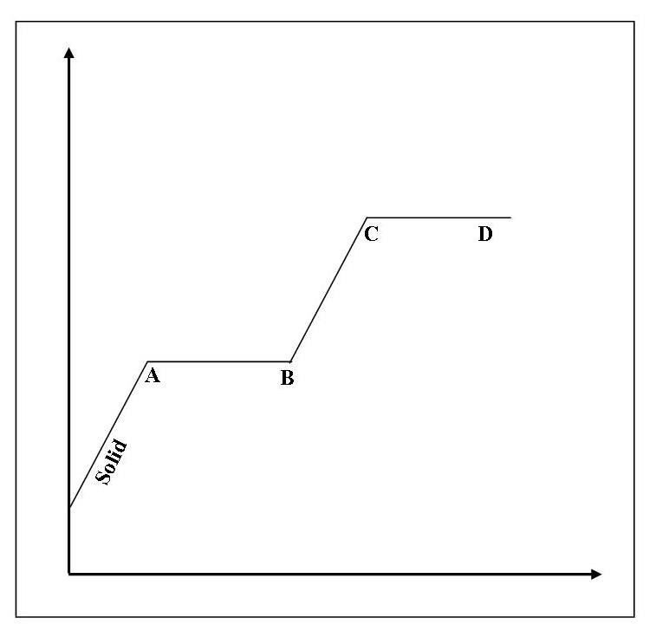
TIME
TEMPERATURE
i) What is the state of substance Q between B and C (1 Mark)
………………………………………………………………………………………………………
ii) Using the kinetic theory of matter, explain what happens at the part labeled A (2 Marks)
………………………………………………………………………………………………………
………………………………………………………………………………………………………
iii) State any two changes would occur on the graph if impurities were introduced in substance Q (2 Marks)
………………………………………………………………………………………………………
………………………………………………………………………………………………………
………………………………………………………………………………………………………
d) The table below shows some properties of sugar, naphthalene and camphor.
SOLID | SOLUBILITY IN ETHANOL | SOLUBILITY IN ETHER
Naphthalene | Insoluble | Insoluble
Sugar | Soluble | Insoluble
Camphor | Soluble | Soluble
i) Explain how you would obtain solid sugar from a mixture of naphthalene, sugar and camphor (3 Marks)
………………………………………………………………………………………………………
………………………………………………………………………………………………………
………………………………………………………………………………………………………
………………………………………………………………………………………………………
………………………………………………………………………………………………………
………………………………………………………………………………………………………
ii) Give two reasons as to why ice cream vendors prefer to use dry ice as a coolant compared to ordinary ice (2 Marks)
………………………………………………………………………………………………………
………………………………………………………………………………………………………
………………………………………………………………………………………………………
2. a) State four apparatus which can be used to measure accurate volume in the laboratory (4 Marks)
………………………………………………………………………………………………………
………………………………………………………………………………………………………
………………………………………………………………………………………………………
………………………………………………………………………………………………………
b) Give two reasons why many apparatus in the laboratory are made up glass (2 Marks)
………………………………………………………………………………………………………
………………………………………………………………………………………………………
………………………………………………………………………………………………………
c) Explain why the bright yellow zone of a luminous flame produces a lot light (2 Marks)
………………………………………………………………………………………………………
………………………………………………………………………………………………………
………………………………………………………………………………………………………
d) Give two reasons as to why a non-luminous flame should be put off after use or changed to a luminous flame (2 Marks)
………………………………………………………………………………………………………
………………………………………………………………………………………………………
3. Form 1 students performed an experiment in which they inserted a wooden splint in different parts of a non-luminous flame. The results are as shown below:
Charred parts
ii
i
Central part uncharred

a) What were they investigated (1 Mark)
………………………………………………………………………………………………………
b) What did they conclude (2 Marks)
………………………………………………………………………………………………………
c) Why was the central part of splint ii left uncharred? (2 Marks)
………………………………………………………………………………………………………
………………………………………………………………………………………………………
d) State any five laboratory safety rules (5 Marks)
………………………………………………………………………………………………………
………………………………………………………………………………………………………
………………………………………………………………………………………………………
………………………………………………………………………………………………………
………………………………………………………………………………………………………
………………………………………………………………………………………………………
4. a) Form One students added a colourless liquid to anhydrous copper (ii) sulphate. Its colour changed from white to blue. They then concluded that the colourless liquid was pure water.
i) Why was their conclusion wrong? (2 Marks)
………………………………………………………………………………………………………
………………………………………………………………………………………………………
ii) Describe an experiment which they could conduct to correct their conclusion (2 Marks)
………………………………………………………………………………………………………
………………………………………………………………………………………………………
………………………………………………………………………………………………………
iii) Differentiate between a compound and a mixture (1 Mark)
………………………………………………………………………………………………………
………………………………………………………………………………………………………
………………………………………………………………………………………………………
………………………………………………………………………………………………………
b) What is an element? (1 Marks)
………………………………………………………………………………………………………
………………………………………………………………………………………………………
………………………………………………………………………………………………………

c) State the chemical symbol of the elements below: (4 Marks)
i) Calcium
………………………………………………………………………………………………………
ii) Chlorine
………………………………………………………………………………………………………
iii) Silicon
………………………………………………………………………………………………………
iv) Sulphur
………………………………………………………………………………………………………
5. a) Give the difference in the chemical composition of: (3 Marks)
i) Magnesium sulphate and Magnesium sulphite
……………………………………………………………………………………………………..
……………………………………………………………………………………………………..
…………………………………………………………………………………………………….
ii) Ammonia and ammonium
……………………………………………………………………………………………………..
……………………………………………………………………………………………………..
……………………………………………………………………………………………………..
iii) Calcium nitrate and calcium nitrite
……………………………………………………………………………………………………..
…………………………………………………………………………………………………….
……………………………………………………………………………………………………..
b) Study the chemical equations below and state whether it is a temporary change or a permanent change:
i) A+B A+B (2 Marks)
………………………………………………………………………………………………………
ii) A+B AB (2 Marks)
iii) (2 Marks)
+

………………………………………………………………………………………………………
c) What is an atom (1 Mark)
………………………………………………………………………………………………………
………………………………………………………………………………………………………
………………………………………………………………………………………………………
6. Study the diagram below and answer the questions that follow:
Q
SOLID
LIQUIDS

GASES

T
R
U
S
P

a) Name the processes labeled; (6 Marks)
P-……………………………………………………………………………………………………....
Q-………………………………………………………………………………………………………
R-………………………………………………………………………………………………………
S-………………………………………………………………………………………………………
T-………………………………………………………………………………………………………
U-………………………………………………………………………………………………………

b) Explain how you would separate a mixture of aluminium chloride, sand and common salt to obtain crystals of common salt. (4 Marks)
………………………………………………………………………………………………………
………………………………………………………………………………………………………
………………………………………………………………………………………………………
………………………………………………………………………………………………………
………………………………………………………………………………………………………
………………………………………………………………………………………………………
………………………………………………………………………………………………………
7. a) Explain why a filter paper is preferred for filtration in the laboratory compared to a sieve (2 Marks)
………………………………………………………………………………………………………
………………………………………………………………………………………………………
………………………………………………………………………………………………………
b) Decantation is not an efficient way of separating insoluble solid-liquid mixtures. Explain. (2 Marks)
………………………………………………………………………………………………………
………………………………………………………………………………………………………
………………………………………………………………………………………………………
c) What is the significance of the following when separating a soluble solid-liquid mixture;
i) Heating the evaporating dish using a water bath (2 Marks)
………………………………………………………………………………………………………
………………………………………………………………………………………………………
ii) Using an evaporating dish and not a boiling tube (2 Marks)
……………………………………………………………………………………………………..
…………………………………………………………………………………………………….
d) State any two applications of crystallization in real life (2 Marks)
……………………………………………………………………………………………………

