FORM 4
BIOLOGY PAPER 1
PRE- MOCK I – MARCH 2016
TIME 2HRS

NAME…………………………………………………….. ADMIN NO…….. CLASS……..

INSTRUCTIONS
- Answer all the questions in the spaces provided.

Examiners use only

80

- State two features of each of the following taxa (4mks)
- Insect
……………………………………………………………………………………………………………………………………………………………………………………………………
- Pteridophyta
...........................................................................................................................................................................................................................................................................................................
- State three factors that cause seed dormancy? (3mks)
………………………………………………………………………………………………………………………………………………………………………………………………………………………………………………………………………………………………………………………………………………………………………………………………
- How are red blood cells adapted to their function? (3mks)
…………………………………………………………………………………………………………………………………………………………………………………………………………………………………………………………………………………………………………………………………………………………………………………………………………
……………………………………………………………………………………………………………………………………………………………………………………………………
- In what ways do muscle fibres of the biceps differ from those of the stomach? (4mks)
…………………………………………………………………………………………………………………………………………………………………………………………………………………………………………………………………………………………………………………………………………………………………………………………………………………………………………………………………………………………….......................
- What is adaptive radiation? Give two examples (3mks)
…………………………………………………………………………………………………………………………………………………………………………………………………………………………………………………………………………………………………………………………………………………………………………………………………………
……………………………………………………………………………………………………………………………………………………………………………………………………
- An experiment was set up as shown using wheat seedlings
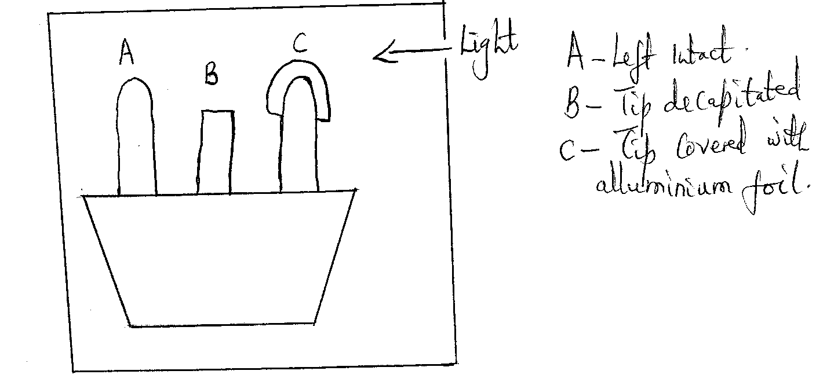
State the role of each of the following seedlings
- Seedling A (1mk)
………………………………………………………………………………………………
(ii) Seedling B (1mk)
………………………………………………………………………………………………
- Seedling C (1mk)
……………………………………………………………………………………………..
- Name the organelles in which the following process occur (3mks)
- Synthesis of ribosomes
……………………………………………………………………………………………..
- Synthesis of lysosomes
……………………………………………………………………………………………..
- Packaging of secretions
…………………………………………………………………………………………….
- Define the following terms as used in evolution (2mks)
- Vestigial structures
……………………………………………………………………………………………..
- Isolation
…………………………………………………………………………………………….
- i) Explain the importance of contraction of erector pili muscle of a mammal skin. (1mk)
……………………………………………………………………………………………..
…………………………………………………………………………………………….
…………………………………………………………………………………………….
- Give two functions of sebum (2mks)
………………………………………………………………………………………………
…………………………………………………………………………………………….
…………………………………………………………………………………………….
…………………………………………………………………………………………….
- Distinguish between diffusion and active transport (2mks)
………………………………………………………………………………………………….
…………………………………………………………………………………………………..
………………………………………………………………………………………………….
………………………………………………………………………………………………….
11. i) What is excretion (1mk)
………………………………………………………………………………………………….
………………………………………………………………………………………………….
ii) State three nitrogenous wastes excreted by animals (3mks)
…………………………………………………………………………………………………
…………………………………………………………………………………………………
…………………………………………………………………………………………………
…………………………………………………………………………………………………
12. The figure below represents a member of a plant kingdom.
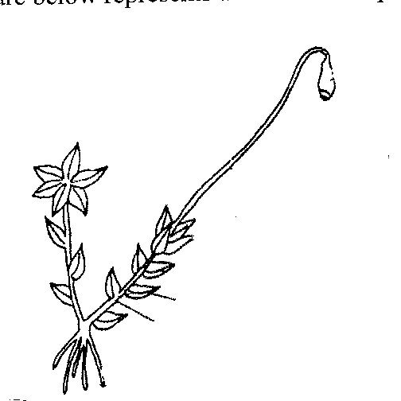
- Name the division (1mk)
………………………………………………………………………………………….………………………………………………………………………………………….
- State two characteristics of members of the division (2mks)
……………………………………………………………………………………………………………………………………………………………………………………………………………………………………………………………………………….
…………………………………………………………………………………………
13. The diagram below represents an organism
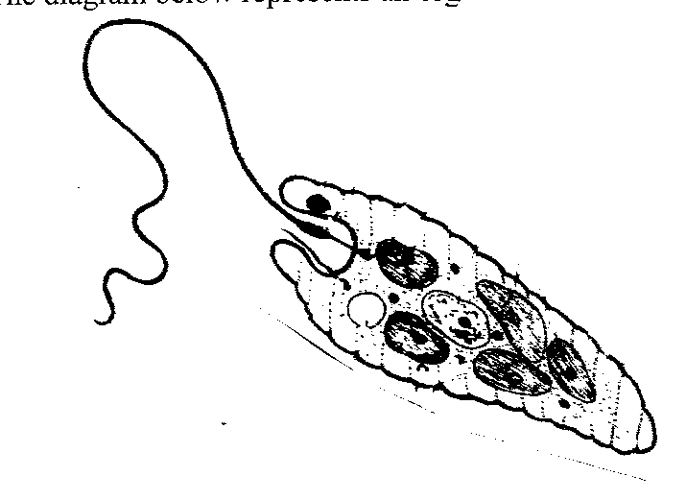
- Name the kingdom to which the organism belongs (1mk)
…………………………………………………………………………………………….
- Suggest the habitat in which the organism lives (1mk)
……………………………………………………………………………………………..
- Give two reasons of your answer (2mks)
………………………………………………………………………………………………………………………………………………………………………………………………
………………………………………………………………………………………………
………………………………………………………………………………………………
14. State two factors that denature enzymes (2mks)
…………………………………………………………………………………………………
…………………………………………………………………………………………………
…………………………………………………………………………………………………
…………………………………………………………………………………………………
15. State the importance of the following process that take place in the nephron of a human
Kidney

- Ultrafiltration (1mk)
………………………………………………………………………………………………
………………………………………………………………………………………………
- Selective reabsorption (1mk)
………………………………………………………………………………………………
………………………………………………………………………………………………
16. State three factors that affect the rate of active transport (2mks)
………………………………………………………………………………………………………………………………………………………………………………………………………………………………………………………………………………………………………………………………………………………………………………………………………………………………
17. a) What is a chromosal mutation? (1mk)
………………………………………………………………………………………………………………………………………………………………………………………………………………
b) State two causes of chromosal mutations (2mks)
………………………………………………………………………………………………………………………………………………………………………………………………………………
18. The diagram below shows a state of cell division in a plant structure.
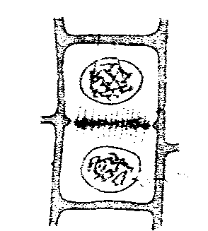

- Name the stage of cell division (1mk)
……………………………………………………………………………….
- Name the part of the plant in which this cell division takes place. (1mk)
……………………………………………………………………………………
19. State two functions of the pituitary glands (2mks)
………………………………………………………………………………………………………………………………………………………………………………………………………………………………………………………………………………………………………………………
………………………………………………………………………………………………………
20. Explain why a person suffering from malaria easily gets muscle cramps. (2mks)
………………………………………………………………………………………………………………………………………………………………………………………………………………………………………………………………………………………………………………………………………………………………………………………………………………………………21. Describe two biotic factors in ecosystems (2mks)
………………………………………………………………………………………………………………………………………………………………………………………………………………………………………………………………………………………………………………………
………………………………………………………………………………………………………
22. Account for the following phases of a sigmoid curve of growth of organisms.
a) Lag phase (2 mks)
………………………………………………………………………………………………………………………………………………………………………………………………………………
………………………………………………………………………………………………………
b) Exponential phase (2 mks)
………………………………………………………………………………………………………
………………………………………………………………………………………………………
………………………………………………………………………………………………………
c) Plateau phase (1 mk)
………………………………………………………………………………………………………………………………………………………………………………………………………………
………………………………………………………………………………………………………
23. Describe the process of double fertilization in flowering plants (4mks)
………………………………………………………………………………………………………………………………………………………………………………………………………………………………………………………………………………………………………………………………………………………………………………………………………………………………………………………………………………………………………………………………………
24. State the products of the light reaction stage of photosynthesis (2mks)
………………………………………………………………………………………………………………………………………………………………………………………………………………
25. The diagram below shows a human tooth
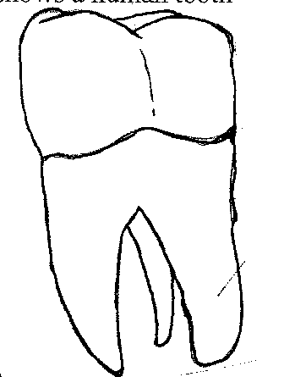
- Identify the tooth (1mk)
………………………………………………………………………………………..
- How is the tooth adapted to its function (2mks)
………………………………………………………………………………………………………………………………………………………………………………………………………………………………………………………………………………………………………………………………………………………………………………………………
26. Write a chemical equation summarizing the process of anaerobic respiration in plants. (1 mk)
………………………………………………………………………………………………………
………………………………………………………………………………………………………
27. Name one animal cell that has no nucleus when fully development. (1 mk)
………………………………………………………………………………………………………
………………………………………………………………………………………………………

28. Define heteroflyly. (1 mk)
………………………………………………………………………………………………………
………………………………………………………………………………………………………
29. State two factors within the seed that would cause seed dormancy. (2 mks)
………………………………………………………………………………………………………
………………………………………………………………………………………………………
………………………………………………………………………………………………………
………………………………………………………………………………………………………
30. What two ideas are proposed by Jean Baptiste Lamarck’s theory? (2 mks)
………………………………………………………………………………………………………
………………………………………………………………………………………………………
………………………………………………………………………………………………………
………………………………………………………………………………………………………
31. Outline one reason why blood clotting does not occur inside blood vessels.
………………………………………………………………………………………………………
………………………………………………………………………………………………………

