Name: …………………………………………………………Class: ……………. Adm. No. ……………
School:…………………………… …………Date:……………………Sign:…………………………
233/1
CHEMISTRY
Paper 1
MAY/JUNE 2016
Time: 2 hours

EKSIKA JOINT EVALUATION TEST
Kenya Certificate to Secondary Education
CHEMISTRY PAPER 1
TIME: 2 HOURS
233/1
CHEMISTRY
Paper 1
MAY/JUNE 2016
Time: 2 hours

INSTRUCTIONS TO CANDIDATES
- Write your name, admission number, date and school in the spaces provided.
- Answer all the questions in the spaces provided.
- All working must be clearly shown where necessary.
- Scientific calculators may be used.

FOR EXAMINERS’ USE ONLY

Questions | Maximum Score | Candidate’s Score
1 – 31 | 80

This paper consists of 13 printed pages. Candidates are advised to check and to make sure all pages are as indicated and no question is missing.

- Elements X and Y reacted forming a compound Z. the compound has the following properties
- It does not conduct electricity in solid state
- It has low melting and boiling points
- What is the nature of elements X and Y 1mk

- What type of structure does compound Z have 1mk

- The following chromatogram was obtained from an experiment to investigate the component of a certain dye
A B C D

- Which two dyes when mixed would produce A 1mk

- Which dye is pure 1mk

- Indicate on the diagram the probable position of the solvent front 1mk

- The flow chart below shows some properties of two allotropes of element P
Allotrope A
Allotrope B
Product of P
Above 96c⁰
Burning to air
Burning to air
Below 96c⁰

- Name allotrope A 1mk

- Write an equation to show the formation of the product of P 1mk

- What does 96⁰ C 1mk

- Study the equation and answer the questions that follows
25O₂(g)+O₂ (g) 25O₃(g)∆H=-197Kj
- Suggest two changes to which the yield of sulphur (vi) oxide could be improved 2mks

- Determine the molar heat of formation of SO₃ from SO₂ and O₂ 1mk

- In an experiment soap solution was added to three separate water samples. The table below shows the volumes of soap solution required to form lather with 100cm³ of each water sample before and after boiling
sample
A B C
27 3 10.6
27 3 3
Volume of soap before boiling (cm³)
Volume of soap after boiling (cm³)

Which water sample is likely to be;
- Soft water 1mk

- Water with temporary hardness 1mk

- Water with permanent hardness 1mk

- 5.0g of calcium carbonate were allowed to react with 25cm³ of 0.1M hydrochloric acid until there was no further reaction. Calculate the mass of calcium carbonate that remained unreacted. (Ca=40.0,C=12.0, O=16) 3mks

- Silicon has three isotopes such as silicon-X, silicon-29 and silicon-30. Their percentages abundance are 92%, 5% and 3% respectively
- Given that the relative atomic mass of silicon is 28.11, determine the value of X 2mks

- Identify the most stable isotope. Give a reason for your answer 1mk

- i) Starting with calcium oxide, describe how a solid sample of calcium carbonate can be prepared in the laboratory 3mks

- State one use of calcium oxide 1mk

- Air was passed through several reagents as shown below in the flow chart
Escaping gas
Concentrated KOH
Excess heated copper turnings
Excess heated magnesium powder
Air

- Write an equation for the reaction which takes place in the chamber with magnesium powder 1mk

- Name one gas which escapes from the chamber. Give a reason for your answer 2mks

- Draw a setup that can be used to separate a mixture of sand and ammonium chloride 3mks

- Study the table below and use it to answer the questions that follow
Add sodium carbonate solution Add few drops of phenolphthalein
No effervescence pink
No effervescence colorless
Effervescence occurs colorless
Substance X
Substance Z
Substance Y

- Which substance contains hydrogen ions 1mk

- Which substance could be sodium chloride solution 1mk

- Which substance could react with an acid to form salt and water only 1mk

- The diagram below represents a charcoal burner. Study it and answer the questions that follow
Blue flame
ii
i
air

Write an equation for the reaction taking place at I and ii
- 1mk

- 1mk

- What safety precautions should be taken when using the charcoal burner 1mk

- a) A gaseous hydrocarbon contain 80% carbon by mass. Determine it empirical formula
(C=12, H=1) 1^{1/}₂mk

b) Given that 0.3g of the hydrocarbon occupy a volume of 224 cm³ at s.t.p, determine its molecular formula (C=12, H=1) , molar gas volume at s.t.p =22.4 dm³ 1^{1/}₂mk

- a)State Charles law 1mk

b) The volume of a sample of nitrogen gas at a temperature of 291k and 1.0x10⁵ pascal was 3.5x10⁻²m³. Calculate the temperature at which the volume of the gas would be 2.8x 10⁻²m³ at 1.0x10⁵ pascal 2mks

15. Study the following flow chart and answer the questions that follow
Alcohol R
Ethene
Compound S
Conc H₂ SO₄
Process T
HCL

- Write the formula of
Alcohol R 1mk

Compound S 1mk

- Name process T 1mk

16. Study the diagram below and use it to answer the questions that follow
R
P
P
+
-

- Name;
i) Radiation represented by Q ¹/₂mk

ii) Radiation represented by R ¹/₂mk

iii) Explain why radiation P is deflected more than R 1mk

- Study the symbols below and answer the questions that follow.
A
Z
Y
X
82 83 82 86
208 212 212 226

Note that the letters are not the actual symbols of the elements. Name any two letters that are isobars. Explain 2mks

17. Study the diagram below and answer the questions that follow

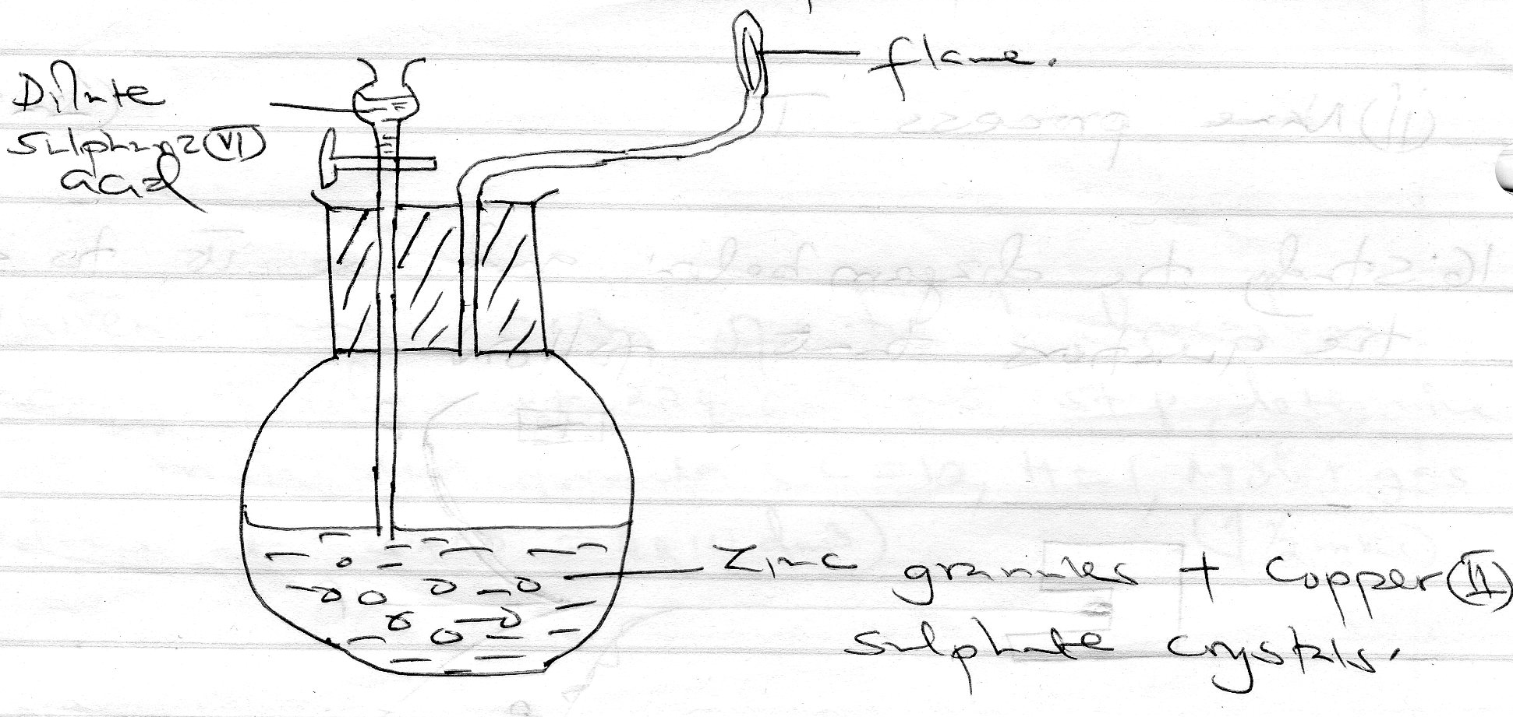

- Write three equations for the reaction that takes place in the set up above 3mks

- State the role of copper (ii) sulphate crystal in the set up 1km

18. the table below describe three experiment on reaction of excess sulphate (vi) acid with 0.5g of zinc done under different conditions. In each case the volume of gas produced was recorded at different time intervals
Experiment | Form of zinc | Concentration H₂SO₃
I | Powder | 0.8M
Ii | Powder | 1.0M
iii | Granules | 0.8M
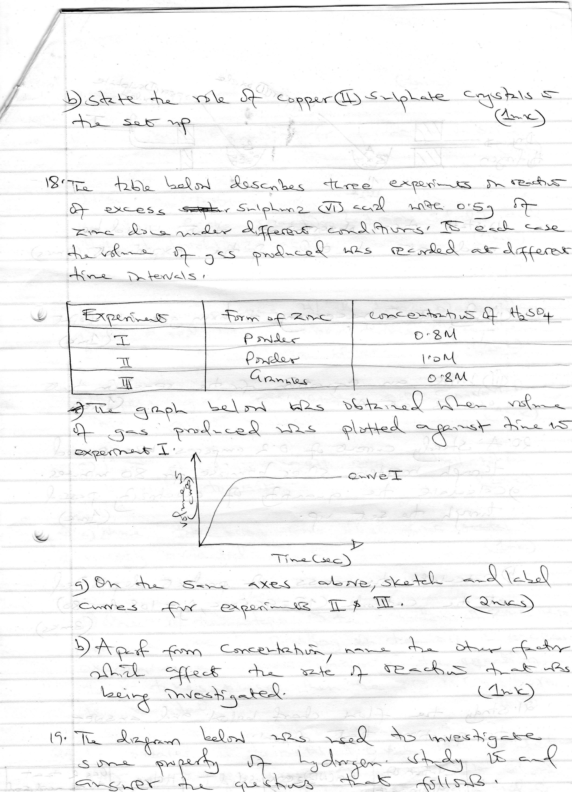
The graph below was obtained when volume of gas produced was plotted against time to experiment. i)

- On the same axes above, sketch and label curves experiments ii& iii 2mks

- A part from concentration ,name the other factor which affect the rate of reaction that was being investigated 1mk

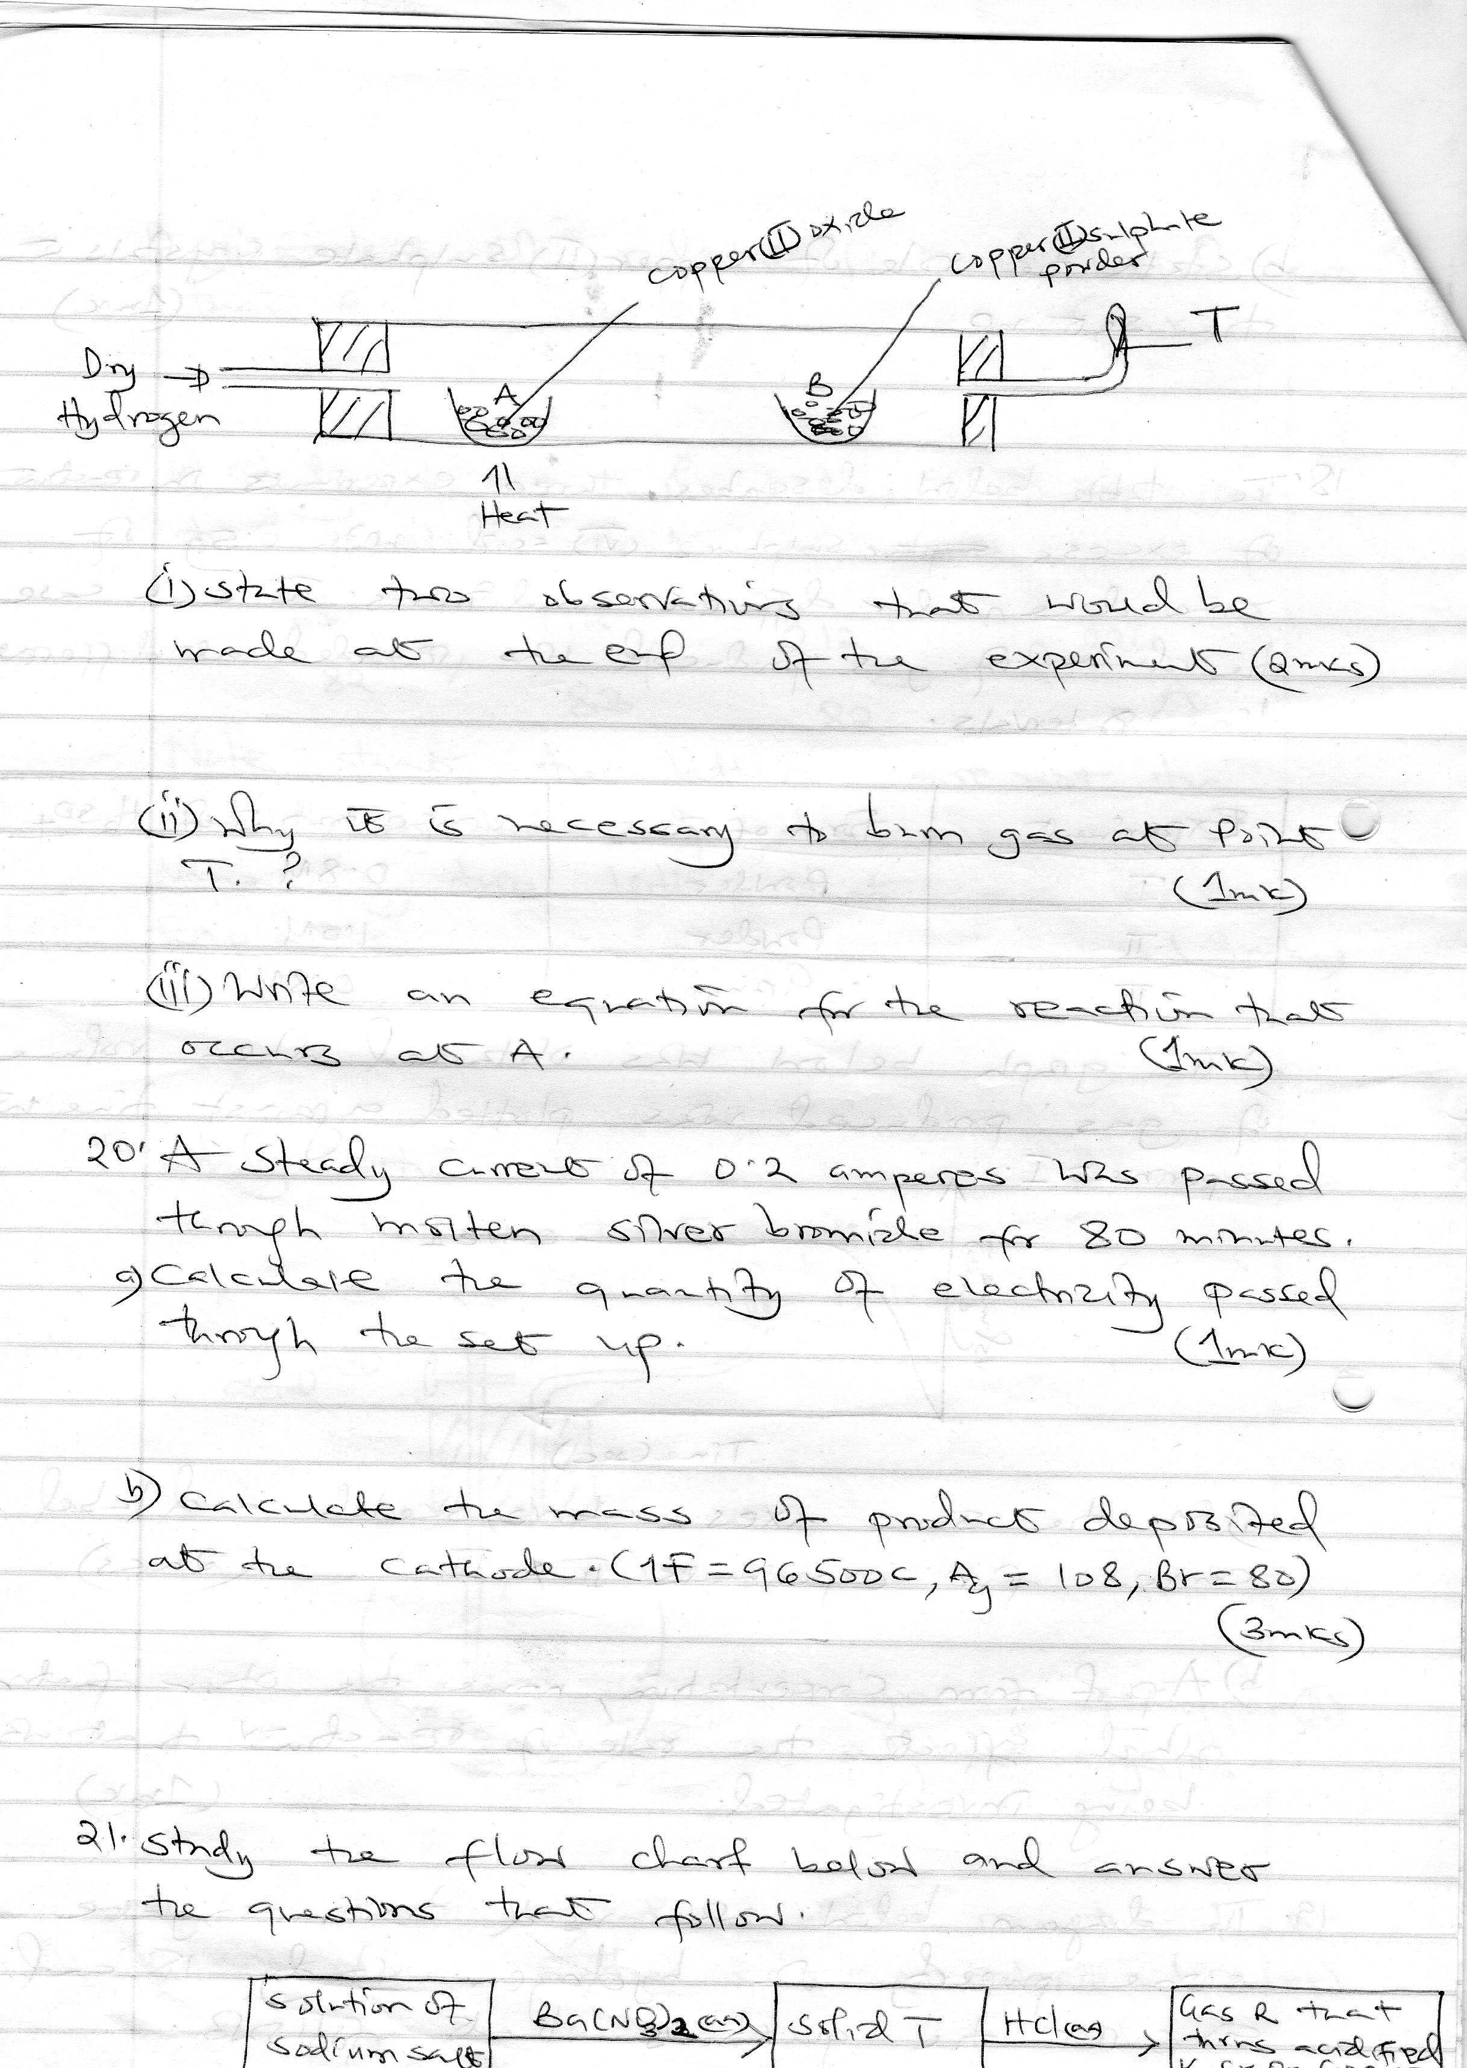
19. The diagram below was used to investigate some property of hydrogen. Study it and answer the questions that follow.

- State two observations that would be made at the of the experiment 2mks

- Why is it necessary to burn gas at point T 1mk

- Write an equation for the reaction that occurs at A 1mk

20. A steady current of 0.2 amperes was passed through molten silver bromide for 80 minutes.
a) Calculate the quantity of electricity passed through the set up. 1mk

b) Calculate the mass of products deposited at the cathode (1F=96500C,Ag=108,Br=80) 3mks

21. Study the flow chart below and answer the questions that follow
Solution of sodium salt
Solid T
Gas R that turns acidified K₂Cr₂O₇ orange to green
Ba(NO₃)₂(aq)
HCl(aq)

- Name the gas R 1mk

- Write ionic equation for formation of solid T 1mk

- Use the information in (b) to write chemical equation for the reaction between solid and dilute hydrochloric acid 1mk

22. Name the process which takes place when;
a) A red litmus paper turns white when dropped into chlorine water 1mk

b) Propane gas molecules are converted into a giant molecule 1mk

c) White phosphorus melts into a ball when exposed to air 1mk

23. a) Name two ores from which zinc metal mostly extracted 1mk

b) One of the steps to the extraction of zinc metal from its ore is roasting of the ore in excess oxygen. Write an equation for the reaction that takes place when the ore in (a) above is roasted 1mk

24. The nitrates of the metal A,B &C were heated over a Bunsen burner flame . The table below shows the products of the reaction. (A,B & C are not the actual symbols of the metals)
Nitrate of metals | Products
A | Metal nitrate and oxygen
B | Metal, nitrogen (iv) oxide and oxygen
C | Metal oxide, nitrogen (iv) and oxygen

- State the chemical family that metal A belongs to 1mk

- Name one metal that is likely to be B 1mk

- Arrange the metals above in order of reactivity starting with the least reactive 1mk

25. a) Define the term molar heat of centralization 1mk

b) The rise to temperature when 50cm³ of sodium hydroxide is reacted with two acids is given in the table below
Acid | 50cm³of Hcl | 50cm³ oxalic acid
Temperature rise (0c) | 7 | 4
Explain the difference to temperature 2mks

26. Carbon (iv) oxide, methane, nitrogen (i) oxide and trichloromethane are green hones gases
i) State one effect of an increased level of these gases to the environment 1mk

ii) Give one source from which each of the following gases is released to the environment;
a) Nitrogen (i) oxide ¹/₂mk

b) Trichloromethane ¹/₂mk

