NAME……………………….…………………….INDEX NO……………………………..
SCHOOL……………………………………………….SIGNATURE………………………

443/1
AGRICULTURE
PAPER 1
JULY-AUGUST -2016
TIME:2 HOURS

KAKAMEGA SOUTH SUB-COUNTY JOINT EVALUATION -2016
Kenya Certificate of Secondary Education (K.C.S.E)
443/1
AGRICULTURE
PAPER 1

INSTRUCTIONS TO CANDIDATES
- Write your name, school and index number in the spaces provided above
- Sign and write the date of the examination in the spaces provided above
- This paper consists of THREE sections A,B and C
- Answer all the questions in section A,B and any TWO in the section C
For examiners use only
SECTION | QUESTION | MAXIMUM SCORE | CANDIDATES SCORE
A | 1 -20 | 30
B | 21– 25 | 20
C |  | 20
 |  | 20
TOTAL SCORE |  | 90

This paper consists of 8 printed pages. Candidates should check the question paper to ensure that all pages are printed as indicated and no questions are missing.

SECTION A(30 MARKS)
Answer all the questions in the spaces provided
- State two ways in which agriculture contributes directly to the development of industries (1mk)
……………………………………………………………………………………………………………………………………………………………………………………
- Give two advantages of shifting cultivation (1mk)
……………………………………………………………………………………………………………………………………………………………………………………
- Name two processes of rock weathering (1mk)
……………………………………………………………………………………………………………………………………………………………………………………
- State three advantages of drip irrigation (1 ½ mks)
……………………………………………………………………………………………………………………………………………………………………………………
- Give three ways in which trees improve soil productivity (1 ½ mks)
……………………………………………………………………………………………………………………………………………………………………………………
- Name two methods which can be used to detect nutrients deficiency in a crop field (1mk)
……………………………………………………………………………………………………………………………………………………………………………………
- State four effects of excessive application of nitrogen fertilizer on crop growth (2mks)
…………………………………………………………………………………………………………………………………………………………………………………………………………………………………………………………………………………………………………………………………………………………………………
- Give three factors that affect the efficiency of pesticides (1 ½ mks)
…………………………………………………………………………………………………………………………………………………………………………………………………………………………………………………………………………………………………………………………………………………………………………
- (a) What is land fragmentation in farming? (1mk)
……………………………………………………………………………………………………………………………………………………………………………………
(b)State two causes of land fragmentation in Kenya since independence (1mk)
……………………………………………………………………………………………………………………………………………………………………………………
- State two advantages of establishing a mixed grass- legume posture instead of planting a pure grass pasture
…………………………………………………………………………………………………………………………………………………………………………………………………………………………………………………………………………………………………………………………………………………………………………
- Give any two financial statement which may be prepared on a farm (1mk)
……………………………………………………………………………………………………………………………………………………………………………………
- List four agricultural support services available to a livestock farmer (2mks)
…………………………………………………………………………………………………………………………………………………………………………………………………………………………………………………………………………………………………………………………………………………………………………
- State three ways by which land as a factor of production could be made more productive (1 ½ mks)
……………………………………………………………………………………………………………………………………………………………………………………
- Outline two ways of controlling damping off diseases on vegetable seedlings in a nursery (1mk)
……………………………………………………………………………………………………………………………………………………………………………………
- State three functions of the coffee Board of Kenya (1 ½ mks)
……………………………………………………………………………………………………………………………………………………………………………………
- Differentiate between soil structure and soil texture (1mk)
……………………………………………………………………………………………………………………………………………………………………………………
- State four effects of strong wind on crop production (2mks)
…………………………………………………………………………………………………………………………………………………………………………………………………………………………………………………………………………………………………………………………………………………………………………
- State four effects of pests with both piercing and sucking mouth parts on crops (2mks)
………………………………………………………………………………………………………………………………………………………………………………………………………………………………………………………………………………………………………………………………………………………………………..
- State four pieces of information contained on a land title deed (2mks)
…………………………………………………………………………………………………………………………………………………………………………………………………………………………………………………………………………………………………………………………………………………………………………
- Give four factors that may influence the supply of a commodity in a market (2mks)
…………………………………………………………………………………………………………………………………………………………………………………………………………………………………………………………………………………………………………………………………………………………………………
- The diagram below illustrates a feature observed after digging the soil several metres deep. Study the diagram carefully and answer the questions that follow.
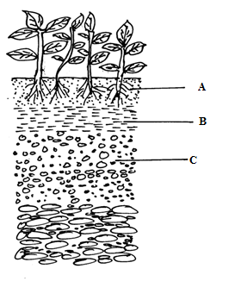

- Identify the features that the diagram above represents in the study of soil(1mk)
………………………………………………………………………………………………………………………………………………………………………………

- Name the parts of the diagram labeled A,B and C (3mks)
…………………………………………………………………………………………………………………………………………………………………………………………………………………………………………………………………………………………………………………………………………………………………………
- State two ways in which the knowledge of the above feature would be of benefit to a farmer (2mks)
…………………………………………………………………………………………………………………………………………………………………………………………………………………………………………………………………………………………………………………………………………………………………………

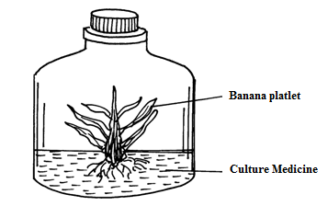
- The diagram below illustrates materials and a method of vegetative propagation .Study it and answer the questions that follow

- Identify the method of propagation illustrated above (1mk)
……………………………………………………………………………………………………………………………………………………………………………
- Give two advantages associated with the method above (3mks)
…………………………………………………………………………………………………………………………………………………………………………………………………………………………………………………………………………………………………………………………………………………………………………

- A farmer has four plots p1,p2,p3 and p4 as shown on the diagrams below. Each of the plots has an agromic problem as indicated
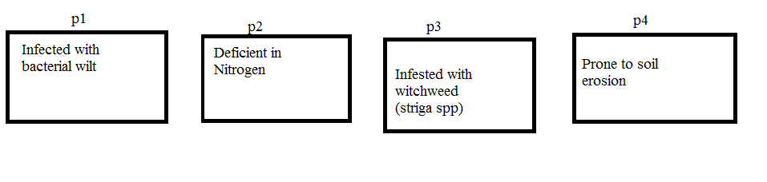
The farmer intends to grow maize ,Irish potatoes ,peas and Rhodes grass. Plan a rotational programme for the first year of rotation
Crop plot
Rhodes grass ____________________
Irish potatoes ____________________
Peas ____________________
Maize ____________________
- A plot of land measures 6.6 m long by 3.6 wide .This plot is prepared for planting cabbages at a spacing of 60cm by 60cm.The outermost rows starts at 30cm from the edges all round the plot. Showing your working calculate.
- The number of the rows falling on the width side of the plot (1mk)

- The number of cabbages seedlings that should be planted on the plot

- On 5-1-2001 Tamu Farm purchased on credit the following items from a K.F.A shop
20 bags of dairy meat,70kg @ sh 1,100 per bag 16 bags of bran,70 kg each @ sh 700 per bag 18 bags of D.S.P fertilizer,each 2kg @ sh.300 per bag 45 nags of seed maize ,each 2kg @ sh .300 per bag 8 shearing knives (medium sized @ sh .300 per knife.
- Prepare the purchase order that Tamu Farm made to K.F.A (6mks)

- The illustrations below show a newly constructed cut-off drain .Study it and answer the questions that follow.
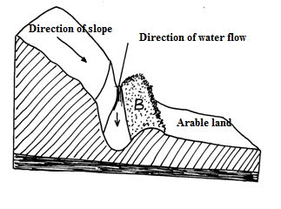

(a)
(i) Identify the parts of the cut-off drain labeled A and B
A……………………………………………………………………….
B………………………………………………………………………..

(ii)Describe the procedure of constructing a cut-off drain
…………………………………………………………………………………………………………………………………………………………………………………………………………………………………………………………………………….
(iii)How can the part of the structure labeled B be stabilized after it has been constructed
………………………………………………………………………………………………………………………………………………………………………………………………………………………………………………………………………………
(iv)State any one factor that would determine the width and depth of the cut-off drain
………………………………………………………………………………………………………………………………………………………………………………………………………………………………………………………………………………..

SECTION C(40 MARKS)
Answer any two questions from section in the spaces provided after question 24
- Describe the field production of dry beans
- (Phaseolus vulgaris) under the following sub- headings
(i)Varieties common in Kenya (2mks)
(ii)Selection and preparation of planting materials (3mks)
(iii)Planting and weeding (8mks)
- Describe the management of trees grown under various agro-forestry system (7mks)
- (a)Discuss the importance of budgeting in agricultural production (10mks)
(b)Explain the role of agricultural co-operative in Kenya (10mks)
- (a)Describe five methods a farmer can use in harvesting water on the farm(5mks)
(b)Explain seven ways by which soil loses fertility (7mks)
(c )State the uses of water in the farm (8mks)
…………………………………………………………………………………………………………………………………………………………………………………………………………………………………………………………………………………………………………………………………………………………………………………………………………………………………………………………………………………………………………………………………………………………………………………………………………………………………………………………………………………………………………………………………………………………………………………………………………………………………………………………………………………………………………………………………………………………………………………………………………………………………………………………………………………………………………………………………………………………………………………………………………………………………………………………………………………………………………………………………………………………………………………………………………………………………………………………………………………………………………………………………………………………………………………………………………………………………………………………………………………………………………………………………………………………………………………………………………………………………………………………………………………………………………………………………………………………………………………………………………………………………………………………………………………………………………………………………………………………………………………………………………………………………………………………………………………………………………………………………………………………………………………………………………………………………………………………………………………………………………………………………………………………………………………………………………………………………………………………………………………………………………………………………………………………………………………………………………………………………………………………………………………………………………………………………………………………………………………………………………………………………………………………………………………………………………………………………………………………………………………………………………………………………………………………………………………………………………………………………………………………………………………………………………………………………………………………………………………………………………………………………………………………………………………………………………………………………………………………………………………………………………………………………………………………………………………………………………………………………………………………………………………………………………………………………………………………………………………………………………………………………………………………………………………………………………………………………………………………………………………………………………………………………………………………………………………………………………………………………………………………………………………………………………………………………………………………………………………………………………………………………………………………………………………………………………………………………………………………………………………………………………………………………………………………………………………………………………………………………………………………………………………………………………………………………………………………………………………………………………………………………………………………………………………………………………………………………………………………………………………………………………………………………………………………………………………………………………………………………………………………………………………………………………………………………………………………………………………………………………………………………………………………………………………………………………………………………………………………………………………………………………………………………………………………………………………………………………………………………………………………………………………………………………………………………………………………………………………………………………………………………………………………………………………………………………………………………………………………………………………………………………………………………………………………………………………………………………………………………………………………………………………………………………………………………………………………………………………………………………………………………………………………………………………………………………………………………………………………………………………………………………………………………………………………………………………………………………………………………………………………………………………………………………………………………………………………………………………………………………………………………………………………………………………………………………………………………………………………………………………………………………………………………………………………………………………………………………………………………………………………………………………………………………………………………………………………………………………………………………………………………………………………………………………………………………………………………………………………………………………………………………………………………………………………………………………………………………………………………………………………………………………………………………………………………………………………………………………………………………………………………………………………………………………………………………………………………………………………………………………………………………………………………………………………………………………………………………………………………………………………………………………………………………………………………………………………………………………………………………………………………………………………………………………………………………………………………………………………………………………………………………………………………………………………………………………………………………………………………………………………………………………………………………………………………………………………………………………………………………………………………………………………………………………………………………………………………………………………………………………………………………………………………………………………………………………………………………………………………………………………………………………………………………………………………………………………………………………………………………………………………………………………………………………………………………………………………………………………………………………………………………………………………………………………………………………………………………………………………………………………………………………………………………………………………………………………………………………………………………………………………………………………………………………………………………………………………………………………………………………………………………………………………………………………………………………………………………………………………………………………………………………………………………………………………………………………………………………………………………………………………………………………………………………………………………………………………………………………………………………………………………………………………………………………………………………………………………………………………………………………………………………………………………………………………………………………………………………………………………………………………………………………………………………………………………………………………………………………………………………………………………………………………………………………………………………………………………………………………………………………………………………………………………………………………………………………………………………………………………………………………………………………………………………………………………………………………………………………………………………………………………………………………………………………………………………………………………………………………………………………………………………………………………………………………………………………………………………………………………………………………………………………………………………………………………………………………………………………………………………………………………………………………………………………………………………………………………………………………………………………………………………………………………………………………………………………………………………………………………………………………………………………………………………………………………………………………………………………………………………………………………………………………………………………………………………………………………………………………………..

