NAME ………………………………………………………INDEX NO……………………………
SCHOOL………………………………………………………SIGNATURE………………………

443/2
AGRICULTURE
PAPER 2
JULY/AUGUST -2016
TIME: 2 HOURS

KAKAMEGA SOUTH SUB-COUNTY JOINT EVALUATION -2016
Kenya Certificate of Secondary Education (K.C.S.E)
443/2
AGRICULTURE
PAPER 2
JULY/AUGUST -2016
TIME: 2 HOURS

INSTRUCTIONS TO CANDIDATES
- Write your name, school and index number in the spaces provided above
- Sign and write the date of the examination in the spaces provided above
- This paper consists of THREE sections A,B and C
- Answer all the questions in section A,B and any TWO in the section C
- All the questions should be answered in the spaces provided

FOR EXAMINERS USE ONLY
SECTION | QUESTION | MAXIMUM SCORE | CANDIDATES SCORE
A | 1 -17 | 30
B | 18 – 21 | 20
C |  | 20
 |  | 20
 | TOTAL | 90

This paper consists of 9 printed pages. Candidates should check the question paper to ensure that all pages are printed as indicated and no questions are missing.

SECTION A:30 MARKS
Answer ALL questions in this section in the spaces provided
- Name two viral diseases that affect each of the following livestock
(a)Cattle (1mk)
………………………………………………………………………………………………………………………………………………………………………………………………………………
(b)Poultry (1mk)
……………………………………………………………………………………………………………………………………………………………………………………………………………….
- Name one intermediate host for each of the following livestock parasite.
(a) Liverfluke (Fasciola spp) ( ½ mk)
……………………………………………………………………………………………………………………………………………………………………………………………………………….
(b)Tape worm (Taenia spp) ( ½ mk)
……………………………………………………………………………………………………………………………………………………………………………………………………………….
- State four importance of colostrums to a newly born calf (2mks)
……………………………………………………………………………………………………………………………………………………………………………………………………………………………………………………………………………………………………………………………………………………………………………………………………………………………………………………………………………………………………………………………………….
- State four harmful effects of ticks in livestock rearing (2mks)
……………………………………………………………………………………………………………………………………………………………………………………………………………………………………………………………………………………………………………………………………………………………………………………………………………………………………………………………………………………………………………………………………….
- Give the difference between raddling and crutching in sheep management (1mk)
………………………………………………………………………………………………………………………………………………………………………………………………………………………………………………………………………………………………………………………………………………………………………………………………………………………………
- State four importance for castrating a male goat (2mks)
……………………………………………………………………………………………………………………………………………………………………………………………………………………………………………………………………………………………………………………………………………………………………………………………………………………………………………………………………………………………………………………………………….
- State four limitations of using hydroelectric power on the farm (2mks)
……………………………………………………………………………………………………………………………………………………………………………………………………………………………………………………………………………………………………………………………………………………………………………………………………………………………………………………………………………………………………………………………………….
- State four reasons for care and maintaining a wheelbarrow in good working condition(2mks) ………………………………………………………………………………………………………………………………………………………………………………………………………………………………………………………………………………………………………………………………………………………………………………………………………………………………………………………………………………………………………………………………….
- Name two predisposing factors of foot rot diseases in livestock (1mk)
……………………………………………………………………………………………………………………………………………………………………………………………………………………………………………………………………………………………………………………..
- Name two hormones that affect milk let down in dairy cattle (1mk)
……………………………………………………………………………………………………………………………………………………………………………………………………………………………………………………………………………………………………………………….
- State four conditions that may lead to a farmer using animal drawn ox-plough than tractor drawn mould board plough (2mks)
………………………………………………………………………………………………………………………………………………………………………………………………………………………………………………………………………………………………………………………………………………………………………………………………………………………………………………………………………………………………………………………………………
- State four uses of concrete in construction of farm building and structures (2mks)
……………………………………………………………………………………………………………………………………………………………………………………………………………………………………………………………………………………………………………………………………………………………………………………………………………………………………………………………………………………………………………………………………….
- Give four microbial activities in the rumen of cattle (2mks)
……………………………………………………………………………………………………………………………………………………………………………………………………………………………………………………………………………………………………………………………………………………………………………………………………………………………..
- State four reasons for swarming of bees ` (2mks)
……………………………………………………………………………………………………………………………………………………………………………………………………………………………………………………………………………………………………………………………………………………………………………………………………………………………………………………………………………………………………………………………………….
- List four problems associated with air cooled engines (2mks
………………………………………………………………………………………………………………………………………………………………………………………………………………………………………………………………………………………………………………………………………………………………………………………………………………………………………………………………………………………………………………………………………
- State four effects of lack of proteins in livestock (2mks)
……………………………………………………………………………………………………………………………………………………………………………………………………………………………………………………………………………………………………………………………………………………………………………………………………………………………………………………………………………………………………………………………………….
- Name four light chicken breeds (2mks)
……………………………………………………………………………………………………………………………………………………………………………………………………………………………………………………………………………………………………………………………………………………………………………………………………………………………………………………………………………………………………………………………………….

SECTION B(20 MARKS)
Answer all the questions in this section in the spaces provided
- The following illustration shows the behavior of chicks in a brooder. Study them carefully and answer the questions that follow.

- Explain the cause of behavior observed in chicks for each of the illustrations labeled A ,B and C (1 ½ mks)
A……………………………………………………………………………………………….
………………………………………………………………………………………………..
B……………………………………………………………………………………………………………………………………………………………………………………………………
C……………………………………………………………………………………………………………………………………………………………………………………………………..
- A part from what is seen in C state other four observations that will be seen in chicks (2mks)
………………………………………………………………………………………………………………………………………………………………………………………………………………………………………………………………………………………………………………………………………………………………………………………………………………………………………………………………………………………………………………………………………………………………………………………………………………...

- Name the part labeled Z ( ½ mk)
…………………………………………………………………………………………
- Give one reason for making the brooder wall round in shape (1mk)
……………………………………………………………………………………………………………………………………………………………………………………………………
- The diagrams below show the digestive system of cattle .Study it and answer the questions that follow.

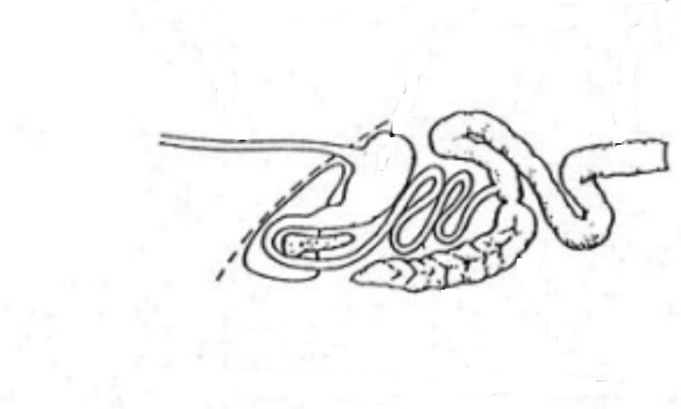
A
F
G
B
C
D
E

- Name the parts labeled B,C and G
B……………………………………………………………………………………….( ½ mk)
C……………………………………………………………………………. ………..( ½ mk)
G……………………………………………………………………………………..( ½ mk)
- State one function of the part labeled D and G
D (½ mk)
………………………………………………………………………………………………………………………………………………………………………………………………………….
B (½ mk)
…………………………………………………………………………………………………
…………………………………………………………………………………………………..
(c) Give one enzyme that is produced by the part labeled E and F
E……………………………………………………………………………………………(½ mk)
F……………………………………………………………………………………………(½ mk)
d) Name three microbial products at part labeled A (1 ½ mk)
……………………………………………………………………………………………………………………………………………………………………………………………………………………………………………………………………………………………………………………………………………………………………………………………………………………………....
- The illustration below shows tools used in farm workshop

A

B

C

- Identify tools A,B and C
A………………………………………………………………………………………..(½ mk)
B………………………………………………………………………………………..(½ mk)
C……………………………………………………………………………………….( ½ mk)
- State the main function of the tools above (1mk)
……………………………………………………………………………………………………………………………………………………………………………………………………
- State one advantage of tool C over tool A (1mk)
……………………………………………………………………………………………………………………………………………………………………………………………………
- State three maintenance practices carried out on tool C above (1 ½ mk)
…………………………………………………………………………………………………………………………………………………………………………………………………………………………………………………………………………………………………………………………………………………………………………………………………………
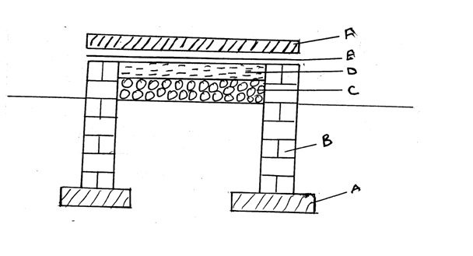
- The diagram below represents foundation of a permanent house. Use it to answers the question that follow.
(i)Name the parts
B…………………………………………………………………………………( ½ mk)
C…………………………………………………………………………………( ½ mk)
D………………………………………………………………………………….( ½ mk)
F…………………………………………………………………………………..( ½ mk)
(ii) State two factors that determine the thickness of the part labeled A (1mk)
………………………………………………………………………………………………………………………………………………………………………………………………………………………………………………………………………………………………………………………

(ii) State two functional of part E (2mks)
………………………………………………………………………………………………………………………………………………………………………………………………………………………………………………………………………………………………………………………………………………………………………………………………………………………………
SECTION C (40 MARKS)
- (a)Describe two feeding practices in artificial rearing of a dairy calf (10mks)
(b)Describe mastitis disease under the following sub- headings
(i)Causal organism (1mk)
(ii)Three signs infection (3mk)
(iii)Six control measures (6mks)
- (a) Describe five signs of internal parasite infestation in livestock (5mks)
(b)Explain five factors that should be considered when sitting homestead on the farms (5mks)
(c )State five difference between petrol and diesel engine (5mks)
(d)Describe five uses of dead fences on the farm (5mks)
- (a) Giving a relevant example in each case, describe the role of the various component of a balanced diet in livestock nutrition (10 mks)
(b)Explain the importance of each of the function difference between a disc plough and a moldboard plough in land preparation (10 mks)
……………………………………………………………………………………………………………………………………………………………………………………………………………………………………………………………………………………………………………………………………………………………………………………………………………………………………………………………………………………………………………………………………………………………………………………………………………………………………………………………………………………………………………………………………………………………………………………………………………………………………………………………………………………………………………………………………………………………………………………………………………………………………………………………………………………………………………………………………………………………………………………………………………………………………………………………………………………………………………………………………………………………………………………………………………………………………………………………………………………………………………………………………………………………………………………………………………………………………………………………………………………………………………………………………………………………………………………………………………………………………………………………………………………………………………………………………………………………………………………………………………………………………………………………………………………………………………………………………………………………………………………………………………………………………………………………………………………………………………………………………………………………………………………………………………………………………………………………………………………………………………………………………………………………………………………………………………………………………………………………………………………………………………………………………………………………………………………………………………………………………………………………………………………………………………………………………………………………………………………………………………………………………………………………………………………………………………………………………………………………………………………………………………………………………………………………………………………………………………………………………………………………………………………………………………………………………………………………………………………………………………………………………………………………………………………………………………………………………………………………………………………………………………………………………………………………………………………………………………………………………………………………………………………………………………………………………………………………………………………………………………………………………………………………………………………………………………………………………………………………………………………………………………………………………………………………………………………………………………………………………………………………………………………………………………………………………………………………………………………………………………………………………………………………………………………………………………………………………………………………………………………………………………………………………………………………………………………………………………………………………………………………………………………………………………………………………………………………………………………………………………………………………………………………………………………………………………………………………………………………………………………………………………………………………………………………………………………………………………………………………………………………………………………………………………………………………………………………………………………………………………………………………………………………………………………………………………………………………………………………………………………………………………………………………………………………………………………………………………………………………………………………………………………………………………………………………………………………………………………………………………………………………………………………………………………………………………………………………………………………………………………………………………………………………………………………………………………………………………………………………………………………………………………………………………………………………………………………………………………………………………………………………………………………………………………………………………………………………………………………………………………………………………………………………………………………………………………………………………………………………………………………………………………………………………………………………………………………………………………………………………………………………………………………………………………………………………………………………………………………………………………………………………………………………………………………………………………………………………………………………………………………………………………………………………………………………………………………………………………………………………………………………………………………………………………………………………………………………………………………………………………………………………………………………………………………………………………………………………………………………………………………………………………………………………………………………………………………………………………………………………………………………………………………………………………………………………………………………………………………………………………………………………………………………………………………………………………………………………………………………………………………………………………………………………………………………………………………………………………………………………………………………………………………………………………………………………………………………………………………………………………………………………………………………………………………………………………………………………………………………………………………………………………………………………………………………………………………………………………………………………………………………………………………………………………………………………………………………………………………………………………………………………………………………………………………………………………………………………………………………………………………………………………………………………………………………………………………………………………………………………………………………………………………………………………………………………………………………………………………………………………………………………………………………………………………………………………………………………………………………………………………………………………………………………………………………………………………………………………………………………………………………………………………………………………………………………………………………………………………………………………………………………………………………………………………………………………………………………………………………………………………………………………………………………………………………………………………………………………………………………………………………………………………………………………………………………………………………………………………………………………………………………………………………………………………………………………………………………………………………………………………………………………………………………………………………………………………………………………………………………………………………………………………………………………………………………………………………………………………………………………………………………………………………………………………………………………………………………………………………………………………………………………………………………………………………………………………………………………………………………………………………………………………………………………………………………………………………………………………………………………………………………………………………………………………………………………………………………………………………………………………………………………………………………………………………………………………………………………………………………………………………………………………………………………………………………………………….

