NAME: ………………………………………………..INDEX NO:………………………………….
SCHOOL: ……………………………………………..SIGNATURE :………………………………
DATE: …………………………………………………

231/1
BIOLOGY
THEORY
Paper 1
July/August, 2016
Time: 2 Hours

KAKAMEGA SOUTH SUB-COUNTY JOINT EVALUATION TEST – 2016
Kenya Certificate of Secondary Examination ( KCSE)

231/1
BIOLOGY
THEORY
PAPER 1

INSTRUCTIONS TO CANDIDATES
- Write your name, index number and school in the spaces provided above
- Sign and write the date of the examination in the spaces provided above
- Answer ALL the questions in the spaces provided on the question paper
- Candidates should answer the questions in English

FOR EXAMINER’S USE ONLY
QUESTION | MAXIMUM SCORE | CANDIDATE’S SCORE
1-27 | 80

This paper consists of 10 printed pages Check the Question paper to ensure that all pages are printed as indicated and no question are missing.

1. Name the cell organelles responsible for:
a) Protein synthesis (1 mk)
……………………………………………………………………………………………………….
b) Destroying worn-out organelles and damaged cells (1 mk)
……………………………………………………………………………………………………….
2. Distinguish between haemolysis and plasmolysis (2 mks)
……………………………………………………………………………………………………….
……………………………………………………………………………………………………….
……………………………………………………………………………………………………….
3. State three roles of the placenta during pregnancy (3 mks)
……………………………………………………………………………………………………….
……………………………………………………………………………………………………….
……………………………………………………………………………………………………….
4. Name two classes of phylum Arthropoda with a cephalothorax (2 mks)
……………………………………………………………………………………………………….
……………………………………………………………………………………………………….
……………………………………………………………………………………………………….
5. The diagram below represents a blood vessel.

a) Name the type of vessel (1 mk)
……………………………………………………………………………………………………….
b) Identify structure T (1 mk)
……………………………………………………………………………………………………….
c) What is the function of structure T (1 mk)
……………………………………………………………………………………………………….
……………………………………………………………………………………………………….
6. a) Salivary amylase does not digest starch in the stomach. Give a reason.
……………………………………………………………………………………………………….
……………………………………………………………………………………………………….
……………………………………………………………………………………………………….
b) Name any two digestive enzymes secreted by the pancreases (2 mks)
……………………………………………………………………………………………………….
……………………………………………………………………………………………………….
……………………………………………………………………………………………………….
7. State three roles of a fruit in a plant. (1 ½ mks)
………………………………………………………………………………………………………………………………………………………………………………………………………………………………………………………………………………………………………………………………………………………………………………………………………………………………
8. a) Name the principal site of gaseous exchange in the lungs of humans (I mk)
……………………………………………………………………………………………………….
……………………………………………………………………………………………………….
b) State two ways in which the structure named in a) above is adapted to its function (2 mks)
……………………………………………………………………………………………………….
……………………………………………………………………………………………………….
……………………………………………………………………………………………………….
9. Give a reason why water logging favours denitrification (2 mks)
……………………………………………………………………………………………………….
……………………………………………………………………………………………………….
………………………………………………………………………………………………………
10. The diagram below represents a bone obtained from the hind limb of a goat.

a) Identify the bone (1 mk)
……………………………………………………………………………………………………….

b) Name the part labeled 3 (1 mk)
……………………………………………………………………………………………………….
c) Name the type of joint formed at the part labeled 4 (1 mk)
……………………………………………………………………………………………………….
11. The diameter of the field of view was estimated to be 50mm under a certain magnification. Six cells were observed along the diameter of the field of view. What was the diameter of the cell in
Microns (2 mks)
……………………………………………………………………………………………………….
……………………………………………………………………………………………………….
……………………………………………………………………………………………………….
12 a) Distinguish between homologous and analogous structures
……………………………………………………………………………………………………….
……………………………………………………………………………………………………….
……………………………………………………………………………………………………….
b) Give an example in each case (2 mks)
Homologous structure
……………………………………………………………………………………………………….
……………………………………………………………………………………………………….
Analogous structure ……………………………………………………………………………………………………….
……………………………………………………………………………………………………….
13. Name the types of response shown by the following:
a) Movement of ants away from naphthalene bails (1mk)
……………………………………………………………………………………………………….
……………………………………………………………………………………………………….
b) Euglena moving near the surface of water (1mk)
……………………………………………………………………………………………………….
……………………………………………………………………………………………………….

c) Irish potatoes’ adventitious roots growing downwards (1 mk)
……………………………………………………………………………………………………….
……………………………………………………………………………………………………….
14. Hemophilia is a sex-linked characteristic. A normal man married a carrier woman for this characteristic.
a) Using letter H for normal and h for haemophilia, work out the genotype of the offspring
(3mks)

b) What is the probability of one of the sons being haemophiliac? (1 mk)
……………………………………………………………………………………………………….
……………………………………………………………………………………………………….
15. State three methods by which plants get rid of their excretory wastes (3 mk)
……………………………………………………………………………………………………….
……………………………………………………………………………………………………….
……………………………………………………………………………………………………….
16. a) Name two hormones that regulate glucose level in blood (2 mks)
……………………………………………………………………………………………………….
……………………………………………………………………………………………………….
b) Name the organ that produces the named hormones above (1 mk)
……………………………………………………………………………………………………….
……………………………………………………………………………………………………….

17. T he following diagram shows a longitudinal section through a root apex
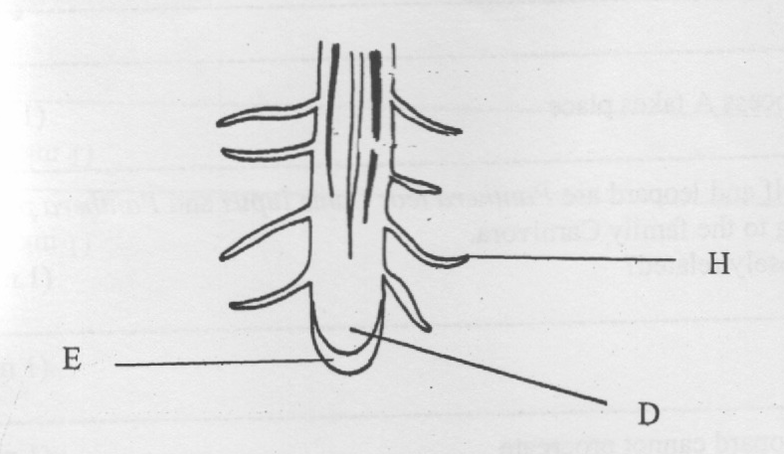

a) Identify’ the parts labeled H and D (2mks)
H……………………………………………………………………………………………..
D……………………………………………………………………………………………
b) State the function of E (1mk)
………………………………………………………………………………………………………………………………………………………………………………………………………
18. The diagram below illustrates a certain eye defect

a) Name the eye defect (1 mk)
……………………………………………………………………………………………………….
b) i) State one cause of the above eye defect (1 mk)
………………………………………………………………………………………
ii) What role does the lens play in the correction of the defect? (2 mks)
……………………………………………………………………………………………………….……………………………………………………………………………………………………….………………………………………………………

19. The scheme below shows two interrelated processes A and B that occur in the same cell.
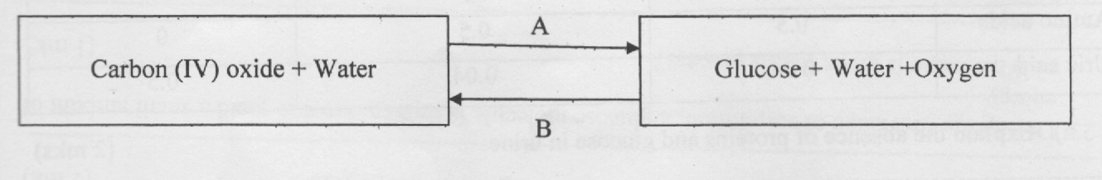

a) Identified processes A and B
A……………………………………………………………………………………………
B……………………………………………………………………………………………..
b) Name the organelle where process A takes place (1mk)
………………………………………………………………………………………………
………………………………………………………………………………………………
20. The scientific name of a lion, wolf and leopard are Panthera leo, Canis lupus and Panthera padus respectively. All the three belong to the family Carnivora,
a) Which of the organisms are closely related? (1 mk)
……………………………………………………………………………………………………….………………………………………………………………………………………
b) What does Canis refer to? (1 mk)
………………………………………………………………………………………………
………………………………………………………………………………………………
c) Explain why the lion and the leopard cannot procreate (1 mk)
……………………………………………………………………………………………………….………………………………………………………………………………………
21. Examine the diagram below which has been drawn from a plant section

a) Name the plant organ from which the section was obtained (1 mk)
……………………………………………………………………………………………………….
……………………………………………………………………………………………………….
b) Name the parts labeled A and B (2 mks)
……………………………………………………………………………………………………….
……………………………………………………………………………………………………….
22. Use the table below to answer the following questions
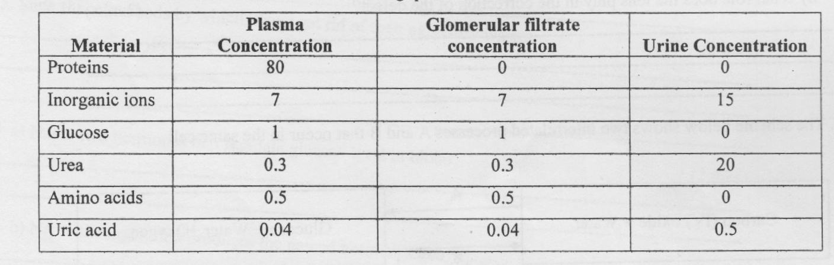
a) Explain the absence of proteins and glucose in urine (2 mks)
……………………………………………………………………………………………………….………………………………………………………………………………………
b) One of the symptoms of diabetes mellitus is the presence of glucose in urine. Give the name of this condition. (1mk)
……………………………………………………………………………………………………….………………………………………………………………………………………
c) State the reagent used to test for the presence of glucose in b) above (1mk)
……………………………………………………………………………………………………….………………………………………………………………………………………
23. During the first stage of respiration, a glucose molecule is broken down to yield a small amount of energy
a) What name is given to this process? (1mk)
……………………………………………………………………………………………………….………………………………………………………………………………………
b) State where the process takes place in the cell (1mk)
……………………………………………………………………………………………………….………………………………………………………………………………………
24. Name the branch of Biology that deals with the study of ;
a) Insects (1mk)
……………………………………………………………………………………………………….………………………………………………………………………………………
b) Fungi (1mk)
……………………………………………………………………………………………………….………………………………………………………………………………………
c) Parasites
……………………………………………………………………………………………………….………………………………………………………………………………………
25. List down three support tissues in old dicotyledonous plants. (3mk)
……………………………………………………………………………………………………….……………………………………………………………………………………………………….
26. The diagram below shows a cell undergoing a stage in cell division
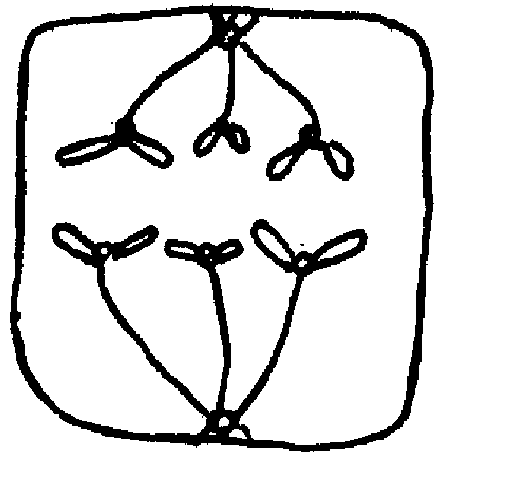

- Identify the stage (1 mk)
……………………………………………………………………………………………………….…………………………………………………………………………………………..
b) Give a reason for your answer in a) above (1 mk)
……………………………………………………………………………………………………….………………………………………………………………………………………

c) Draw a diagram to show the next stage of the cell division (2 mk)

27. Name the organism that:
a) Causes malaria
……………………………………………………………………………………………………….………………………………………………………………………………………
b) Transmits malaria (1mk)
……………………………………………………………………………………………………….………………………………………………………………………………………

