NAME: ………………………………………………..INDEX NO:………………………………….
SCHOOL: ……………………………………..SIGNATURE:………………………………………
DATE: …………………………………………………

233/1
Chemistry
Theory
July/August 2016
Time: 2 Hours

KAKAMEGA SOUTH SUB-COUNTY JOINT EVALUATION TEST – 2016
Kenya Certificate of Secondary Examination ( KCSE)

233/1
Chemistry
Theory

INSTRUCTIONS TO CANDIDATES
- Write your name and index number in the spaces provided above.
- Sign and write the date of examination in the spaces provided above.
- Answer all the questions in the spaces provided in the questions paper.
- Mathematical tables and silent electronic calculators may be used.
- All working must be shown where necessary.

QUESTION | MAXIMUM SCORE | CANDIDATE’S SCORE
 | 80

This paper consists of 12 printed pages Check the Question paper to ensure that all pages are printed as indicated and no question are missing.
- Identify the laboratory apparatus used for each of the following purposes in a chemistry laboratory?
- Holding and supporting pieces of apparatus such as burettes during experiments. (1mk)
………………………………………………………………………………………………
- Scooping solid chemical substances during experiments (1mk)
………………………………………………………………………………………………
- Storage of liquid chemicals in a laboratory.
………………………………………………………………………………………………
- Pure air contains about 1% argon.
- State the name of the group of elements to which argon belongs. ( ½ mk)
………………………………………………………………………………………………
- Write the electronic configuration to argon? ( ½ mk)
………………………………………………………………………………………………
- Why is argon used in lamps? (1mk)
………………………………………………………………………………………………
……………………………………………………………………………………………….
- An Isotope of argon has a mass number of 40. Calculate the number of neutrons in this Isotope of argon. (1mk)
………………………………………………………………………………………………
……………………………………………………………………………………………….
………………………………………………………………………………………………
- Study the flow chart below and answer the questions that follow:
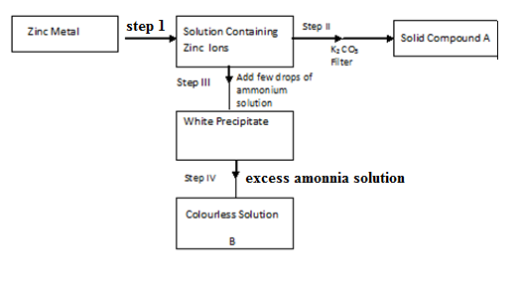

- Name the reagent in step I ( ½ mk)
…………………………………………………………………………………………….
ii) Compound A ( ½ mk)
………………………………………………………………………………………………
- Write an ionic equation for the reaction in step ( IV) ( 1mk)
………………………………………………………………………………………………
- 30 cm³ of the solution containing 2.88gdm⁻³ of an alkali MOH completely reacts with 40 cm³ of 0.045M sulphuric (Vi) acid .
- Calculate the molarity of the alkali. (2mks)
………………………………………………………………………………………………
……………………………………………………………………………………………….
………………………………………………………………………………………………
- Calculate the relative atomic mass of x in the alkali ( 0 = 16, S= 32,H = 1. ( 2mks)
………………………………………………………………………………………………
………………………………………………………………………………………………
………………………………………………………………………………………………
- The table below gives some information about the melting and the likely structures in substances V,W, and X. Complete the table by filling the missing Information in the spaces numbered. I,II and III (3mks)
Element | Structure | Example | Melting point
V | Grant Metallic | (i) | High
W | II | F₂ | Low
X | III | Si | Very high

- The arrangement below is used to prepare nitrogen (iv) oxide.
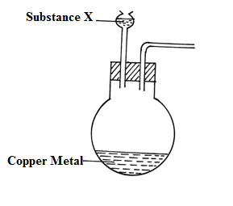

- Complete the diagram to show the collection of the gas. ( 1mk)
- Identify substance X. ( 1mk)
……………………………………………………………………………………………….
- Write a balanced equation for the reaction that occurs in the conical flask. ( 1mk)
………………………………………………………………………………………………
………………………………………………………………………………………………
- Given the standard electrodes potentials.
Half reactions | Elvolts
Zn²⁺_{(aq)} / Zn_{(s)} | -0.76
Cu²⁺_{(aq)}/ Cu _{(s)} | + 0.34
Cr³⁺_{(aq)/} Cr_{(s)} | - 0.74
Co²⁺ _{(aq)} / Co _{(s)} | + 0.28

From the following cell combinations copper- Zinc half cells.
Chromium cobalt half cells.
- Which reaction is faster? Explain by use of electrode potentials? (2mks)
………………………………………………………………………………………………
………………………………………………………………………………………………
………………………………………………………………………………………………
- Write the cell representation for the chromium – cobalt half cells. (1mk)
………………………………………………………………………………………………
………………………………………………………………………………………………
8. A freshly picked red flower petal was placed in a gas jar containing moist sulphur (IV) oxide gas.
i) State the observation made after sometime. ( 1mk)
………………………………………………………………………………………………
………………………………………………………………………………………………
ii) Consider the reaction shown below.
2H₂S _{(g)} + SO_{2(g)} 3S_{(s)} + 2 H₂0₍₁₎
From the above reaction. Identify the reducing agent. Explain. (2mks)
……………………………………………………………………………………………………….
………………………………………………………………………………………………………
………………………………………………………………………………………………………
- Using the equation, show how calcium hydroxide is used to control pollution caused by sulphate (iv) oxide in a sulphuric (vi) acid plant. ( 1mk)
………………………………………………………………………………………………
………………………………………………………………………………………………
9. The relative rate of diffusion of two gases X and Y are in the ratio 3:2 respectively. Given that the
relative formula mass of X is 48, calculate the relative formula mass of Y. (2mks)
……………………………………………………………………………………………………….
………………………………………………………………………………………………………
……………………………………………………………………………………………………….
10. a) In the fractional distillation of liquid air explain how each of the following components
are removed prior to liquifaction of air.
i) Dust particles (1mk)
………………………………………………………………………………………………
………………………………………………………………………………………………
ii) Carbon (iv) Oxide (1mk)
……………………………………………………………………………………………
………………………………………………………………………………………….
- Water Vapour (1mk)
………………………………………………………………………………………………
………………………………………………………………………………………………
- Explain why removal of carbon (iv) oxide should occur before compression and condensation of air into liquid state. ( 1mk)
………………………………………………………………………………………………
……………………………………………………………………………………………….
11. An element R has an atomic number 12.
a) Write the electro configuration of the ion of R. ( 1mk)

b) Write the formula of the nitride of R. (1mk)

c) The nitride of R dissolves in water. Write a balanced equation to show what happens. (1mk)

12. The set up below was set up to electrolysis molten sodium chloride.

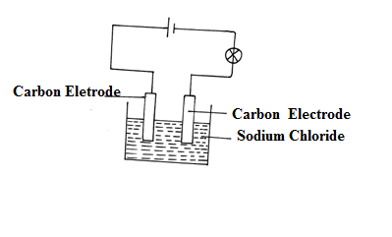

a) State the observation that was made at the anode during the electrolysis. ( ½ mk)
………………………………………………………………………………………………
………………………………………………………………………………………………
b) Name the electrode of which reduction occurs ( ½ mk)
………………………………………………………………………………………………
c) Write an equation for the reaction that occurs at anode electrode. ( 1mk)

13. Use for diagram below to answer the questions that follows:-
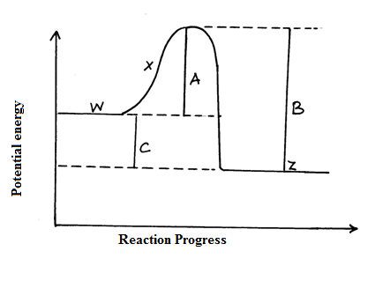

- Name the letter that corresponds to:_
i) Activation energy of the reaction (1mk)
………………………………………………………………………………………………
……………………………………………………………………………………………….

ii) Change in energy for the overall reaction. (1mk)
………………………………………………………………………………………………
……………………………………………………………………………………………….
b) The reaction exothermic or endothermic. Explain. (2mk)
………………………………………………………………………………………………
……………………………………………………………………………………………….
………………………………………………………………………………………………
14. The solubility of potassium nitrate is 155g/100g of solvent at 75⁰C and 38g/100g potassium
nitrate will crystallizes out if 50g of a saturated solution at 75c⁰ was cooled to 25⁰c. ( 3mks)
……………………………………………………………………………………………………
…………………………………………………………………………………………………..
…………………………………………………………………………………………………..

15. Study the set up below and answer the question that follows.
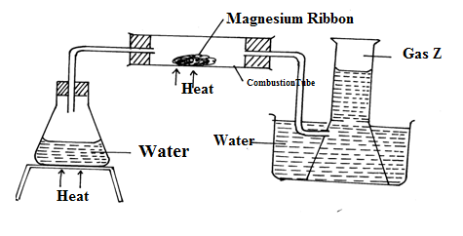

a) Write an equation for the reaction which takes place in the combustion tube. ( 1mk)
………………………………………………………………………………………………
……………………………………………………………………………………………….
b) What property of gas Z to allows it to be collected as shown in the diagram. ( ½ mk)
………………………………………………………………………………………………
c) Identify gas Z ( ½ mk)
………………………………………………………………………………………………

16. a) Give the IUPAC names of the following compounds.
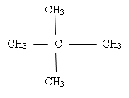
i)

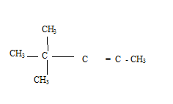
ii)

b) The flow chart below shows the three main steps in the preparation of a detergent.

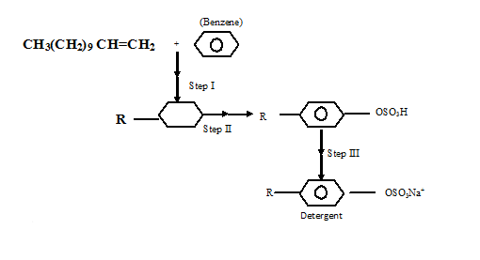

i) State the condition for step I ( ½ mk)
………………………………………………………………………………………………
(ii) Name the reagent for the reaction in step (II) ( ½ mk)
……………………………………………………………………………………………….
iii) For step III Name :
- The reaction ( ½ mk)
………………………………………………………………………………………………

- The reagent used ( ½ mk)
………………………………………………………………………………………………
17. You are provided with dilute sulphuric (vi) oxide nitric acid and lead (ii) Oxide. Explain how you
can prepare a sample of lead (ii) sulphate. ( 2mks)
…………………………………………………………………………………………………….
……………………………………………………………………………………………………
……………………………………………………………………………………………………
18. a) Distinguish between allotropes and Isomers. (2mks)
………………………………………………………………………………………………
……………………………………………………………………………………………….
b) Other than sulphur , Name two elements that are allotropic. (2mks)
………………………………………………………………………………………………
……………………………………………………………………………………………….
19. The diagram below shows preparation hydrochloric acid.
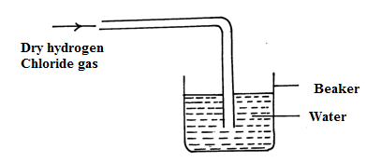

i) State one mistake in the diagram ( 1mk)
………………………………………………………………………………………………
……………………………………………………………………………………………….
ii) Hydrogen chloride gas does not have any effect on litmus paper unlike hydrochloric acid. Explain. (1mk)
………………………………………………………………………………………………
………………………………………………………………………………………………
iii) State one use of hydrogen chloride gas. ( 1mk)
………………………………………………………………………………………………
………………………………………………………………………………………………

20. A radioactive element R decays emitting two alpha(α) and Beta(β) Particle to form $\begin{matrix}214 \\ 81\end{matrix}Si$
a) What is the atomic number of R? (1mk)
………………………………………………………………………………………………
b) After 224 days 1/16 of mass of R remained. determine the half life of R? (2mks)
………………………………………………………………………………………………
……………………………………………………………………………………………….
………………………………………………………………………………………………
21. The table below shows atomic numbers of elements represented by the letter R to Y. The letters are not
the actual chemical symbols of the elements.
Elements | R | S | T | U | V | W | Z | Y
Atomic Number | 3 | 7 | 8 | 9 | 10 | 11 | 12 | 13

i) Two elements that belong to the same period of the periodic table. ( ½ mk)
………………………………………………………………………………………………
ii) Two elements in the same group ( ½ mk)
………………………………………………………………………………………………
iii) Write down the formula of the compounds when Z combines with U. ( 1mk)
………………………………………………………………………………………………
………………………………………………………………………………………………
22. Using dots(.) and crosses (x), draw electronic structures to show the bonding in the following
compounds.
i) Water ( 1mk)
………………………………………………………………………………………………
………………………………………………………………………………………………
ii) Calcium oxide ( 1mk)
………………………………………………………………………………………………
………………………………………………………………………………………………
23. a) State the Le chatelieur’s principle. ( 1mk)
………………………………………………………………………………………………
………………………………………………………………………………………………

b) One of the steps in the commercial manufacture of nitric ( v) acid is the oxidation of ammonia according to the equation.
4 NH₃ (g) + 50_{2(g)} 4No (_{g)}+ 6 H₂ 0_{(i)} DH = 908 KJmol⁻.
How would true position of the equilibrium change in the following circumstances? Explain.
i) An increase in pressure ( 1 ½ mk)
………………………………………………………………………………………………
……………………………………………………………………………………………….
ii) A decrease in temperature (1 ½ mk)
………………………………………………………………………………………………
………………………………………………………………………………………………
iii) The addition of a catalyst ( 1mk)
………………………………………………………………………………………………
………………………………………………………………………………………………
24. The flow chart below shows the preparation of carbon (ii) Oxide and its reaction.
H₂C₂ 0₄(s) + H₂ SO_{4(s)}
Products B & C
Conc. KOH(_{aq)}
Heated CuO_{(s)}

- Name the type of reaction taking place between H₂ C₂O₄ and concentrated H₂ SO₄
………………………………………………………………………………………………
………………………………………………………………………………………………
b) Write an equation for the production of B and C. (1mk)
………………………………………………………………………………………………
……………………………………………………………………………………………….
c) State two uses of carbon (II) Oxide . (1mk)
………………………………………………………………………………………………
………………………………………………………………………………………………
25. Paper chromatography of a plant extracts gave the following results.
Solvent | Number of sports
Quinine | 1
Cocaine | 6
Papain | 4
Titanium | 2

Which of the extracts.
i) Is more pure. Explain. ( 1mk)
………………………………………………………………………………………………
……………………………………………………………………………………………….
ii) Is most dense. Explain?
………………………………………………………………………………………………
………………………………………………………………………………………………
26. 50 cm³ of methane gas ( CH₄) was exploded until 170 cm³ of oxygen and under complete
Combustion.
a) Write an equation for the complete combustion of methane. (1mk)
………………………………………………………………………………………………
………………………………………………………………………………………………
b) Determine the amount of oxygen that remained unreacted. ( 2mks)
………………………………………………………………………………………………
………………………………………………………………………………………………
27. The main reaction of the contact process is 2S0_{2(g)} + O_{2(g)} 2S0_{3(g) ∆ H =} -98KJ
a) Name two factors that would favour maximum yield in this reaction. ( 1mk)
………………………………………………………………………………………………
………………………………………………………………………………………………
b) Which substance can be recycled in this process. (1mk)
………………………………………………………………………………………………
………………………………………………………………………………………………
- Why is SO₃ formed dissolves in sulphuric acid and not in water.
………………………………………………………………………………………………
……………………………………………………………………………………………….
………………………………………………………………………………………………

