NAME: ………………………………………………..INDEX NO:………………………………….
SCHOOL: ……………………………………………..SIGNATURE :…………………………………
DATE: …………………………………………………

233/2
Chemistry
Theory
July/August
Time: 2 Hours

KAKAMEGA SOUTH SUB- COUNTY JOINT EVALUATION TEST – 2016
Kenya Certificate of Secondary Examination ( KCSE)

233/2
Chemistry
Theory

INSTRUCTIONS TO CANDIDATES
- Write your name and index number in the spaces provided above.
- Sign and write the date of examination in the spaces provided above.
- Answer all the questions in the spaces provided in the questions paper.
- Mathematical tables and silent electronic calculators may be used.
- All working must be shown where necessary.

QUESTION | MAXIMUM SCORE | CANDIDATE’S SCORE
 | 80

This paper consists of 10 printed pages Check the Question paper to ensure that all pages are printed as indicated and no question are missing.

- The figure below is used to investigate the effect of carbon (II) Oxide on copper (II) Oxide. Study it and answer the questions that follow.
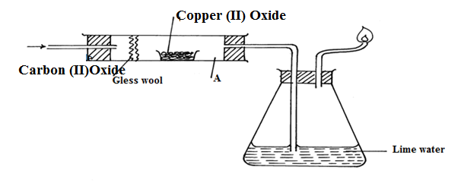

- Write a chemical equation of the reaction for the preparation of carbon (II) oxide in the laboratory. (1mk)

- What precaution should be taken when preparing carbon (II) Oxide? ( 2mks)
………………………………………………………………………………………………………………………………………………………………………………………………………………………………………………………………………………………………
- State the observations made in apparatus A and B at the end of the experiment? (2mks)
A…………………………………………………………………………………………..
B…………………………………………………………………………………………..
- Write the chemical equation for the reaction in apparatus A. ( 1mk)
………………………………………………………………………………………………………………………………………………………………………………………………………………………………………………………………………………………………
- State the reducing agent in (d) above. (1mk)
………………………………………………………………………………………………………………………………………………………………………………………………………………………………………………………………………………………………

- State two application of carbon (II) Oxide (2mks)
………………………………………………………………………………………………………………………………………………………………………………………………………………………………………………………………………………………………
- Carbon (IV) oxide in air forming a Gas P.
(i) Name the gas P (1mk)
………………………………………………………………………………………………………………………………………………………………………………………………………………………………………………………………………………………………
ii) State two applications of the gas P (2mks)
………………………………………………………………………………………………………………………………………………………………………………………………………………………………………………………………………………………………
2. The table below shows some information concerning elements S, T,V, U and W,. The letters are not the actual symbols of the elements.
Elements | Formula of Oxide | Period
S | S₂0 | 2
T | T₂O₃ | 3
U | UO₂ or UO₃ | 3
V | Does not form oxide | 3
W | W₂O | 4

a) Write down:
i) The electron arrangement of element W. (1mk)
………………………………………………………………………………………………………………………………………………………………………………………………………………………………………………………………………………………………
ii) The formula of the ion formed by element T. ( 1mk)
………………………………………………………………………………………………………………………………………………………………………………………………

b) Two of the oxides, S₂O and UO₃ were separately dissolved in distilled water. Compare the PH values of resulting solutions. (2mks)
………………………………………………………………………………………………………………………………………………………………………………………………………………………………………………………………………………………………
c) Compare with explanations, the following.
i) The reactivity of S with that of W. (3mks)
………………………………………………………………………………………………………………………………………………………………………………………………………………………………………………………………………………………………
ii) The electrical conductivity of element T with that of magnesium. ( 2mks)
………………………………………………………………………………………………………………………………………………………………………………………………………………………………………………………………………………………………
iii) The meeting point of element V with that of element x which is just below U in the group. ( 2mks)
………………………………………………………………………………………………………………………………………………………………………………………………………………………………………………………………………………………………
d) Identify element V. (1mk)
………………………………………………………………………………………………………………………………………………………………………………………………
3. a) The following table gives the standard electrode potential for a number of half.-reactions
Zn²⁺_{aq)} + 2e⁻ Zn _{(s)} -0.76
Fe²⁺ _{(aq)} + 2e⁻ Fe_{( s)} -0.44
I_{2(s)} + 2e- 2I⁻_{(aq)} + 0.54
Fe³⁺ _{(aq)} + e Fe ²⁺_{(aq)} + 0.77
Ge⁴⁺ _{(aq)} + e- Ge³⁺_{(aq)} + 1.61

- Write a cell equation for the reaction that would give the highest emf. (2mks)

- The strongest reducing agent. Give reason. (2mk)
………………………………………………………………………………………………………………………………………………………………………………
- Which substances in the table could be used to convert iodide ions to iodine(1mk)
………………………………………………………………………………………………………………………………………………………………………………
- Write an equation for the reaction you would expect to occur when an iron nail is placed in a solution of iron (II) sulphate. (1mk)

b) In the production of aluminum for aluminum oxide, 100 A was passed for 5 hours. How much aluminum was obtained? ( 1F = 96500C,Al = 27) (2mks)
……………………………………………………………………………………………………………………………………………………………………………………………………………………………………………………………………………………………..
c) With an example ,define
i) Primary cell (2mks)
………………………………………………………………………………………………………………………………………………………………………………………………
ii) Secondary cell (2mks)
………………………………………………………………………………………………………………………………………………………………………………………………
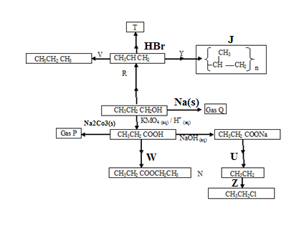
4. Study the reaction scheme below and answer the questions that follow.

a) Name
i) Gas P………………………………………………………………………………………
ii) Gas Q………………………………………………………………………………………
iii) Substance J………………………………………………………………………………..
b) Write the structural formula of T ( 1mk)
……………………………………………………………………………………………………………………………………………………………………………………………………………………………………………………………………………………………….
c) State the characteristics property of substance N ( 1mk)
……………………………………………………………………………………………………………………………………………………………………………………………..
d) Name process Y
………………………………………………………………………………………………
e) Name the type of reaction represented as Z. (1mk)
…………………………………………………………………………………………….
f) Name the reagent and condition for reaction
i) V ………………………………………………………………………………… ( 2mks)
……………………………………………………………………………………
ii) U………………………………………………………………………………… ( 2mks)
…………………………………………………………………………………..
iii) W……………………………………………………………………………….. ( 2mks)
…………………………………………………………………………………..
g) Name Process R
…………………………………………………………………………………… ( 1mk)
5. a) The flow chart below shows the industrial manufacture of nitric (v) acid. Study it and
answer the questions that follow:
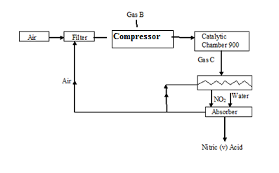

- Identify substances B and C ( 2mk)
B……………………………………………………………………
C…………………………………………………………………….
- Write an equation for the reaction that occurs in the catalytic chamber. ( 1mk)
……………………………………………………………………………………………………………………………………………………………………………………………………
(iii) Using an equation or otherwise. Explain the reaction that takes place in the absorber.(1mk)
………………………………………………………………………………………………………………………………….…………………………………………………………………
(iv) Explain why nitric (v) acid is stored in brown bottles. ( 1mk)
……………………………………………………………………………………………………………………………………………………………………………………………………………………………………………………………………………………………………….
- Explain what happens when drops of concentrated nitric (v) acid are put on dry, warm sawdust. (2mks)
……………………………………………………………………………………………………………………………………………………………………………………………………...
(vi). Give one industrial use of nitric (vi) acid. (1mk)
………………………………………………………………………………………………………………………………………………………………………………………………………………………………………………………………………
- Chlorine and ammonia gas react producing products depending on the reagent in excess. Write the equations for the reactions when:-
- Chlorine is in excess ( 1mk)
………………………………………………………………………………………………………………………………………………………………………………………………
- Ammonia is excess. (1mk)
…………………………………………………………………………………………………………………………………………………………………………………………….

- Study the flow diagram below on extraction of copper and answer the questions that follow.
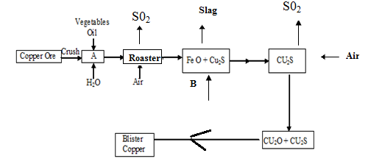

- Name the copper ore used for the extraction of copper. ( 1mk)
……………………………………………………………………………………………………………………………………………………………………………………………………………..
- The amount of copper in the copper ore is small state the method used to separate the impurities from the ore in chamber A.
- i) Which substances is fed into the roaster from chamber A? (1mk)
………………………………………………………………………………………………………………………………………………………………………………………………
- Write an equation for the reaction that takes place in the roaster. ( 1mk)
……………………………………………………………………………………………………………………….………………………………………………………………………
d) Name B and state it’s function. (2mks)
………………………………………………………………………………………………………………………………………………………………………………………………………………………………………………………………………………………………
e) Why is blister copper not fit for making electrical conductors? (1mk)
………………………………………………………………………………………………………………………………………………………………………………………………
g) When copper is reacted with concentrated nitric (v) acid & blue solution is formed.
i) Name the blue solution. (1mk)
……………………………………………………………………………………………………………………………………………………………………………………………..

ii) Name and write the formula of the substance formed when the blue solution reacts with
excess aqueous ammonia. (2mks)
………………………………………………………………………………………………………………………………………………………………………………………………
7. The solubility in grammes of sodium nitrate in 100g of water are given for various temperatures
in ⁰c.
Temp (⁰C) | 10 | 20 | 30 | 40 | 50 | 60 | 70 | 80 | 90 | 100
Solubility in g/100g of H₂O | 73 | 80 | 88 | 96 | 104 | 114 | 124 | 148 | 162 | 180

- i) Plot the solubility curve for sodium Nitrate.(Temperature on x-axis ) ( 3mks)
………………………………………………………………………………………………………………………………………………………………………………………………………………………………………………………………………………………..……
ii) Determine the temperature at which the solubility of the salt is 150g/100g of water.(1mk)
………………………………………………………………………………………………………………………………………………………………………………………………
- Given 100g of a saturated solution of sodium Nitrate at 10⁰C, Determine the mass of .
- Solute in the solution
……………………………………………………………………………………………………………………………………………………………………………………………………
ii) Solvent in the solution. (1mk)
……………………………………………………………………………………………………………………………………………………………………………………………….
- Salt that will be dissolved by the amount of solvent in (b) above at 12⁰ C. (1mk)
………………………………………………………………………………………………………………………………………………………………………………………………
iv) Salt which must be added to the solution to form a saturated solution at 80⁰ C? (1mk)
………………………………………………………………………………………………………………………………………………………………………………………………

- If a solution containing 140g of salt in 100g of solvent initially at 95⁰ is cooled to 45⁰C.
- At what temperature will crystals start forming? ( 1mk)
…………………………………………………………………………………………………………………………………………………………………………………………………………………………..…………………………………………………………………
- How much salt will crystallize out? ( 1mk)
………………………………………………………………………………………………………………………………………………………………………………………………

