**NAME: ………………………………………………..INDEX NO:…………………**

**SCHOOL: ……………………………SIGNATURE:………………………………………**

**DATE: …………………………**

**121/2**

**Mathematics**

**Paper 2**

**2 ½ Hours**

**JULY/AUGUST- 2016**

**KAKAMEGA SOUTH SUB-COUNTY JOINT EVALUATION TEST-2016**

**Kenya Certificate of Secondary Examination (KCSE)**

**121/2**

**Mathematics**

**Paper 2**

**INSTRUCTIONS TO CANDIDATES**

1. Write your name , index number and school in spaces provided above.
2. Sign and write the date of the examination in spaces provided.
3. This paper contains two sections; section I and section II.
4. Answer ALL questions in section I and any FIVE questions in section II.
5. All answers and working MUST be shown on the question paper in the spaces provided below each question.
6. Show ALL steps in your calculations, giving your answer at each stage in the space provided.
7. Marks may be awarded for correct working even if the answer is wrong.
8. Non-programmable , silent electronic calculators and KNEC mathematical tables may be used except where stated otherwise.
9. Candidates should check the question paper to ascertain that all the pages are printed as indicated and that no question is missing.

**FOR EXAMINERS USE ONLY**

**SECTION I**

|  |  |  |  |  |  |  |  |  |  |  |  |  |  |  |  |  |
| --- | --- | --- | --- | --- | --- | --- | --- | --- | --- | --- | --- | --- | --- | --- | --- | --- |
| **1** | **2** | **3** | **4** | **5** | **6** | **7** | **8** | **9** | **10** | **11** | **12** | **13** | **14** | **15** | **16** | **TOTAL** |
|  |  |  |  |  |  |  |  |  |  |  |  |  |  |  |  |  |

**SECTION II**

|  |  |  |  |  |  |  |  |  |
| --- | --- | --- | --- | --- | --- | --- | --- | --- |
| **17** | **18** | **19** | **20** | **21** | **22** | **23** | **24** | **TOTAL** |
|  |  |  |  |  |  |  |  |  |

**GRAND TOTAL**

**SECTION 1**

1. Use logarithms to evaluate; (3mks)
$$\sqrt[3]{\frac{4.68 X {0.1324}^{2}}{5\log{7}}}$$

2. Make x subject of the formular (3mks)

H = $\sqrt[n]{\frac{t+kx}{T-kx }}$

1. Solve the following equation by completing the square method. (3mks)

- 5x + 3 = 0

1. In the figure below two chords PQ and RS intersect externally at A. PQ = 13cm, RS = 8cm. If AQ is 1cm shorter than AS. Find the length of AS.

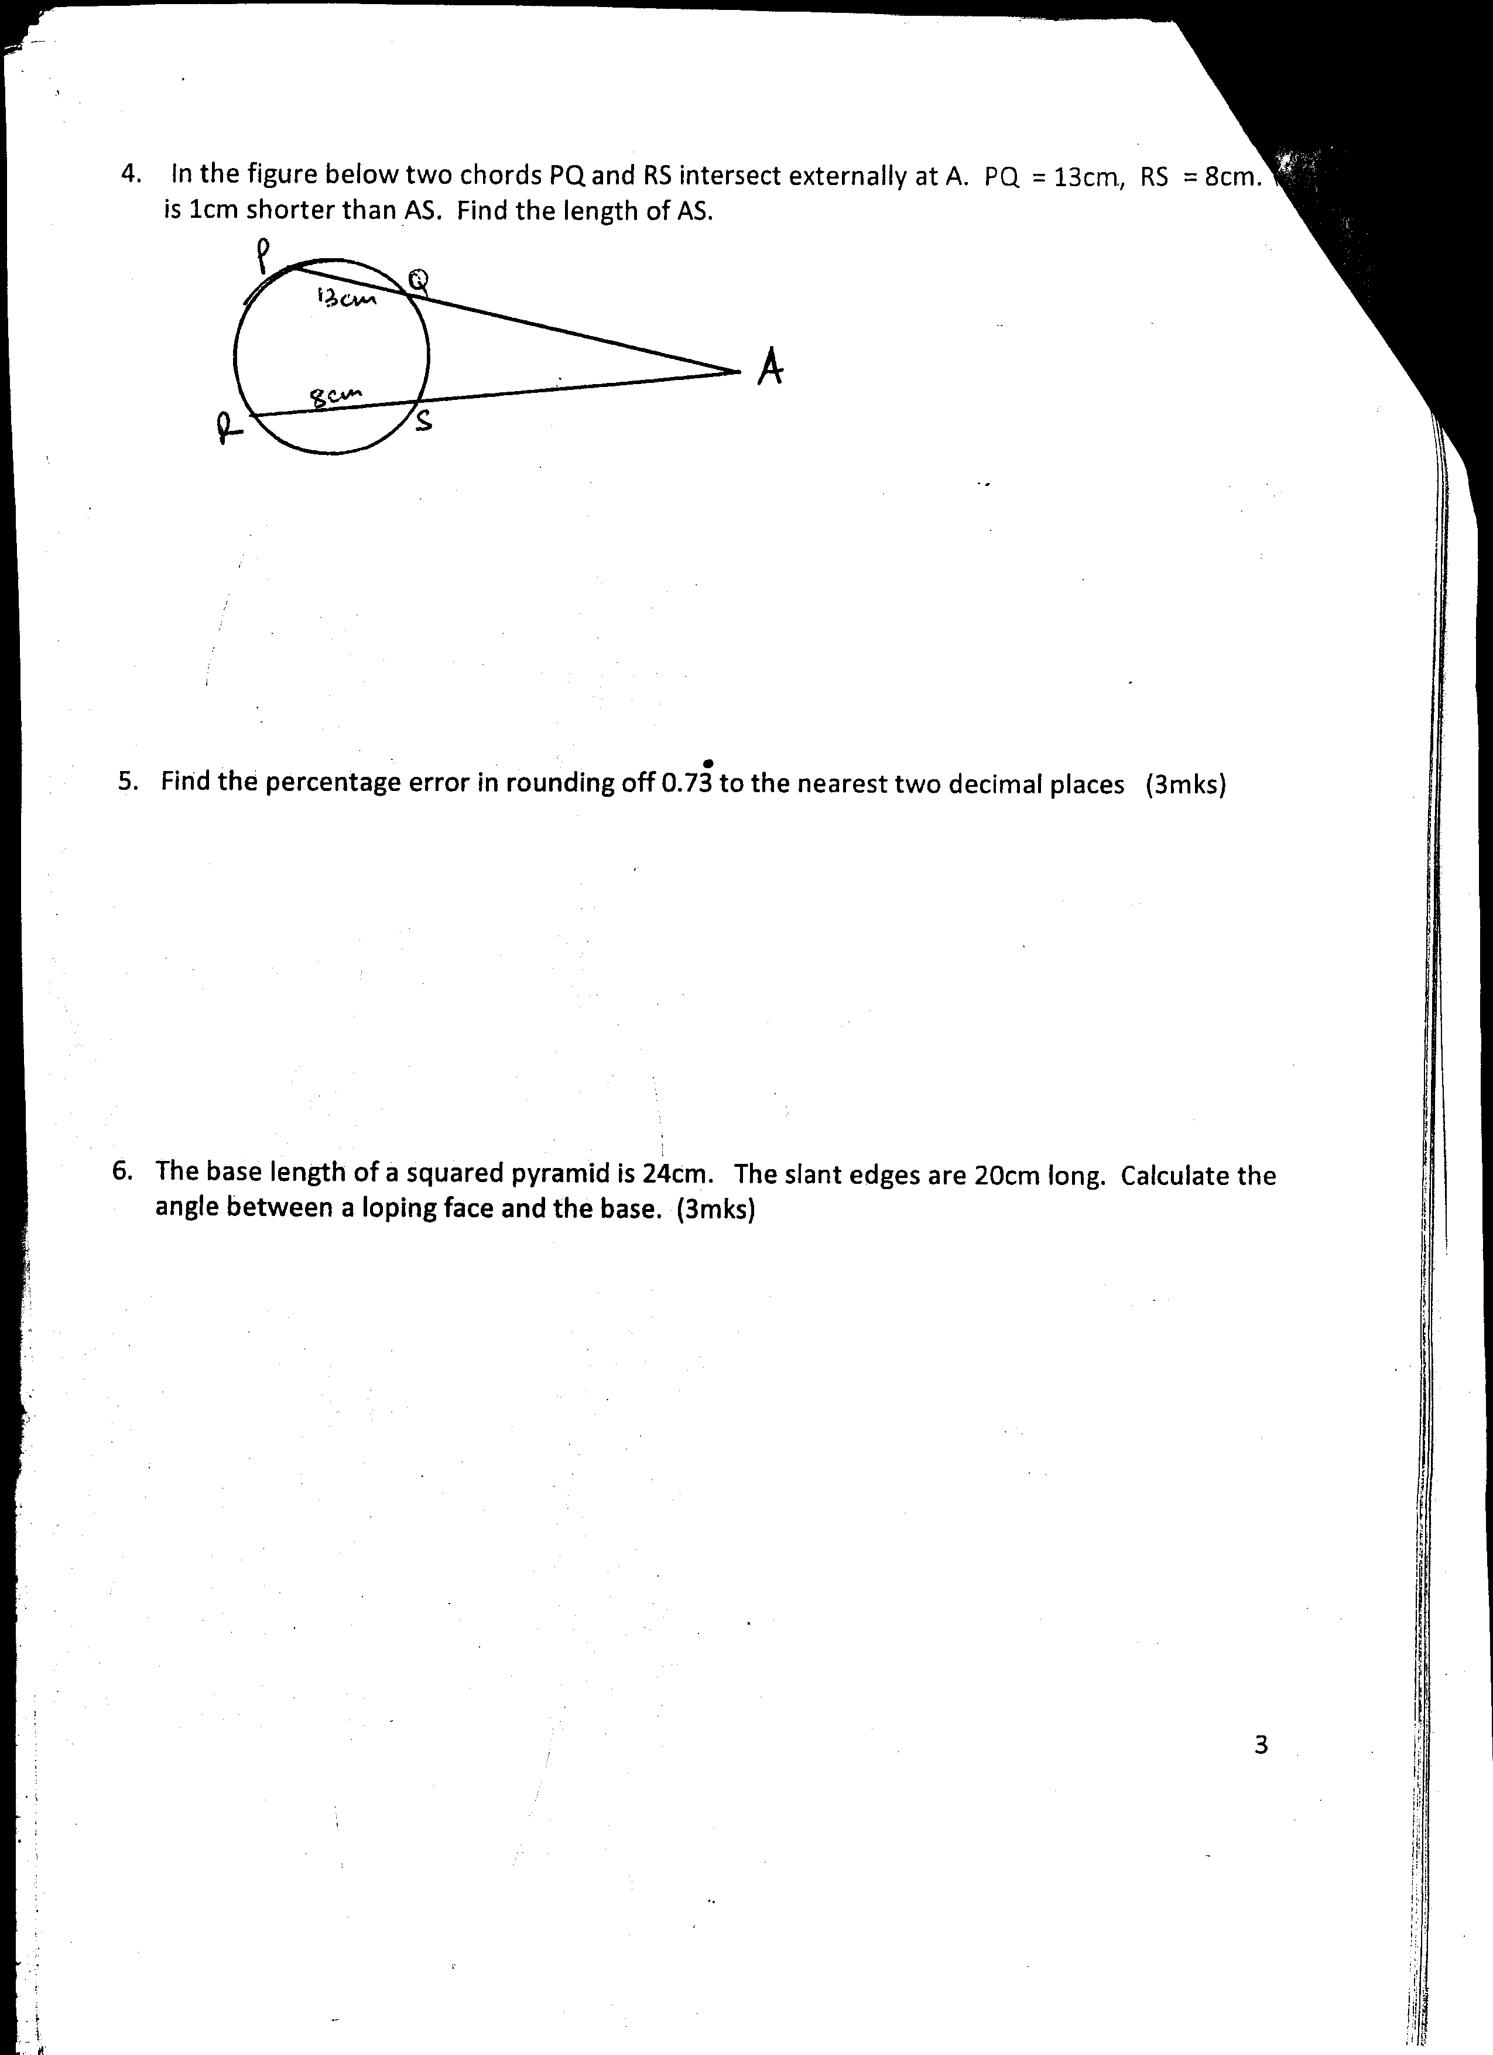

1. Find the percentage error in rounding off 0.7 $\dot{3}$ to the nearest two decimal places (3mks)
2. The base length of a squared pyramid is 24cm. The slant edges are 20cm long. Calculate the angle between a sloping face and the base. (3mks)
3. The sum of the first four terms of an arithmetic progression is 14. If the sum of the first eight terms is 108, find the sixth term of this progression. (3mks)
4. (a) Expand ${(3 +a )}^{5}$ (2mks)

(b) Hence evaluate ${( 2.97)}^{5}$ correct to 4 significant figures (2mks)

1. Grade A tea costs Ksh. 100 per kg while grade B costs Ksh. 150 per kg. Find the ratio in which the two grades should be mixed to get a mixture worth Ksh. 140 per kg. (3mks)
2. Three friends Aloice, Kennedy and Chore went out for shopping. Aloice bought 2 cards , 2kg of sugar and ½ kg of beans, Kennedy bought 1 card, 3kg of sugar and 1 ½ kg of beans while Charo bought 5 cards, 4kg of sugar and 2 kg of beans.
3. Write this information in the form of a matrix (1mk)
4. The cost of a card is sh.100, a kg of sugar at sh.90 and a kg of beans at sh.180. Use matrix multiplication to find the amount of money spent by the three boys. (2mks)
5. Find the centre and radius of a circle whose equation is; (3mks)

+ + 8x - 5y + 10 = 0

1. Simplify without using calculators or mathematical table (3mks)
$$\frac{\sin{{60}^{0 }- 1}}{\cos{{30}^{0}}+ 1}$$

2. Simplify; (3mks)
$$\frac{{12x}^{2 }- 16x}{20-11x-3x}$$

3. P varies directly as R squared and inversely as the square root of Q. Find the percentage change in R if P increases in the ratio 5:2 and Q decreases by 10% (3mks)
4. A ship cruises 60km on a bearing of ${230}^{0}$ it then changes course and heads due west for 80km. calculate its direct distance from the starting point. (3mks)
5. Under a transformation whose matrix X = a triangle whose area is ${12.5cm}^{2}$ is mapped onto a triangle whose area is ${50cm}^{2}$. Find two possible values of a. (3mks)

**SECTION II 50 MARKS**

**(Answer any Five questions in this section )**

1. An aircraft leaves town P $\left({30}^{0}S, {17}^{0}E\right)$ and moves directly to Q (${60}^{0}N,{17}^{0}E$). It then moved at an average speed of 300 knots for 8 hours westwards to town R. Determine;
2. The distance PQ in nautical miles (3mks)
3. The position of town R (3mks)
4. The local time at R if the local time at Q is 3.15p.m (2mks)
5. The total distance moved from P to R in km. Take 1nm = 1.853km (2mks)
6. The table below shows monthly income tax rates for a certain year.

|  |  |
| --- | --- |
| Income, k£ p.m | Rate of tax, shs per £ |
| 1 – 342 | 2 |
| 343 – 684 | 3 |
| 685 – 1026 | 4 |
| 1027 – 1368 | 5 |
| 1369 – 1710 | 6 |
| Over 1710 | 7 |

A civil servant earns a salary of Ksh.42,000 and is provided with a house at a normal rent of Ksh.1500 per month.

1. Taxable income is the employee’s salary plus 15% of the salary less nominal rent. Calculate the civil servants taxable income in k£ p.m (2mks)
2. If the employee is entitled to a personal relief of Ksh.900p.m, what is his PAYE (5mks)
3. The following deductions are also made from his monthly pay; NHIF Ksh.630; WCPS – Ksh. 540, union dues Ksh. 330; SACCO loan recovery – Ksh. 7,000, co-operatives shares – Ksh.2500. Calculate his net pay (3mks)
4. (a) Using a ruler and a pair of compasses only, construct triangle ABC in which AB = 6, BC=5.5cm and angle ABC = ${60}^{0}.$ Measure AC (3mks)

(b) On the same side of AB as C,

1. Determine the locus of a point P such that angle APB = ${60}^{0}$ (3mks)
2. Construct the locus of R such that AR = 3cm (1mk)
3. Identify the region T such that AR ≥ 3cm and $<APB ≥{60}^{0}$ by shading the unwanted parts (3mks)
4. Mukumbeti flying company has two types of aeroplanes. The smaller one uses 180 litres of fuel per hour while the bigger one uses 300 litres per hour. The fuel available per week is 18000 litres. The company is allowed 80 flying hours per week. To keep the aeroplane in good condition, the bigger plane must be flown for x hours a week while the smaller aeroplane must be flown y hours per week.
5. Write down all the inequalities in x and y, representing the above information. (3mks)
6. On the grid provided, draw all the inequalities in (a) above by shading the unwanted regions (4mks)
7. The profit on the smaller aeroplane is Ksh.4000 per hour while that on the bigger one is Ksh. 6000 per hour. Use the graph drawn in (b) above to estimate the maximum profit that the company made per week. (3mks)
8. A box contains red and green apples. There are 8 red and 28 green apples. One apple is picked from the box at random without replacement then a second apple also picked at random.
9. Draw a tree diagram to represent the information up to when the second apple is picked. List down all the possible outcomes. (3mks)
10. Find the probability that;
11. The first apple picked is red (1mk)
12. The second apple picked is green (2mks)
13. Both apples are of same colour (2mks)
14. The apples picked are of different colours (2mks)
15. In an agricultural centre, the length of a sample of 50 maize cobs were measured and recorded as shown on the table below;

|  |  |  |  |  |  |  |
| --- | --- | --- | --- | --- | --- | --- |
| Length (cm) | 8 – 10 | 11 – 13 | 14 – 16 | 17 – 19 | 20 – 22 | 23 – 25 |
| No. of cobs | 4 | 7 | 11 | 15 | 8 | 5 |

Use the date above to estimate;

1. The median (3mks)
2. The mean (2mks)
3. The variance (3mks)
4. The standard deviation (2mks)
5. (a) Complete the table given below by filling in the blank boxes

|  |  |  |  |  |  |  |  |  |  |  |  |  |  |
| --- | --- | --- | --- | --- | --- | --- | --- | --- | --- | --- | --- | --- | --- |
| $$X^{0}$$ | 0 | $${15}^{0}$$ | $${30}^{0}$$ | $${45}^{0}$$ | $${60}^{0}$$ | $${75}^{0}$$ | $${90}^{0}$$ | $${105}^{0}$$ | $${120}^{0}$$ | $${135}^{0}$$ | $${150}^{0}$$ | $${165}^{0}$$ | $${180}^{0}$$ |
| 3 $\cos{X^{0}}$ | 3.0 |  | 2.60 |  | 1.50 |  | 0 | -0.75 |  |  |  |  | -3.0 |
| 4 $\sin{(2x- {10}^{0}}$) | 0.69 | 1.37 |  | 3.94 | 3.76 |  | 0.69 |  |  |  | -3.76 |  | -0.69 |

(b) Using a scale of 1cm rep. ${15}^{0}$ on the x-axis and 2cm to represent 1 unit on the vertical axis, draw the graphs of y = 3 $\cos{X^{0}}$ and y = 4 $\sin{(2x- {10}^{0}}$) using the same axes on the grid provided (5mks)



(c) Use the graph to find the values of x for which 3 $\cos{X^{0}}$- 4 $\sin{(2x- {10}^{0}}$)= 0 (1mk)

(d) State the period and amplitude for the two graphs (2mks)

1. In the figure below, **OQ** = **q** and **OR** = r. point x divides **OQ** in the ratio 3:4. Lines **XR** and **YQ** intersect at **E**.

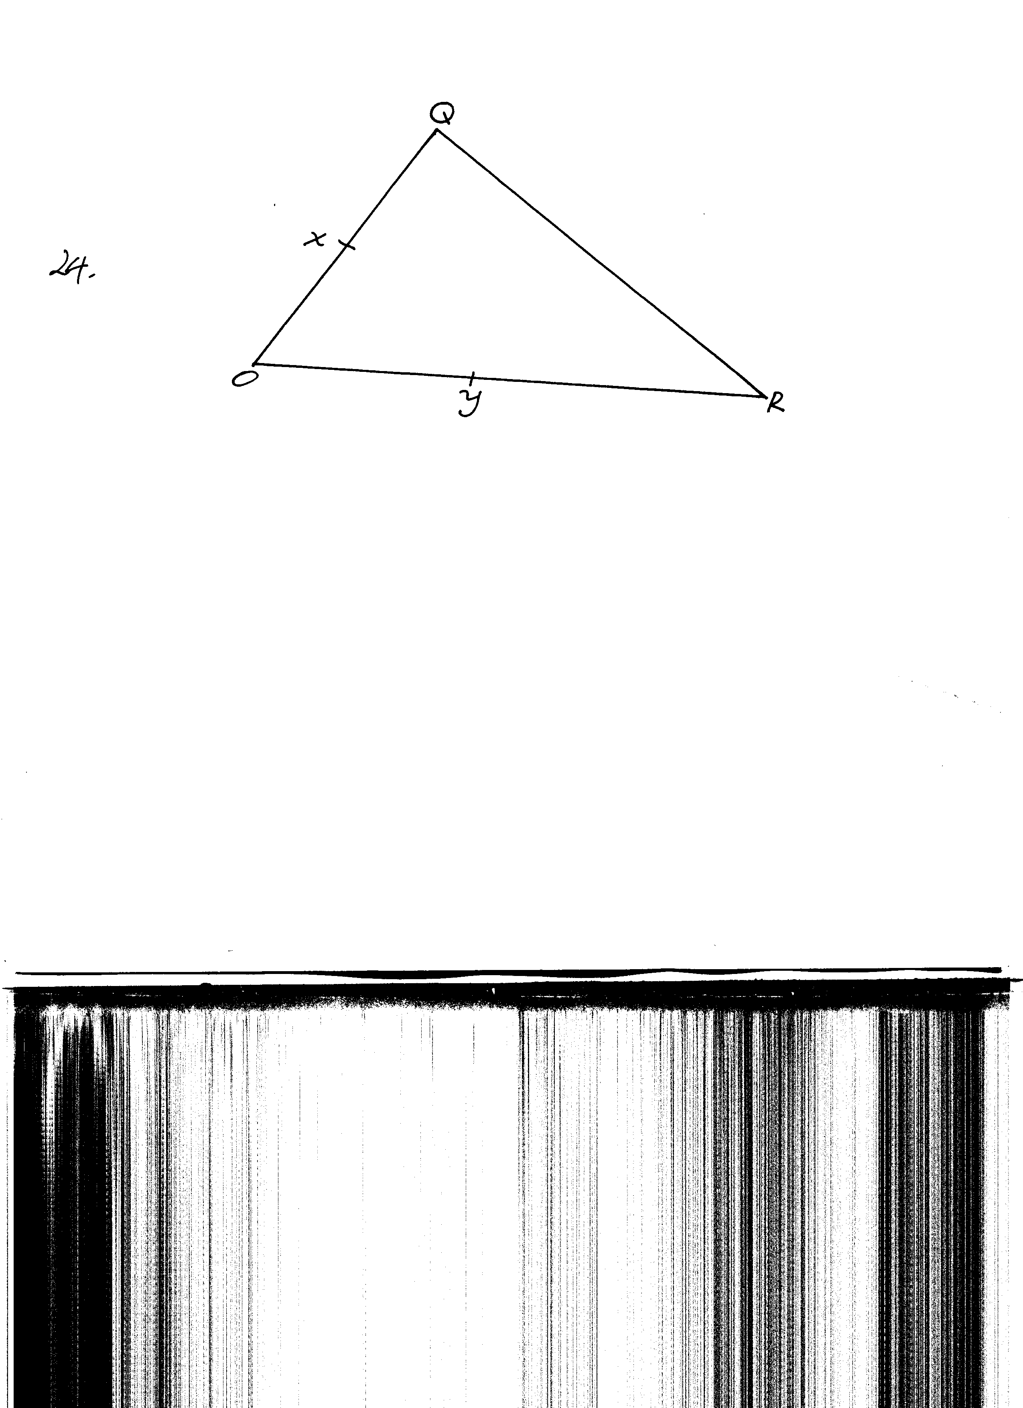

1. Express in terms of **q** and **r**
2. **XR**  (1mk)
3. **YQ** (1mk)
4. If **XE** = **MXR** and **YE** = **n y Q** express **OE** in terms of;
5. **r, q** and **m** 1mk)
6. **r, q** and **n** (1mk)
7. Using the results in (b) above, find the values of m and n (6mks)