NAME: ………………………………………………..INDEX NO:………………………………….
SCHOOL: ……………………………………………..SIGN:………………………………………
DATE: …………………………………………………

232/1
PHYSICS
Paper I
Theory
JULY/AUGUST-2016
Time: 2 Hours

KAKAMEGA SOUTH SUB-COUNTY JOINT EVALUATION TEST – 2016
Kenya Certificate of Secondary Examination ( KCSE)
232/1
PHYSICS
Paper I
Theory

INSTRUCTIONS TO CANDIDATES
• Write your name and index number in the spaces provided above.
• Answer all the questions both in section A and B in the spaces provided below each question
• All workings must be clearly shown,
• Mathematical tables and silent electronic calculators may be used.
• Take : Acceleration due to gravity, g 10m/s²
Density of water = Ig/cm³
For examiner’s use only
SECTION | QUESTION | MAXIMUM SCORE | CANDIDATE’S SCORE
Section A | 1-13 | 25
Section B | 14 | 11
 | 15 | 08
 | 16 | 12
 | 17 | 11
 | 18 | 13
 | TOTAL | 80

This paper consists of 11 printed pages Check the Question paper to ensure that all pages are printed as indicated and no question are missing.
SECTION A (25 MARKS)
Answer ALL the questions in this section in the spaces provided
1. (a) Draw a diagram to represent a scale of a micrometer screw gauge of thimble scale 50
divisions and reading 3.68mm

(b) Determine the actual reading if the micrometer screw gauge above has a zero error of 0.03mm. (1mk)
…………………………………………………………………………………………..
…………………………………………………………………………………………
……………………………………………………………………………………………
…………………………………………………………………………………………..
……………………………………………………………………………………………
2. State why braking systems use Liquid and not gases. (lmk)
…………………………………………………………………………………………………….
…………………………………………………………………………………………………….
……………………………………………………………………………………………………..
……………………………………………………………………………………………………...
……………………………………………………………………………………………………..
3. The figure 1 below shows the level of mercury and water in a beaker.
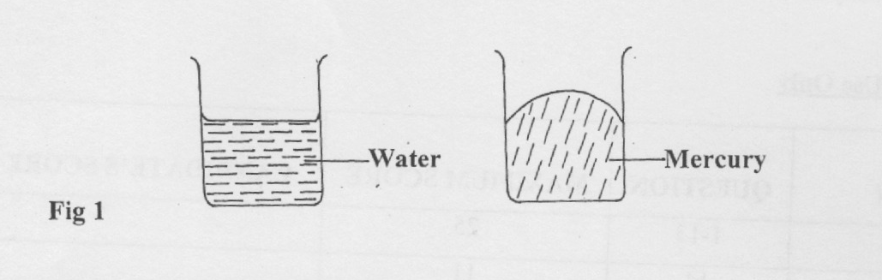

Explain the difference in the shape of the meniscus. (1mk)
…………………………………………………………………………………………………….
…………………………………………………………………………………………………….
…………………………………………………………………………………………………….
4. The figure 2 below shows a wooden sphere with a nail hammered into it at point H as shown below.
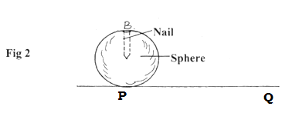
The sphere is rolled on a horizontal ground and comes to rest after sometime at point Q.
Draw the sphere after it comes to rest at point Q (1mk)

5. A 50g mass is placed on a straight air track sloping at an angle of 45° to the horizontal.
(a) Calculate in ms⁻² , the acceleration of the load as it slides down. (3mks)
…………………………………………………………………………………………..
…………………………………………………………………………………………
……………………………………………………………………………………………

(b) Calculate the distance it would move from rest in 0.20s (3mks)
…………………………………………………………………………………………..
…………………………………………………………………………………………
……………………………………………………………………………………………
…………………………………………………………………………………………..
……………………………………………………………………………………………

6. What is the safe speed a motorist should drive at on a level bend of radius 96m if the co-efficient of friction between the road and the tyres is 0.36m? (3mks)
…………………………………………………………………………………………..…………………………………………………………………………………………………………………………………………………………………………………………………………………………………………………………………………………..……………………………………………
7. A roller coaster has a vertical loop of radius 12m. The cars hurtle round the loop at l4ms⁻² point in the loop does the passenger feel heaviest. (1mk)

8. Sketch on the axis provided below a velocity - time graph of a motion of a stone thrown vertically upward from the edge of a platform and eventually the stone lands without bouncing on the ground below the platform. (1mk)
9. The figure 4 below shows two light sheets of paper arranged as shown.
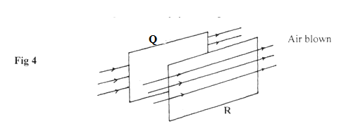

State what is observed if strong air is blown at the same time behind paper Q and in front of paper R as shown (1mk)
………………………………………………………………………………………………………
……………………………………………………………………………………………………….
10. A glass stopper is weighed in air then immersed wholly in water and reweighed. The readings obtained are 2.5N in air and 2.0N in water. Given that the density of water is 1000kg/m. Calculate the density of the stopper. (3mks)
…………………………………………………………………………………………………….
…………………………………………………………………………………………………….
……………………………………………………………………………………………………..
……………………………………………………………………………………………………..
……………………………………………………………………………………………………
11. Explain why it is safe to hold the other end of a burning match stick. (1mk)
……………………………………………………………………………………………………….
………………………………………………………………………………………………………
12. State two physical quantities that remain constant while pure ice is being converted to water.
(2mks)
…………………………………………………………………………………………………….
……………………………………………………………………………………………………
…………………………………………………………………………………………………….
13. State any two characteristics of an ideal gas. (2mks)
……………………………………………………………………………………………………..
………………………………………………………………………………………………………
………………………………………………………………………………………………………
SECTION B (55 MARKS)
Answer all the questions in this section.
14. A lead shot of mass 40g is tied to a string of length 70cm. It is swung vertically at 5 revolutions per second.
(a) Determine;
(i) Periodic time, (2mks)
…………………………………………………………………………………………..
…………………………………………………………………………………………
……………………………………………………………………………………………
(ii) Angular velocity (2mks)
…………………………………………………………………………………………..
…………………………………………………………………………………………
……………………………………………………………………………………………
(iii) Linear velocity (2mks)
…………………………………………………………………………………………..
…………………………………………………………………………………………
……………………………………………………………………………………………
(iv) Maximum tension in the string.
…………………………………………………………………………………………..
…………………………………………………………………………………………
……………………………………………………………………………………………
(b) The figure 5 below shows a container with small holes at the bottom in which wet clothes have been put. When the container is whirled in air at high speed as shown, it is observed that the clothes dry faster. Explain how the rotation of the container causes the clothes to dry faster. (2mks)
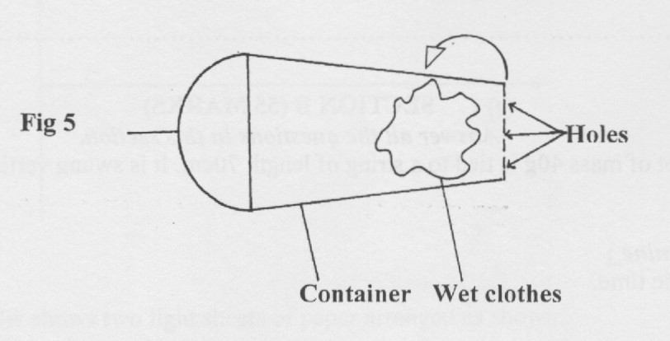
15. A certain substance contracts when heated at a certain temperature and expands when cooled at the same temperature.
(i) Name the substance (lmk)
…………………………………………………………………………………………..
…………………………………………………………………………………………
……………………………………………………………………………………………
(ii) State one disadvantage of this behaviour. (lmk)
…………………………………………………………………………………………..
…………………………………………………………………………………………
……………………………………………………………………………………………
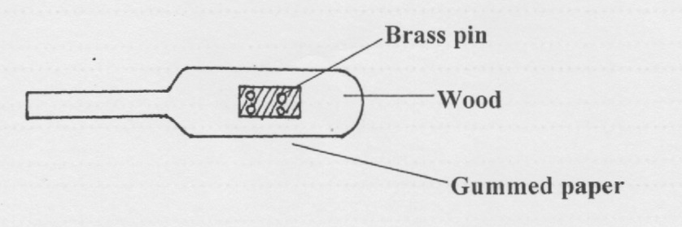
(b) The figure 6 below shows four brass pins pressed on a cooking stuck until they are flat on the wood. A white gummed paper was then stuck on the wood covering the pins. The stick was then passed over a Bunsen flame a few times.

It was observed that the paper got charred leaving four white spots. Explain this observation.
(1 mk)
…………………………………………………………………………………………..
…………………………………………………………………………………………
……………………………………………………………………………………………
(c) The figure 7 below shows an experiment carried out by form one student.
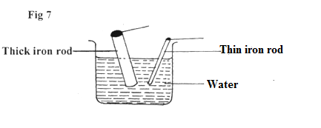
- The students dipped two iron rods of the same length but of different thickness into a beaker of hot water at the same time. What was the experiment about? (1mk)
…………………………………………………………………………………………..
…………………………………………………………………………………………
……………………………………………………………………………………………
(ii) State and explain the observations made after about 10 minutes. (2mks)
…………………………………………………………………………………………..
…………………………………………………………………………………………
……………………………………………………………………………………………
(iii) If the two rods were much longer, state and explain any difference from C (ii) above that would be made in the observation. (2mks)
…………………………………………………………………………………………..
…………………………………………………………………………………………
……………………………………………………………………………………………
16. (a) Explain why a gas exerts increased pressure when it is compressed into a small space.
(2mk)
…………………………………………………………………………………………..
…………………………………………………………………………………………
……………………………………………………………………………………………
(b) State the law that relates the volume of a gas to the temperature of the gas. (lmk)
…………………………………………………………………………………………..
…………………………………………………………………………………………
……………………………………………………………………………………………
(c) A balloon is filled with air to a volume of 200ml at a temperature of 293K. Determine volume when the temperature rises to 353K at the same pressure.
…………………………………………………………………………………………..
…………………………………………………………………………………………
……………………………………………………………………………………………
(d) To verify Boyle’s law a set-up consisting of a U-tube was made as shown in the figure 8 below. The tube contains mercury with air in the sealed end.
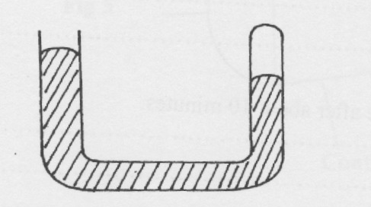
(i) Explain what is observed when more mercury is added. (2mks)
…………………………………………………………………………………………..
…………………………………………………………………………………………
……………………………………………………………………………………………
(ii) Suggest a method used to maintain the temperature of air constant in the experiment. (lmk)
…………………………………………………………………………………………..
…………………………………………………………………………………………
……………………………………………………………………………………………
e) (i) Explain why Boyle’s law would not hold for gases such as methane, (lmk)
…………………………………………………………………………………………..
…………………………………………………………………………………………
(ii) Sketch the graph of pressure against volume for an ideal gas. (2mks)
…………………………………………………………………………………………..
…………………………………………………………………………………………
17. State the Archimedes’s principle. (1mk)
…………………………………………………………………………………………..
…………………………………………………………………………………………
……………………………………………………………………………………………
(b) You are provided with the following apparatus;
• A spring balance
- A small piece of metal
• Eureka can
• A beam balance
• A string
• A beaker
• A retort stand
• Some water.
With the aid of a well labeled diagram, describe an experiment you would perform in the laboratory using the above apparatus to verify Archimedes’s principle for a totally immersed body. (7mks)

(c) A simple hydrometer has a cylindrical cross-sectional area of 2.0cm² and weighed to have a total mass of 15g. What length of the hydrometer is immersed when it floats on water of density:1.0 g/cm³? (3mks)
…………………………………………………………………………………………..
…………………………………………………………………………………………
……………………………………………………………………………………………
18. (a) What is specific latent heat of fusion? (1mk)
…………………………………………………………………………………………..
…………………………………………………………………………………………
(b) State two factors which affect freezing point of ice. (2mks)
…………………………………………………………………………………………..
…………………………………………………………………………………………
……………………………………………………………………………………………
(c) Figure 9 below illustrates an experiment in which electrical energy is used to determine specific latent heat of fusion.
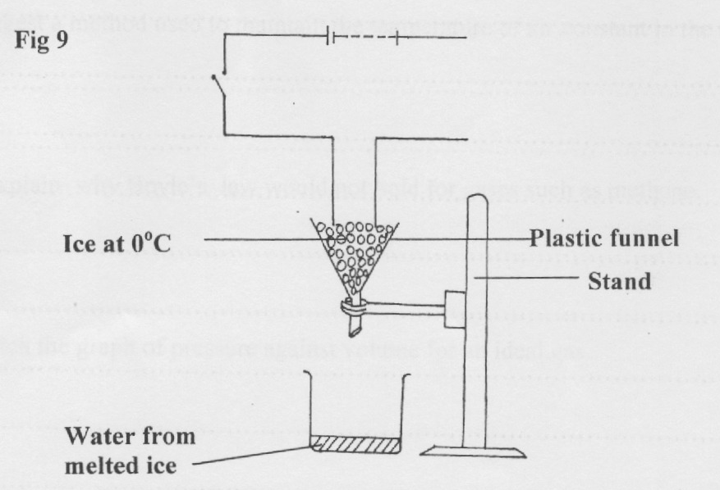

(i) Other than time, state other measurements that would be used to determine the quantity of heat Q, absorbed by ice in unit time. (2mks)
…………………………………………………………………………………………..
…………………………………………………………………………………………
……………………………………………………………………………………………
(ii) Complete the circuit to show connection of the essential circuit components.(3mks)
…………………………………………………………………………………………..
…………………………………………………………………………………………
……………………………………………………………………………………………
(iii) Describe how the experiment can be used to determine the latent heat of’ fusion of ice. (3mks)
…………………………………………………………………………………………..
…………………………………………………………………………………………
……………………………………………………………………………………………
(d) In a similar experiment, the following readings were obtained when the heater was switched on for 5 minutes
Voltmeter reading = 6.OV
Ammeter reading = 1.25 A
Temperature rise reading = 10°C
If by the end of the experiment, 200g of water at 0°C was collected determine the latent heat of fusion of ice. (2mks)
…………………………………………………………………………………………..
…………………………………………………………………………………………
……………………………………………………………………………………………
…………………………………………………………………………………………..
……………………………………………………………………………………………
…………………………………………………………………………………………..
…………………………………………………………………………………………
……………………………………………………………………………………………
…………………………………………………………………………………………..
……………………………………………………………………………………………

