**NAME: ………………………………………………..INDEX NO:………………………………….**

**SCHOOL: ……………………………………..SIGNATURE:………………………………………**

**DATE: …………………………………………………**

**232/2**

**PHYSICS**

**Paper 2**

**Theory**

**July/August, 2016**

**Time: 2 Hours**

**KAKAMEGA SOUTH SUB-COUNTY JOINT EVALUATION TEST – 2016**

**Kenya Certificate of Secondary Examination ( KCSE)**

**232/2**

**PHYSICS**

**Paper 2**

**Theory**

**INSTRUCTIONS TO CANDIDATES**

* Write your name and index number in the spaces provided above.

• This paper consists of 2 sections A and B

• Answer all questions in section A and B in the spaces provided.

• ALL working MUST be clearly shown.

• Mathematical tables and silent scientific calculators may be used.

**For examiner’s use only**

|  |  |  |  |
| --- | --- | --- | --- |
| **SECTION** | **QUESTION** | **MAXIMUM SCORE** | **CANDIDATE’S SCORE** |
| Section A | 1-14 | 25 |  |
| Section B | 15 | 12 |  |
| 16 | 08 |  |
| 17 | 7 |  |
| 18 | 7 |  |
| 19 | 11 |  |
| 20 | 10 |  |
| **TOTAL** | **80** |  |

***This paper consists of 12 printed pages Check the Question paper to ensure that all pages are printed as indicated and no question are missing.***

1. State any 2 ways of in increasing the size of an image formed by a fixed pinhole camera.(2 mks)

……………………………………………………………………………………………………….

………………………………………………………………………………………………………. ……………………………………………………………………………………………………….

2. State 2 advantages of alkaline battery over a lead acid battery. (2 mks)

……………………………………………………………………………………………………….

………………………………………………………………………………………………………. ……………………………………………………………………………………………………….

3. The diagrams below show a soft iron plate in a solenoid and a permanent magnet suspended by a spring.

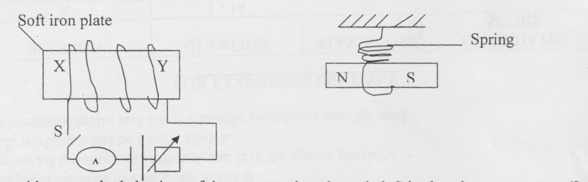

State with reason the behaviour of the magnet when the switch S is closed. (2 mks)

……………………………………………………………………………………………………….

………………………………………………………………………………………………………. ……………………………………………………………………………………………………….

4. A man, standing between 2 parallel vertical walls, claps his hands. He hears the first echo 0.3 seconds later and the next echo after a further 0.2 seconds. If the velocity of sound in air is 300m/h. Calculate the distance between the walls. (3 mks)

……………………………………………………………………………………………………….

………………………………………………………………………………………………………. ……………………………………………………………………………………………………….

5. Silicon was doped with boron to form an extrinsic semi conductor. What is the majority charge

carriers? (1 mark)

……………………………………………………………………………………………………….

………………………………………………………………………………………………………. ……………………………………………………………………………………………………….

6. The table below shows an electromagnetic spectrum. Complete the table in the order of increasing

wavelength from A- B. (2 marks)

|  |  |  |  |  |  |  |
| --- | --- | --- | --- | --- | --- | --- |
| A |  |  | Visible  Light |  |  | B |

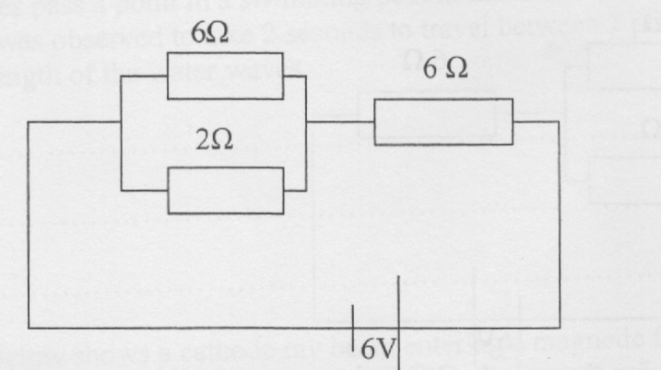7. The figure below shows a 6V battery connected to an arrangement of resistors.

Determine the current flowing through 2 Ω resistor. (3 marks)

……………………………………………………………………………………………………….

………………………………………………………………………………………………………. ……………………………………………………………………………………………………….

8. State difference between semi conductors and metallic conductors. (1 mark)

……………………………………………………………………………………………………….

………………………………………………………………………………………………………. ……………………………………………………………………………………………………….

9. A radioactive sample has a mass of 16g and a half-life of 10 days. How much of the original sample remains after 40 days. (2 marks)

……………………………………………………………………………………………………….

………………………………………………………………………………………………………. ……………………………………………………………………………………………………….

10. Negatively charged rod is brought near the cap of a lightly charged electroscope. The leaf divergence first reduces but as the rod comes nearer, it diverges more.

i) State the charge of the electroscope. (1 mark)

……………………………………………………………………………………………………….

………………………………………………………………………………………………………. ……………………………………………………………………………………………………….

(ii) Explain the behaviour of the leaf above. (1 mark)

……………………………………………………………………………………………………….

………………………………………………………………………………………………………. ……………………………………………………………………………………………………….

11. Water waves pass a point in a swimming pool at the rate of 30 crests per 60 seconds. One of the crests was observed to take 2 seconds to travel between 2 points, 6m apart. Determine

the wavelength of the water waves. (2 marks)

……………………………………………………………………………………………………….

………………………………………………………………………………………………………. ……………………………………………………………………………………………………….

12. The figure below shows a cathode ray beam entering a magnetic field, perpendicular to the plane of the paper complete the diagram to show the path of the beam in the field. (1 mark)

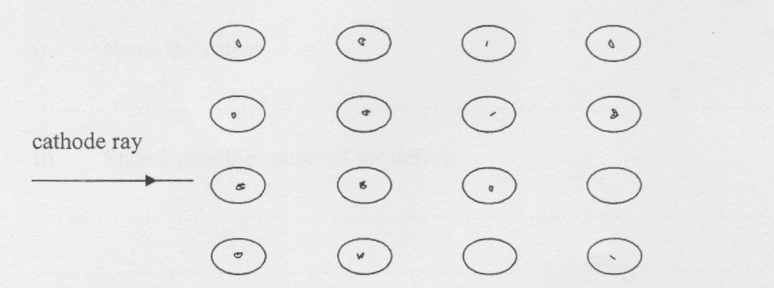

13. The diagram below shows a junction diode.

|  |  |
| --- | --- |
| p | n |

Complete the diagram to show how the diode can be connected in a reverse bias mode. (1 mark)

14. An Uranium 236 isotope has a symbol $\begin{matrix}2361 \\ 92\end{matrix} U$ when bombarded by a neutron, it splits to give s

Substances K and L and 2 neutrons. Calculate the values of a and b in the equation below.

(1 mark)

$\begin{matrix}236 \\ 92\end{matrix} U + \begin{matrix}1 \\ 1 \end{matrix}n \begin{matrix}95 \\ 56 \end{matrix} K + \begin{matrix}a \\ b \end{matrix}L \begin{matrix}+2 \\ 0\end{matrix}$ n

……………………………………………………………………………………………………….

………………………………………………………………………………………………………. ……………………………………………………………………………………………………….

***SECTION B (55 MARKS)***

***Answer all questions from this section in the spaces provided***.

15. a) The figure below shows rays of light entering a human eye which has a defect.

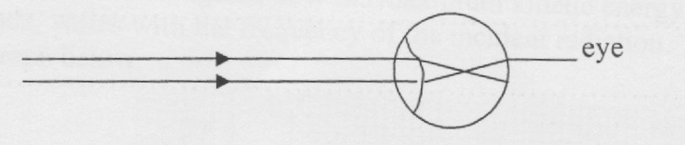

i) Name the defect (1 mark)

………………………………………………………………………………………

ii) State 2 possible causes of the defect. (1 mark)

……………………………………………………………………………………………………….……………………………………………………………………………………………………….………………………………………………………

iii) In the space below, draw a ray diagram to show how the defect can be corrected.

(1mark)

b) A small bright object O lies at the bottom of a beaker containing water of depth h. A convex lens of focal length 15cm is held at the surface of the water. With this arrangement the image of O is formed at a point 45cm from the water surface as shown in the figure below.

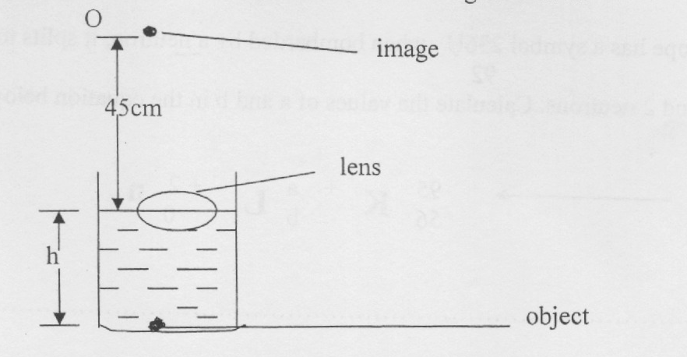

Taking the refractive index of water to be 4/3. Determine

1. the apparent depth of the object (2 marks)

(ii) The real depth h, of the object (3 marks)

c.) A ray light is incident at right angles at the face AD, of a right angled isosceles prism of refractive index 1.6 as shown in the figure below.

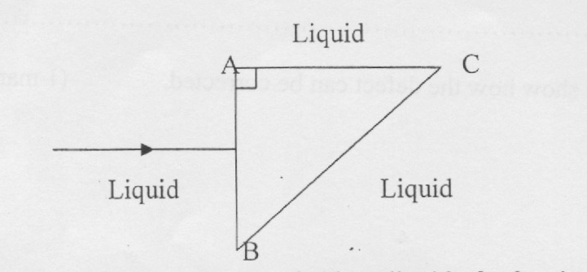

If the prism is surrounded by a liquid of refractive index 1.40.

Determine:

1. The angle of incidence on the face BC. (1 mark)

……………………………………………………………………………………………………………………………………………………………………………………………………………….………………………………………………………

(ii) The angle of refraction on the face BC. (3 marks)

………………………………………………………………………………………

………………………………………………………………………………………. ……………………………………………………………………………………….

16. a) Define the term “Work function” (1 mark)

………………………………………………………………………………………

………………………………………………………………………………………. ……………………………………………………………………………………….

b) A student investigated how the maximum kinetic energy of the photoelectrons, emitted from a zinc cathode, varies with the frequency of the incident radiation. The results obtained were plotted as shown on the graph below.

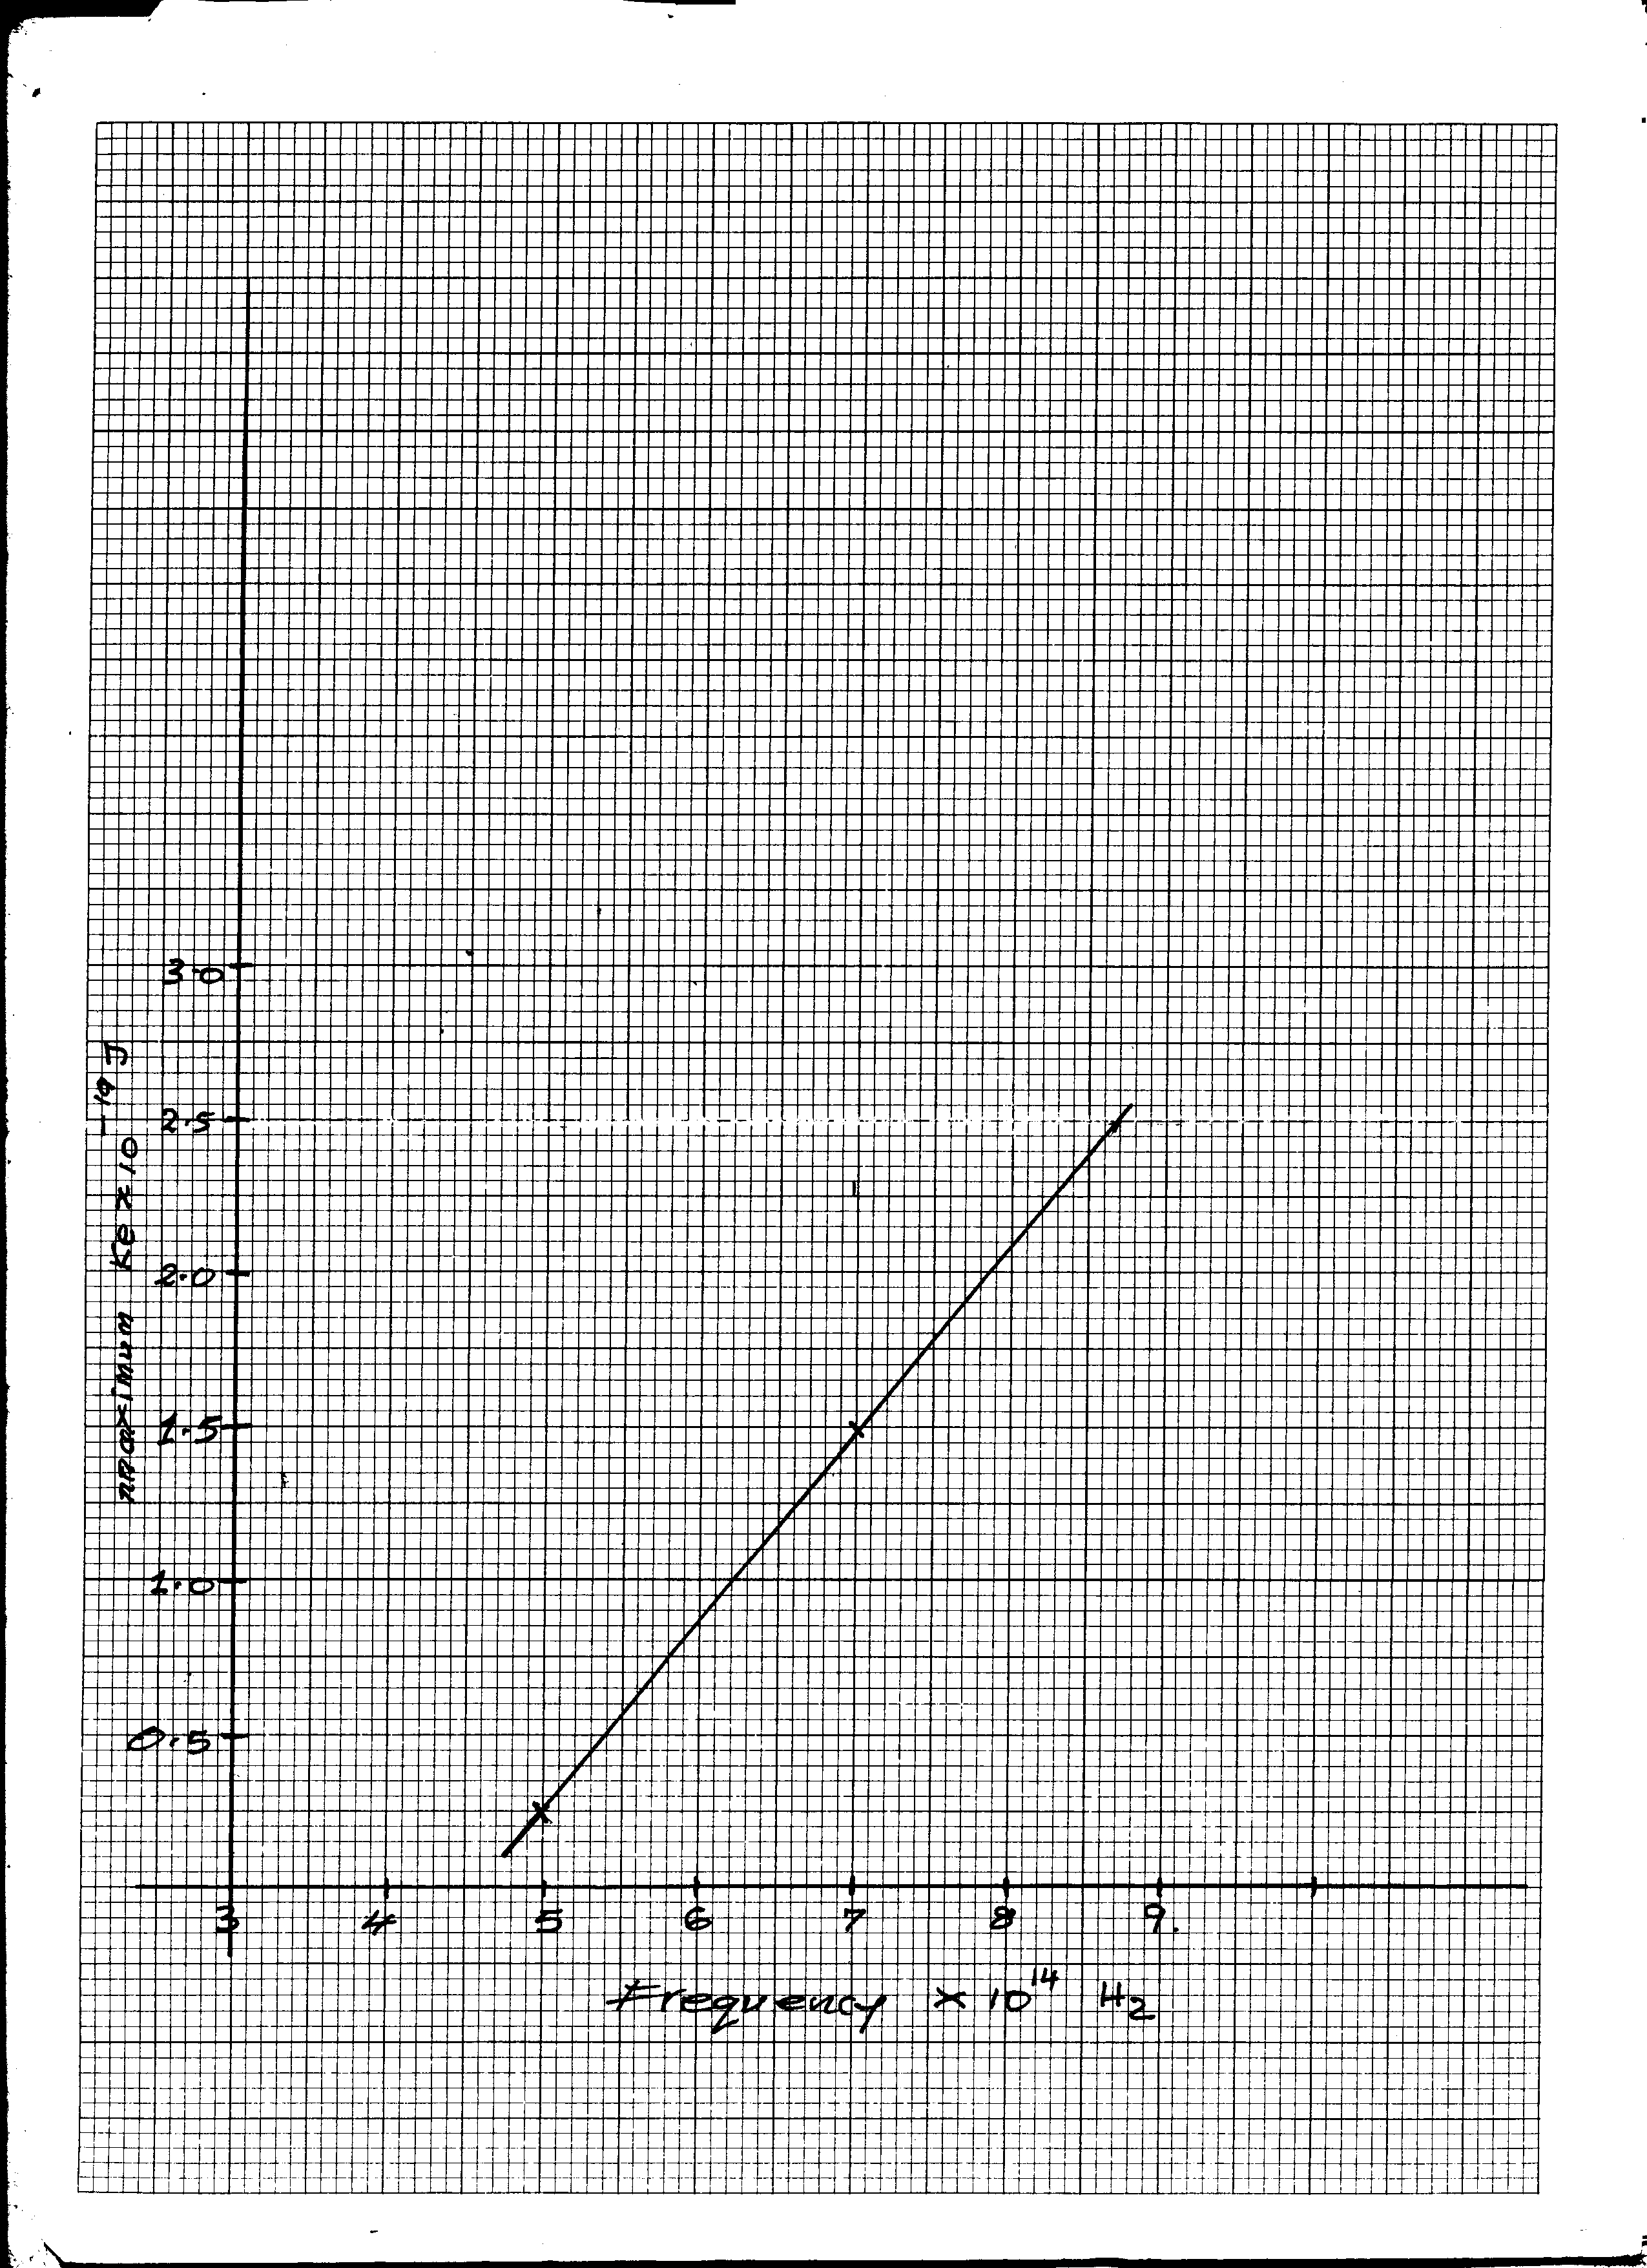

From the graph determine:

1. The plank’s constant

(ii) The work function of the cathode (3 marks)

C. The diagram below shows a circuit containing a battery, 2 identical lamps and a photoconductive cell or a light dependent resistor. (L.D.R)

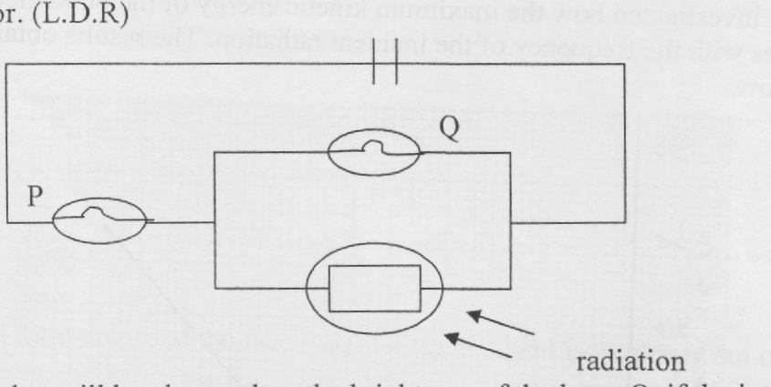

State and explain what will be observed on the brightness of the lamp Q, if the intensity of the

radiation falling on the LDR is increased gradually. (2 marks)

………………………………………………………………………………………………………………………………………………………………………………………………………………………………………………………………………………………………………………………

7. a) A transformer has 960 turns in its primary coil and n turns in its secondary coil and is

connected to a 240 V supply. Given that the transformer is 80% efficient and it is used to operate a 6V, 24W bulb. Find:

1. The number of turns in its secondary coil. (2 marks)

(ii) The current flowing in the primary coil. (2 marks)

b) Explain why the voltage of mains electricity has to be stepped up immediately after power

generation. (1 mark)

………………………………………………………………………………………………

……………………………………………………………………………………………….……………………………………………………………………………………………….

c) An immersion heater is rated 5 KW 250V. It is used for 2 hours daily. If electricity cost sh l2.00 per unit, calculate the weekly cost of running the heater. (2 marks)

………………………………………………………………………………………………

……………………………………………………………………………………………….……………………………………………………………………………………………….

18. a) Explain how doping produces a p-type semi conductor for pure semi conductor material

b) You are provided with 4 diodes, A resistor, an a.c of low voltage and enough connecting wires

(i) In the spaces provided below, sketch the circuit diagram for a full wave rectifier and indicate the terminals where the output voltage v may be connected. (2 marks)

(ii) On the axes provided below, sketch the graph of output voltage against time for the rectifier. (1 Mark)

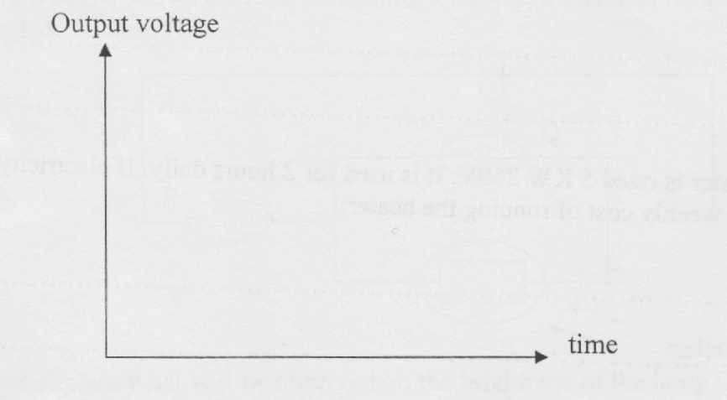

1. A capacitor is now connected across the output. Explain its effect on the output.

(2 marks)

………………………………………………………………………………………………

……………………………………………………………………………………………….……………………………………………………………………………………………….

19. a) Define the term “e.m.f” of a cell. (I mark)

………………………………………………………………………………………………

……………………………………………………………………………………………….……………………………………………………………………………………………….

b) A battery is connected in series with an ammeter and a variable resistor R. The resistor is varied and the corresponding readings of the ammeter recorded in the table below.

|  |  |  |  |  |  |  |
| --- | --- | --- | --- | --- | --- | --- |
| Resistance RΩ | 1.0 | 2.0 | 3.0 | 4.0 | 5.0 | 10.0 |
| Current 1(A) | 2.0 | 1.5 | 1.2 | 1.0 | 0.75 | 0.5 |

(i) Draw a circuit diagram of the circuit that was used to perform this experiment. (1 mark)

(ii) On the grip provided, plot a graph of R (y-axis) against I (x-axis). (5 marks)



(iii) Use your graph to determine the internal resistance of the battery.

1. Determine the e.m.f of the cell,

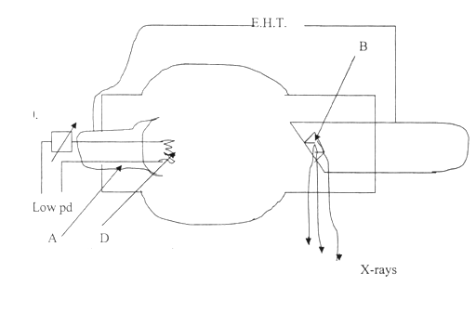20. The diagram below shows an X-ray tube

a) State the functions of A and C (2 marks)

………………………………………………………………………………………………

……………………………………………………………………………………………….……………………………………………………………………………………………….

b) What adjustment on the x-ray tube will:

(i) Increase the hardness of the x-rays (1 mark)

………………………………………………………………………………………………

……………………………………………………………………………………………….……………………………………………………………………………………………….

(ii) Reduce the intensity of the x-rays. (1 mark)

………………………………………………………………………………………………

……………………………………………………………………………………………….……………………………………………………………………………………………….

c). (i) An x-ray tube has an accelerating p.d of 50 kV. Determine the shortest wavelength

of its x-ray beam. (Planks constant h = 6.63X10-34 Js charge on an electron

e = 1.6X10-19C average velocity of light, c=30X108 m/s? (3 marks)



(i) An isotope of uranium  decays by emitting an alpha particle and a beta particle forming a new element M. Write down an equation for the reaction.

(1 mark)

(ii) Explain what causes chain reaction in a nuclear reactor. (1 mark)

………………………………………………………………………………………………

……………………………………………………………………………………………….……………………………………………………………………………………………….

(iii) Give one application of radioactivity. (1 mark)

………………………………………………………………………………………………

……………………………………………………………………………………………….……………………………………………………………………………………………….