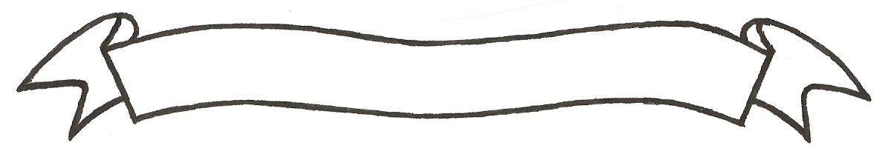

MERU UNIVERSITY OF SCIENCE AND TECHNOLOGY
P.O. Box 972-60200 – Meru-Kenya.
Tel: 020-2069349, 061-2309217. 064-30320 Cell phone: +254 712524293, +254 789151411
Fax: 064-30321
Website: www.must.ac.ke Email: info@must.ac.ke

University Examinations 2015/2016

FIRST YEAR, SECOND SEMESTER EXAMINATION FOR THE DIPLOMA IN BUSINESS ADMINISTRATION AND DIPLOMA IN PURCHASING AND SUPPLIES MANAGMENT

BFD 2154: PRINCIPLES OF AUDITING

DATE: NOVEMBER 2015 TIME: 2 HOURS

INSTRUCTIONS: Answer question one and any other two questions

QUESTION ONE (30 MARKS)
- Explain with your own words how you understand the clause “true and fair view” (2 Marks)
- Highlight five problems encountered in gathering audit evidence (5 Marks)
- Explain why an audit is necessary for a limited liability company (6 Marks)
- Outline the reasons as to why the incoming auditor should communicate with retiring auditor
(5 Marks)
- Define and explain the meaning of audit programme (4 Marks)
- Distinguish between statutory and non-statutory audit (4 Marks)
- Okoth and company certified public accountant (K) is a firm based in Meru paramount plaza. In the beginning of the year they were appointed to be the auditors of Meru University of Science and Technology. Explain extent to which you would advice the firm to rely on the work of the internal auditor in the institution. (4 Marks)

QUESTION TWO (20 MARKS)
- With an aid of examples, distinguish between auditing and accounting (10 Marks)
- Meru slopes Hotel ltd came to you seeking to know whether they require an auditor in their hotel business. Advice them on the purpose of audit (10 Marks)
QUESTION THREE (20 MARKS)
- Briefly discuss these types of audits:
i) Interim audit and final audit (4 Marks)
ii) Continuous audit and procedural audit (4 Marks)
iii) Management audit and balance sheet audit (4 Marks)
- Define audit (2 Marks)
- List and explain advantages of audit firm using standardized audit programme in its assignment (6 Marks)
QUESTION FOUR (20 MARKS)
You are in charge of a group of audit trainees who have just been employed by your audit firm.
This is the audit trainees first assignment and they are aware that they are supposed to prepare audit working papers what information they should include in the working papers.
Required:
- Explain the importance of audit working papers (4 Marks)
- Identify the type of information that the audit trainee should include in the audit working papers (8 Marks)
- Some audit staff preferred standardized audit working papers. What is the meaning by the term standardized working papers (2 Marks)
- Explain any three advantages of using standardized working papers in (c) above (6 Marks)

QUESTION FIVE (20 MARKS)
- Distinguish between auditing and investigation (4 Marks)
- What are the similarities and differences between internal and external auditor? (6 Marks)
- Discuss how the auditor of a public company may be appointed under companies act (6 Marks)
- List and explain the right of an auditor as stipulated in the companies Act. (4 Marks)

