NAME………………………………………………………. INDEX NO……………………………………….…
SCHOOL………………………………………………..……SIGNATURE………………….DATE……..……..

231/2
BIOLOGY
PAPER 2
JULY/AUGUST 2017
TIME 2HOURS.

JULY/AUGUST EVALUATION TEST

FORM FOUR EXAM

BIOLOGY
PAPER 2
JULY/AUGUST 2017
TIME: 2HOURS.

Instructions to candidate
- Write your name, school, index number in the space provided at the top of the paper.
- Sign and write the date of examination in the space provided above.
- Answer ALL the questions in the spaces provided.

1.a) Each human somatic (body) cell has 46 chromosomes in its nucleus. How many of these are sex chromosomes? (1 mark)
…………………………………………………………………………………………………………………………………………………………………………………………………………………………………………………………………………................…………
b) Haemophilia is due to a recessive gene. The gene is sex-linked and located on the X-chromosome. The figure below shows some offspring from phenotypically normal parents.
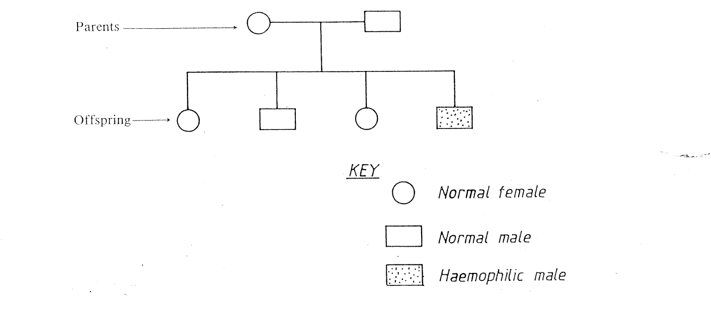
- Work out the genotypes of the offspring. (4 marks)
………………………………………………………………………………………………………………………………………………………………………………………………………………………………………………………………………………………………………………………………………………………………………………………………………………………………………………………………………………………………………………………………………………………………………………………………………………………………………………………………………………………………
c) Explain why sex linked disorders are more common in males than in females. (3 marks)
…………………………………………………………………………………………………………………………………………………………………………………………………………………………………………………………………………………………........
…………………………………………………………………………………………........
…………………………………………………………………………………………........
2. In Europe upto the 19th century, most moth i.e. Biston betularia were white. Today upto 97% of the population recorded in the industrial towns in Europe are black. In rural areas most moth found are white speckled form.
i) Briefly explain how this has come about. (5 marks)
………………………………………………………………………………………………………………………………………………………………………………………………
…………………………………………………………………………………………………………………………………………………………………………………………………………………………………………………………………………………………………………………………………………………………………………………………..…
………………………………………………………………………………………………………………………………………………………………………………………………
………………………………………………………………………………………………………………………………………………………………………………………………………………………………………………………………………………………………
………………………………………………………………………………………………
………………………………………………………………………………………………………………………………………………………………………………………………………………………………………………………………………………………………
………………………………………………………………………………………………
………………………………………………………………………………………………………………………………………………………………………………………………………………………………………………………………………………………………
ii) Name one cause of variation in nature. (1 mark)
………………………………………………………………………………………………………………………………………................................................................................…
iii) Which theory of evolution does it support? (1 mark)
………………………………………………………………………………………………………………………………………………………………………………………………
iv) In order to increase the quantity and quality of agriculture produce, man selects organisms with desirable characteristics to be parents of next generation. Name the practice. (1 mark)
………………………………………………………………………………………………………………………………………………………………………………………………
3. A group of students set- up an experiment as shown below, the experimental set –ups were left for 20 minutes
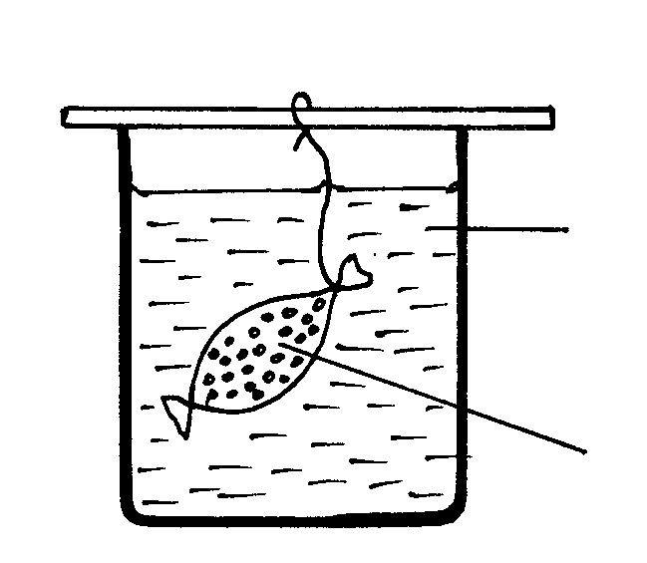
B

A

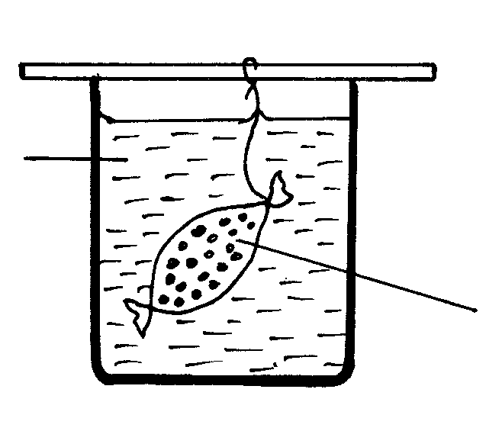
Iodine solution

Starch solution which has been boiled for 5 minutes with dilute Hydrochloric acid
HCl.

Starch Solution
The
The observations after 20 minutes were as shown in the table below
Set –up | Observation
A | Inside tubing | Outside tubing
A | Blue –Black colour | Colour of Iodine
B | Colour of Iodine | Colour of Iodine

- State the process being demonstrated in set –up A (1mark)
….....………………………………………………………………………………………………………………………….…………………………………………….………………………
- Give an explanation for results in set - up A (4marks)
…………………………………………………………………………………………….
….....………………………………………………………………………………………
…………………………………………………………………………………………….
….....………………………………………………………………………………………
….....………………………………………………………………………………………
…………………………………………………………………………………………….
….....………………………………………………………………………………………
- Why was there no blue – black colour inside the visking tubing in set – up B? (3marks)

….....………………………………………………………………………………………
…………………………………………………………………………………………….
….....………………………………………………………………………………………
….....………………………………………………………………………………………
…………………………………………………………………………………………….
….....………………………………………………………………………………………

4. During an ecological study of a lake, a group of students recorded the following observations.
(i) Planktonic crustaceans feed on planktonic algae;
(ii) Small fish feeds on planktonic crustaceans, worms and insect larvae;
(iii) Worms feed on insect larvae;
(iv) A bird species feeds on small fish, planktonic crustaceans, worms and large fish;
(v) Insect larvae feed on planktonic algae;
(vi) Large fish feeds on small fish.
(a) From this record of observations, construct a food web. (4 marks)
….....………………………………………………………………………………………
…………………………………………………………………………………………….
….....………………………………………………………………………………………
….....………………………………………………………………………………………
…………………………………………………………………………………………….
….....………………………………………………………………………………………
….....………………………………………………………………………………………

(b) From the food web, isolate and write down a food chain that ends with:-
(i) Bird species as a secondary consumer. (1 mark)
………………………………………………………………………………………………………
(ii) Large fish as a tertiary consumer. (1 mark)
…………………………………………………………………………………………………

(c) The biomass of the producers in the lake was found to be greater than that of primary consumers. Explain this observation. (2 marks)
….....………………………………………………………………………………………
…………………………………………………………………………………………….
….....………………………………………………………………………………………
….....………………………………………………………………………………………
…………………………………………………………………………………………….
….....………………………………………………………………………………………

5. The diagram below shows a set up that was used to demonstrate a certain physiological process.

The glucose solution was boiled and oil added on top of it. The glucose solution was then allowed to cool before adding yeast suspension.
(a) Identify the physiological process that was being investigated using the above set up. (1 mark)
………………………………………………………………………………………………………
(b) Why was glucose boiled during the experiment? (1 mark)
………………………………………………………………………………………………………
(c) What was the importance of cooling the glucose before adding the yeast suspension?(1 mark)
………………………………………………………………………………………………………
(d) What observation would be made in test tube at the end of the experiment? (1 mark)
………………………………………………………………………………………………………
(e) How would the observation made in (d) above be affected if oil was not added on top of the yeast suspension during the experiment? (1 mark)
………………………………………………………………………………………………………
(f) In another investigation, a bird was found to use 10 litres of oxygen to give a respiratory quotient of 0.7 during period of flight. Name the type of food that was being respired by the bird and determine the amount of carbon (IV) oxide produced during the same flight.
Type of food
………………………………………………………………………………………… (1 mark)
Volume of carbon (IV) oxide produced. (2 marks)
………………………………………………………………………………………………………
…………………………………………………………………………………………………..….

SECTION B
Answer question 6 (COMPULSORY) and either question 7 or 8 in the spaces provided.
6. An experiment was done to determine the concentration in the blood of two hormones X and Y produced in the ovaries of a healthy woman aged 30 years within a period of 28 days. The results obtained are shown in the table below.
Time (days) | Concentration of hormone X (arbitrary units) | Concentration of hormone Y (arbitrary units)
2 | 5 | 4
4 | 12 | 4
6 | 18 | 4
8 | 28 | 4
10 | 40 | 4
12 | 56 | 4
14 | 24 | 4
16 | 20 | 9
18 | 24 | 20
20 | 24 | 36
22 | 22 | 48
24 | 16 | 32
26 | 8 | 24
28 | 3 | 4

(a)Using same axes, plot a graph of the concentration of hormones X and Y against time. (7 marks)
(b)Suggest the identity of the hormones X and Y. (2 marks)
X .........................................................................................................................................
Y .........................................................................................................................................

(c) When was the concentration of hormones X and Y equal? (1 mark)
X .........................................................................................................................................
Y .........................................................................................................................................
(d) Explain the role played by the hormones X and Y during menstrual cycle. (4 marks)
X .........................................................................................................................................
Y .........................................................................................................................................

(e) Briefly describe three features and mechanisms that hinder self-pollination and self fertilization in plants. (6 marks)
….....………………………………………………………………………………………
…………………………………………………………………………………………….
….....………………………………………………………………………………………
….....………………………………………………………………………………………
…………………………………………………………………………………………….
….....………………………………………………………………………………………
….....………………………………………………………………………………………
…………………………………………………………………………………………….
….....………………………………………………………………………………………
….....………………………………………………………………………………………
…………………………………………………………………………………………….
….....………………………………………………………………………………………
….....………………………………………………………………………………………
…………………………………………………………………………………………….
….....………………………………………………………………………………………

7. a) During a voting exercise tension was high. One of the aspirants was furious and wanted to face a very aggressive opponent. Explain the physiological changes that occur in his body to prepare him for the fight. (14 marks)

b) Identify each of the following responses described below:-
i) A person coughs whenever a foreign body irritates the respiratory tract. (1 mark)
ii) Whenever a bell is rung, a dog is presented with a meal. After several days of practice, the dog salivates once the bell is rung even if food is not available.
(1 mark)

c) State the differences be
tween the two responses identified in (b) above. (4 marks)

8. (a) Describe how gaseous exchange occurs in terrestrial plants. (13 marks)
(b) Describe the process of urea formation. (7 marks)
….....………………………………………………………………………………………
…………………………………………………………………………………………….
….....………………………………………………………………………………………
….....………………………………………………………………………………………
…………………………………………………………………………………………….
….....………………………………………………………………………………………
….....………………………………………………………………………………………
…………………………………………………………………………………………….
….....………………………………………………………………………………………
….....………………………………………………………………………………………
…………………………………………………………………………………………….
….....………………………………………………………………………………………
….....………………………………………………………………………………………
…………………………………………………………………………………………….
….....………………………………………………………………………………………
….....………………………………………………………………………………………
…………………………………………………………………………………………….
….....………………………………………………………………………………………
….....………………………………………………………………………………………
…………………………………………………………………………………………….
….....………………………………………………………………………………………
….....………………………………………………………………………………………
…………………………………………………………………………………………….
….....………………………………………………………………………………………
….....………………………………………………………………………………………
…………………………………………………………………………………………….
….....………………………………………………………………………………………
….....………………………………………………………………………………………
…………………………………………………………………………………………….
….....………………………………………………………………………………………
….....………………………………………………………………………………………
…………………………………………………………………………………………….
….....………………………………………………………………………………………
….....………………………………………………………………………………………
…………………………………………………………………………………………….
….....………………………………………………………………………………………
….....………………………………………………………………………………………
…………………………………………………………………………………………….
….....………………………………………………………………………………………
….....………………………………………………………………………………………
…………………………………………………………………………………………….
….....………………………………………………………………………………………
….....………………………………………………………………………………………
…………………………………………………………………………………………….
….....………………………………………………………………………………………
….....………………………………………………………………………………………
…………………………………………………………………………………………….
….....………………………………………………………………………………………
….....………………………………………………………………………………………
…………………………………………………………………………………………….
….....………………………………………………………………………………………
….....………………………………………………………………………………………
…………………………………………………………………………………………….
….....………………………………………………………………………………………
….....………………………………………………………………………………………
…………………………………………………………………………………………….
….....………………………………………………………………………………………
….....………………………………………………………………………………………
…………………………………………………………………………………………….
….....………………………………………………………………………………………
….....………………………………………………………………………………………
…………………………………………………………………………………………….
….....………………………………………………………………………………………
….....………………………………………………………………………………………
…………………………………………………………………………………………….
….....………………………………………………………………………………………
….....………………………………………………………………………………………
…………………………………………………………………………………………….
….....………………………………………………………………………………………
….....………………………………………………………………………………………
…………………………………………………………………………………………….
….....………………………………………………………………………………………
….....………………………………………………………………………………………
…………………………………………………………………………………………….
….....………………………………………………………………………………………
….....………………………………………………………………………………………
…………………………………………………………………………………………….
….....………………………………………………………………………………………
….....………………………………………………………………………………………
…………………………………………………………………………………………….
….....………………………………………………………………………………………
….....………………………………………………………………………………………

